YUKON WILDLAND FIRE MANAGEMENT WEATHER FORECAST - 9:00 AM ISSUE

4-Jun-2025
YESTERDAY'S VALUES
Community | Max  Temp  (°C) | Diff.  from  Normal | Min Temp  (°C) | Diff. from Normal | Pcpn  (mm) | Min RH | Max RH | L110 | L30
Old Crow | 11.3 | -4.1 | 0.7 | -2.8 | 4.0 | 28 | 96 | 0 | 0
Fort Mcpherson Airport | 5.5 |  | 2.5 |  | 0.0M | 44 | 57 | 0 | 0
Rock River Climate | 8.9 |  | -0.6 |  | 0.2 | 64 | 94 | NA | NA
Eagle Plains Fire | 14.9 |  | 0.5 |  | 1.6 | 39 | 99 | 1 | 0
Antimony Creek | 21.4 |  | 5.2 |  | 0.0 | 19 | 63 | 0 | 0
Klondike Fc | M |  | M |  | M | M | M | 0 | 0
Forty Mile | 20.2 |  | 6.4 |  | 0.0 | 21 | 50 | 0 | 0
Henderson | 17.2 |  | 5.9 |  | 0.0 | 23 | 48 | 0 | 0
Barlow | 20.2 |  | 7.6 |  | 0.0 | 26 | 50 | 0 | 0
Mayo A | 18.7 | -0.2 | 8.4 | 3.1 | 0.0 | 30 | 74 | 1 | 0
Stewart Crossing | 20.5 |  | 9.5 |  | 0.3 | 24 | 79 | 0 | 0
Willow Creek | 20.3 |  | 6.1 |  | 0.0 | 25 | 63 | 0 | 0
Pelly Farm | 22.3 | 3.1 | 6.9 | 2.9 | 0.0 | 24 | 79 | 0 | 0
Carmacks | 23.5 |  | 6.2 |  | 0.0 | 20 | 51 | 0 | 0
Drury Creek | 19.4 |  | 1.6 |  | 0.0 | 25 | 78 | 0 | 0
Faro | 16.6 | -0.9 | 7.8 | 3.1 | 0.0 | 27 | 56 | 0 | 0
Ross River | 17.5 |  | -2.3 |  | 0.0 | 26 | 93 | 0 | 0
Macmillan Pass | 11.5 |  | 1.9 |  | 0.0 | 42 | 71 | 0 | 0
Beaver Creek A | 18.4 | 1.6 | 3.0 | 0.0 | 0.0M | 18 | 68 | 0 | 0
Beaver Creek Town | 19.3 |  | 4.4 |  | 0.0 | 16 | 65 | 0 | 0
Burwash A | 17.9 | 2.2 | -0.7 | -2.5 | 0.0M | 22 | 72 | 0 | 0
Haines Junction | 18.0 | 1.3 | 0.0 | -0.6 | 0.0 | 25 | 80 | 0 | 0
Rainbow | 16.8 |  | 5.5 |  | 0.0 | 28 | 59 | 0 | 0
Champagne | 17.3 |  | 6.2 |  | 0.0 | 24 | 58 | 0 | 0
Braeburn | 20.4 |  | 4.7 |  | 0.0 | 21 | 57 | 0 | 0
Nursery | 21.5 |  | -1.7 |  | 0.0 | 17 | 84 | 0 | 0
Whitehorse Auto | 18.0 | 1.3 | 5.2 | 1.8 | 0.0 | 22 | 69 | 0 | 0
Mount Sima | 13.4 |  | 4.5 |  | 0.0 | 29 | 56 | 0 | 0
Carcross | 15.3 |  | 6.8 |  | 0.0 | 35 | 67 | 0 | 0
Atlin | 14.8 |  | 4.0 |  | 0.0 | 32 | 73 | 0 | 0
Jakes Corner | 17.6 |  | 2.1 |  | 0.0 | 25 | 77 | 0 | 0
Teslin | 16.8M |  | 6.1M |  | 0.0M | 30M | 60M | 0 | 0
Quiet Lake | 18.6 |  | 0.5 |  | 0.0 | 25 | 83 | 0 | 0
Swift River | 16.3 |  | 4.9 |  | 0.0 | 32 | 78 | 0 | 0
Tuchitua | 18.6 |  | -2.1 |  | 0.0 | 24 | 99 | 0 | 0
Hasselburg | 15.3 |  | 2.4 |  | 0.0 | 30 | 79 | 0 | 0
Tom Creek | 16.6 |  | 4.0 |  | 0.0 | 32 | 71 | 0 | 0
Watson Lake | 16.5 | -0.8 | 2.0 | -2.5 | 0.0 | 27 | 81 | 0 | 0
Iron Creek | 19.2 |  | -0.6 |  | 0.0 | 25 | 95 | 0 | 0
Max Temp is the actual maximum temperature in °C from yesterday afternoon or evening.
Min Temp is the actual overnight minimum temperature in °C up until 6:00 AM this morning.
Diff. from Normal is the difference from the 30 year average max or min temperature.
Pcpn is the precipitation in mm since 13:00 yesterday.
Min RH is the minimum observed RH in % from yesterday afternoon or evening.
Max RH is the maximum observed overnight RH in % up until 6:00 AM this morning.
L110 is the actual number of lightning strikes within 110 km and in the Yukon for 24 hours ending at 06:00 AM this morning.
L30 is the actual number of lightning strikes within 30 km and in the Yukon for 24 hours ending at 06:00 AM this morning.
M is missing data. * denotes precipitation at stations that failed to report for at least part of the evening and overnight period.

SYNOPSIS:
Today: An upper low over Alaska begins to push eastward into the Yukon. This change won’t be dramatic, but it will bring increasing cloud cover to most of the territory during the day, and a slight risk of showers late today into the overnight hours. Scattered showers expected in the Old Crow region during the day. Temperatures cool by a degree or two compared to yesterday, but winds remain gusty across Kluane, Southern Lakes, and Tintina, where south/southwesterly gusts of 35-50 km/h are possible. RHs in the 25-35% range across the territory, except higher in Old Crow.

Thursday: The upper low continues to advance into the Yukon from Alaska. It is expected to keep temperatures in the mid-teens through most regions, combined with RHs in the 30-40% range. With the upper low pushing into the region, conditions will become increasingly unsettled in the Yukon: greater chance of showers or thundershowers for most regions on Thursday, particularly through the Klondike, Northern Tutchone, Tatchun, and Beaver Creek district. Isolated to scattered lightning risk through these regions as scattered convective cells are expected to develop during the afternoon and evening. Lowest POPs in Kluane, Southern Lakes, and Tintina where showers aren’t likely to develop but southwesterly winds will remain gusty.

Friday: The risk of scattered showers lingers through central and northern territory, while a weak ridge is expected to build back into southwest and south-central Yukon late in the day, leading to clearing skies. Temperatures in the teens with driest conditions in Kluane, Southern Lakes, and Tintina where Min RHs in the 20-30% are possible. Gusts of 30-40 km/h remain possible across southern Yukon.

Saturday: Weak ridging briefly builds back into the territory, leading to highs climbing into the upper teens, except cooler in the northern Klondike. Ridging will be brief, with the ridge expected to quickly break down by Saturday evening/Sunday as the next upper low deepens in the Gulf of Alaska.

Sunday: Unsettled weather returns to the Yukon as widespread cloud cover and shower activity is expected on Sunday with the upper low advancing into the territory. Temperatures expected to cool back down into the teens.

Forecast for | Wednesday | (Peak burning period and overnight)
Community | Clouds | Pcpn | POP | POL | Max Temp | Min RH | Min Temp | Max  RH | Wind Dir | Wind Speed
Old Crow | BKN | R-/RW- | 60 |  | 8 | 68 | 0 | 90 | 20 | 18
Klondike Fc | BKN | RW- | 20 |  | 18 | 25 | 7 | 80 | 90 | 10
Mayo A | BKN | RW- | 20 |  | 16 | 30 | 10 | 79 | 140 | 12
Carmacks | BKN |  | 10 |  | 20 | 25 | 6 | 68 | 180 | 15G30
Faro | BKN | R-/RW- | 30 |  | 16 | 27 | 4 | 84 | 220 | 15
Ross River | BKN | R-/RW- | 30 |  | 18 | 27 | 3 | 76 | 220 | 14
Beaver Creek Town | BKN | RW- | 20 |  | 17 | 30 | 5 | 76 | 290 | 10
Burwash A | SCT |  | 0 |  | 14 | 33 | 3 | 69 | 160 | 25G45
Haines Junction | BKN |  | 0 |  | 13 | 36 | 5 | 82 | 180 | 20G40
Whitehorse Auto | BKN | RW- | 20 |  | 14 | 35 | 7 | 75 | 160 | 20G40
Teslin | BKN | R-/RW- | 30 |  | 14 | 35 | 7 | 79 | 180 | 15G35
Watson Lake | BKN | R-/RW- | 30 |  | 18 | 30 | 8 | 74 | 250 | 15G35
POP is probability of precipitation in %.
POL is probability of lightning in %.

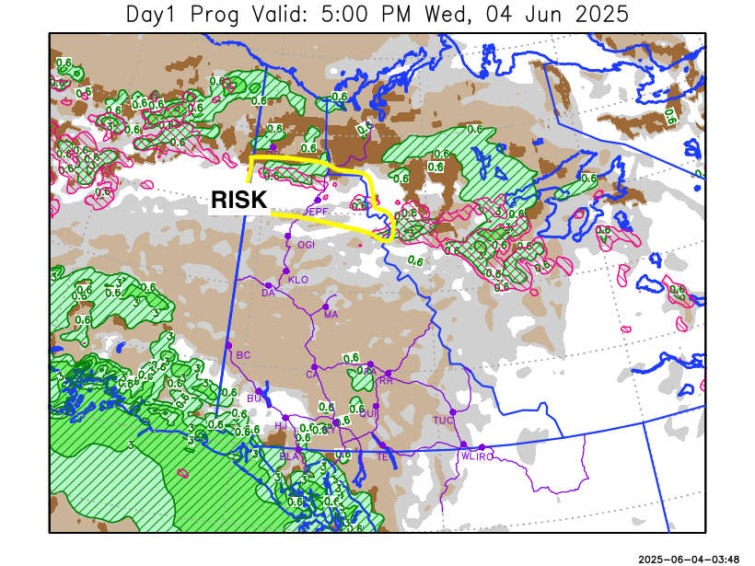
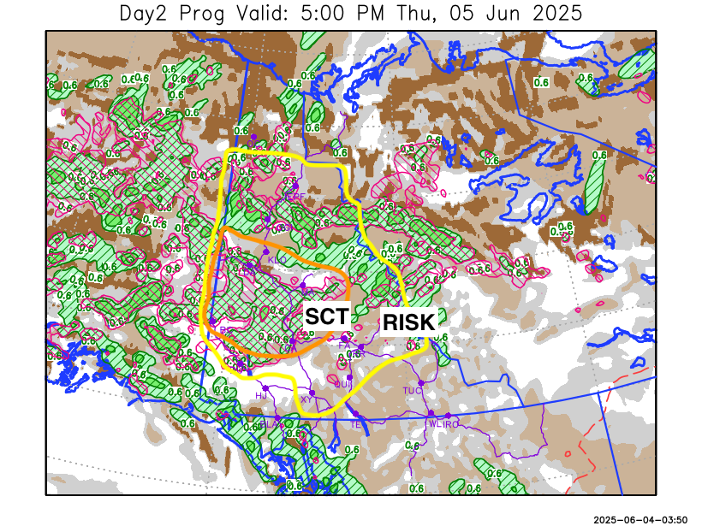

Forecast for | Thursday | (Peak burning period and overnight)
Community | Clouds | Pcpn | POP | POL | Max Temp | Min RH | Min Temp | Max  RH | Wind Dir | Wind Speed
Old Crow | BKN | RW- | 30 |  | 8 | 63 | 0 | 86 | 20 | 15G25
Klondike Fc | BKN | R-/TRW- | 80 | SCT | 14 | 66 | 6 | 89 | 270 | 8
Mayo A | BKN | R-/TRW- | 80 | SCT | 15 | 52 | 9 | 87 | 250 | 14
Carmacks | BKN | RW-/TRW- | 60 | SCT | 19 | 35 | 6 | 83 | 250 | 12
Faro | BKN | RW-/TRW- | 60 | ISO | 13 | 42 | 3 | 90 | 250 | 15G30
Ross River | BKN | RW-/TRW- | 60 | ISO | 16 | 40 | 2 | 78 | 250 | 15G30
Beaver Creek Town | BKN | RW-/TRW- | 60 | SCT | 17 | 32 | 2 | 72 | 270 | 16
Burwash A | BKN | RW-/TRW- | 60 | ISO | 14 | 32 | 2 | 76 | 200 | 15
Haines Junction | BKN |  | 10 |  | 15 | 32 | 2 | 81 | 200 | 20G40
Whitehorse Auto | BKN | RW-/TRW- | 20 | RISK | 15 | 29 | 5 | 68 | 220 | 20G40
Teslin | SCT |  | 10 |  | 14 | 35 | 4 | 71 | 220 | 20G40
Watson Lake | SCT |  | 10 |  | 17 | 35 | 6 | 57 | 250 | 20G40

Forecast for |  |  | Friday |  |  | (Peak burning period and overnight)
Community |  |  | Clouds |  |  | Pcpn |  | POP |  | POL |  | Max Temp |  | Min RH | Min Temp | Max  RH | Wind Dir | Wind Speed
Old Crow |  |  | BKN |  |  | RW- |  | 40 |  |  |  | 12 |  | 56 | 2 | 91 | 70 | 8
Klondike Fc |  |  | BKN |  |  | RW-/TRW- |  | 40 |  | RISK |  | 16 |  | 44 | 5 | 85 | 270 | 12
Mayo A |  |  | BKN |  |  | RW-/TRW- |  | 40 |  | RISK |  | 15 |  | 49 | 7 | 85 | 270 | 13
Carmacks |  |  | BKN |  |  | RW-/TRW- |  | 20 |  | RISK |  | 18 |  | 34 | 4 | 72 | 270 | 10
Faro |  |  | BKN |  |  | RW- |  | 20 |  |  |  | 14 |  | 52 | 2 | 83 | 250 | 14
Ross River |  |  | SCT |  |  | RW- |  | 20 |  |  |  | 16 |  | 38 | 1 | 76 | 270 | 14
Beaver Creek Town |  |  | SCT |  |  | RW- |  | 20 |  |  |  | 18 |  | 25 | 1 | 68 | 270 | 14
Burwash A |  |  | SCT |  |  |  |  | 0 |  |  |  | 14 |  | 27 | 2 | 74 | 160 | 15
Haines Junction |  |  | SCT |  |  |  |  | 0 |  |  |  | 16 |  | 26 | 2 | 87 | 180 | 15G30
Whitehorse Auto |  |  | BKN |  |  |  |  | 0 |  |  |  | 16 |  | 24 | 4 | 75 | 250 | 15G30
Teslin |  |  | BKN |  |  |  |  | 0 |  |  |  | 14 |  | 28 | 3 | 75 | 250 | 15G30
Watson Lake |  |  | BKN |  |  |  |  | 0 |  |  |  | 16 |  | 27 | 6 | 57 | 270 | 20G40
3-Day Forecast Precipitation Totals from 13:00 Yesterday
OC | 10.4 |  | FA | 6.5 |  |  | JAK | 0.7
EPF | 8.1 |  | RR | 3.1 |  |  | TE | 0.7
ANT | 9.4 |  | BC | 4.1 |  |  | QUI | 1.7
DA | 10.4 |  | BCT | 4.1 |  |  | SWI | 1.9
FMI | 11.2 |  | BU | 6.0 |  |  | FL | 5.2
HEN | 9.3 |  | HJF | 0.0 |  |  | TUC | 2.6
BAR | 8.4 |  | RAI | 0.2 |  |  | HAS | 0.7
MA | 5.6 |  | CH | 0.3 |  |  | TC | 0.7
STW | 5.2 |  | BR | 4.8 |  |  | WL | 0.7
WIL | 5.3 |  | NU | 0.9 |  |  | PE | 4.4
XY | 0.5 |  | IRO | 0.3 |  |  | CA | 6.8
CC | 0.0 |  | ELK | 0.0 |  |  | DRU | 11.6
ATL | 1.9 |  | NA | NA |  |  | NA | NA
Matt Desorcy Meteorologist

Disclaimer : The information in these forecasts is collected and prepared for internal use by the Government of Yukon. The forecasts are specifically designed to meet the needs of the Wildland Fire Management and may not cover the requirements of other parties. Weather warnings or advisories are not included as part of the forecasts. Wildland Fire Management makes no representation and provides no warranty as to the accuracy of its weather forecasts. Any use the recipient chooses to make of the forecasts will be at its sole risk.

