YUKON WILDLAND FIRE MANAGEMENT WEATHER FORECAST - 9:00 AM ISSUE

7-Jun-2025
YESTERDAY'S VALUES
Community | Max  Temp  (°C) | Diff.  from  Normal | Min Temp  (°C) | Diff. from Normal | Pcpn  (mm) | Min RH | Max RH | L110 | L30
Old Crow | 14.2 | -2.2 | 2.0 | -2.3 | 0.0 | 50 | 95 | 2 | 0
Fort Mcpherson Airport | 12.2 |  | 3.9 |  | 0.1M | 62 | 92 | 0 | 0
Rock River Climate | 10.4 |  | 4.2 |  | 0.0 | 64 | 87 | NA | NA
Eagle Plains Fire | 12.0 |  | 4.7 |  | 1.8 | 55 | 97 | 1 | 0
Antimony Creek | 19.4 |  | -0.6 |  | 0.0 | 32 | 99 | 4 | 4
Klondike Fc | 17.3 |  | 7.1 |  | 0.0 | 35 | 80 | 4 | 0
Forty Mile | 15.5 |  | 2.3 |  | 0.6 | 41 | 98 | 0 | 0
Henderson | 11.7 |  | 4.6 |  | 0.0 | 49 | 81 | 4 | 0
Barlow | 13.9 |  | 3.6 |  | 1.1 | 43 | 95 | 4 | 0
Mayo A | 14.3 | -5.1 | 3.3 | -2.5 | 0.3 | 55 | 95 | 2 | 0
Stewart Crossing | 14.5 |  | 2.3 |  | 3.6 | 48 | 100 | 5 | 0
Willow Creek | 10.6 |  | -0.7 |  | 1.6 | 63 | 99 | 1 | 0
Pelly Farm | 18.1 | -1.6 | -0.3 | -4.8 | 0.0 | 33 | 97 | 0 | 0
Carmacks | 18.9 |  | 1.4 |  | 0.0 | 28 | 94 | 0 | 0
Drury Creek | 12.9 |  | -0.8 |  | 2.4 | 60 | 98 | 0 | 0
Faro | 14.1 | -3.9 | -1.0 | -6.2 | 0.0 | 43 | 96 | 0 | 0
Ross River | 16.1 |  | -3.7 |  | 0.0 | 33 | 94 | 0 | 0
Macmillan Pass | 9.5 |  | 1.2 |  | 0.4 | 55 | 100 | 0 | 0
Beaver Creek A | 14.2 | -3.2 | -1.7 | -5.3 | 0.0M | 29 | 86 | 0 | 0
Beaver Creek Town | 15.0 |  | -1.4 |  | 2.3 | 27 | 93 | 0 | 0
Burwash A | 15.1 | -1.1 | 4.6 | 2.3 | 0.0M | 23 | 57 | 0 | 0
Haines Junction | 16.0 | -2.6 | -0.6 | -2.4 | 0.0 | 28 | 87 | 0 | 0
Rainbow | 17.0 |  | 4.4 |  | 0.0 | 25 | 68 | 0 | 0
Champagne | 17.2 |  | -0.1 |  | 0.0 | 20 | 78 | 0 | 0
Braeburn | 16.3 |  | -3.0 |  | 1.6 | 23 | 95 | 0 | 0
Nursery | 19.3 |  | 0.5 |  | 0.0 | 18 | 77 | 0 | 0
Whitehorse Auto | 16.9 | -0.4 | 4.0 | 0.1 | 0.0 | 17 | 64 | 0 | 0
Mount Sima | 12.7 |  | 1.6 |  | 0.0 | 22 | 62 | 0 | 0
Carcross | 15.8 |  | -2.2 |  | 0.0 | 28 | 89 | 0 | 0
Atlin | 14.7 |  | 3.1 |  | 0.0 | 25 | 62 | 0 | 0
Jakes Corner | 17.6 |  | -1.0 |  | 0.0 | 21 | 75 | 0 | 0
Teslin | 14.4M |  | -0.6M |  | 0.0 | 25M | 82M | 0 | 0
Quiet Lake | 18.1 |  | -1.7 |  | 0.0 | 26 | 91 | 0 | 0
Swift River | 15.6 |  | -2.8 |  | 0.0 | 27 | 88 | 0 | 0
Tuchitua | 15.4 |  | -4.3 |  | 0.0 | 41 | 97 | 0 | 0
Hasselburg | 15.0 |  | 0.8 |  | 0.0 | 29 | 80 | 0 | 0
Tom Creek | 15.6 |  | 1.8 |  | 0.0 | 31 | 73 | 0 | 0
Watson Lake | 15.4 | -2.5 | 0.2 | -4.8 | 0.0 | 28 | 86 | 0 | 0
Iron Creek | 17.9 |  | -2.1 |  | 0.0 | 28 | 95 | 0 | 0
Max Temp is the actual maximum temperature in °C from yesterday afternoon or evening.
Min Temp is the actual overnight minimum temperature in °C up until 6:00 AM this morning.
Diff. from Normal is the difference from the 30 year average max or min temperature.
Pcpn is the precipitation in mm since 13:00 yesterday.
Min RH is the minimum observed RH in % from yesterday afternoon or evening.
Max RH is the maximum observed overnight RH in % up until 6:00 AM this morning.
L110 is the actual number of lightning strikes within 110 km and in the Yukon for 24 hours ending at 06:00 AM this morning.
L30 is the actual number of lightning strikes within 30 km and in the Yukon for 24 hours ending at 06:00 AM this morning.
M is missing data. * denotes precipitation at stations that failed to report for at least part of the evening and overnight period.

SYNOPSIS:
Today: Upper ridging across the Yukon is beginning to break down, signaling a shift toward more unsettled weather in the coming days. However, today will remain quiet, with only a slight chance of showers and a slight risk of a thunderstorm in the Klondike and Northern Tutchone regions. Elsewhere, dry conditions are expected, with temperatures ranging from the mid-teens to low twenties. Winds will increase from the southeast to 20–30 km/h, gusting to 40–50 km/h across most regions in response to a developing low-pressure system. Rain chances will increase tonight into early Sunday as low pressure develops over the territory.

Sunday: A developing low-pressure system will bring widespread rain to the northern half of the Yukon on Sunday. Rain is most likely in the Klondike, Old Crow, and Northern Tutchone regions. Farther south, rain will be more isolated, with a few light showers in the Kluane, Tatchun, Southern Lakes, and Tintina regions. However, there is some uncertainty in how far south the more widespread rain will reach; therefore, the northern portions of these regions may see more persistent showers. Winds will be quite variable across the Yukon, with strong south to southwest winds expected in the Kluane, Southern Lakes, and Tintina regions; strong northeast winds in Old Crow; and highly variable speeds and directions elsewhere around the low-pressure centre. However, most locations will eventually shift toward west or southwest winds by late in the day as the low begins to move east. Check the tabular forecast for the average wind in your area. Due to the presence of low pressure and upper troughing, cool temperatures in the single digits to teens are expected, with no crossovers.

Monday: The low-pressure system from Sunday shifts east, but rain showers will linger. The best chance for rain remains in the Klondike and Northern Tutchone regions, though showers are possible across the entire territory. Temperatures will remain cool, with highs in the teens, except for the occasional reading into the twenties in the south (e.g., Carmacks). Winds will be mostly from the west at 15–20 km/h. No crossovers are expected.

Tuesday: An upper low will move into the Gulf of Alaska on Tuesday, potentially bringing a chance of showers to the southern Yukon. Otherwise, little active weather is expected with broad troughing across the Yukon and temperatures remaining cool.

Wednesday: The upper low mentioned in Tuesday’s forecast continues to shift slowly southeast in the Gulf of Alaska. This may again bring some showers to the southern Yukon, but otherwise little active weather is expected.

Forecast for | Saturday | (Peak burning period and overnight)
Community | Clouds | Pcpn | POP | POL | Max Temp | Min RH | Min Temp | Max  RH | Wind Dir | Wind Speed
Old Crow | SCT | TRW/RW- | 30 | 10 | 19 | 30 | 9 | 90 | 110 | 30G50
Klondike Fc | SCT | TRW/RW- | 30 | 10 | 18 | 25 | 9 | 85 | 110 | 25G40
Mayo A | SCT | TRW/RW- | 30 | 10 | 19 | 30 | 12 | 90 | 140 | 25G45
Carmacks | BKN |  | 20 | 0 | 22 | 20 | 8 | 85 | 160 | 30G50
Faro | BKN |  | 20 | 0 | 17 | 30 | 6 | 85 | 160 | 25G40
Ross River | BKN |  | 20 | 0 | 19 | 30 | 6 | 80 | 160 | 25G40
Beaver Creek Town | BKN |  | 20 | 0 | 20 | 20 | 5 | 90 | 110 | 20
Burwash A | BKN |  | 20 | 0 | 15 | 20 | 4 | 70 | 160 | 35G55
Haines Junction | BKN |  | 20 | 0 | 16 | 30 | 4 | 90 | 180 | 25G40
Whitehorse Auto | BKN |  | 20 | 0 | 16 | 20 | 7 | 80 | 160 | 30G50
Teslin | BKN |  | 20 | 0 | 16 | 25 | 8 | 80 | 160 | 25G40
Watson Lake | SCT |  | 20 | 0 | 18 | 25 | 11 | 85 | 180 | 25G40
POP is probability of precipitation in %.
POL is probability of lightning in %.

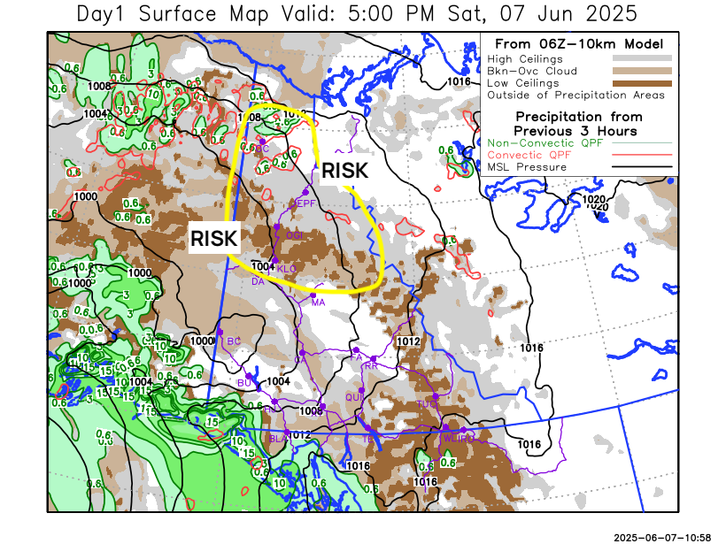
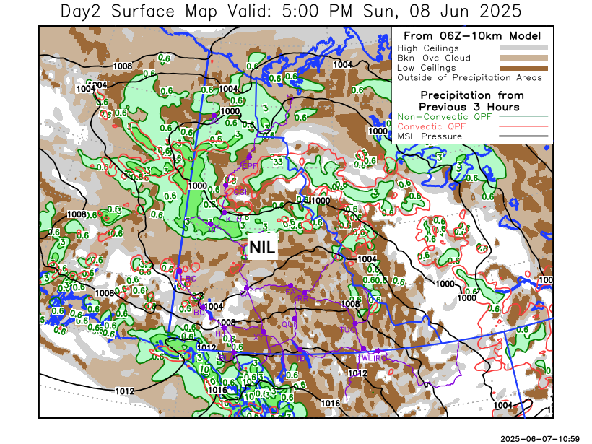

Forecast for | Sunday | (Peak burning period and overnight)
Community | Clouds | Pcpn | POP | POL | Max Temp | Min RH | Min Temp | Max  RH | Wind Dir | Wind Speed
Old Crow | OVC | R | 90 | 0 | 12 | 60 | 4 | 100 | 30 | 25G40
Klondike Fc | OVC | R | 90 | 0 | 15 | 60 | 6 | 100 | 270 | 15
Mayo A | OVC | R | 90 | 0 | 14 | 50 | 10 | 100 | 220 | 15
Carmacks | BKN | RW- | 60 | 0 | 18 | 45 | 6 | 95 | 220 | 20
Faro | BKN | RW- | 40 | 0 | 12 | 45 | 3 | 95 | 220 | 20G30
Ross River | BKN | RW- | 40 | 0 | 16 | 40 | 2 | 95 | 220 | 20G30
Beaver Creek Town | BKN | RW- | 50 | 0 | 18 | 35 | 2 | 90 | 270 | 15
Burwash A | BKN | RW- | 40 | 0 | 13 | 40 | 2 | 90 | 180 | 20G40
Haines Junction | BKN | RW- | 40 | 0 | 13 | 45 | 3 | 90 | 200 | 25G40
Whitehorse Auto | BKN | RW- | 40 | 0 | 13 | 35 | 5 | 90 | 200 | 25G45
Teslin | BKN | RW- | 30 | 0 | 11 | 40 | 5 | 90 | 220 | 20G35
Watson Lake | BKN | RW- | 30 | 0 | 15 | 35 | 6 | 85 | 250 | 25G40

Forecast for |  |  | Monday |  |  | (Peak burning period and overnight)
Community |  |  | Clouds |  |  | Pcpn | POP |  | POL |  | Max Temp |  | Min RH | Min Temp | Max  RH | Wind Dir | Wind Speed
Old Crow |  |  | BKN |  |  | R- | 80 |  | 0 |  | 12 |  | 55 | 4 | 100 | 0 | 15
Klondike Fc |  |  | BKN |  |  | R- | 80 |  | 0 |  | 16 |  | 45 | 5 | 100 | 300 | 20
Mayo A |  |  | BKN |  |  | R- | 80 |  | 0 |  | 16 |  | 45 | 8 | 100 | 270 | 20
Carmacks |  |  | BKN |  |  | RW- | 50 |  | 0 |  | 20 |  | 35 | 7 | 95 | 270 | 15
Faro |  |  | BKN |  |  | RW- | 40 |  | 0 |  | 14 |  | 45 | 4 | 95 | 270 | 20
Ross River |  |  | SCT |  |  | RW- | 40 |  | 0 |  | 17 |  | 40 | 3 | 95 | 270 | 20
Beaver Creek Town |  |  | SCT |  |  | RW- | 40 |  | 0 |  | 18 |  | 30 | 2 | 95 | 290 | 10
Burwash A |  |  | SCT |  |  | RW- | 40 |  | 0 |  | 15 |  | 30 | 4 | 90 | 290 | 15
Haines Junction |  |  | SCT |  |  | RW- | 40 |  | 0 |  | 15 |  | 45 | 2 | 90 | 270 | 20G30
Whitehorse Auto |  |  | SCT |  |  | RW- | 40 |  | 0 |  | 16 |  | 30 | 4 | 90 | 250 | 20
Teslin |  |  | SCT |  |  | RW- | 40 |  | 0 |  | 14 |  | 35 | 3 | 90 | 250 | 20
Watson Lake |  |  | BKN |  |  | RW- | 40 |  | 0 |  | 16 |  | 30 | 6 | 95 | 270 | 20
3-Day Forecast Precipitation Totals from 13:00 Yesterday
OC | 12.2 |  | FA | 2.8 |  | JAK | 1.1
EPF | 14.4 |  | RR | 0.1 |  | TE | 0.6
ANT | 9.9 |  | BC | 5.0 |  | QUI | 1.6
DA | 12.6 |  | BCT | 7.3 |  | SWI | 3.1
FMI | 18.8 |  | BU | 0.5 |  | FL | 3.2
HEN | 11.1 |  | HJF | 2.0 |  | TUC | 1.6
BAR | 13.4 |  | RAI | 1.8 |  | HAS | 0.6
MA | 5.3 |  | CH | 1.2 |  | TC | 1.2
STW | 10.8 |  | BR | 1.8 |  | WL | 0.6
WIL | 7.8 |  | NU | 0.6 |  | PE | 3.9
XY | 0.2 |  | IRO | 1.3 |  | CA | 2.8
CC | 2.6 |  | ELK | 0.4 |  | DRU | 7.5
ATL | 2.4 |  | NA | NA |  | NA | NA
Scott Kehler Meteorologist

Disclaimer : The information in these forecasts is collected and prepared for internal use by the Government of Yukon. The forecasts are specifically designed to meet the needs of the Wildland Fire Management and may not cover the requirements of other parties. Weather warnings or advisories are not included as part of the forecasts. Wildland Fire Management makes no representation and provides no warranty as to the accuracy of its weather forecasts. Any use the recipient chooses to make of the forecasts will be at its sole risk.

