YUKON WILDLAND FIRE MANAGEMENT WEATHER FORECAST - 9:00 AM ISSUE

16-Jun-2025
YESTERDAY'S VALUES
Community | Max  Temp  (°C) | Diff.  from  Normal | Min Temp  (°C) | Diff. from Normal | Pcpn  (mm) | Min RH | Max RH | L110 | L30
Old Crow | 26.1 | 7.3 | 13.6 | 7.2 | 0.0 | 28 | 64 | 0 | 0
Fort Mcpherson Airport | 23.9 |  | 10.9 |  | 0.0 | 36 | 80 | 0 | 0
Rock River Climate | 21.4 |  | 11.3 |  | 0.0 | 33 | 67 | - | -
Eagle Plains Fire | 26.8 |  | 11.3 |  | 0.0 | 17 | 68 | 0 | 0
Antimony Creek | 28.0 |  | 6.4 |  | 0.0 | 20 | 90 | 18 | 3
Klondike Fc | 29.0 |  | 9.3 |  | 0.0 | 23 | 86 | 9 | 2
Forty Mile | 27.8 |  | 9.8 |  | 0.0 | 19 | 87 | 3 | 0
Henderson | 23.2 |  | 12.6 |  | 0.0 | 23 | 61 | 26 | 1
Barlow | 25.5 |  | 12.6 |  | 0.8 | 22 | 57 | 26 | 0
Mayo A | 26.5 | 5.6 | 9.1 | 2.0 | 0.0 | 21 | 80 | 13 | 0
Stewart Crossing | 27.3 |  | 8.7 |  | 0.0 | 21 | 86 | 24 | 0
Willow Creek | 26.4 |  | 7.9 |  | 0.0 | 22 | 82 | 23 | 1
Pelly Farm | 26.2 | 5.1 | 9.0 | 3.1 | 0.0 | 23 | 87 | 27 | 9
Carmacks | 23.7 |  | 9.4 |  | 0.0 | 28 | 94 | 8 | 0
Drury Creek | 22.7 |  | 8.6 |  | 0.0 | 32 | 98 | 0 | 0
Faro | 21.3 | 1.9 | 8.4 | 1.8 | 0.0 | 25 | 85 | 0 | 0
Ross River | 24.9 |  | 6.6 |  | 0.0 | 25 | 91 | 0 | 0
Macmillan Pass | 20.4 |  | 3.5 |  | 0.0 | 23 | 82 | 0 | 0
Beaver Creek A | 22.3 | 3.5 | 9.7 | 4.6 | 0.2 | 32 | 78 | 4 | 0
Beaver Creek Town | 22.7 |  | 9.8 |  | 0.0 | 29 | 87 | 3 | 0
Burwash A | 16.2 | -1.4 | 6.1 | 2.4 | 0.5M | 53 | 99 | 1 | 0
Haines Junction | 12.3 | -6.3 | 8.5 | 5.9 | 3.7 | 81 | 99 | 0 | 0
Rainbow | 12.7 |  | 6.8 |  | 3.6 | 82 | 100 | 0 | 0
Champagne | 13.2 |  | 7.8 |  | 4.3 | 79 | 100 | 0 | 0
Braeburn | 21.6 |  | 6.9 |  | 0.0 | 33 | 98 | 0 | 0
Nursery | 14.9 |  | 5.8 |  | 1.4 | 78 | 100 | 0 | 0
Whitehorse Auto | 13.3 | -5.3 | 5.6 | 0.5 | 0.6 | 75 | 99 | 0 | 0
Mount Sima | 10.8 |  | 6.9 |  | 1.5 | 77 | 97 | 0 | 0
Carcross | 14.6 |  | 2.9 |  | 0.3 | 71 | 99 | 0 | 0
Atlin | 18.1 |  | 4.7 |  | 4.2 | 41 | 98 | 0 | 0
Jakes Corner | 14.7 |  | 2.5 |  | 0.3 | 71 | 99 | 0 | 0
Teslin | 15.7 |  | 3.4 |  | 0.0 | 64 | 99 | 0 | 0
Quiet Lake | 13.7 |  | 7.9 |  | 0.6 | 58 | 98 | 0 | 0
Swift River | 14.3 |  | 3.3 |  | 1.6 | 62 | 100 | 0 | 0
Tuchitua | 21.7 |  | 3.2 |  | 0.0 | 36 | 98 | 0 | 0
Hasselburg | 18.2 |  | 8.5 |  | 0.0 | 46 | 90 | 0 | 0
Tom Creek | 16.1 |  | 7.4 |  | 0.0 | 56 | 99 | 0 | 0
Watson Lake | 15.9 | -3.3 | 5.3 | -1.0 | 0.0 | 62 | 100 | 0 | 0
Iron Creek | 18.5 |  | 5.1 |  | 0.0 | 52 | 100 | 0 | 0
Max Temp is the actual maximum temperature in °C from yesterday afternoon or evening.
Min Temp is the actual overnight minimum temperature in °C up until 6:00 AM this morning.
Diff. from Normal is the difference from the 30 year average max or min temperature.
Pcpn is the precipitation in mm since 13:00 yesterday.
Min RH is the minimum observed RH in % from yesterday afternoon or evening.
Max RH is the maximum observed overnight RH in % up until 6:00 AM this morning.
L110 is the actual number of lightning strikes within 110 km and in the Yukon for 24 hours ending at 06:00 AM this morning.
L30 is the actual number of lightning strikes within 30 km and in the Yukon for 24 hours ending at 06:00 AM this morning.
M is missing data. * denotes precipitation at stations that failed to report for at least part of the evening and overnight period.

SYNOPSIS:
Today: A new, deepening low in the Gulf of AK will keep conditions unsettled across the southern half of the Territory today, while an upper-level ridge will be in place through central and northern Yukon. Scattered to widespread convection will build all throughout central and southern Yukon, with thundershowers likely by early afternoon. Showers in southern Yukon become widespread by early evening, with a band of widespread moderate rainfall entering the Yukon from the south during the evening and bringing overnight rain to Kluane, Southern Lakes and Tintina. Mostly sunny in Old Crow with moderate NE winds and RHs in the low to mid-twenties. Klondike, Northern Tutchone and Tatchun will see temperatures in the mid-to-high 20s with RH 25-30% (risk of slight crossovers), while other regions will reach the high teens to low 20s with RH near 40%, or higher. Moderate confidence in lightning progs, due to smoke potentially suppressing convection somewhat.
PurpleAir AQ map: click here | Firesmoke.ca: Click here

Tuesday: Tonight’s rain in the south dissipates by early morning, and most of southern Yukon will see some clearing as the upper ridge strengthens slightly (upper-low in the Gulf of AK lessens its impact). Tintina will remain mostly cloudy with patchy light rain until early afternoon, then some clearing with a few convective showers developing. Convective showers and thundershowers will build in Dawson, Northern Tutchone and Tatchun by early afternoon and will last throughout the remainder of the day – scattered lightning possible as a result. Temperatures reach mid-20s in the north and central with crossovers possible, and high teens to low twenties in the south. Winds generally light to moderate SE across southern and central Yukon.

Wednesday: Upper-level ridging expands slightly, leading to slightly warmer temperatures in the low-20s building into southern Yukon. Isolated to scattered convective showers and thundershowers expected to develop late in the day through most of southern and central Yukon, while the northern Territory remains warm and dry. Temperatures in the mid- to upper-20s and RH 25-35% across central and northern Yukon.

Thursday: Ridging is expected to gradually continue to build throughout the Yukon. Weather will be similar to Wednesday with scattered showers and a risk of thundershowers in all central and southern districts. Temperatures reach the low to mid-20s in the south and mid- to upper-20s in central and northern Territory. RHs in the 25-35% range, with crossovers likely in Old Crow and possible elsewhere.

Friday: The upper-level ridge axis is expected to shift into western Yukon, leading to continued warm conditions. As a result of the ridge building in, coverage in afternoon convection is expected to decrease, with mainly sunny skies prevailing through most regions. Highs in the mid- to upper-20s and RHs in the 20-30% range with crossovers possible.

Forecast for | Monday | (Peak burning period and overnight)
Community | Clouds | Pcpn | POP | POL | Max Temp | Min RH | Min Temp | Max  RH | Wind Dir | Wind Speed
Old Crow | FEW |  | 0 |  | 27 | 23 | 12 | 57 | 70 | 20G30
Klondike Fc | SCT | RW-/TRW- | 30 | ISO | 28 | 27 | 13 | 63 | 70 | 12
Mayo A | SCT | RW-/TRW- | 30 | ISO | 26 | 25 | 16 | 62 | 70 | 12
Carmacks | SCT | RW-/TRW- | 40 | SCT | 26 | 30 | 11 | 81 | 110 | 11
Faro | SCT | RW-/TRW- | 30 | ISO | 24 | 30 | 10 | 79 | 110 | 15
Ross River | SCT | RW-/TRW- | 30 | ISO | 26 | 27 | 9 | 81 | 110 | 15
Beaver Creek Town | SCT | RW-/TRW- | 60 | SCT | 24 | 33 | 9 | 84 | 90 | 14
Burwash A | BKN | RW-/TRW- | 80 | SCT | 17 | 50 | 7 | 90 | 110 | 16
Haines Junction | BKN | RW-/TRW- | 70 | SCT | 21 | 43 | 6 | 93 | 160 | 12
Whitehorse Auto | BKN | RW-/TRW- | 70 | SCT | 20 | 47 | 8 | 86 | 90 | 15
Teslin | BKN | RW-/TRW- | 70 | SCT | 19 | 38 | 8 | 88 | 90 | 16
Watson Lake | BKN | RW-/TRW- | 70 | SCT | 21 | 40 | 11 | 90 | 110 | 16
POP is probability of precipitation in %.
POL is probability of lightning in %.

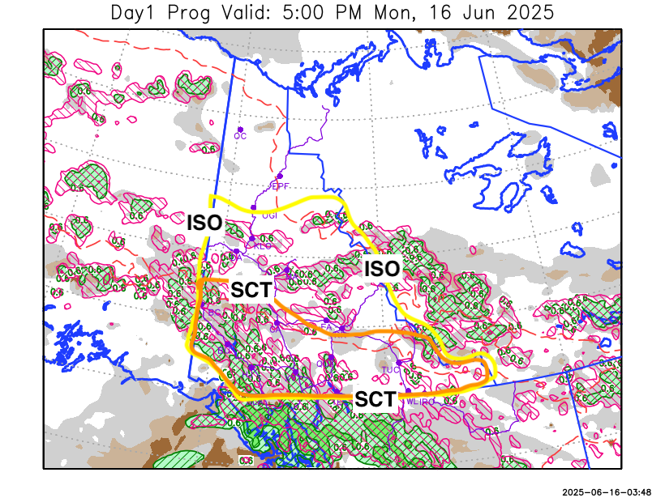
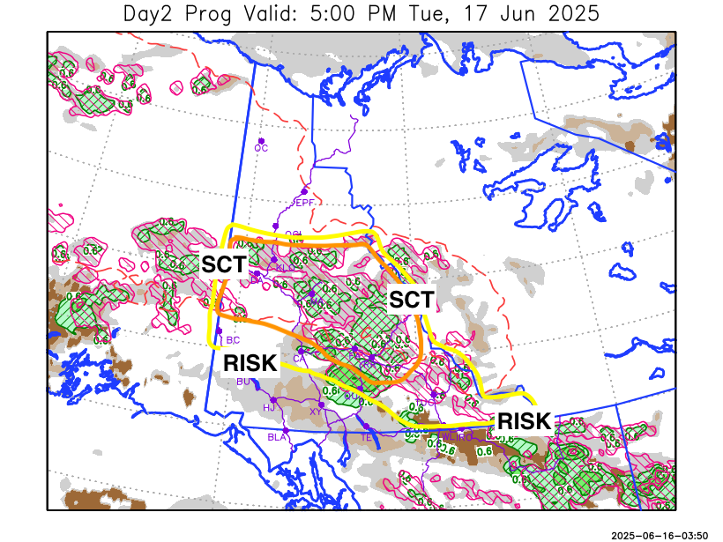
Forecast for | Tuesday | (Peak burning period and overnight)
Community | Clouds | Pcpn | POP | POL | Max Temp | Min RH | Min Temp | Max  RH | Wind Dir | Wind Speed
Old Crow | FEW |  | 0 |  | 26 | 23 | 12 | 61 | 70 | 16
Klondike Fc | BKN | RW-/TRW- | 60 | SCT | 28 | 30 | 13 | 81 | 40 | 12
Mayo A | BKN | RW-/TRW- | 60 | SCT | 26 | 33 | 16 | 79 | 110 | 8
Carmacks | SCT | RW-/TRW- | 30 | ISO | 23 | 37 | 12 | 80 | 110 | 8
Faro | BKN | RW-/TRW- | 60 | SCT | 22 | 38 | 10 | 82 | 110 | 10
Ross River | BKN | RW-/TRW- | 60 | SCT | 24 | 38 | 8 | 82 | 140 | 13
Beaver Creek Town | FEW | RW-/TRW- | 30 | ISO | 24 | 30 | 8 | 71 | 110 | 13
Burwash A | SCT |  | 0 |  | 18 | 34 | 8 | 72 | 140 | 15
Haines Junction | SCT |  | 0 |  | 21 | 35 | 9 | 77 | 340 | 10
Whitehorse Auto | BKN |  | 10 |  | 19 | 38 | 11 | 81 | 110 | 12
Teslin | BKN |  | 10 |  | 17 | 45 | 9 | 86 | 70 | 8
Watson Lake | BKN | RW-/TRW- | 40 | RISK | 18 | 53 | 11 | 82 | 110 | 14

Forecast for |  |  | Wednesday |  |  | (Peak burning period and overnight)
Community |  |  | Clouds |  |  | Pcpn |  | POP |  | POL |  | Max Temp |  | Min RH | Min Temp | Max  RH | Wind Dir | Wind Speed
Old Crow |  |  | FEW |  |  |  |  | 0 |  |  |  | 27 |  | 23 | 12 | 61 | 60 | 18
Klondike Fc |  |  | SCT |  |  | RW-/TRW- |  | 30 |  | ISO |  | 28 |  | 32 | 14 | 74 | 40 | 7
Mayo A |  |  | BKN |  |  | RW-/TRW- |  | 30 |  | ISO |  | 25 |  | 36 | 16 | 75 | 40 | 8
Carmacks |  |  | SCT |  |  | RW-/TRW- |  | 20 |  | ISO |  | 27 |  | 32 | 14 | 73 | 40 | 9
Faro |  |  | BKN |  |  | RW-/TRW- |  | 30 |  | ISO |  | 23 |  | 37 | 12 | 75 | 0 | 8
Ross River |  |  | BKN |  |  | RW-/TRW- |  | 30 |  | ISO |  | 26 |  | 30 | 9 | 74 | 290 | 7
Beaver Creek Town |  |  | SCT |  |  | RW-/TRW- |  | 40 |  | SCT |  | 26 |  | 32 | 10 | 74 | 90 | 11
Burwash A |  |  | BKN |  |  | RW-/TRW- |  | 40 |  | SCT |  | 20 |  | 40 | 11 | 78 | 40 | 12
Haines Junction |  |  | BKN |  |  | RW-/TRW- |  | 40 |  | SCT |  | 23 |  | 35 | 12 | 83 | 40 | 10
Whitehorse Auto |  |  | BKN |  |  | RW-/TRW- |  | 40 |  | ISO |  | 23 |  | 35 | 13 | 74 | 70 | 10
Teslin |  |  | SCT |  |  | RW-/TRW- |  | 30 |  | ISO |  | 22 |  | 34 | 11 | 79 | 70 | 14
Watson Lake |  |  | SCT |  |  |  |  | 0 |  |  |  | 23 |  | 30 | 12 | 68 | 90 | 16
3-Day Forecast Precipitation Totals from 13:00 Yesterday
OC | 0.0 |  | FA | 3.0 |  |  | JAK | 4.9
EPF | 0.0 |  | RR | 2.1 |  |  | TE | 3.4
ANT | 3.1 |  | BC | 3.7 |  |  | QUI | 7.2
DA | 2.7 |  | BCT | 3.5 |  |  | SWI | 9.2
FMI | 1.7 |  | BU | 5.3 |  |  | FL | 5.1
HEN | 2.1 |  | HJF | 10.1 |  |  | TUC | 9.1
BAR | 4.0 |  | RAI | 9.2 |  |  | HAS | 15.7
MA | 1.9 |  | CH | 7.3 |  |  | TC | 10.1
STW | 2.5 |  | BR | 1.7 |  |  | WL | 8.9
WIL | 3.2 |  | NU | 4.3 |  |  | PE | 1.7
XY | 3.8 |  | IRO | 12.4 |  |  | CA | 1.4
CC | 5.3 |  | ELK | 14.5 |  |  | DRU | 5.3
ATL | 10.1 |  | NA | NA |  |  | NA | NA
Matt Desorcy Meteorologist

Disclaimer : The information in these forecasts is collected and prepared for internal use by the Government of Yukon. The forecasts are specifically designed to meet the needs of the Wildland Fire Management and may not cover the requirements of other parties. Weather warnings or advisories are not included as part of the forecasts. Wildland Fire Management makes no representation and provides no warranty as to the accuracy of its weather forecasts. Any use the recipient chooses to make of the forecasts will be at its sole risk.

