YUKON WILDLAND FIRE MANAGEMENT WEATHER FORECAST - 9:00 AM ISSUE

17-Jun-2025
YESTERDAY'S VALUES
Community | Max  Temp  (°C) | Diff.  from  Normal | Min Temp  (°C) | Diff. from Normal | Pcpn  (mm) | Min RH | Max RH | L110 | L30
Old Crow | 25.8 | 6.8 | 11.6 | 5.0 | 0.0 | 24 | 68 | 0 | 0
Fort Mcpherson Airport | 23.3 |  | 13.2 |  | 0.0 | 24 | 70 | 0 | 0
Rock River Climate | 19.1 |  | 9.6 |  | 0.0 | 31 | 63 | - | -
Eagle Plains Fire | 24.3 |  | 11.2 |  | 0.0 | 25 | 56 | 0 | 0
Antimony Creek | 29.2 |  | 6.4 |  | 0.6 | 20 | 98 | 35 | 0
Klondike Fc | 29.0 |  | 8.2 |  | 0.3 | 20 | 96 | 39 | 0
Forty Mile | 28.4 |  | 11.3 |  | 0.0 | 21 | 81 | 9 | 1
Henderson | 24.5 |  | 12.4 |  | 1.0 | 24 | 75 | 87 | 1
Barlow | 26.8 |  | 13.3 |  | 2.5 | 26 | 61 | 39 | 1
Mayo A | 26.8 | 5.8 | 13.4 | 6.1 | 0.0 | 21 | 68 | 11 | 0
Stewart Crossing | 27.6 |  | 15.2 |  | 0.0 | 21 | 69 | 87 | 0
Willow Creek | 25.9 |  | 8.7 |  | 0.5 | 22 | 88 | 113 | 3
Pelly Farm | 27.1 | 5.9 | 9.3 | 3.2 | 0.0 | 24 | 92 | 199 | 25
Carmacks | 25.6 |  | 7.9 |  | 0.0 | 30 | 89 | 137 | 13
Drury Creek | 24.9 |  | 8.3 |  | 0.0 | 24 | 84 | 95 | 0
Faro | 22.9 | 3.3 | 7.6 | 0.8 | 0.0 | 27 | 87 | 123 | 13
Ross River | 23.9 |  | 7.1 |  | 0.0 | 27 | 94 | 126 | 12
Macmillan Pass | 20.6 |  | 4.9 |  | 0.0 | 24 | 82 | 0 | 0
Beaver Creek A | 21.1 | 2.2 | 6.1 | 0.9 | 1.2M | 38 | 100 | 94 | 3
Beaver Creek Town | 22.6 |  | 5.8 |  | 0.3 | 34 | 95 | 92 | 4
Burwash A | 20.5 | 2.8 | 6.6 | 2.7 | 0.7M | 34 | 98 | 124 | 4
Haines Junction | 24.8 | 5.9 | 6.3 | 3.2 | 3.8 | 27 | 94 | 57 | 9
Rainbow | 21.7 |  | 4.2 |  | 2.8 | 31 | 97 | 44 | 2
Champagne | 23.4 |  | 2.8 |  | 2.6 | 26 | 99 | 40 | 3
Braeburn | 25.2 |  | 3.9 |  | 0.0 | 27 | 97 | 68 | 0
Nursery | 24.1 |  | 7.5 |  | 4.4 | 27 | 95 | 31 | 10
Whitehorse Auto | 21.1 | 2.3 | 6.4 | 1.2 | 0.8 | 37 | 83 | 30 | 11
Mount Sima | 18.8 |  | 4.7 |  | 3.3 | 43 | 87 | 30 | 11
Carcross | 19.5 |  | -1.5 |  | 0.3 | 45 | 95 | 28 | 4
Atlin | 16.3 |  | 2.2 |  | 1.8 | 55 | 97 | 6 | 0
Jakes Corner | 20.9 |  | 2.0 |  | 1.6 | 36 | 95 | 28 | 2
Teslin | 20.0 |  | 4.2 |  | 5.8 | 36 | 99 | 59 | 0
Quiet Lake | 21.6 |  | 7.9 |  | 4.8 | 34 | 99 | 126 | 0
Swift River | 21.0 |  | 4.4 |  | 1.9 | 37 | 98 | 143 | 3
Tuchitua | 23.0 |  | 9.1 |  | 8.3 | 34 | 100 | 281 | 1
Hasselburg | 20.5 |  | 9.0 |  | 12.2 | 40 | 100 | 274 | 25
Tom Creek | 21.1 |  | 8.7 |  | 13.9 | 39 | 100 | 259 | 36
Watson Lake | 22.7 | 3.3 | 10.8 | 4.3 | 4.0 | 37 | 100 | 232 | 22
Iron Creek | 25.0 |  | 10.2 |  | 7.9 | 32 | 100 | 191 | 25
Max Temp is the actual maximum temperature in °C from yesterday afternoon or evening.
Min Temp is the actual overnight minimum temperature in °C up until 6:00 AM this morning.
Diff. from Normal is the difference from the 30 year average max or min temperature.
Pcpn is the precipitation in mm since 13:00 yesterday.
Min RH is the minimum observed RH in % from yesterday afternoon or evening.
Max RH is the maximum observed overnight RH in % up until 6:00 AM this morning.
L110 is the actual number of lightning strikes within 110 km and in the Yukon for 24 hours ending at 06:00 AM this morning.
L30 is the actual number of lightning strikes within 30 km and in the Yukon for 24 hours ending at 06:00 AM this morning.
M is missing data. * denotes precipitation at stations that failed to report for at least part of the evening and overnight period.

SYNOPSIS:
Today: Most of southern Yukon will see some clearing and drier weather as the upper ridge strengthens slightly and the upper-low in the Gulf of AK lessens its impact. Tintina will remain mostly cloudy with showers until early afternoon, then some clearing with a few convective showers/thundershowers developing. Scattered pop-up showers and thundershowers will build in Dawson, Northern Tutchone and Tatchun by early afternoon and will last throughout the remainder of the day, being the focus for today’s convective activity – scattered lightning possible through central Yukon as a result. Temperatures reach mid- to upper-20s in the north and central with crossovers possible, and high teens to low twenties in the south. Winds generally light to moderate E-SE across southern and central Yukon.

Wednesday: Upper-level ridging expands slightly, leading to warmer temperatures by a couple degrees in southern Yukon as highs climb into the low- to mid-20s. Isolated to scattered convective showers and thundershowers expected to develop late in the day through most of southern and central Yukon, while the northern Territory remains warm and dry. Temperatures in the mid- to upper-20s and RH 25-35% across central and northern Yukon with risk of crossovers, particularly in the Old Crow district.

Thursday: Ridging is expected to gradually continue to build throughout the Yukon. Weather will be similar to Wednesday with isolated to scattered showers and a risk of thundershowers across a broad area of Yukon, though coverage of the convection decreases slightly with the ridge strengthening. Temperatures reach the low to mid-20s in the south and mid- to upper-20s in central and northern Territory. RHs in the 25-35% range with crossovers likely in the Klondike and Northern Tutchone, but also possible elsewhere.

Friday: The upper-level ridge axis is expected to shift into the Yukon, leading to continued warm conditions. As a result of the ridge building in, coverage in afternoon convection is expected to continue to decrease, with mainly sunny skies prevailing through most regions except for a slight risk of pop-up showers/thundershowers in eastern Yukon. Highs in the mid- to upper-20s and RHs in the 20-30% range with crossovers possible.

Saturday: Ridging remains in place throughout the Territory, keeping conditions warm in the mid- to upper-20s with slight crossovers possible. Isolated to scattered convective showers and thundershowers are forecast to develop through the Klondike, Northern Tutchone, as well as southeast Yukon as convection develops around the periphery of the ridge.

Forecast for | Tuesday | (Peak burning period and overnight)
Community | Clouds | Pcpn | POP | POL | Max Temp | Min RH | Min Temp | Max  RH | Wind Dir | Wind Speed
Old Crow | FEW |  | 0 |  | 26 | 22 | 12 | 62 | 80 | 20
Klondike Fc | SCT | RW-/TRW- | 60 | SCT | 27 | 30 | 14 | 82 | 40 | 8
Mayo A | BKN | RW-/TRW- | 60 | SCT | 25 | 31 | 16 | 82 | 140 | 8
Carmacks | SCT | RW-/TRW- | 30 | SCT | 24 | 31 | 11 | 80 | 140 | 10
Faro | SCT | RW-/TRW- | 60 | SCT | 22 | 39 | 10 | 83 | 110 | 11
Ross River | SCT | RW-/TRW- | 60 | SCT | 24 | 38 | 8 | 83 | 140 | 13
Beaver Creek Town | SCT | RW-/TRW- | 20 | ISO | 23 | 29 | 9 | 66 | 110 | 15
Burwash A | SCT |  | 0 | 0 | 19 | 31 | 7 | 69 | 140 | 15
Haines Junction | SCT |  | 0 | 0 | 23 | 30 | 8 | 73 | 340 | 11
Whitehorse Auto | SCT |  | 0 | 0 | 20 | 34 | 11 | 78 | 110 | 12
Teslin | SCT | RW-/TRW- | 20 | RISK | 19 | 35 | 10 | 82 | 70 | 10
Watson Lake | BKN | RW-/TRW- | 60 | SCT | 18 | 55 | 11 | 85 | 90 | 13
POP is probability of precipitation in %.
POL is probability of lightning in %.

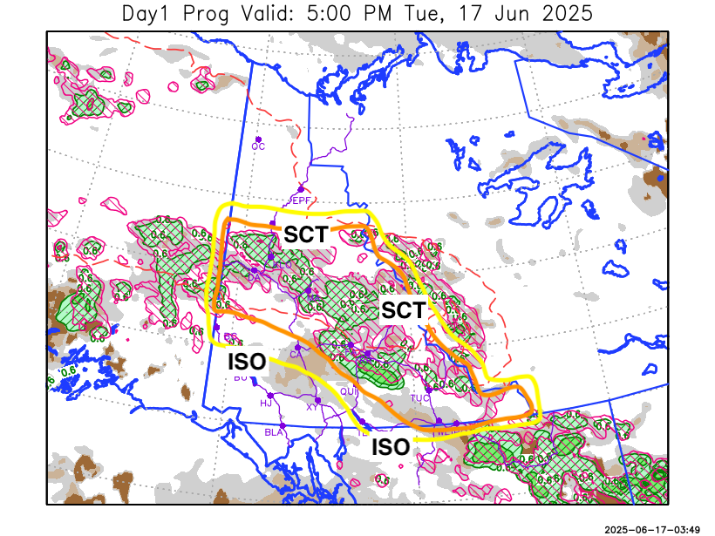
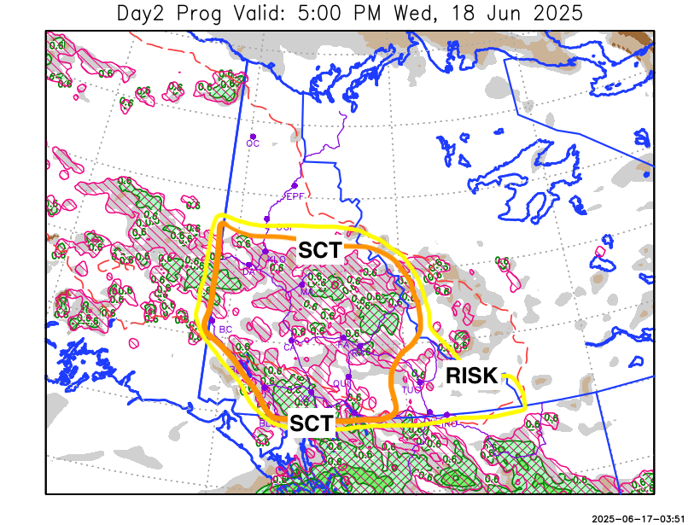

Forecast for | Wednesday | (Peak burning period and overnight)
Community | Clouds | Pcpn | POP | POL | Max Temp | Min RH | Min Temp | Max  RH | Wind Dir | Wind Speed
Old Crow | FEW |  | 10 |  | 27 | 22 | 12 | 62 | 70 | 15
Klondike Fc | SCT | RW-/TRW- | 30 | SCT | 28 | 30 | 14 | 74 | 40 | 6
Mayo A | SCT | RW-/TRW- | 30 | SCT | 26 | 32 | 16 | 74 | 20 | 9
Carmacks | SCT | RW-/TRW- | 30 | SCT | 27 | 32 | 13 | 80 | 320 | 12
Faro | SCT | RW-/TRW- | 40 | SCT | 23 | 38 | 11 | 80 | 0 | 8
Ross River | SCT | RW-/TRW- | 40 | SCT | 26 | 32 | 9 | 78 | 290 | 9
Beaver Creek Town | SCT | RW-/TRW- | 40 | SCT | 26 | 31 | 10 | 75 | 250 | 8
Burwash A | SCT | RW-/TRW- | 40 | SCT | 22 | 38 | 10 | 81 | 0 | 8
Haines Junction | BKN | RW-/TRW- | 40 | SCT | 24 | 33 | 11 | 85 | 320 | 12
Whitehorse Auto | SCT | RW-/TRW- | 40 | SCT | 23 | 39 | 13 | 80 | 70 | 10
Teslin | SCT | RW-/TRW- | 30 | SCT | 22 | 38 | 11 | 79 | 70 | 12
Watson Lake | SCT | RW-/TRW- | 20 | RISK | 23 | 31 | 12 | 70 | 90 | 16

Forecast for |  |  | Thursday |  |  | (Peak burning period and overnight)
Community |  |  | Clouds |  |  | Pcpn |  | POP |  | POL |  | Max Temp |  | Min RH | Min Temp | Max  RH | Wind Dir | Wind Speed
Old Crow |  |  | SCT |  |  | RW-/TRW- |  | 20 |  | RISK |  | 27 |  | 25 | 13 | 62 | 20 | 17
Klondike Fc |  |  | FEW |  |  | RW-/TRW- |  | 30 |  | ISO |  | 30 |  | 21 | 15 | 68 | 40 | 6
Mayo A |  |  | FEW |  |  | RW-/TRW- |  | 20 |  | RISK |  | 28 |  | 23 | 16 | 65 | 20 | 12
Carmacks |  |  | SCT |  |  | RW-/TRW- |  | 30 |  | ISO |  | 29 |  | 28 | 14 | 70 | 0 | 11
Faro |  |  | SCT |  |  | RW-/TRW- |  | 40 |  | SCT |  | 25 |  | 33 | 11 | 68 | 340 | 13
Ross River |  |  | SCT |  |  | RW-/TRW- |  | 40 |  | SCT |  | 27 |  | 33 | 9 | 68 | 320 | 10
Beaver Creek Town |  |  | SCT |  |  | RW-/TRW- |  | 20 |  | RISK |  | 27 |  | 32 | 12 | 70 | 340 | 7
Burwash A |  |  | BKN |  |  | RW-/TRW- |  | 40 |  | SCT |  | 22 |  | 40 | 11 | 78 | 290 | 10
Haines Junction |  |  | BKN |  |  | RW-/TRW- |  | 40 |  | SCT |  | 25 |  | 33 | 12 | 83 | 340 | 15
Whitehorse Auto |  |  | SCT |  |  | RW-/TRW- |  | 30 |  | SCT |  | 24 |  | 36 | 13 | 82 | 270 | 13
Teslin |  |  | SCT |  |  | RW-/TRW- |  | 40 |  | SCT |  | 23 |  | 34 | 12 | 87 | 40 | 10
Watson Lake |  |  | SCT |  |  | RW-/TRW- |  | 40 |  | SCT |  | 23 |  | 31 | 12 | 83 | 90 | 8
3-Day Forecast Precipitation Totals from 13:00 Yesterday
OC | 0.2 |  | FA | 4.2 |  |  | JAK | 2.9
EPF | 0.0 |  | RR | 2.1 |  |  | TE | 7.0
ANT | 2.2 |  | BC | 1.7 |  |  | QUI | 7.1
DA | 1.3 |  | BCT | 0.8 |  |  | SWI | 2.8
FMI | 0.7 |  | BU | 3.0 |  |  | FL | 3.0
HEN | 3.9 |  | HJF | 7.3 |  |  | TUC | 11.5
BAR | 5.1 |  | RAI | 6.4 |  |  | HAS | 15.7
MA | 2.0 |  | CH | 4.2 |  |  | TC | 16.0
STW | 2.6 |  | BR | 0.2 |  |  | WL | 5.5
WIL | 3.1 |  | NU | 5.1 |  |  | PE | 1.8
XY | 2.1 |  | IRO | 10.4 |  |  | CA | 1.5
CC | 1.9 |  | ELK | 4.3 |  |  | DRU | 5.9
ATL | 4.5 |  | NA | NA |  |  | NA | NA
Matt Desorcy Meteorologist

Disclaimer : The information in these forecasts is collected and prepared for internal use by the Government of Yukon. The forecasts are specifically designed to meet the needs of the Wildland Fire Management and may not cover the requirements of other parties. Weather warnings or advisories are not included as part of the forecasts. Wildland Fire Management makes no representation and provides no warranty as to the accuracy of its weather forecasts. Any use the recipient chooses to make of the forecasts will be at its sole risk.

