YUKON WILDLAND FIRE MANAGEMENT WEATHER FORECAST - 9:00 AM ISSUE

19-Jun-2025
YESTERDAY'S VALUES
Community | Max  Temp  (°C) | Diff.  from  Normal | Min Temp  (°C) | Diff. from Normal | Pcpn  (mm) | Min RH | Max RH | L110 | L30
Old Crow | 27.4 | 8.0 | 11.1 | 4.1 | 0.0 | 22 | 77 | 4 | 0
Fort Mcpherson Airport | 23.3 |  | 9.0 |  | 0.1M | 35 | 79 | 0 | 0
Rock River Climate | 22.9 |  | 10.2 |  | 0.0 | 31 | 70 | - | -
Eagle Plains Fire | 25.9 |  | 12.7 |  | 0.0 | 23 | 63 | 0 | 0
Antimony Creek | 28.4 |  | 4.1 |  | 4.6 | 22 | 100 | 187 | 33
Klondike Fc | 27.8 |  | 6.1 |  | 0.0 | 21 | 97 | 180 | 42
Forty Mile | 28.7 |  | 9.9 |  | 0.0 | 20 | 86 | 109 | 23
Henderson | 24.4 |  | 14.0 |  | 0.0 | 27 | 58 | 186 | 13
Barlow | 26.4 |  | 10.6 |  | 2.8 | 32 | 83 | 256 | 21
Mayo A | 25.2 | 3.9 | 9.0 | 1.5 | 5.6 | 33 | 88 | 247 | 29
Stewart Crossing | 26.5 |  | 7.1 |  | 0.3 | 29 | 98 | 263 | 11
Willow Creek | 25.7 |  | 6.0 |  | 0.0 | 28 | 98 | 274 | 24
Pelly Farm | 28.1 | 6.7 | 5.5 | -0.8 | 0.3 | 24 | 98 | 217 | 21
Carmacks | 28.1 |  | 8.6 |  | 0.0 | 24 | 81 | 115 | 22
Drury Creek | 27.7 |  | 6.9 |  | 0.0 | 22 | 85 | 80 | 0
Faro | 25.1 | 5.3 | 7.9 | 0.8 | 0.0 | 20 | 79 | 63 | 0
Ross River | 25.6 |  | 3.1 |  | 0.0 | 24 | 94 | 79 | 0
Macmillan Pass | 19.0 |  | 5.9 |  | 1.2 | 38 | 80 | 68 | 0
Beaver Creek A | 24.9 | 5.7 | 6.0 | 0.5 | 0.3 | 28 | 99 | 21 | 0
Beaver Creek Town | 26.1 |  | 5.2 |  | 0.3 | 24 | 96 | 19 | 0
Burwash A | 22.7 | 4.8 | 10.5 | 6.4 | 0.5M | 30 | 84 | 24 | 0
Haines Junction | 26.5 | 7.3 | 10.2 | 7.5 | 0.3 | 23 | 87 | 15 | 0
Rainbow | 25.4 |  | 9.3 |  | 0.0 | 22 | 86 | 13 | 0
Champagne | 24.8 |  | 6.2 |  | 0.0 | 21 | 91 | 18 | 0
Braeburn | 26.9 |  | 3.3 |  | 0.0 | 22 | 97 | 35 | 4
Nursery | 25.3 |  | 10.0 |  | 0.0 | 22 | 86 | 26 | 0
Whitehorse Auto | 23.5 | 4.5 | 10.7 | 5.2 | 0.0 | 23 | 86 | 25 | 1
Mount Sima | 21.6 |  | 12.4 |  | 1.3 | 30 | 59 | 22 | 5
Carcross | 24.4 |  | 5.7 |  | 0.8 | 25 | 95 | 22 | 12
Atlin | 23.6 |  | 7.3 |  | 0.6 | 29 | 100 | 13 | 0
Jakes Corner | 25.7 |  | 7.5 |  | 0.3 | 22 | 85 | 22 | 3
Teslin | 23.1M |  | 8.1M |  | 0.0 | 27M | 92M | 12 | 0
Quiet Lake | 24.9 |  | 7.2 |  | 0.3 | 23 | 90 | 2 | 0
Swift River | 22.7 |  | 5.7 |  | 0.0 | 27 | 88 | 2 | 0
Tuchitua | 24.5 |  | 6.5 |  | 3.8 | 28 | 100 | 9 | 1
Hasselburg | 22.6 |  | 9.6 |  | 0.3 | 28 | 86 | 7 | 1
Tom Creek | 22.0 |  | 8.7 |  | 0.3 | 31 | 81 | 6 | 1
Watson Lake | 22.5 | 2.9 | 7.5 | 0.8 | 0.0 | 31 | 97 | 6 | 1
Iron Creek | 24.5 |  | 2.9 |  | 0.0 | 28 | 100 | 3 | 0
Max Temp is the actual maximum temperature in °C from yesterday afternoon or evening.
Min Temp is the actual overnight minimum temperature in °C up until 6:00 AM this morning.
Diff. from Normal is the difference from the 30 year average max or min temperature.
Pcpn is the precipitation in mm since 13:00 yesterday.
Min RH is the minimum observed RH in % from yesterday afternoon or evening.
Max RH is the maximum observed overnight RH in % up until 6:00 AM this morning.
L110 is the actual number of lightning strikes within 110 km and in the Yukon for 24 hours ending at 06:00 AM this morning.
L30 is the actual number of lightning strikes within 30 km and in the Yukon for 24 hours ending at 06:00 AM this morning.
M is missing data. * denotes precipitation at stations that failed to report for at least part of the evening and overnight period.

SYNOPSIS:
Today: Ridging is expected to gradually continue to build throughout the Yukon, expanding southwards. Weather will be similar to yesterday with isolated to scattered showers and a risk of thundershowers across a broad area of Yukon. Coverage of the convection decreases slightly in central Yukon with the ridge strengthening but increases slightly in southern Yukon. Temperatures reach the low to mid-20s in the south, and upper-20s in central and northern Territory. RHs generally in the 20-30% range, with crossovers likely in the Klondike and Northern Tutchone but also possible elsewhere. Winds generally light and variable in direction, except gustier near any convective cells that develop.

Friday: The upper-level ridge axis is expected to shift into the Yukon, leading to continued warm conditions. As a result of the ridge building in, coverage of afternoon convection is expected to continue to decrease in southern and central Yukon with mainly sunny skies prevailing through most locations, though isolated cells can’t be ruled out, especially in the Klondike and Kluane. Highest POPs in the northern Klondike (Old Crow district) where scattered showers and thunderstorms are expected to develop late in the day, lasting into the evening. Highs in the mid- to upper-20s and RHs in the 20-30% range with crossovers likely, except slightly cooler with better moisture in Tintina. Winds light and variable across the Territory, except gusty near any convective cells.

Saturday: Ridging remains in place throughout the Territory, keeping conditions warm in the mid- to upper-20s (a few low 30s possible in central Yukon), with scattered to widespread crossovers likely. Isolated to scattered convective showers and thundershowers are forecast to develop through the Klondike, Northern Tutchone, as well as southeast Yukon as convection develops around the core of the ridge. Highest POPs in the northern Klondike.

Sunday: Very similar conditions to Saturday as seasonably warm, summer-like weather persists in the Yukon. Highs generally in the mid- to upper-20s with risk of crossovers in most regions, except slightly cooler with higher RHs in Old Crow. Convective showers and thundershowers possible, particularly in central and northern Yukon, as well as the Tintina region.

Monday: Slight weakening of the upper-level ridge leading to scattered convection in the Territory, with highest confidence in central Yukon. As the ridge weakens slightly and convection coverage increases, temperatures cool by a few degrees throughout the Yukon. Highs expected to be in the mid-twenties for central and southern regions, while near the 20°C mark in the Old Crow district.

Forecast for | Thursday | (Peak burning period and overnight)
Community | Clouds | Pcpn | POP | POL | Max Temp | Min RH | Min Temp | Max  RH | Wind Dir | Wind Speed
Old Crow | FEW | RW-/TRW- | 20 | RISK | 27 | 23 | 13 | 60 | 20 | 16
Klondike Fc | FEW | RW-/TRW- | 20 | ISO | 29 | 20 | 14 | 68 | 20 | 8
Mayo A | FEW | RW-/TRW- | 20 | ISO | 26 | 25 | 15 | 70 | 30 | 13
Carmacks | FEW | RW-/TRW- | 30 | SCT | 28 | 25 | 14 | 69 | 0 | 12
Faro | SCT | RW-/TRW- | 40 | SCT | 25 | 26 | 11 | 68 | 0 | 10
Ross River | SCT | RW-/TRW- | 40 | SCT | 26 | 25 | 9 | 72 | 320 | 10
Beaver Creek Town | FEW | RW-/TRW- | 40 | SCT | 26 | 26 | 11 | 75 | 0 | 10
Burwash A | SCT | RW-/TRW- | 60 | SCT | 22 | 31 | 10 | 85 | 220 | 13
Haines Junction | SCT | RW-/TRW- | 60 | SCT | 25 | 27 | 11 | 87 | 320 | 15
Whitehorse Auto | SCT | RW-/TRW- | 40 | SCT | 24 | 24 | 14 | 83 | 20 | 11
Teslin | SCT | RW-/TRW- | 30 | SCT | 24 | 26 | 13 | 81 | 320 | 11
Watson Lake | BKN | RW-/TRW- | 40 | SCT | 23 | 27 | 13 | 74 | 90 | 10
POP is probability of precipitation in %.
POL is probability of lightning in %.

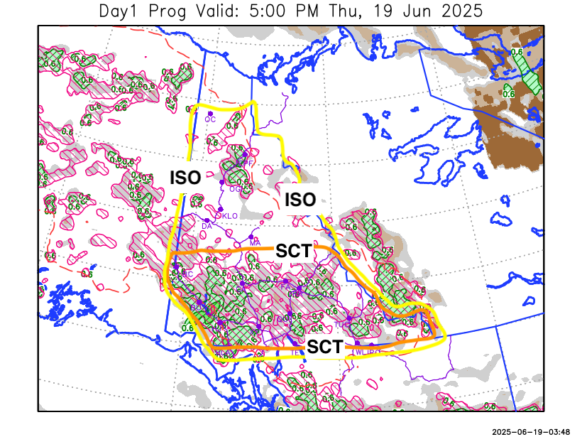
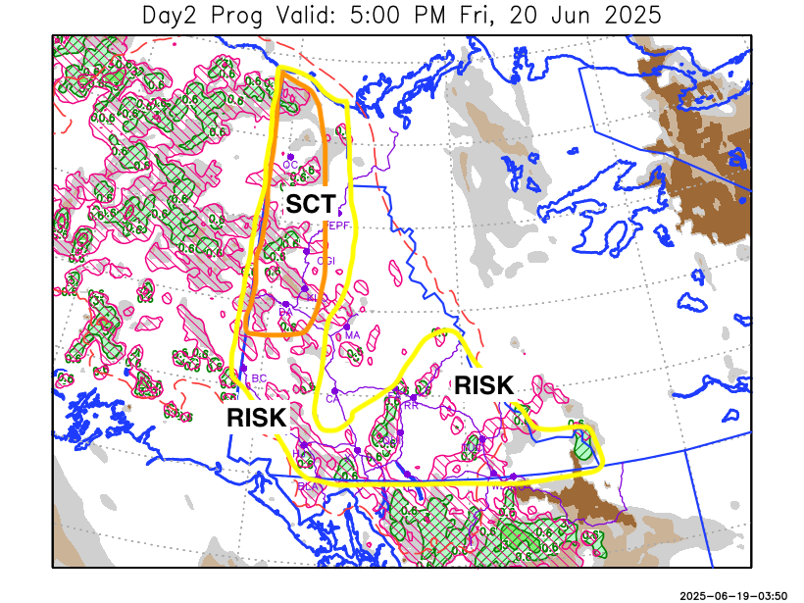
Forecast for | Friday | (Peak burning period and overnight)
Community | Clouds | Pcpn | POP | POL | Max Temp | Min RH | Min Temp | Max  RH | Wind Dir | Wind Speed
Old Crow | SCT | RW-/TRW- | 40 | SCT | 28 | 22 | 15 | 74 | 200 | 10
Klondike Fc | FEW | RW-/TRW- | 30 | SCT | 30 | 20 | 16 | 69 | 0 | 6
Mayo A | CLR |  | 10 |  | 27 | 24 | 16 | 61 | 50 | 8
Carmacks | CLR |  | 10 |  | 29 | 23 | 14 | 59 | 0 | 11
Faro | FEW | RW-/TRW- | 20 | RISK | 25 | 24 | 12 | 53 | 310 | 10
Ross River | FEW | RW-/TRW- | 20 | RISK | 27 | 22 | 10 | 56 | 270 | 9
Beaver Creek Town | FEW | RW-/TRW- | 20 | RISK | 29 | 22 | 11 | 69 | 220 | 12
Burwash A | FEW | RW-/TRW- | 20 | RISK | 24 | 25 | 10 | 68 | 160 | 12
Haines Junction | FEW | RW-/TRW- | 20 | RISK | 28 | 23 | 11 | 70 | 250 | 11
Whitehorse Auto | FEW | RW-/TRW- | 20 | RISK | 26 | 21 | 14 | 64 | 0 | 12
Teslin | FEW | RW-/TRW- | 20 | RISK | 24 | 25 | 12 | 74 | 180 | 10
Watson Lake | FEW | RW-/TRW- | 20 | RISK | 21 | 40 | 11 | 76 | 110 | 15

Forecast for |  |  | Saturday |  |  | (Peak burning period and overnight)
Community |  |  | Clouds |  |  | Pcpn |  | POP |  | POL |  | Max Temp |  | Min RH | Min Temp | Max  RH | Wind Dir | Wind Speed
Old Crow |  |  | BKN |  |  | RW-/TRW- |  | 60 |  | SCT |  | 27 |  | 30 | 15 | 81 | 270 | 10
Klondike Fc |  |  | SCT |  |  | RW-/TRW- |  | 20 |  | RISK |  | 29 |  | 23 | 16 | 76 | 280 | 7
Mayo A |  |  | FEW |  |  | RW-/TRW- |  | 20 |  | RISK |  | 28 |  | 26 | 18 | 73 | 270 | 8
Carmacks |  |  | SCT |  |  |  |  | 0 |  |  |  | 30 |  | 23 | 16 | 63 | 140 | 8
Faro |  |  | FEW |  |  |  |  | 0 |  |  |  | 26 |  | 25 | 14 | 59 | 290 | 12
Ross River |  |  | FEW |  |  |  |  | 0 |  |  |  | 28 |  | 21 | 12 | 61 | 290 | 13
Beaver Creek Town |  |  | SCT |  |  | RW-/TRW- |  | 20 |  | RISK |  | 29 |  | 23 | 11 | 65 | 270 | 11
Burwash A |  |  | FEW |  |  | RW-/TRW- |  | 20 |  | RISK |  | 26 |  | 22 | 12 | 62 | 140 | 10
Haines Junction |  |  | FEW |  |  | RW-/TRW- |  | 20 |  | RISK |  | 29 |  | 20 | 10 | 75 | 200 | 15
Whitehorse Auto |  |  | SCT |  |  |  |  | 0 |  |  |  | 27 |  | 21 | 15 | 63 | 250 | 8
Teslin |  |  | SCT |  |  |  |  | 0 |  |  |  | 26 |  | 23 | 14 | 65 | 250 | 8
Watson Lake |  |  | SCT |  |  | RW-/TRW- |  | 20 |  | RISK |  | 26 |  | 26 | 13 | 79 | 270 | 12
3-Day Forecast Precipitation Totals from 13:00 Yesterday
OC | 2.0 |  | FA | 1.6 |  |  | JAK | 2.0
EPF | 0.7 |  | RR | 1.0 |  |  | TE | 1.4
ANT | 4.6 |  | BC | 1.2 |  |  | QUI | 2.0
DA | 0.0 |  | BCT | 1.2 |  |  | SWI | 3.1
FMI | 0.0 |  | BU | 4.2 |  |  | FL | 2.9
HEN | 0.0 |  | HJF | 3.7 |  |  | TUC | 6.4
BAR | 2.8 |  | RAI | 5.0 |  |  | HAS | 2.4
MA | 5.6 |  | CH | 4.4 |  |  | TC | 2.9
STW | 0.3 |  | BR | 1.2 |  |  | WL | 2.1
WIL | 0.3 |  | NU | 1.6 |  |  | PE | 0.4
XY | 1.9 |  | IRO | 3.1 |  |  | CA | 0.2
CC | 3.7 |  | ELK | 1.1 |  |  | DRU | 1.1
ATL | 3.0 |  | NA | NA |  |  | NA | NA
Matt Desorcy Meteorologist

Disclaimer : The information in these forecasts is collected and prepared for internal use by the Government of Yukon. The forecasts are specifically designed to meet the needs of the Wildland Fire Management and may not cover the requirements of other parties. Weather warnings or advisories are not included as part of the forecasts. Wildland Fire Management makes no representation and provides no warranty as to the accuracy of its weather forecasts. Any use the recipient chooses to make of the forecasts will be at its sole risk.

