YUKON WILDLAND FIRE MANAGEMENT WEATHER FORECAST - 9:00 AM ISSUE

20-Jun-2025
YESTERDAY'S VALUES
Community | Max  Temp  (°C) | Diff.  from  Normal | Min Temp  (°C) | Diff. from Normal | Pcpn  (mm) | Min RH | Max RH | L110 | L30
Old Crow | 23.3M | 3.8 | 11.3M | 4.2 | 0.0 | 32M | 68M | 6 | 0
Fort Mcpherson Airport | 20.7 |  | 7.8 |  | 0.0M | 23 | 74 | 0 | 0
Rock River Climate | 18.8 |  | 10.5 |  | 0.0 | 33 | 45 | - | -
Eagle Plains Fire | 26.0 |  | 10.4 |  | 0.0 | 29 | 59 | 46 | 1
Antimony Creek | 30.0 |  | 7.4 |  | 0.0 | 18 | 90 | 98 | 3
Klondike Fc | 31.3 |  | 7.3 |  | 0.3 | 17 | 94 | 98 | 2
Forty Mile | 30.6 |  | 11.2 |  | 0.0 | 16 | 71 | 36 | 7
Henderson | 26.8 |  | 15.4 |  | 0.0 | 20 | 45 | 143 | 3
Barlow | 27.3 |  | 15.3 |  | 0.0 | 21 | 52 | 128 | 26
Mayo A | 26.6 | 5.2 | 12.2 | 4.6 | 0.0 | 23 | 55 | 146 | 18
Stewart Crossing | 28.3 |  | 9.0 |  | 0.8 | 21 | 98 | 184 | 9
Willow Creek | 28.6 |  | 8.4 |  | 0.0 | 20 | 86 | 209 | 8
Pelly Farm | 28.3 | 6.8 | 8.5 | 2.0 | 0.0 | 24 | 97 | 263 | 25
Carmacks | 29.9 |  | 11.9 |  | 1.3 | 23 | 72 | 241 | 8
Drury Creek | 27.2 |  | 6.3 |  | 0.8 | 23 | 91 | 202 | 18
Faro | 25.8 | 5.9 | 10.0 | 2.8 | 0.2 | 21 | 69 | 176 | 21
Ross River | 28.6 |  | 4.1 |  | 5.9 | 19 | 98 | 129 | 3
Macmillan Pass | 21.5 |  | 2.9 |  | 0.0 | 21 | 81 | 54 | 0
Beaver Creek A | 26.4 | 7.1 | 11.1 | 5.5 | 0.0 | 25 | 68 | 122 | 2
Beaver Creek Town | 27.8 |  | 8.9 |  | 2.0 | 20 | 89 | 123 | 2
Burwash A | 22.9 | 4.9 | 5.7 | 1.4 | 1.4M | 39 | 98 | 320 | 68
Haines Junction | 26.3 | 7.4 | 4.9 | 1.3 | 3.3 | 30 | 99 | 260 | 31
Rainbow | 25.5 |  | 6.0 |  | 6.7 | 29 | 100 | 219 | 40
Champagne | 26.0 |  | 1.7 |  | 0.0 | 23 | 99 | 176 | 4
Braeburn | 28.9 |  | 4.7 |  | 2.4 | 20 | 97 | 226 | 9
Nursery | 27.4 |  | 7.0 |  | 0.0 | 20 | 95 | 111 | 3
Whitehorse Auto | 25.0 | 5.9 | 8.7 | 3.1 | 0.0 | 24 | 86 | 69 | 4
Mount Sima | 23.7 |  | 10.0 |  | 0.0 | 21 | 73 | 62 | 2
Carcross | 26.4 |  | 8.9 |  | 0.0 | 20 | 87 | 11 | 0
Atlin | 24.2M |  | 8.6M |  | 2.8 | 27M | 92M | 0 | 0
Jakes Corner | 27.6 |  | 8.6 |  | 0.0 | 20 | 79 | 11 | 0
Teslin | 24.5 |  | 7.4 |  | 0.4 | 22 | 91 | 10 | 0
Quiet Lake | 25.7 |  | 5.8 |  | 0.5 | 28 | 90 | 42 | 3
Swift River | 25.0 |  | 6.6 |  | 0.0 | 19 | 90 | 22 | 0
Tuchitua | 26.3 |  | 2.6 |  | 0.0 | 25 | 100 | 52 | 4
Hasselburg | 24.5 |  | 7.5 |  | 0.0 | 25 | 87 | 41 | 2
Tom Creek | 24.1 |  | 9.7 |  | 1.6 | 31 | 88 | 31 | 6
Watson Lake | 23.4 | 3.7 | 10.8 | 3.9 | 0.0 | 27 | 87 | 27 | 2
Iron Creek | 26.7 |  | 10.5 |  | 1.4 | 24 | 99 | 23 | 0
Max Temp is the actual maximum temperature in °C from yesterday afternoon or evening.
Min Temp is the actual overnight minimum temperature in °C up until 6:00 AM this morning.
Diff. from Normal is the difference from the 30 year average max or min temperature.
Pcpn is the precipitation in mm since 13:00 yesterday.
Min RH is the minimum observed RH in % from yesterday afternoon or evening.
Max RH is the maximum observed overnight RH in % up until 6:00 AM this morning.
L110 is the actual number of lightning strikes within 110 km and in the Yukon for 24 hours ending at 06:00 AM this morning.
L30 is the actual number of lightning strikes within 30 km and in the Yukon for 24 hours ending at 06:00 AM this morning.
M is missing data. * denotes precipitation at stations that failed to report for at least part of the evening and overnight period.

SYNOPSIS:
Today: The upper-level ridge axis is expected to shift into the Yukon, leading to continued warm and dry conditions. Regardless of the ridge building in, convective showers and thundershowers are expected to develop this afternoon with daytime heating, resulting in isolated to scattered lightning across a broad area. Highest lightning risk in western Yukon, and lowest through northern Tutchone/Tatchun. Highs in the mid- to upper-20s (a few low 30s possible in central Yukon) and RHs in the 20-30% range with crossovers likely, except slightly cooler with higher RHs in Tintina. Winds light and variable in direction across the Territory, except gusty near any convective cells.

Saturday: Ridging remains in place throughout the Territory, keeping conditions warm in the upper-20s with a few low-30s possible in central Yukon – scattered to widespread crossovers anticipated. Scattered to widespread convective showers and thundershowers are forecast to develop through the Klondike and Northern Tutchone, generally near and north of Dawson/Mayo, as convection develops around the periphery of the ridge. Isolated showers and thundershowers still possible through the remainder of the Yukon but cells more isolated in nature. Winds light and variable through most regions except gusty in the Haines Junction district out of the southwest, and moderate southeast in Tintina. Gusts possible near and convective cells.

Sunday: Very similar conditions to Saturday as seasonably warm, summer-like weather persists in the Yukon. Highs generally in the mid- to upper-20s (a few low-30s in central Yukon) with risk of crossovers in most regions, except for higher RHs in Old Crow and Tintina. Convective showers and thundershowers possible, particularly in central and northern Yukon (From Beaver Creek/Tatchun region, northwards), as well as the Tintina region.

Monday: Slight weakening of the upper-level ridge leading to scattered convection in the Territory, with highest confidence in central Yukon. As the ridge weakens slightly and convection coverage increases, temperatures cool by a few degrees throughout the Yukon, and crossover risk will decrease as a result. Highs expected to be in the mid-twenties throughout the Territory.

Tuesday: Slight downtrend in fire weather continues into Tuesday as a weak upper-level trough develops in the region, leading to scattered to widespread showers/thundershowers in central and southern Yukon. Highest confidence in central Yukon for the unsettled weather. Highs in the low to mid-20s.

Forecast for | Friday | (Peak burning period and overnight)
Community | Clouds | Pcpn | POP | POL | Max Temp | Min RH | Min Temp | Max  RH | Wind Dir | Wind Speed
Old Crow | SCT | RW-/TRW- | 40 | SCT | 27 | 22 | 15 | 73 | 90 | 15
Klondike Fc | FEW | RW-/TRW- | 30 | SCT | 29 | 20 | 16 | 67 | 110 | 7
Mayo A | FEW | RW-/TRW- | 20 | ISO | 28 | 21 | 16 | 58 | 20 | 8
Carmacks | FEW | RW-/TRW- | 20 | RISK | 30 | 22 | 14 | 57 | 0 | 10
Faro | FEW | RW-/TRW- | 20 | RISK | 26 | 23 | 12 | 50 | 300 | 14
Ross River | FEW | RW-/TRW- | 20 | RISK | 28 | 21 | 10 | 52 | 270 | 10
Beaver Creek Town | FEW | RW-/TRW- | 20 | SCT | 29 | 23 | 11 | 69 | 220 | 8
Burwash A | FEW | RW-/TRW- | 30 | SCT | 24 | 28 | 10 | 64 | 340 | 12
Haines Junction | FEW | RW-/TRW- | 30 | SCT | 28 | 24 | 11 | 69 | 250 | 15
Whitehorse Auto | FEW | RW-/TRW- | 20 | ISO | 26 | 23 | 14 | 60 | 0 | 15
Teslin | FEW | RW-/TRW- | 20 | ISO | 25 | 25 | 12 | 73 | 180 | 10
Watson Lake | FEW | RW-/TRW- | 40 | SCT | 20 | 42 | 11 | 76 | 140 | 16
POP is probability of precipitation in %.
POL is probability of lightning in %.

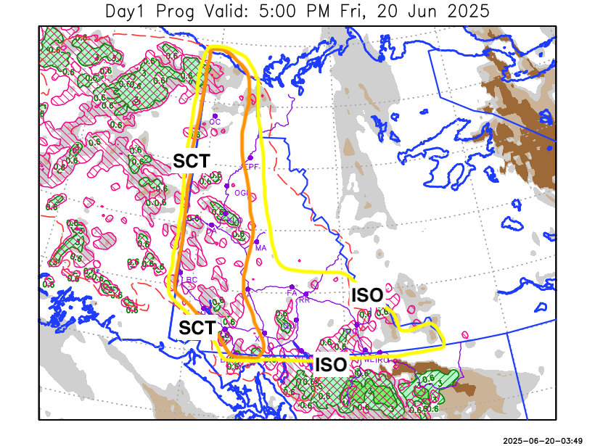
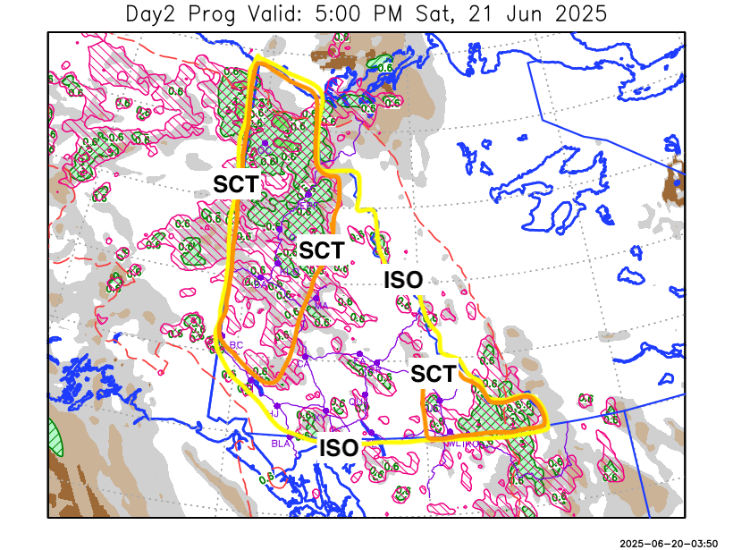
Forecast for | Saturday | (Peak burning period and overnight)
Community | Clouds | Pcpn | POP | POL | Max Temp | Min RH | Min Temp | Max  RH | Wind Dir | Wind Speed
Old Crow | BKN | RW-/TRW- | 60 | SCT | 27 | 34 | 13 | 84 | 20 | 14
Klondike Fc | SCT | RW-/TRW- | 30 | SCT | 30 | 23 | 15 | 77 | 320 | 7
Mayo A | FEW | RW-/TRW- | 20 | ISO | 28 | 24 | 17 | 73 | 270 | 10
Carmacks | FEW | RW-/TRW- | 20 | ISO | 31 | 20 | 15 | 63 | 140 | 7
Faro | FEW | RW-/TRW- | 20 | ISO | 27 | 23 | 13 | 56 | 270 | 13
Ross River | FEW | RW-/TRW- | 20 | ISO | 29 | 19 | 12 | 55 | 270 | 13
Beaver Creek Town | SCT | RW-/TRW- | 30 | SCT | 29 | 24 | 12 | 61 | 290 | 14
Burwash A | FEW | RW-/TRW- | 30 | SCT | 26 | 21 | 11 | 62 | 220 | 10
Haines Junction | FEW | RW-/TRW- | 20 | ISO | 29 | 19 | 9 | 76 | 200 | 15G30
Whitehorse Auto | SCT | RW-/TRW- | 20 | ISO | 27 | 23 | 14 | 64 | 250 | 10
Teslin | FEW | RW-/TRW- | 20 | RISK | 26 | 22 | 13 | 68 | 250 | 8
Watson Lake | FEW | RW-/TRW- | 30 | SCT | 26 | 24 | 13 | 76 | 110 | 17

Forecast for |  |  | Sunday |  |  | (Peak burning period and overnight)
Community |  |  | Clouds |  |  | Pcpn |  | POP |  | POL |  | Max Temp |  | Min RH | Min Temp | Max  RH | Wind Dir | Wind Speed
Old Crow |  |  | BKN |  |  | RW-/TRW- |  | 40 |  | SCT |  | 26 |  | 36 | 14 | 83 | 40 | 14
Klondike Fc |  |  | SCT |  |  | RW-/TRW- |  | 40 |  | SCT |  | 30 |  | 22 | 15 | 77 | 320 | 9
Mayo A |  |  | SCT |  |  | RW-/TRW- |  | 40 |  | SCT |  | 28 |  | 24 | 17 | 72 | 40 | 10
Carmacks |  |  | FEW |  |  | RW-/TRW- |  | 20 |  | ISO |  | 31 |  | 20 | 14 | 63 | 140 | 12
Faro |  |  | SCT |  |  | RW-/TRW- |  | 40 |  | SCT |  | 27 |  | 25 | 13 | 70 | 270 | 12
Ross River |  |  | SCT |  |  | RW-/TRW- |  | 40 |  | SCT |  | 29 |  | 24 | 11 | 74 | 220 | 13
Beaver Creek Town |  |  | BKN |  |  | RW-/TRW- |  | 60 |  | SCT |  | 29 |  | 26 | 11 | 82 | 290 | 14
Burwash A |  |  | SCT |  |  | RW-/TRW- |  | 30 |  | ISO |  | 25 |  | 22 | 11 | 71 | 130 | 20
Haines Junction |  |  | SCT |  |  |  |  | 10 |  |  |  | 28 |  | 20 | 8 | 81 | 200 | 15G30
Whitehorse Auto |  |  | SCT |  |  | RW-/TRW- |  | 20 |  | RISK |  | 27 |  | 23 | 13 | 71 | 220 | 11
Teslin |  |  | FEW |  |  | RW-/TRW- |  | 20 |  | RISK |  | 26 |  | 23 | 12 | 67 | 220 | 14
Watson Lake |  |  | SCT |  |  | RW-/TRW- |  | 40 |  | SCT |  | 25 |  | 30 | 14 | 77 | 140 | 11
3-Day Forecast Precipitation Totals from 13:00 Yesterday
OC | 5.3 |  | FA | 0.2 |  |  | JAK | 0.3
EPF | 5.0 |  | RR | 5.9 |  |  | TE | 0.4
ANT | 0.1 |  | BC | 0.3 |  |  | QUI | 0.5
DA | 0.3 |  | BCT | 2.3 |  |  | SWI | 1.4
FMI | 0.8 |  | BU | 1.4 |  |  | FL | 0.7
HEN | 0.7 |  | HJF | 3.4 |  |  | TUC | 0.9
BAR | 0.7 |  | RAI | 6.7 |  |  | HAS | 0.8
MA | 0.0 |  | CH | 0.0 |  |  | TC | 2.7
STW | 1.1 |  | BR | 2.4 |  |  | WL | 1.4
WIL | 0.1 |  | NU | 0.0 |  |  | PE | 0.0
XY | 0.0 |  | IRO | 3.9 |  |  | CA | 1.3
CC | 0.1 |  | ELK | 5.3 |  |  | DRU | 0.8
ATL | 3.7 |  | NA | NA |  |  | NA | NA
Matt Desorcy Meteorologist

Disclaimer : The information in these forecasts is collected and prepared for internal use by the Government of Yukon. The forecasts are specifically designed to meet the needs of the Wildland Fire Management and may not cover the requirements of other parties. Weather warnings or advisories are not included as part of the forecasts. Wildland Fire Management makes no representation and provides no warranty as to the accuracy of its weather forecasts. Any use the recipient chooses to make of the forecasts will be at its sole risk.

