YUKON WILDLAND FIRE MANAGEMENT WEATHER FORECAST - 9:00 AM ISSUE

21-Jun-2025
YESTERDAY'S VALUES
Community | Max  Temp  (°C) | Diff.  from  Normal | Min Temp  (°C) | Diff. from Normal | Pcpn  (mm) | Min RH | Max RH | L110 | L30
Old Crow | 29.0 | 9.3 | 14.0 | 6.7 | 0.0 | 21 | 82 | 95 | 3
Fort Mcpherson Airport | 26.7 |  | 12.3 |  | 0.0M | 23 | 64 | 0 | 0
Rock River Climate | 24.3M |  | 14.1M |  | 0.0M | 23M | 46M | NA | NA
Eagle Plains Fire | 26.6 |  | 15.8 |  | 0.0 | 17 | 31 | 0 | 0
Antimony Creek | 29.7 |  | 6.4 |  | 0.0 | 20 | 94 | 59 | 7
Klondike Fc | 30.3 |  | 8.2 |  | 0.0 | 19 | 87 | 64 | 5
Forty Mile | 29.8 |  | 13.7 |  | 0.0 | 18 | 69 | 48 | 0
Henderson | 26.1 |  | 16.2 |  | 0.0 | 25 | 46 | 92 | 6
Barlow | 29.3 |  | 14.6 |  | 0.0 | 20 | 52 | 54 | 3
Mayo A | 28.5 | 6.9 | 10.9 | 3.1 | 0.0 | 15 | 76 | 11 | 1
Stewart Crossing | 30.1 |  | 10.3 |  | 0.0 | 19 | 76 | 46 | 0
Willow Creek | 29.4 |  | 7.8 |  | 0.0 | 17 | 87 | 43 | 0
Pelly Farm | 30.3 | 8.7 | 9.7 | 3.1 | 0.0 | 20 | 93 | 90 | 10
Carmacks | 31.6 |  | 13.1 |  | 0.0 | 17 | 63 | 49 | 0
Drury Creek | 28.9 |  | 8.2 |  | 0.0 | 14 | 81 | 3 | 1
Faro | 27.3 | 7.3 | 7.7 | 0.4 | 0.0 | 14 | 66 | 1 | 0
Ross River | 28.2 |  | 2.3 |  | 0.0 | 13 | 93 | 1 | 0
Macmillan Pass | 20.1 |  | 4.6 |  | 0.0 | 21 | 56 | 0 | 0
Beaver Creek A | 27.9 | 8.5 | 8.6 | 2.8 | 0.3 | 22 | 74 | 22 | 7
Beaver Creek Town | 29.2 |  | 7.8 |  | 0.0 | 18 | 83 | 21 | 7
Burwash A | 26.5 | 8.4 | 2.9 | -1.5 | 0.0M | 24 | 91 | 69 | 1
Haines Junction | 29.2 | 10.4 | 8.6 | 5.3 | 0.0 | 23 | 89 | 183 | 67
Rainbow | 28.9 |  | 8.8 |  | 0.0 | 23 | 82 | 209 | 47
Champagne | 28.9 |  | 5.3 |  | 3.0 | 23 | 96 | 215 | 33
Braeburn | 30.2 |  | 5.9 |  | 0.0 | 16 | 93 | 165 | 3
Nursery | 29.2 |  | 8.9 |  | 0.0 | 17 | 85 | 176 | 0
Whitehorse Auto | 26.9 | 7.7 | 11.5 | 5.8 | 0.0 | 16 | 66 | 144 | 0
Mount Sima | 24.8 |  | 14.8 |  | 0.0 | 20 | 46 | 134 | 3
Carcross | 28.5 |  | 8.1 |  | 0.0 | 18 | 86 | 60 | 2
Atlin | 24.7 |  | 9.0 |  | 0.4 | 33 | 83 | 15 | 0
Jakes Corner | 27.2 |  | 8.0 |  | 1.8 | 15 | 85 | 46 | 13
Teslin | 26.3 |  | 7.7 |  | 0.0 | 19 | 93 | 24 | 0
Quiet Lake | 29.4 |  | 5.7 |  | 0.0 | 14 | 78 | 13 | 0
Swift River | 24.6 |  | 3.7 |  | 1.6 | 27 | 95 | 25 | 4
Tuchitua | 27.1 |  | 2.6 |  | 0.0 | 23 | 99 | 16 | 0
Hasselburg | 24.5 |  | 4.0 |  | 0.0 | 28 | 96 | 26 | 14
Tom Creek | 22.0 |  | 8.8 |  | 0.0 | 36 | 72 | 17 | 0
Watson Lake | 21.5 | 1.7 | 10.0 | 3.0 | 0.0 | 36 | 68 | 17 | 0
Iron Creek | 22.1 |  | 2.7 |  | 0.0 | 43 | 99 | 0 | 0
Max Temp is the actual maximum temperature in °C from yesterday afternoon or evening.
Min Temp is the actual overnight minimum temperature in °C up until 6:00 AM this morning.
Diff. from Normal is the difference from the 30 year average max or min temperature.
Pcpn is the precipitation in mm since 13:00 yesterday.
Min RH is the minimum observed RH in % from yesterday afternoon or evening.
Max RH is the maximum observed overnight RH in % up until 6:00 AM this morning.
L110 is the actual number of lightning strikes within 110 km and in the Yukon for 24 hours ending at 06:00 AM this morning.
L30 is the actual number of lightning strikes within 30 km and in the Yukon for 24 hours ending at 06:00 AM this morning.
M is missing data. * denotes precipitation at stations that failed to report for at least part of the evening and overnight period.

SYNOPSIS:
Today: An upper-level ridge of high pressure remains in place across the Yukon, leading to hot conditions with highs mainly in the upper twenties to low thirties. Widespread crossovers are expected by the afternoon. Daytime heating will also trigger the development of pulse‐type showers and thunderstorms across most of the territory starting in the afternoon and persisting into the evening; these cells will develop and dissipate quickly, affecting localized areas. Synoptic winds this afternoon will be from the west to northwest at 10–15 km/h. However, thunderstorm outflows will locally distort the wind field: near any shower or storm, expect gustier winds and sudden shifts, such that the wind direction is coming from the shower/storm.
Sunday: The upper-level ridge remains intact, so another hot day is anticipated with widespread crossovers by afternoon. Daytime heating will again initiate showers and thunderstorms that last into the evening. Synoptic winds will stay light, but thunderstorm outflows will produce the same localized gusts and directional shifts noted for today.
Monday: The ridge shows signs of weakening, but the transition will heighten fire-weather risks. Highs will again reach the upper twenties in most areas, with some highs reaching near 30 C. A developing low-pressure system over Alaska is expected to strengthen winds—especially across northern Yukon—bringing a stronger easterly flow, and may induce stronger southerly winds in the south.
Tuesday: Weak troughing begins to edge into the territory, ushering in a modest cooling trend by midweek. This shift will slightly raise precipitation chances (and somewhat reduce the lightning risk), though isolated thunderstorms remain possible. Winds may stay elevated due to the nearby Alaskan low.
Wednesday: Weak troughing is forecast to persist, keeping temperatures near normal for late June. Expect light showers and a slight risk of thunderstorms, but no indication of widespread precipitation at this time.
Forecast for | Saturday | (Peak burning period and overnight)
Community | Clouds | Pcpn | POP | POL | Max Temp | Min RH | Min Temp | Max  RH | Wind Dir | Wind Speed
Old Crow | SCT | RW-/TRW- | 40 | 20 | 29 | 20 | 14 | 80 | 330 | 15
Klondike Fc | SCT | RW-/TRW- | 50 | 40 | 30 | 20 | 15 | 85 | 320 | 10
Mayo A | SCT | RW-/TRW- | 50 | 40 | 29 | 15 | 17 | 80 | 270 | 10
Carmacks | SCT | RW-/TRW- | 40 | 20 | 32 | 15 | 16 | 70 | 290 | 10
Faro | SCT | RW-/TRW- | 50 | 40 | 28 | 15 | 13 | 70 | 290 | 10
Ross River | SCT | RW-/TRW- | 50 | 40 | 29 | 15 | 12 | 75 | 290 | 10
Beaver Creek Town | SCT | RW-/TRW- | 30 | 10 | 30 | 20 | 12 | 75 | 290 | 10
Burwash A | FEW | RW-/TRW- | 30 | 10 | 27 | 20 | 11 | 85 | 220 | 10
Haines Junction | FEW | RW-/TRW- | 30 | 10 | 29 | 20 | 9 | 85 | 200 | 10
Whitehorse Auto | FEW | RW-/TRW- | 30 | 10 | 28 | 15 | 14 | 70 | 250 | 10
Teslin | FEW | RW-/TRW- | 30 | 10 | 27 | 20 | 14 | 85 | 250 | 10
Watson Lake | SCT | RW-/TRW- | 40 | 10 | 26 | 25 | 14 | 80 | 320 | 10
POP is probability of precipitation in %.
POL is probability of lightning in %.

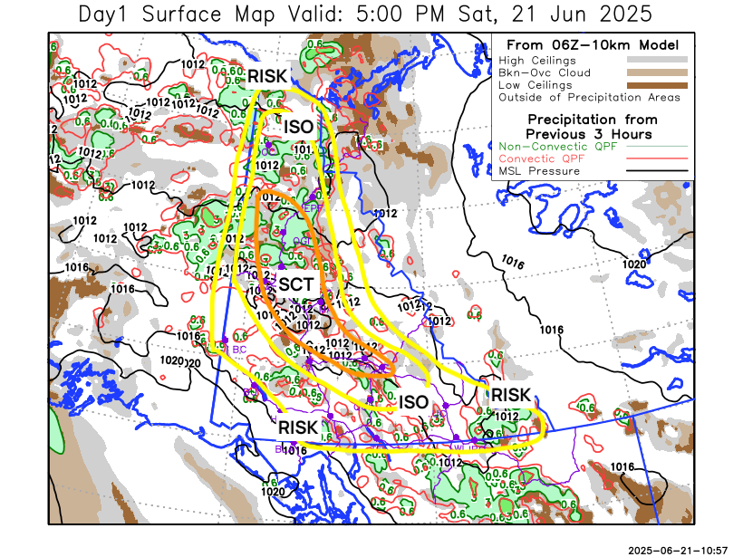
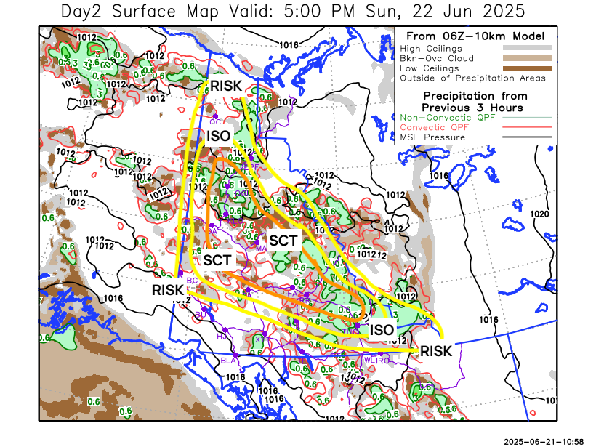

Forecast for | Sunday | (Peak burning period and overnight)
Community | Clouds | Pcpn | POP | POL | Max Temp | Min RH | Min Temp | Max  RH | Wind Dir | Wind Speed
Old Crow | SCT | RW-/TRW- | 40 | 10 | 26 | 20 | 14 | 85 | 40 | 10
Klondike Fc | SCT | RW-/TRW- | 50 | 40 | 30 | 20 | 15 | 85 | 0 | 10
Mayo A | SCT | RW-/TRW- | 50 | 40 | 28 | 20 | 18 | 80 | 0 | 10
Carmacks | SCT | RW-/TRW- | 40 | 20 | 32 | 15 | 14 | 75 | 110 | 10
Faro | SCT | RW-/TRW- | 50 | 40 | 28 | 15 | 13 | 75 | 270 | 10
Ross River | SCT | RW-/TRW- | 50 | 40 | 29 | 15 | 11 | 80 | 290 | 10
Beaver Creek Town | SCT | RW-/TRW- | 30 | 10 | 30 | 20 | 11 | 85 | 270 | 10
Burwash A | FEW |  | 16 | 0 | 25 | 25 | 9 | 70 | 110 | 10
Haines Junction | FEW |  | 20 | 0 | 28 | 25 | 8 | 85 | 200 | 10
Whitehorse Auto | FEW |  | 20 | 0 | 28 | 15 | 13 | 75 | 220 | 10
Teslin | FEW |  | 20 | 0 | 26 | 20 | 12 | 80 | 220 | 10
Watson Lake | SCT | RW-/TRW- | 40 | 20 | 25 | 25 | 13 | 90 | 90 | 10

Forecast for |  |  | Monday |  | (Peak burning period and overnight)
Community |  |  | Clouds |  | Pcpn |  | POP |  | POL |  | Max Temp |  | Min RH | Min Temp | Max  RH | Wind Dir | Wind Speed
Old Crow |  |  | SCT |  | RW- |  | 30 |  | 0 |  | 27 |  | 20 | 14 | 85 | 110 | 20G30
Klondike Fc |  |  | SCT |  | RW-/TRW- |  | 40 |  | 20 |  | 28 |  | 20 | 14 | 90 | 110 | 20
Mayo A |  |  | SCT |  | RW-/TRW- |  | 50 |  | 20 |  | 28 |  | 15 | 17 | 85 | 90 | 20
Carmacks |  |  | BKN |  | RW-/TRW- |  | 50 |  | 20 |  | 30 |  | 15 | 12 | 75 | 160 | 15
Faro |  |  | BKN |  | RW-/TRW- |  | 50 |  | 20 |  | 25 |  | 20 | 12 | 85 | 220 | 15
Ross River |  |  | BKN |  | RW-/TRW- |  | 50 |  | 20 |  | 26 |  | 20 | 10 | 85 | 180 | 15
Beaver Creek Town |  |  | BKN |  | RW-/TRW- |  | 50 |  | 20 |  | 26 |  | 20 | 9 | 85 | 290 | 15
Burwash A |  |  | SCT |  | RW- |  | 50 |  | 10 |  | 22 |  | 30 | 10 | 80 | 140 | 20
Haines Junction |  |  | SCT |  | RW- |  | 40 |  | 10 |  | 23 |  | 30 | 7 | 90 | 270 | 20
Whitehorse Auto |  |  | SCT |  | RW- |  | 40 |  | 10 |  | 24 |  | 20 | 11 | 80 | 200 | 20
Teslin |  |  | FEW |  | RW- |  | 30 |  | 10 |  | 23 |  | 25 | 9 | 80 | 220 | 15
Watson Lake |  |  | BKN |  | RW- |  | 60 |  | 10 |  | 22 |  | 30 | 13 | 85 | 220 | 20
3-Day Forecast Precipitation Totals from 13:00 Yesterday
OC | 2.6 |  | FA | 3.9 |  | JAK | 1.8
EPF | 3.4 |  | RR | 4.0 |  | TE | 0.3
ANT | 1.1 |  | BC | 3.3 |  | QUI | 3.1
DA | 1.1 |  | BCT | 3.0 |  | SWI | 3.0
FMI | 1.1 |  | BU | 0.7 |  | FL | 7.0
HEN | 2.7 |  | HJF | 0.0 |  | TUC | 8.9
BAR | 1.8 |  | RAI | 0.0 |  | HAS | 8.7
MA | 2.0 |  | CH | 3.0 |  | TC | 7.5
STW | 2.2 |  | BR | 0.5 |  | WL | 6.8
WIL | 2.4 |  | NU | 0.0 |  | PE | 2.3
XY | 0.0 |  | IRO | 7.1 |  | CA | 0.4
CC | 0.3 |  | ELK | 5.2 |  | DRU | 3.9
ATL | 0.4 |  | NA | NA |  | NA | NA
Scott Kehler Meteorologist

Disclaimer : The information in these forecasts is collected and prepared for internal use by the Government of Yukon. The forecasts are specifically designed to meet the needs of the Wildland Fire Management and may not cover the requirements of other parties. Weather warnings or advisories are not included as part of the forecasts. Wildland Fire Management makes no representation and provides no warranty as to the accuracy of its weather forecasts. Any use the recipient chooses to make of the forecasts will be at its sole risk.

