YUKON WILDLAND FIRE MANAGEMENT WEATHER FORECAST - 9:00 AM ISSUE

22-Jun-2025
YESTERDAY'S VALUES
Community | Max  Temp  (°C) | Diff.  from  Normal | Min Temp  (°C) | Diff. from Normal | Pcpn  (mm) | Min RH | Max RH | L110 | L30
Old Crow | 24.9 | 5.0 | 12.7 | 5.3 | 0.0 | 41 | 82 | 12 | 1
Fort Mcpherson Airport | 24.4 |  | 11.0 |  | 0.0M | 34 | 96 | 4 | 0
Rock River Climate | 22.6 |  | 12.5 |  | 0.0 | 22 | 73 | NA | NA
Eagle Plains Fire | 25.8 |  | 15.9 |  | 0.0 | 23 | 60 | 167 | 1
Antimony Creek | 28.6 |  | 7.0 |  | 0.0 | 23 | 93 | 161 | 14
Klondike Fc | 30.0 |  | 8.4 |  | 0.0 | 22 | 94 | 127 | 5
Forty Mile | 29.7 |  | 10.3 |  | 0.0 | 22 | 78 | 46 | 0
Henderson | 27.8 |  | 15.2 |  | 0.0 | 21 | 49 | 73 | 2
Barlow | 28.1 |  | 14.0 |  | 0.0 | 23 | 62 | 224 | 0
Mayo A | 26.2 | 4.5 | 8.7 | 0.8 | 4.6 | 36 | 95 | 200 | 33
Stewart Crossing | 29.6 |  | 10.3 |  | 0.0 | 21 | 94 | 273 | 12
Willow Creek | 28.6 |  | 8.1 |  | 8.2 | 24 | 97 | 287 | 42
Pelly Farm | 30.7 | 9.0 | 9.2 | 2.5 | 0.0 | 23 | 96 | 294 | 33
Carmacks | 30.1 |  | 11.4 |  | 0.0 | 24 | 77 | 292 | 23
Drury Creek | 27.4 |  | 9.0 |  | 0.0 | 26 | 87 | 160 | 0
Faro | 26.7 | 6.6 | 9.4 | 2.0 | 0.0 | 19 | 76 | 170 | 0
Ross River | 28.7 |  | 5.8 |  | 0.0 | 20 | 93 | 240 | 33
Macmillan Pass | 23.5 |  | 7.2 |  | 0.0 | 15 | 67 | 0 | 0
Beaver Creek A | 28.4 | 8.9 | 7.1 | 1.2 | 0.0 | 22 | 76 | 17 | 12
Beaver Creek Town | 30.5 |  | 7.6 |  | 0.0 | 17 | 81 | 19 | 12
Burwash A | 27.0 | 8.8 | 4.9 | 0.4 | 0.0M | 21 | 80 | 47 | 0
Haines Junction | 28.1 | 9.5 | 6.0 | 2.4 | 0.0 | 23 | 82 | 31 | 0
Rainbow | 28.4 |  | 8.5 |  | 0.0 | 21 | 72 | 19 | 0
Champagne | 28.9 |  | 4.2 |  | 0.0 | 16 | 84 | 94 | 0
Braeburn | 31.0 |  | 4.7 |  | 0.8 | 19 | 97 | 169 | 28
Nursery | 30.7 |  | 5.4 |  | 0.0 | 13 | 94 | 125 | 1
Whitehorse Auto | 27.9 | 8.6 | 11.5 | 5.6 | 0.0 | 20 | 65 | 99 | 1
Mount Sima | 26.1 |  | 13.9 |  | 0.0 | 20 | 44 | 74 | 1
Carcross | 26.6 |  | 8.6 |  | 0.0 | 26 | 84 | 31 | 0
Atlin | 27.6 |  | 9.1 |  | 0.0 | 20 | 66 | 22 | 0
Jakes Corner | 28.6 |  | 7.9 |  | 0.5 | 20 | 87 | 118 | 5
Teslin | 26.4 |  | 7.3 |  | 0.8 | 28 | 98 | 173 | 15
Quiet Lake | 25.7 |  | 6.0 |  | 5.9 | 31 | 100 | 343 | 36
Swift River | 26.3 |  | 6.7 |  | 0.8 | 23 | 99 | 130 | 10
Tuchitua | 30.7 |  | 5.2 |  | 0.0 | 13 | 99 | 9 | 0
Hasselburg | 27.6 |  | 10.2 |  | 0.0 | 17 | 76 | 83 | 0
Tom Creek | 27.1 |  | 12.3 |  | 0.0 | 14 | 72 | 11 | 0
Watson Lake | 27.5 | 7.5 | 11.8 | 4.7 | 0.0 | 12 | 71 | 14 | 0
Iron Creek | 30.0 |  | 9.0 |  | 0.0 | 13 | 99 | 59 | 3
Max Temp is the actual maximum temperature in °C from yesterday afternoon or evening.
Min Temp is the actual overnight minimum temperature in °C up until 6:00 AM this morning.
Diff. from Normal is the difference from the 30 year average max or min temperature.
Pcpn is the precipitation in mm since 13:00 yesterday.
Min RH is the minimum observed RH in % from yesterday afternoon or evening.
Max RH is the maximum observed overnight RH in % up until 6:00 AM this morning.
L110 is the actual number of lightning strikes within 110 km and in the Yukon for 24 hours ending at 06:00 AM this morning.
L30 is the actual number of lightning strikes within 30 km and in the Yukon for 24 hours ending at 06:00 AM this morning.
M is missing data. * denotes precipitation at stations that failed to report for at least part of the evening and overnight period.

SYNOPSIS:
Sunday: The upper-level ridge remains intact, so another hot day is expected, with widespread crossovers by the afternoon. Daytime heating will again trigger showers and thunderstorms across most of the territory in the afternoon, which will persist into the evening. Synoptic winds will be mostly light and variable; however, thunderstorm outflows will locally distort the wind field. Near any shower or storm, expect gustier winds and sudden shifts, with winds blowing from the storm’s direction.
Monday: The ridge will begin to weaken, but the transition will be gradual. Highs on Monday will again reach the mid- to upper twenties in most areas, with some locations approaching 30 °C. A developing low-pressure system over Alaska is expected to strengthen winds, producing an enhanced easterly flow in the Klondike and Northern Tutchone regions. Stronger southerly winds are also likely in Kluane and the Southern Lakes. Showers and thunderstorms are expected in the afternoon and evening, with the greatest risk across central Yukon (see Day 2 map below).
Tuesday: Weak troughing begins to edge into the territory, ushering in a modest cooling trend by midweek. This shift will slightly raise precipitation chances (and slightly reduce the prevalence of lightning), but some thunderstorms are still expected. Winds may stay elevated in some regions due to the nearby Alaskan low.
Wednesday: Weak troughing is forecast to persist, keeping temperatures near normal for late June. Expect light showers and a slight risk of thunderstorms, but no indication of widespread precipitation at this time.
Thursday: Little change is expected in the pattern for late week. The Yukon remains between a trough to the east and a ridge to the west. The result is likely to be near normal temperatures with highs in the low to mid twenties and frequent chances for spotty convective showers and thunderstorms.

Forecast for | Sunday | (Peak burning period and overnight)
Community | Clouds | Pcpn | POP | POL | Max Temp | Min RH | Min Temp | Max  RH | Wind Dir | Wind Speed
Old Crow | SCT | TRW-/RW- | 40 | 20 | 27 | 25 | 14 | 80 | 60 | 15
Klondike Fc | SCT | TRW-/RW- | 50 | 40 | 29 | 20 | 15 | 90 | Vrb | 10
Mayo A | BKN | TRW-/RW- | 50 | 40 | 28 | 30 | 18 | 95 | Vrb | 10
Carmacks | SCT | TRW-/RW- | 40 | 20 | 31 | 25 | 15 | 85 | Vrb | 10
Faro | BKN | TRW-/RW- | 50 | 40 | 27 | 20 | 13 | 80 | 310 | 15
Ross River | BKN | TRW-/RW- | 50 | 40 | 29 | 20 | 11 | 85 | 310 | 10
Beaver Creek Town | SCT | TRW-/RW- | 40 | 20 | 30 | 20 | 11 | 80 | Vrb | 10
Burwash A | SCT | RW- | 30 | 10 | 26 | 25 | 10 | 80 | 110 | 15
Haines Junction | SCT | RW- | 30 | 0 | 28 | 20 | 9 | 80 | 270 | 20
Whitehorse Auto | SCT | TRW-/RW- | 30 | 10 | 28 | 20 | 13 | 70 | Vrb | 10
Teslin | SCT | TRW-/RW- | 40 | 10 | 26 | 25 | 12 | 90 | Vrb | 10
Watson Lake | BKN | TRW-/RW- | 50 | 20 | 26 | 20 | 13 | 85 | 300 | 15
POP is probability of precipitation in %.
POL is probability of lightning in %.

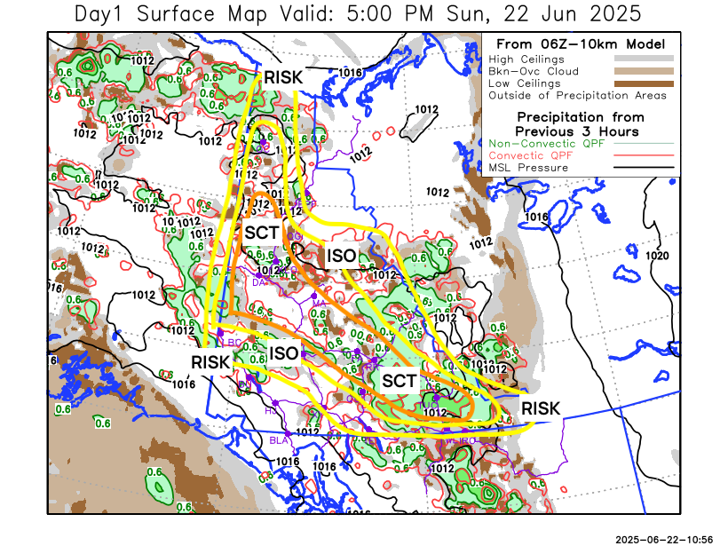
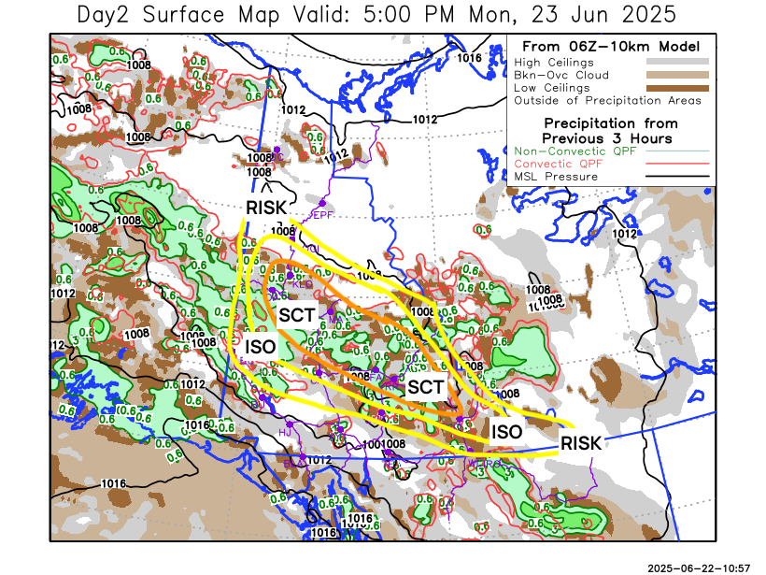

Forecast for | Monday | (Peak burning period and overnight)
Community | Clouds | Pcpn | POP | POL | Max Temp | Min RH | Min Temp | Max  RH | Wind Dir | Wind Speed
Old Crow | SCT |  | 20 | 0 | 26 | 25 | 13 | 80 | 90 | 20
Klondike Fc | SCT | TRW-/RW- | 40 | 40 | 28 | 30 | 14 | 90 | 90 | 20
Mayo A | SCT | TRW-/RW- | 50 | 40 | 28 | 30 | 17 | 90 | 70 | 20
Carmacks | BKN | TRW-/RW- | 50 | 20 | 29 | 25 | 12 | 85 | 140 | 15
Faro | BKN | TRW-/RW- | 60 | 40 | 24 | 25 | 12 | 90 | 140 | 15
Ross River | BKN | TRW-/RW- | 60 | 40 | 26 | 25 | 10 | 90 | 140 | 15
Beaver Creek Town | BKN | TRW-/RW- | 40 | 10 | 26 | 25 | 10 | 90 | 270 | 10
Burwash A | SCT |  | 20 | 0 | 23 | 25 | 9 | 80 | 140 | 25
Haines Junction | SCT |  | 20 | 0 | 24 | 25 | 7 | 90 | 180 | 15
Whitehorse Auto | BKN |  | 20 | 0 | 24 | 25 | 12 | 80 | 200 | 20G30
Teslin | SCT |  | 20 | 0 | 23 | 30 | 10 | 80 | 220 | 20
Watson Lake | BKN | TRW-/RW- | 63 | 0 | 20 | 30 | 12 | 85 | 110 | 20G30

Forecast for |  |  | Tuesday |  |  | (Peak burning period and overnight)
Community |  |  | Clouds |  |  | Pcpn |  | POP |  | POL |  | Max Temp |  | Min RH | Min Temp | Max  RH | Wind Dir | Wind Speed
Old Crow |  |  | FEW |  |  |  |  | 0 |  | 0 |  | 26 |  | 25 | 14 | 75 | 90 | 20
Klondike Fc |  |  | SCT |  |  | TRW-/RW- |  | 40 |  | 20 |  | 25 |  | 30 | 13 | 90 | 120 | 15
Mayo A |  |  | SCT |  |  | TRW-/RW- |  | 50 |  | 20 |  | 24 |  | 35 | 15 | 90 | 120 | 15
Carmacks |  |  | BKN |  |  | TRW-/RW- |  | 50 |  | 20 |  | 26 |  | 25 | 10 | 80 | 160 | 15
Faro |  |  | BKN |  |  | TRW-/RW- |  | 50 |  | 20 |  | 22 |  | 30 | 10 | 85 | Vrb | 10
Ross River |  |  | BKN |  |  | TRW-/RW- |  | 50 |  | 20 |  | 23 |  | 30 | 9 | 85 | Vrb | 10
Beaver Creek Town |  |  | SCT |  |  | TRW-/RW- |  | 40 |  | 10 |  | 20 |  | 30 | 8 | 85 | Vrb | 10
Burwash A |  |  | SCT |  |  |  |  | 20 |  | 0 |  | 18 |  | 35 | 8 | 85 | 140 | 20
Haines Junction |  |  | SCT |  |  |  |  | 20 |  | 0 |  | 21 |  | 30 | 6 | 90 | 270 | 20
Whitehorse Auto |  |  | SCT |  |  |  |  | 10 |  | 0 |  | 20 |  | 25 | 9 | 80 | 200 | 20
Teslin |  |  | SCT |  |  |  |  | 20 |  | 0 |  | 19 |  | 30 | 9 | 80 | 220 | 15
Watson Lake |  |  | BKN |  |  | TRW-/RW- |  | 30 |  | 10 |  | 21 |  | 35 | 12 | 80 | 220 | 15
3-Day Forecast Precipitation Totals from 13:00 Yesterday
OC | 0.2 |  | FA | 10.0 |  |  | JAK | 0.5
EPF | 0.0 |  | RR | 11.0 |  |  | TE | 1.5
ANT | 5.2 |  | BC | 12.3 |  |  | QUI | 13.5
DA | 5.3 |  | BCT | 12.3 |  |  | SWI | 5.0
FMI | 5.5 |  | BU | 3.2 |  |  | FL | 17.4
HEN | 7.3 |  | HJF | 0.0 |  |  | TUC | 13.3
BAR | 4.9 |  | RAI | 0.0 |  |  | HAS | 12.0
MA | 8.8 |  | CH | 0.0 |  |  | TC | 10.7
STW | 5.5 |  | BR | 1.4 |  |  | WL | 11.5
WIL | 14.6 |  | NU | 0.5 |  |  | PE | 6.2
XY | 1.7 |  | IRO | 13.1 |  |  | CA | 2.0
CC | 0.0 |  | ELK | 6.0 |  |  | DRU | 8.4
ATL | 0.0 |  | NA | NA |  |  | NA | NA
Scott Kehler Meteorologist

Disclaimer : The information in these forecasts is collected and prepared for internal use by the Government of Yukon. The forecasts are specifically designed to meet the needs of the Wildland Fire Management and may not cover the requirements of other parties. Weather warnings or advisories are not included as part of the forecasts. Wildland Fire Management makes no representation and provides no warranty as to the accuracy of its weather forecasts. Any use the recipient chooses to make of the forecasts will be at its sole risk.

