YUKON WILDLAND FIRE MANAGEMENT WEATHER FORECAST - 9:00 AM ISSUE

30-Jun-2025
YESTERDAY'S VALUES
Community | Max  Temp  (°C) | Diff.  from  Normal | Min Temp  (°C) | Diff. from Normal | Pcpn  (mm) | Min RH | Max RH | L110 | L30
Old Crow | 26.0 | 5.3 | 13.3 | 4.9 | 3.0 | 29 | 91 | 158 | 7
Fort Mcpherson Airport | 25.8 |  | 13.8 |  | 0.6 | 43 | 97 | 241 | 0
Rock River Climate | 20.9 |  | 10.7 |  | 1.8 | 41 | 91 | NA | NA
Eagle Plains Fire | 21.7 |  | 11.6 |  | 3.8 | 44 | 96 | 304 | 26
Antimony Creek | 17.4 |  | 6.2 |  | 0.0 | 64 | 100 | 72 | 0
Klondike Fc | 19.8 |  | 10.3 |  | 0.0 | 67 | 100 | 97 | 0
Forty Mile | 23.2 |  | 10.8 |  | 26.4 | 42 | 100 | 136 | 53
Henderson | 14.4 |  | 9.0 |  | 2.1 | 73 | 97 | 39 | 0
Barlow | 16.9 |  | 9.8 |  | 4.4 | 62 | 94 | 12 | 0
Mayo A | 19.0 | -3.4 | 9.3 | 0.5 | 0.0 | 58 | 93 | 3 | 0
Stewart Crossing | 21.1 |  | 7.9 |  | 3.3 | 45 | 99 | 9 | 2
Willow Creek | 20.2 |  | 4.4 |  | 0.0 | 33 | 94 | 8 | 0
Pelly Farm | 22.9 | 0.5 | 6.8 | -0.9 | 0.0 | 31 | 83 | 12 | 0
Carmacks | 20.9 |  | 4.6 |  | 0.0 | 33 | 84 | 0 | 0
Drury Creek | 19.1 |  | 2.9 |  | 0.0 | 37 | 92 | 0 | 0
Faro | 19.7 | -1.0 | 7.1 | -1.3 | 0.2 | 33 | 74 | 0 | 0
Ross River | 20.8 |  | 0.9 |  | 0.0 | 30 | 97 | 0 | 0
Macmillan Pass | 15.1 |  | 6.6 |  | 0.4 | 54 | 99 | 0 | 0
Beaver Creek A | 16.6 | -3.6 | 10.0 | 3.1 | 0.1 | 64 | 96 | 4 | 0
Beaver Creek Town | 17.2 |  | 9.9 |  | 1.3 | 62 | 96 | 4 | 0
Burwash A | 15.8 | -3.1 | 6.7 | 1.2 | 0.2M | 52 | 83 | 5 | 0
Haines Junction | 11.3 | -7.4 | 6.0 | 1.9 | 5.9 | 75 | 98 | 0 | 0
Rainbow | 9.5 |  | 4.5 |  | 3.7 | 72 | 97 | 0 | 0
Champagne | 12.1 |  | 4.0 |  | 1.3 | 64 | 94 | 0 | 0
Braeburn | 17.8 |  | -1.5 |  | 0.0 | 42 | 97 | 0 | 0
Nursery | 18.0 |  | -0.4 |  | 0.0 | 44 | 97 | 0 | 0
Whitehorse Auto | 15.7 | -4.3 | 3.8 | -2.9 | 0.0 | 38 | 88 | 0 | 0
Mount Sima | 13.4 |  | 5.0 |  | 1.1 | 45 | 77 | 0 | 0
Carcross | 17.4 |  | 1.2 |  | 0.0 | 39 | 92 | 0 | 0
Atlin | 16.6 |  | 5.1 |  | 0.0 | 37 | 77 | 0 | 0
Jakes Corner | 19.0 |  | 1.3 |  | 0.0 | 31 | 90 | 0 | 0
Teslin | 16.6 |  | 1.7 |  | 0.4 | 39 | 97 | 0 | 0
Quiet Lake | 21.0 |  | 4.7 |  | 0.0 | 31 | 89 | 0 | 0
Swift River | 16.7 |  | -1.4 |  | 0.6 | 41 | 98 | 0 | 0
Tuchitua | 21.8 |  | 3.1 |  | 0.0 | 31 | 98 | 0 | 0
Hasselburg | 17.8 |  | 2.7 |  | 0.8 | 44 | 92 | 0 | 0
Tom Creek | 19.0 |  | 3.6 |  | 0.8 | 37 | 92 | 0 | 0
Watson Lake | 18.3 | -2.4 | 4.2 | -3.9 | 0.4 | 30 | 88 | 0 | 0
Iron Creek | 21.8 |  | 0.9 |  | 0.0 | 28 | 98 | 0 | 0
Max Temp is the actual maximum temperature in °C from yesterday afternoon or evening.
Min Temp is the actual overnight minimum temperature in °C up until 6:00 AM this morning.
Diff. from Normal is the difference from the 30 year average max or min temperature.
Pcpn is the precipitation in mm since 13:00 yesterday.
Min RH is the minimum observed RH in % from yesterday afternoon or evening.
Max RH is the maximum observed overnight RH in % up until 6:00 AM this morning.
L110 is the actual number of lightning strikes within 110 km and in the Yukon for 24 hours ending at 06:00 AM this morning.
L30 is the actual number of lightning strikes within 30 km and in the Yukon for 24 hours ending at 06:00 AM this morning.
M is missing data. * denotes precipitation at stations that failed to report for at least part of the evening and overnight period.

SYNOPSIS:
Today: Today, weak ridging persists across the northern Yukon, while a weak trough lies over the south. This pattern will bring slightly warmer temperatures to the Klondike and Old Crow regions, with cooler conditions farther south. Daytime highs will reach the mid-twenties in the Klondike and Old Crow, while most other areas of the territory will see temperatures in the upper teens to lower 20s. As a result, crossovers are generally unlikely. Daytime heating over the Klondike and Northern Tutchone regions may spark isolated thunderstorms, producing spotty rainfall, and there is only a slight chance of showers elsewhere. Winds will be mostly light (10–15 km/h or less), except a bit windier at Haines Junction and Burwash.

Tuesday: The ridge over the northern Yukon will break down Tuesday, allowing showers and thunderstorms to become more widespread across the territory. Rain and thunder chances will expand to most regions. In the north, temperatures will dip slightly, with highs in Old Crow hovering in the low 20s °C. Farther south, readings will climb a bit, with some locations—like Carmacks and area —reaching the mid-20s °C. Winds will remain generally light, though breezier from the northeast at Old Crow. Gusts and sudden shifts are also possible around showers and storms. Finally, a late-day cold front may bring more widespread rain to the Klondike and Northern Tutchone regions from late Tuesday into early Wednesday.

Wednesday: A cold front will sweep across the Yukon, dropping temperatures and bringing a band of rain. This band is expected to pass through the Klondike and Northern Tutchone regions early Wednesday before reaching the southern Yukon by midday. At present, rainfall from this feature looks most likely in the eastern half of the territory, though future forecasts will refine the details. North-to-east winds will strengthen with the frontal passage, gusting up to 20–30 km/h.

Thursday: Following the cold frontal passage, it looks like relatively quiet and normal weather for late week. Temperatures will mostly be in the low twenties, with some stations climbing into the mid twenties. Precipitation chances will be low.

Friday: Little change for Friday with perhaps some weak riding rebuilding and highs mostly in the low to mid-twenties. Precipitation chances will be low.

Forecast for | Monday | (Peak burning period and overnight)
Community | Clouds | Pcpn | POP | POL | Max Temp | Min RH | Min Temp | Max  RH | Wind Dir | Wind Speed
Old Crow | SCT | TRW-/RW- | 60 | 30 | 25 | 30 | 14 | 95 | Vrb | 10
Klondike Fc | SCT | TRW-/RW- | 60 | 30 | 24 | 40 | 12 | 95 | Vrb | 10
Mayo A | SCT | TRW-/RW- | 50 | 20 | 22 | 45 | 14 | 95 | Vrb | 10
Carmacks | SCT | RW- | 30 | 0 | 24 | 30 | 10 | 85 | 140 | 15
Faro | SCT |  | 20 | 0 | 21 | 30 | 9 | 85 | Vrb | 10
Ross River | SCT |  | 20 | 0 | 22 | 35 | 7 | 85 | Vrb | 10
Beaver Creek Town | SCT | TRW-/RW- | 30 | 10 | 21 | 35 | 7 | 95 | Vrb | 10
Burwash A | SCT | RW- | 30 | 0 | 18 | 50 | 7 | 95 | 120 | 20
Haines Junction | SCT |  | 20 | 0 | 20 | 40 | 7 | 95 | 270 | 20
Whitehorse Auto | SCT | RW- | 30 | 0 | 19 | 30 | 10 | 90 | 140 | 15
Teslin | SCT | RW- | 30 | 0 | 18 | 35 | 9 | 95 | 180 | 15
Watson Lake | SCT |  | 20 | 0 | 20 | 30 | 10 | 90 | 200 | 15
POP is probability of precipitation in %.
POL is probability of lightning in %.

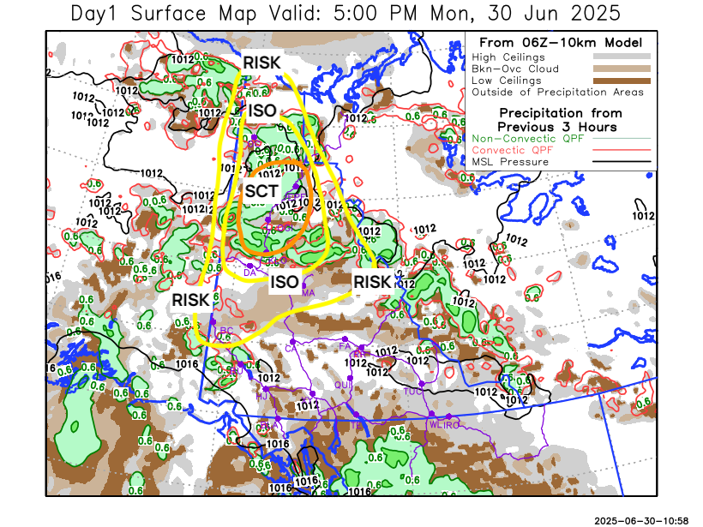
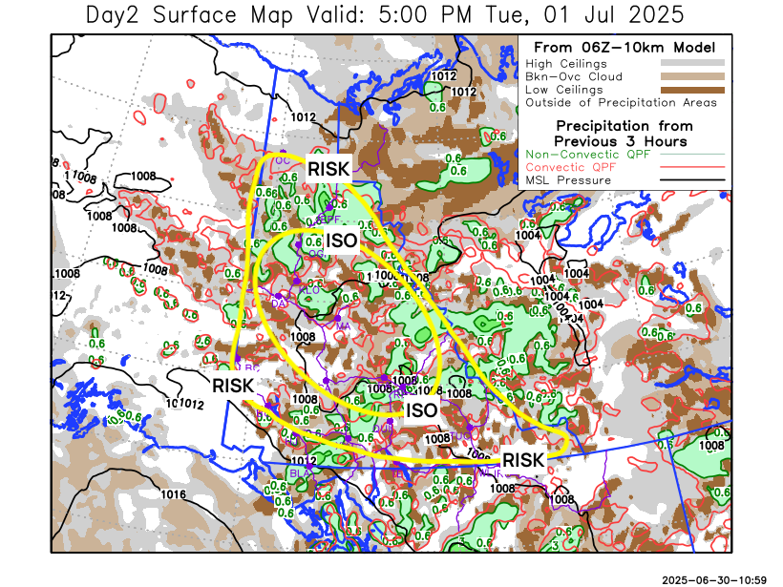

Forecast for | Tuesday | (Peak burning period and overnight)
Community | Clouds | Pcpn | POP | POL | Max Temp | Min RH | Min Temp | Max  RH | Wind Dir | Wind Speed
Old Crow | SCT | TRW-/RW- | 40 | 10 | 23 | 35 | 11 | 95 | 40 | 20
Klondike Fc | BKN | TRW-/RW- | 50 | 20 | 25 | 35 | 13 | 95 | 20 | 10
Mayo A | BKN | TRW-/RW- | 60 | 20 | 25 | 40 | 15 | 95 | Vrb | 10
Carmacks | SCT | TRW-/RW- | 50 | 20 | 26 | 30 | 13 | 95 | Vrb | 10
Faro | SCT | TRW-/RW- | 50 | 20 | 22 | 40 | 9 | 95 | Vrb | 10
Ross River | SCT | TRW-/RW- | 50 | 20 | 23 | 40 | 8 | 95 | Vrb | 10
Beaver Creek Town | SCT | TRW-/RW- | 50 | 20 | 24 | 40 | 10 | 90 | Vrb | 10
Burwash A | SCT | TRW-/RW- | 50 | 10 | 19 | 45 | 10 | 85 | Vrb | 10
Haines Junction | SCT | TRW-/RW- | 50 | 10 | 22 | 35 | 8 | 95 | 270 | 20
Whitehorse Auto | SCT | TRW-/RW- | 40 | 10 | 20 | 35 | 10 | 90 | 220 | 15
Teslin | SCT | TRW-/RW- | 30 | 10 | 19 | 45 | 9 | 90 | 250 | 15
Watson Lake | SCT | TRW-/RW- | 30 | 10 | 20 | 40 | 10 | 85 | 250 | 15

Forecast for |  |  | Wednesday |  |  | (Peak burning period and overnight)
Community |  |  | Clouds |  |  | Pcpn | POP |  | POL |  | Max Temp |  | Min RH | Min Temp | Max  RH | Wind Dir | Wind Speed
Old Crow |  |  | FEW |  |  | RW- | 30 |  | 0 |  | 24 |  | 30 | 12 | 90 | 90 | 20
Klondike Fc |  |  | FEW |  |  | RW | 50 |  | 0 |  | 24 |  | 35 | 11 | 95 | 40 | 20
Mayo A |  |  | SCT |  |  | R- | 70 |  | 0 |  | 22 |  | 40 | 13 | 95 | 40 | 20
Carmacks |  |  | BKN |  |  | RW- | 60 |  | 10 |  | 22 |  | 50 | 11 | 95 | 20 | 15
Faro |  |  | BKN |  |  | R- | 80 |  | 0 |  | 17 |  | 60 | 8 | 95 | 40 | 15
Ross River |  |  | BKN |  |  | R- | 80 |  | 0 |  | 19 |  | 60 | 6 | 95 | 40 | 15
Beaver Creek Town |  |  | BKN |  |  | RW- | 50 |  | 10 |  | 22 |  | 45 | 8 | 90 | 0 | 10
Burwash A |  |  | BKN |  |  | RW- | 50 |  | 0 |  | 16 |  | 60 | 9 | 95 | 320 | 15
Haines Junction |  |  | BKN |  |  | RW- | 60 |  | 0 |  | 18 |  | 60 | 8 | 95 | 200 | 15
Whitehorse Auto |  |  | BKN |  |  | R- | 70 |  | 0 |  | 15 |  | 55 | 10 | 95 | 250 | 20
Teslin |  |  | BKN |  |  | R- | 70 |  | 0 |  | 16 |  | 55 | 8 | 95 | 220 | 15
Watson Lake |  |  | BKN |  |  | R- | 70 |  | 10 |  | 19 |  | 45 | 11 | 95 | 250 | 15
3-Day Forecast Precipitation Totals from 13:00 Yesterday
OC | 3.3 |  | FA | 10.1 |  | JAK | 8.6
EPF | 10.4 |  | RR | 4.8 |  | TE | 7.6
ANT | 3.0 |  | BC | 6.2 |  | QUI | 8.2
DA | 4.2 |  | BCT | 7.4 |  | SWI | 9.3
FMI | 32.0 |  | BU | 6.7 |  | FL | 6.6
HEN | 7.1 |  | HJF | 10.7 |  | TUC | 5.1
BAR | 8.5 |  | RAI | 8.0 |  | HAS | 6.0
MA | 3.0 |  | CH | 5.9 |  | TC | 3.8
STW | 5.8 |  | BR | 6.8 |  | WL | 2.7
WIL | 4.0 |  | NU | 5.5 |  | PE | 5.0
XY | 5.7 |  | IRO | 1.4 |  | CA | 6.4
CC | 5.6 |  | ELK | 2.1 |  | DRU | 9.8
ATL | 4.9 |  | NA | NA |  | NA | NA
Scott Kehler Meteorologist

Disclaimer : The information in these forecasts is collected and prepared for internal use by the Government of Yukon. The forecasts are specifically designed to meet the needs of the Wildland Fire Management and may not cover the requirements of other parties. Weather warnings or advisories are not included as part of the forecasts. Wildland Fire Management makes no representation and provides no warranty as to the accuracy of its weather forecasts. Any use the recipient chooses to make of the forecasts will be at its sole risk.

