YUKON WILDLAND FIRE MANAGEMENT WEATHER FORECAST - 9:00 AM ISSUE

1-Jul-2025
YESTERDAY'S VALUES
Community | Max  Temp  (°C) | Diff.  from  Normal | Min Temp  (°C) | Diff. from Normal | Pcpn  (mm) | Min RH | Max RH | L110 | L30
Old Crow | 25.1 | 4.3 | 12.4 | 3.9 | 0.2 | 36 | 95 | 175 | 11
Fort Mcpherson Airport | 25.9 |  | 15.2 |  | 9.5M | 47 | 89 | 291 | 0
Rock River Climate | 20.1 |  | 12.1 |  | 0.4 | 45 | 82 | NA | NA
Eagle Plains Fire | 22.6 |  | 12.3 |  | 0.3 | 43 | 87 | 357 | 35
Antimony Creek | 24.2 |  | 7.4 |  | 0.0 | 28 | 97 | 0 | 0
Klondike Fc | 25.1 |  | 8.9 |  | 0.0 | 36 | 97 | 0 | 0
Forty Mile | 22.2 |  | 9.1 |  | 0.0 | 43 | 100 | 0 | 0
Henderson | 18.7 |  | 11.9 |  | 0.0 | 35 | 70 | 0 | 0
Barlow | 21.8 |  | 12.7 |  | 0.0 | 29 | 70 | 0 | 0
Mayo A | 22.7 | 0.2 | 13.6 | 4.7 | 0.0 | 30 | 71 | 0 | 0
Stewart Crossing | 24.0 |  | 11.3 |  | 0.0 | 24 | 82 | 0 | 0
Willow Creek | 23.8 |  | 8.2 |  | 0.0 | 24 | 79 | 0 | 0
Pelly Farm | 24.4 | 1.9 | 10.2 | 2.4 | 0.0 | 20 | 76 | 0 | 0
Carmacks | 22.1 |  | 5.8 |  | 0.0 | 27 | 73 | 0 | 0
Drury Creek | 21.9 |  | 4.6 |  | 0.0 | 30 | 89 | 0 | 0
Faro | 20.3 | -0.5 | 5.6 | -2.9 | 0.0 | 30 | 90 | 0 | 0
Ross River | 20.9 |  | 8.0 |  | 0.0 | 33 | 89 | 0 | 0
Macmillan Pass | 14.3 |  | 2.3 |  | 1.2 | 57 | 99 | 4 | 0
Beaver Creek A | 20.3 | 0.1 | 4.3 | -2.7 | 0.0 | 34 | 90 | 0 | 0
Beaver Creek Town | 22.1 |  | 4.9 |  | 0.0 | 32 | 94 | 0 | 0
Burwash A | 17.1 | -1.9 | -0.7 | -6.3 | 0.0M | 38 | 90 | 0 | 0
Haines Junction | 19.7 | 0.7 | 8.7 | 4.6 | 0.3 | 33 | 91 | 0 | 0
Rainbow | 19.0 |  | 8.1 |  | 0.6 | 31 | 96 | 0 | 0
Champagne | 19.6 |  | 8.1 |  | 3.4 | 27 | 99 | 0 | 0
Braeburn | 21.9 |  | 5.5 |  | 0.0 | 24 | 91 | 0 | 0
Nursery | 22.0 |  | 9.1 |  | 0.9 | 23 | 98 | 0 | 0
Whitehorse Auto | 18.7 | -1.4 | 9.2 | 2.3 | 1.8 | 26 | 96 | 0 | 0
Mount Sima | 16.2 |  | 6.3 |  | 1.9 | 32 | 98 | 0 | 0
Carcross | 18.7 |  | 3.2 |  | 0.3 | 30 | 95 | 0 | 0
Atlin | 15.0 |  | 5.8 |  | 2.0 | 44 | 98 | 0 | 0
Jakes Corner | 19.5 |  | 7.8 |  | 4.1 | 27 | 98 | 0 | 0
Teslin | 18.5 |  | 3.3 |  | 1.0 | 31 | 99 | 0 | 0
Quiet Lake | 21.6 |  | 9.6 |  | 0.0 | 25 | 94 | 0 | 0
Swift River | 19.7 |  | 4.8 |  | 0.9 | 27 | 99 | 0 | 0
Tuchitua | 25.1 |  | 7.9 |  | 1.1 | 22 | 100 | 0 | 0
Hasselburg | 20.9 |  | 5.6 |  | 0.0 | 24 | 92 | 0 | 0
Tom Creek | 21.3 |  | 9.2 |  | 0.6 | 25 | 98 | 0 | 0
Watson Lake | 20.5 | -0.3 | 11.2 | 3.0 | 0.0 | 24 | 88 | 0 | 0
Iron Creek | 24.5 |  | 6.1 |  | 0.3 | 22 | 99 | 0 | 0
Max Temp is the actual maximum temperature in °C from yesterday afternoon or evening.
Min Temp is the actual overnight minimum temperature in °C up until 6:00 AM this morning.
Diff. from Normal is the difference from the 30 year average max or min temperature.
Pcpn is the precipitation in mm since 13:00 yesterday.
Min RH is the minimum observed RH in % from yesterday afternoon or evening.
Max RH is the maximum observed overnight RH in % up until 6:00 AM this morning.
L110 is the actual number of lightning strikes within 110 km and in the Yukon for 24 hours ending at 06:00 AM this morning.
L30 is the actual number of lightning strikes within 30 km and in the Yukon for 24 hours ending at 06:00 AM this morning.
M is missing data. * denotes precipitation at stations that failed to report for at least part of the evening and overnight period.

SYNOPSIS:
Today: Showers and thundershowers become more widespread across most of the territory except clearing out of Old Crow by late in the day. A late-day cold front slumping southwards through central Yukon will likely bring more widespread patchy rain to the Klondike and Northern Tutchone regions from this evening into early Wednesday. Highs in the central and northern Territory are expected to be in the low to mid-twenties today. Southern Yukon remains a few degrees cooler, with highs forecast to be in the upper teens to low twenties. Winds will remain generally light, though breezier from the northeast in Old Crow. A shift to N/NE winds is expected tonight through central Yukon as a result of the cold frontal passage. Gusts and sudden wind shifts are also possible around convective showers and storms.

Wednesday: A cold front will continue to slowly sweep southward across the Yukon, eventually stalling out in southern Yukon. This front will bring cooling temperatures and a band of rain with embedded thunder to Tatchun, Kluane, northern Tintina, and parts of Southern Lakes. At this point, heaviest rainfall accumulations are likely to fall in Tatchun where the front is expected to stall out, as well as in Kluane where upslope rainfall is possible. North-to-east winds will strengthen with the frontal passage, gusting up to 20–30 km/h, particularly in central Yukon during the first half of the day.

Thursday: Following the cold frontal passage, relatively quiet and normal weather is expected on Thursday. Temperatures will mostly be in the low twenties, with some stations in central and northern Territory climbing into the mid-twenties as a ridge begins building back in. Precipitation chances will be low, other than a slight risk of isolated convective showers/thundershowers in southern Yukon. Mainly sunny skies in the central and northern Territory.

Friday: Ridging continues to build into central and northern Yukon, leading to temperatures in the mid-twenties under sunny skies, with slight risk of crossovers. Isolated convective showers/thundershowers possible in Kluane, Southern Lakes, and Tintina late in the day. Temperatures a couple degrees cooler in the south.

Saturday: Ridging expands across the Yukon, leading to mainly sunny skies across most regions, except for a slight risk of a pop-up shower or thundershower in Kluane where scattered cloud cover is expected. Highs in the mid-twenties through central and northern Yukon with risk of crossovers, while the south remains a degree or two cooler.

Forecast for | Tuesday | (Peak burning period and overnight)
Community | Clouds | Pcpn | POP | POL | Max Temp | Min RH | Min Temp | Max  RH | Wind Dir | Wind Speed
Old Crow | BKN | RW-/TRW- | 30 | RISK | 23 | 37 | 10 | 78 | 40 | 20G30
Klondike Fc | BKN | R-/TRW- | 70 | SCT | 23 | 48 | 13 | 85 | 300 | 14
Mayo A | BKN | R-/TRW- | 70 | SCT | 21 | 45 | 15 | 81 | 0 | 11
Carmacks | BKN | RW-/TRW- | 60 | SCT | 25 | 32 | 13 | 89 | 270 | 8
Faro | BKN | RW-/TRW- | 60 | SCT | 18 | 47 | 10 | 91 | 270 | 12
Ross River | BKN | RW-/TRW- | 60 | SCT | 22 | 42 | 9 | 84 | 280 | 15
Beaver Creek Town | BKN | RW-/TRW- | 30 | ISO | 24 | 31 | 10 | 81 | 340 | 12
Burwash A | BKN | RW-/TRW- | 60 | SCT | 19 | 43 | 10 | 85 | 160 | 12
Haines Junction | BKN | RW-/TRW- | 60 | SCT | 19 | 44 | 8 | 91 | 200 | 15
Whitehorse Auto | BKN | RW-/TRW- | 60 | SCT | 18 | 40 | 10 | 89 | 220 | 15
Teslin | SCT | RW-/TRW- | 60 | SCT | 18 | 42 | 9 | 81 | 220 | 15
Watson Lake | SCT | RW-/TRW- | 40 | ISO | 20 | 39 | 10 | 76 | 250 | 15
POP is probability of precipitation in %.
POL is probability of lightning in %.

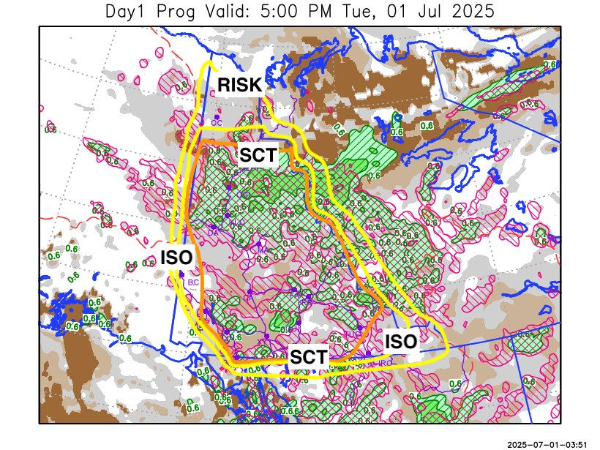
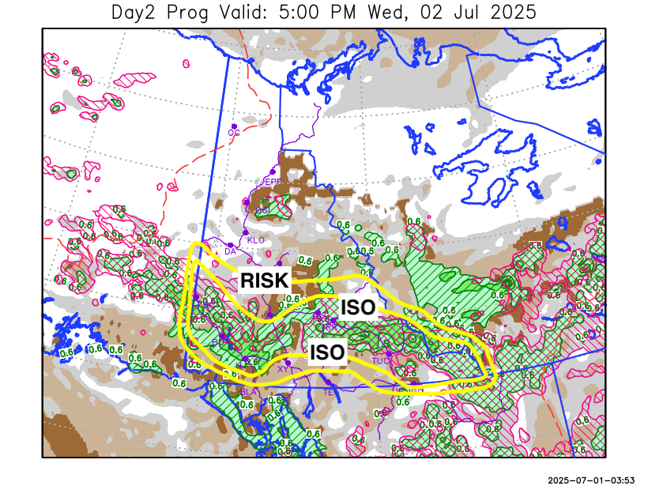

Forecast for | Wednesday | (Peak burning period and overnight)
Community | Clouds | Pcpn | POP | POL | Max Temp | Min RH | Min Temp | Max  RH | Wind Dir | Wind Speed
Old Crow | FEW |  | 0 |  | 23 | 31 | 10 | 69 | 70 | 11
Klondike Fc | SCT |  | 0 |  | 23 | 31 | 10 | 74 | 50 | 14
Mayo A | BKN |  | 10 |  | 20 | 45 | 13 | 76 | 60 | 15G25
Carmacks | BKN | R-/TRW- | 70 | RISK | 20 | 60 | 10 | 90 | 20 | 13
Faro | BKN | R-/TRW- | 70 | ISO | 16 | 72 | 8 | 93 | 20 | 10
Ross River | BKN | R-/TRW- | 70 | ISO | 19 | 60 | 7 | 89 | 0 | 8
Beaver Creek Town | SCT | R-/TRW- | 70 | ISO | 21 | 50 | 8 | 82 | 320 | 12
Burwash A | BKN | R/TRW- | 80 | ISO | 16 | 68 | 9 | 91 | 180 | 12
Haines Junction | OVC | R/TRW- | 80 | ISO | 16 | 70 | 8 | 94 | 200 | 15
Whitehorse Auto | BKN | R-/TRW- | 60 | RISK | 15 | 65 | 9 | 92 | 250 | 12
Teslin | BKN | RW- | 30 |  | 16 | 46 | 9 | 79 | 250 | 15
Watson Lake | BKN | RW-/TRW- | 40 | ISO | 18 | 47 | 10 | 84 | 250 | 15

Forecast for |  |  | Thursday |  |  | (Peak burning period and overnight)
Community |  |  | Clouds |  |  | Pcpn |  | POP |  | POL |  | Max Temp |  | Min RH | Min Temp | Max  RH | Wind Dir | Wind Speed
Old Crow |  |  | FEW |  |  |  |  | 0 |  |  |  | 24 |  | 26 | 9 | 56 | 40 | 20G30
Klondike Fc |  |  | SCT |  |  |  |  | 0 |  |  |  | 25 |  | 32 | 12 | 70 | 70 | 8
Mayo A |  |  | SCT |  |  |  |  | 0 |  |  |  | 24 |  | 33 | 14 | 67 | 0 | 10
Carmacks |  |  | BKN |  |  | RW-/TRW- |  | 20 |  | RISK |  | 24 |  | 35 | 12 | 77 | 20 | 10
Faro |  |  | BKN |  |  | RW-/TRW- |  | 30 |  | RISK |  | 20 |  | 48 | 10 | 81 | 320 | 10
Ross River |  |  | BKN |  |  | RW-/TRW- |  | 30 |  | RISK |  | 22 |  | 43 | 8 | 76 | 320 | 11
Beaver Creek Town |  |  | BKN |  |  | RW-/TRW- |  | 20 |  | RISK |  | 23 |  | 38 | 10 | 74 | 90 | 8
Burwash A |  |  | BKN |  |  | RW-/TRW- |  | 30 |  | RISK |  | 19 |  | 50 | 10 | 83 | 40 | 10
Haines Junction |  |  | BKN |  |  | RW-/TRW- |  | 30 |  | RISK |  | 21 |  | 47 | 8 | 92 | 200 | 12
Whitehorse Auto |  |  | BKN |  |  | RW-/TRW- |  | 30 |  | RISK |  | 19 |  | 49 | 11 | 86 | 320 | 10
Teslin |  |  | BKN |  |  | RW-/TRW- |  | 30 |  | RISK |  | 18 |  | 47 | 9 | 85 | 250 | 12
Watson Lake |  |  | BKN |  |  | RW-/TRW- |  | 30 |  | RISK |  | 19 |  | 46 | 10 | 83 | 290 | 13
3-Day Forecast Precipitation Totals from 13:00 Yesterday
OC | 0.7 |  | FA | 16.5 |  |  | JAK | 12.0
EPF | 5.0 |  | RR | 9.7 |  |  | TE | 6.5
ANT | 2.6 |  | BC | 8.4 |  |  | QUI | 13.7
DA | 2.3 |  | BCT | 8.4 |  |  | SWI | 9.7
FMI | 1.2 |  | BU | 15.6 |  |  | FL | 13.2
HEN | 2.4 |  | HJF | 17.1 |  |  | TUC | 10.6
BAR | 2.4 |  | RAI | 16.0 |  |  | HAS | 8.6
MA | 2.6 |  | CH | 17.4 |  |  | TC | 7.3
STW | 2.3 |  | BR | 10.2 |  |  | WL | 5.9
WIL | 4.6 |  | NU | 13.9 |  |  | PE | 6.2
XY | 14.3 |  | IRO | 5.8 |  |  | CA | 10.2
CC | 7.6 |  | ELK | 12.9 |  |  | DRU | 15.9
ATL | 5.9 |  | NA | NA |  |  | NA | NA
Matt Desorcy Meteorologist

Disclaimer : The information in these forecasts is collected and prepared for internal use by the Government of Yukon. The forecasts are specifically designed to meet the needs of the Wildland Fire Management and may not cover the requirements of other parties. Weather warnings or advisories are not included as part of the forecasts. Wildland Fire Management makes no representation and provides no warranty as to the accuracy of its weather forecasts. Any use the recipient chooses to make of the forecasts will be at its sole risk.

