YUKON WILDLAND FIRE MANAGEMENT WEATHER FORECAST - 9:00 AM ISSUE

2-Jul-2025
YESTERDAY'S VALUES
Community | Max  Temp  (°C) | Diff.  from  Normal | Min Temp  (°C) | Diff. from Normal | Pcpn  (mm) | Min RH | Max RH | L110 | L30
Old Crow | 23.3 | 2.5 | 10.8 | 2.3 | 0.0 | 40 | 79 | 57 | 2
Fort Mcpherson Airport | 20.3 |  | 13.1 |  | 0.9 | 56 | 80 | 35 | 0
Rock River Climate | 16.0 |  | 8.9 |  | 2.4 | 72 | 95 | NA | NA
Eagle Plains Fire | 19.8 |  | 9.2 |  | 0.8 | 55 | 87 | 219 | 18
Antimony Creek | 25.3 |  | 6.0 |  | 7.7 | 33 | 100 | 100 | 14
Klondike Fc | 26.1 |  | 8.5 |  | 2.6 | 34 | 100 | 84 | 8
Forty Mile | 25.7 |  | 9.9 |  | 0.0 | 31 | 96 | 73 | 0
Henderson | 20.3 |  | 10.1 |  | 0.0 | 39 | 93 | 78 | 5
Barlow | 21.8 |  | 9.8 |  | 5.8 | 42 | 93 | 99 | 15
Mayo A | 21.3 | -1.3 | 13.6 | 4.7 | 0.0 | 45 | 69 | 67 | 2
Stewart Crossing | 23.5 |  | 13.4 |  | 0.0 | 31 | 78 | 75 | 1
Willow Creek | 21.6 |  | 10.7 |  | 1.9 | 44 | 98 | 50 | 0
Pelly Farm | 23.4 | 0.9 | 12.3 | 4.4 | 1.6 | 38 | 98 | 24 | 0
Carmacks | 25.6 |  | 12.1 |  | 1.1 | 24 | 85 | 11 | 0
Drury Creek | 20.5 |  | 8.6 |  | 1.0 | 37 | 98 | 16 | 0
Faro | 21.2 | 0.3 | 10.1 | 1.5 | 5.2 | 29 | 93 | 15 | 0
Ross River | 22.3 |  | 6.1 |  | 0.0 | 31 | 96 | 34 | 0
Macmillan Pass | 18.1 |  | 5.8 |  | 12.2 | 37 | 99 | 24 | 0
Beaver Creek A | 23.3 | 3.0 | 11.7 | 4.6 | 0.9 | 25 | 95 | 2 | 0
Beaver Creek Town | 24.4 |  | 11.8 |  | 0.8 | 20 | 95 | 2 | 0
Burwash A | 19.9 | 0.9 | 8.8 | 3.1 | 0.2M | 36 | 95 | 10 | 0
Haines Junction | 20.6 | 1.7 | 8.2 | 3.6 | 1.8 | 36 | 96 | 10 | 2
Rainbow | 19.8 |  | 8.1 |  | 3.1 | 40 | 96 | 10 | 0
Champagne | 20.2 |  | 8.7 |  | 0.5 | 38 | 95 | 11 | 0
Braeburn | 21.9 |  | 9.7 |  | 5.6 | 31 | 97 | 12 | 0
Nursery | 22.7 |  | 9.8 |  | 0.0 | 28 | 80 | 9 | 0
Whitehorse Auto | 18.9 | -1.2 | 9.0 | 2.0 | 0.0 | 37 | 81 | 2 | 0
Mount Sima | 14.8 |  | 8.2 |  | 5.2 | 48 | 92 | 2 | 0
Carcross | 19.0 |  | 7.8 |  | 1.9 | 38 | 99 | 3 | 0
Atlin | 17.0 |  | 9.1 |  | 0.8 | 45 | 86 | 0 | 0
Jakes Corner | 19.5 |  | 8.5 |  | 5.9 | 36 | 98 | 13 | 0
Teslin | 17.6 |  | 8.1 |  | 1.8 | 40 | 95 | 17 | 0
Quiet Lake | 23.9 |  | 9.0 |  | 1.0 | 30 | 88 | 25 | 3
Swift River | 19.3 |  | 4.4 |  | 0.3 | 38 | 95 | 19 | 0
Tuchitua | 22.5 |  | 1.4 |  | 1.3 | 34 | 99 | 113 | 23
Hasselburg | 21.3 |  | 4.3 |  | 0.0 | 31 | 96 | 89 | 7
Tom Creek | 22.7 |  | 5.9 |  | 0.0 | 28 | 97 | 101 | 20
Watson Lake | 21.9 | 1.1 | 7.0 | -1.3 | 5.8 | 23 | 91 | 96 | 19
Iron Creek | 24.2 |  | 2.0 |  | 0.3 | 29 | 99 | 85 | 0
Max Temp is the actual maximum temperature in °C from yesterday afternoon or evening.
Min Temp is the actual overnight minimum temperature in °C up until 6:00 AM this morning.
Diff. from Normal is the difference from the 30 year average max or min temperature.
Pcpn is the precipitation in mm since 13:00 yesterday.
Min RH is the minimum observed RH in % from yesterday afternoon or evening.
Max RH is the maximum observed overnight RH in % up until 6:00 AM this morning.
L110 is the actual number of lightning strikes within 110 km and in the Yukon for 24 hours ending at 06:00 AM this morning.
L30 is the actual number of lightning strikes within 30 km and in the Yukon for 24 hours ending at 06:00 AM this morning.
M is missing data. * denotes precipitation at stations that failed to report for at least part of the evening and overnight period.

SYNOPSIS:
Today: A cold front will continue to slowly sweep southward across the Yukon, eventually stalling out in southern Yukon. This front will bring cooling temperatures and a band of rain with embedded thunder to Tatchun, Kluane, northern Tintina, and parts of Southern Lakes. At this point, heaviest rainfall accumulations (up to 5-10 mm possible) are likely to fall in parts of Tatchun where the front is expected to stall out, as well as in Kluane where upslope rainfall is possible. NE winds will strengthen following the frontal passage, gusting up to 20–30 km/h in central Yukon mid-day today. Highs in the teens to low twenties through most of the Territory, except mid-twenties with RHs in the 25-35% range in the Klondike as an upper-level ridge begins developing in the region.

Thursday: Temperatures remain cooler, in the upper teens to low twenties, across the southern half of the Yukon while central Yukon gradually warms and dries out under a building upper-level ridge. Highs in the mid-twenties with RHs in the 25-35% through the Klondike, Northern Tutchone, and Carmacks district. Winds light and variable throughout the Territory. A stationary front in southern Yukon will be the focus for isolated convective activity in Kluane, Southern Lakes, and Tintina during the afternoon/evening hours.

Friday: Ridging continues to build into central and northern Yukon, leading to temperatures in the mid-twenties under sunny skies, with risk of crossovers as RHs drop into the 20-30% range in Tatchun, Klondike, and Northern Tutchone regions. Isolated convective showers/thundershowers possible in Kluane, Southern Lakes, and Tintina late in the day. Temperatures remain a couple degrees cooler in the south.

Saturday: No significant change in the upper-air pattern expected as ridging remains in place through the central and northern Territory, while conditions remain a bit more unsettled in the south with the risk of late-day convective showers and thundershowers. Highs in the mid-twenties through central and northern Yukon with risk of crossovers, while the south remains a couple degrees cooler.

Sunday: Uncertainty increases in the forecast by Sunday. However, at this point it appears that an upper-low will develop in the Gulf of Alaska. This upper low may produce a few convective showers/thundershowers across the western half of the Yukon while the remainder of the Territory stays dry. Highs remain warmest through central and northern regions, in the mid- to upper twenties with risk of crossovers. Low twenties in southern Yukon.

Forecast for | Wednesday | (Peak burning period and overnight)
Community | Clouds | Pcpn | POP | POL | Max Temp | Min RH | Min Temp | Max  RH | Wind Dir | Wind Speed
Old Crow | SCT |  | 0 |  | 24 | 30 | 11 | 70 | 110 | 12
Klondike Fc | SCT |  | 10 |  | 24 | 35 | 11 | 73 | 40 | 14
Mayo A | BKN | RW- | 30 |  | 19 | 50 | 14 | 76 | 40 | 10G25
Carmacks | OVC | R-/TRW- | 70 | ISO | 19 | 62 | 11 | 91 | 0 | 12
Faro | BKN | R-/TRW- | 80 | ISO | 17 | 65 | 9 | 93 | 20 | 10
Ross River | BKN | R-/TRW- | 80 | ISO | 20 | 58 | 8 | 90 | 20 | 8
Beaver Creek Town | SCT | RW-/TRW- | 70 | SCT | 21 | 51 | 8 | 86 | 70 | 11
Burwash A | BKN | R/TRW- | 90 | RISK | 15 | 75 | 10 | 93 | 320 | 13
Haines Junction | OVC | R-/TRW- | 70 | RISK | 16 | 68 | 8 | 92 | 200 | 13
Whitehorse Auto | BKN | RW-/TRW- | 40 | RISK | 17 | 51 | 10 | 87 | 250 | 12
Teslin | BKN | RW-/TRW- | 30 | RISK | 16 | 53 | 9 | 87 | 250 | 12
Watson Lake | BKN | RW-/TRW- | 40 | SCT | 18 | 42 | 11 | 85 | 340 | 12
POP is probability of precipitation in %.
POL is probability of lightning in %.

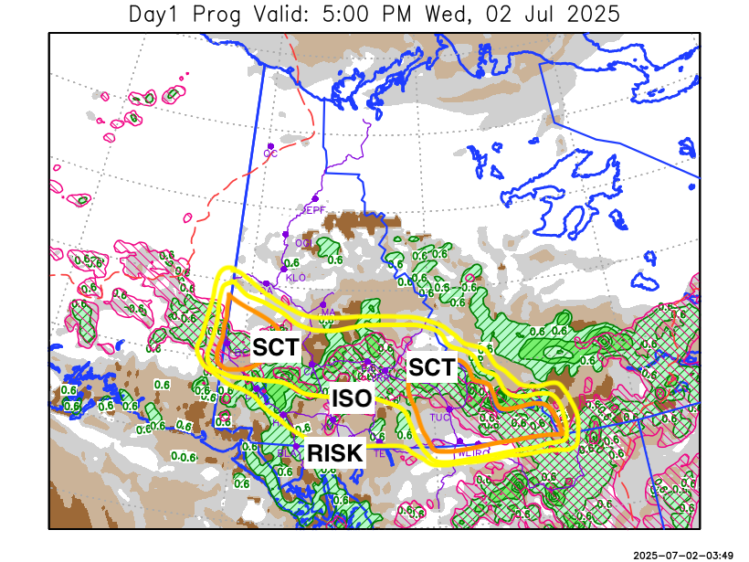
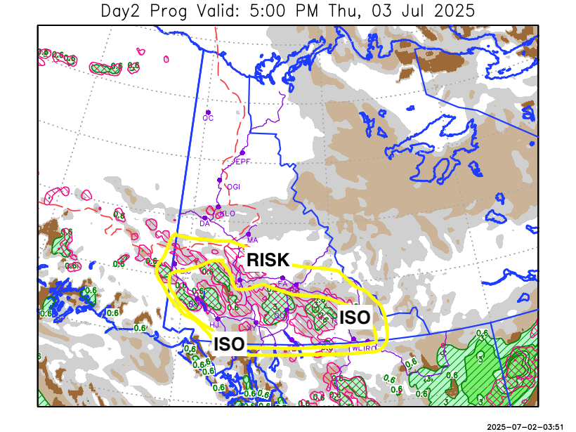

Forecast for | Thursday | (Peak burning period and overnight)
Community | Clouds | Pcpn | POP | POL | Max Temp | Min RH | Min Temp | Max  RH | Wind Dir | Wind Speed
Old Crow | CLR |  | 0 |  | 25 | 25 | 11 | 63 | 40 | 15
Klondike Fc | SCT |  | 0 |  | 26 | 30 | 12 | 71 | 40 | 7
Mayo A | SCT |  | 0 |  | 24 | 32 | 13 | 68 | 20 | 10
Carmacks | BKN | RW-/TRW- | 30 | RISK | 24 | 38 | 12 | 82 | 20 | 11
Faro | BKN | RW-/TRW- | 30 | RISK | 20 | 43 | 10 | 80 | 340 | 11
Ross River | BKN | RW-/TRW- | 30 | RISK | 22 | 40 | 9 | 77 | 290 | 8
Beaver Creek Town | BKN | RW-/TRW- | 20 | RISK | 23 | 41 | 9 | 77 | 70 | 8
Burwash A | BKN | RW-/TRW- | 60 | ISO | 19 | 55 | 10 | 87 | 0 | 10
Haines Junction | BKN | RW-/TRW- | 40 | ISO | 22 | 40 | 10 | 90 | 220 | 8
Whitehorse Auto | BKN | RW-/TRW- | 40 | ISO | 20 | 45 | 11 | 87 | 270 | 12
Teslin | BKN | RW-/TRW- | 40 | ISO | 19 | 44 | 10 | 84 | 250 | 10
Watson Lake | BKN | RW-/TRW- | 40 | ISO | 19 | 43 | 11 | 84 | 250 | 10

Forecast for |  |  | Friday |  |  | (Peak burning period and overnight)
Community |  |  | Clouds |  |  | Pcpn |  | POP |  | POL |  | Max Temp |  | Min RH | Min Temp | Max  RH | Wind Dir | Wind Speed
Old Crow |  |  | FEW |  |  |  |  | 0 |  |  |  | 26 |  | 25 | 13 | 60 | 110 | 10
Klondike Fc |  |  | FEW |  |  |  |  | 0 |  |  |  | 27 |  | 29 | 12 | 66 | 40 | 8
Mayo A |  |  | FEW |  |  |  |  | 0 |  |  |  | 24 |  | 31 | 13 | 68 | 20 | 12
Carmacks |  |  | SCT |  |  |  |  | 0 |  |  |  | 26 |  | 27 | 12 | 64 | 0 | 14
Faro |  |  | SCT |  |  |  |  | 10 |  |  |  | 22 |  | 32 | 10 | 66 | 20 | 10
Ross River |  |  | BKN |  |  |  |  | 10 |  |  |  | 24 |  | 28 | 8 | 67 | 40 | 10
Beaver Creek Town |  |  | BKN |  |  |  |  | 10 |  |  |  | 25 |  | 34 | 10 | 69 | 40 | 9
Burwash A |  |  | BKN |  |  | RW-/TRW- |  | 40 |  | ISO |  | 20 |  | 49 | 10 | 81 | 0 | 10
Haines Junction |  |  | BKN |  |  | RW-/TRW- |  | 40 |  | ISO |  | 23 |  | 40 | 10 | 88 | 220 | 8
Whitehorse Auto |  |  | BKN |  |  | RW-/TRW- |  | 40 |  | ISO |  | 21 |  | 45 | 11 | 85 | 180 | 11
Teslin |  |  | BKN |  |  | RW-/TRW- |  | 40 |  | ISO |  | 19 |  | 55 | 10 | 91 | 250 | 7
Watson Lake |  |  | BKN |  |  | RW-/TRW- |  | 60 |  | ISO |  | 18 |  | 55 | 10 | 82 | 90 | 11
3-Day Forecast Precipitation Totals from 13:00 Yesterday
OC | 0.0 |  | FA | 16.2 |  |  | JAK | 12.1
EPF | 0.8 |  | RR | 9.8 |  |  | TE | 7.4
ANT | 7.7 |  | BC | 7.5 |  |  | QUI | 10.9
DA | 2.6 |  | BCT | 7.4 |  |  | SWI | 9.5
FMI | 0.0 |  | BU | 12.8 |  |  | FL | 10.7
HEN | 0.0 |  | HJF | 10.0 |  |  | TUC | 10.4
BAR | 5.8 |  | RAI | 9.9 |  |  | HAS | 8.7
MA | 1.3 |  | CH | 5.7 |  |  | TC | 6.8
STW | 0.5 |  | BR | 11.7 |  |  | WL | 12.3
WIL | 3.2 |  | NU | 4.1 |  |  | PE | 2.9
XY | 4.3 |  | IRO | 10.1 |  |  | CA | 8.7
CC | 6.8 |  | ELK | 20.8 |  |  | DRU | 12.4
ATL | 5.2 |  | NA | NA |  |  | NA | NA
Matt Desorcy Meteorologist

Disclaimer : The information in these forecasts is collected and prepared for internal use by the Government of Yukon. The forecasts are specifically designed to meet the needs of the Wildland Fire Management and may not cover the requirements of other parties. Weather warnings or advisories are not included as part of the forecasts. Wildland Fire Management makes no representation and provides no warranty as to the accuracy of its weather forecasts. Any use the recipient chooses to make of the forecasts will be at its sole risk.

