YUKON WILDLAND FIRE MANAGEMENT WEATHER FORECAST - 9:00 AM ISSUE

3-Jul-2025
YESTERDAY'S VALUES
Community | Max  Temp  (°C) | Diff.  from  Normal | Min Temp  (°C) | Diff. from Normal | Pcpn  (mm) | Min RH | Max RH | L110 | L30
Old Crow | 22.8 | 1.9 | 9.3 | 0.7 | 0.0 | 29 | 83 | 0 | 0
Fort Mcpherson Airport | 22.2 |  | 12.2 |  | 0.0 | 38 | 73 | 0 | 0
Rock River Climate | 16.7M |  | 9.2M |  | 0.0M | 40M | 66M | - | -
Eagle Plains Fire | 18.8M |  | 9.4M |  | 0.0M | 38M | 75M | 0 | 0
Antimony Creek | 23.7 |  | 9.4 |  | 0.0 | 25 | 90 | 0 | 0
Klondike Fc | 23.7 |  | 11.6 |  | 0.0 | 25 | 88 | 0 | 0
Forty Mile | 23.4 |  | 7.5 |  | 0.0 | 26 | 87 | 0 | 0
Henderson | 18.6 |  | 10.4 |  | 0.0 | 34 | 73 | 16 | 0
Barlow | 21.8 |  | 11.3 |  | 0.0 | 26 | 72 | 0 | 0
Mayo A | 19.4 | -3.2 | 12.7 | 3.7 | 0.4 | 42 | 76 | 0 | 0
Stewart Crossing | 20.9 |  | 13.0 |  | 0.0 | 36 | 75 | 0 | 0
Willow Creek | 20.2 |  | 10.1 |  | 0.3 | 36 | 92 | 0 | 0
Pelly Farm | 23.1 | 0.5 | 9.5 | 1.5 | 0.0 | 33 | 96 | 20 | 0
Carmacks | 17.1 |  | 9.8 |  | 6.3 | 75 | 99 | 7 | 0
Drury Creek | 17.2 |  | 9.0 |  | 0.8 | 64 | 99 | 3 | 0
Faro | 18.7 | -2.2 | 9.9 | 1.2 | 2.0 | 50 | 94 | 9 | 1
Ross River | 19.7 |  | 8.1 |  | 4.7 | 49 | 99 | 9 | 3
Macmillan Pass | 13.0M |  | 0.1M |  | 0.0M | 49M | 92M | 0 | 0
Beaver Creek A | 18.0 | -2.3 | 2.5 | -4.7 | 1.7 | 63 | 100 | 163 | 31
Beaver Creek Town | 21.1M |  | 4.1M |  | 4.4M | 48M | 97M | 163 | 30
Burwash A | 15.3 | -3.8 | 8.9 | 3.1 | 0.2M | 75 | 88 | 72 | 0
Haines Junction | 12.6M | -5.5 | 8.5M | 5.0 | 2.2M | 81M | 95M | 0 | 0
Rainbow | 11.9 |  | 7.5 |  | 1.7 | 79 | 95 | 0 | 0
Champagne | 12.0 |  | 5.6 |  | 0.5 | 74 | 98 | 0 | 0
Braeburn | 18.6 |  | 6.7 |  | 0.0 | 55 | 98 | 0 | 0
Nursery | 16.3 |  | 9.3 |  | 0.0 | 55 | 90 | 0 | 0
Whitehorse Auto | 15.5 | -4.7 | 9.2 | 2.2 | 0.0 | 56 | 84 | 0 | 0
Mount Sima | 11.8M |  | 6.8M |  | 0.0M | 71M | 93M | 0 | 0
Carcross | 12.0 |  | 7.7 |  | 0.0 | 71 | 95 | 0 | 0
Atlin | 14.7 |  | 5.7 |  | 0.0 | 55 | 90 | 0 | 0
Jakes Corner | 13.4 |  | 8.9 |  | 0.0 | 68 | 93 | 0 | 0
Teslin | 15.4 |  | 6.5 |  | 0.2 | 52 | 94 | 0 | 0
Quiet Lake | 20.8 |  | 9.6 |  | 2.4 | 50 | 99 | 3 | 2
Swift River | 18.5 |  | 2.4 |  | 0.0 | 36 | 96 | 0 | 0
Tuchitua | 19.5 |  | 8.4 |  | 9.7 | 43 | 100 | 8 | 0
Hasselburg | 16.9 |  | 8.1 |  | 2.6 | 44 | 97 | 6 | 0
Tom Creek | 20.5 |  | 7.7 |  | 7.3 | 30 | 99 | 16 | 1
Watson Lake | 19.9 | -1.0 | 10.5 | 2.1 | 1.2 | 31 | 88 | 16 | 1
Iron Creek | 23.7 |  | 7.6 |  | 4.4 | 23 | 100 | 25 | 7
Max Temp is the actual maximum temperature in °C from yesterday afternoon or evening.
Min Temp is the actual overnight minimum temperature in °C up until 6:00 AM this morning.
Diff. from Normal is the difference from the 30 year average max or min temperature.
Pcpn is the precipitation in mm since 13:00 yesterday.
Min RH is the minimum observed RH in % from yesterday afternoon or evening.
Max RH is the maximum observed overnight RH in % up until 6:00 AM this morning.
L110 is the actual number of lightning strikes within 110 km and in the Yukon for 24 hours ending at 06:00 AM this morning.
L30 is the actual number of lightning strikes within 30 km and in the Yukon for 24 hours ending at 06:00 AM this morning.
M is missing data. * denotes precipitation at stations that failed to report for at least part of the evening and overnight period.

SYNOPSIS:
Today: Temperatures remain cooler, in the upper teens to low twenties, across the southern half of the Yukon while central Yukon gradually warms and dries out under a building upper-level ridge. Highs in the mid-twenties with RHs in the 25-35% through the Klondike, Northern Tutchone, and Carmacks district. Winds light throughout the Territory, generally out of the N/NE in central and northern regions, and variable in direction across the south. A stationary front in southern Yukon will be the focus for isolated to scattered convective showers and thundershowers in Kluane, Southern Lakes, and Tintina during the afternoon/evening hours (highest POPs in Kluane and Southern Lakes).

Friday: Ridging continues to build into central and northern Yukon. Temperatures in the mid-twenties under mainly sunny skies, with risk of crossovers as RHs drop into the 20-30% range in Tatchun, Klondike, and Northern Tutchone regions. Isolated to scattered convective showers/thundershowers possible in Kluane, Southern Lakes, and Tintina late in the day. Temperatures remain cooler in the south, in the upper teens to low twenties with higher RHs.

Saturday: No significant change in the upper-air pattern expected as ridging remains in place through the central and northern Territory, while conditions remain more unsettled in the south with the risk of convective showers and thundershowers. Highs in the mid to upper twenties through central and northern Yukon with risk of crossovers (min RHs in the 20-30% range), while temperatures in the south remain in the upper teens to low twenties.

Sunday: Uncertainty in the forecast increases by Sunday. An upper-low is forecast to develop in the Gulf of Alaska, while ridging begins to gradually break down in central and northern Yukon. Increasing cloud cover during the day across the southern half of the Yukon, with the risk of a few convective showers and thundershowers. Highs remain warmest through central and northern regions, in the mid- to upper twenties with risk of crossovers. Temperatures reach the low twenties in southern Yukon.

Monday: The upper-low begins to advance eastward into the Territory, bringing increased cloud cover and convective shower/thundershower activity to all regions. Moderate confidence in an overall downtrend in temperatures across central and northern Yukon early next week.

Forecast for | Thursday | (Peak burning period and overnight)
Community | Clouds | Pcpn | POP | POL | Max Temp | Min RH | Min Temp | Max  RH | Wind Dir | Wind Speed
Old Crow | FEW |  | 0 |  | 25 | 24 | 12 | 64 | 40 | 12
Klondike Fc | SCT |  | 0 |  | 26 | 26 | 13 | 65 | 30 | 7
Mayo A | SCT |  | 0 |  | 24 | 30 | 16 | 62 | 20 | 11
Carmacks | BKN | RW-/TRW- | 20 | RISK | 24 | 37 | 13 | 75 | 270 | 8
Faro | BKN | RW-/TRW- | 20 | RISK | 20 | 41 | 11 | 81 | 320 | 8
Ross River | BKN | RW-/TRW- | 20 | RISK | 22 | 35 | 9 | 75 | 320 | 10
Beaver Creek Town | BKN | RW-/TRW- | 30 | ISO | 23 | 38 | 10 | 77 | 40 | 8
Burwash A | BKN | RW-/TRW- | 60 | ISO | 19 | 48 | 11 | 85 | 270 | 10
Haines Junction | BKN | RW-/TRW- | 40 | ISO | 22 | 40 | 10 | 84 | 220 | 11
Whitehorse Auto | BKN | RW-/TRW- | 40 | ISO | 20 | 40 | 12 | 83 | 270 | 10
Teslin | BKN | RW-/TRW- | 40 | ISO | 19 | 42 | 11 | 86 | 250 | 11
Watson Lake | BKN | RW-/TRW- | 20 | RISK | 19 | 39 | 11 | 82 | 270 | 10
POP is probability of precipitation in %.
POL is probability of lightning in %.

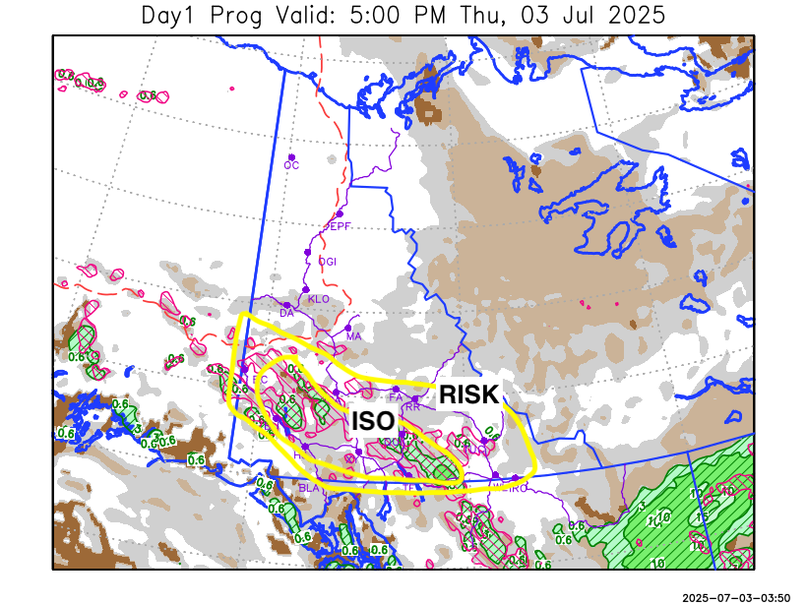
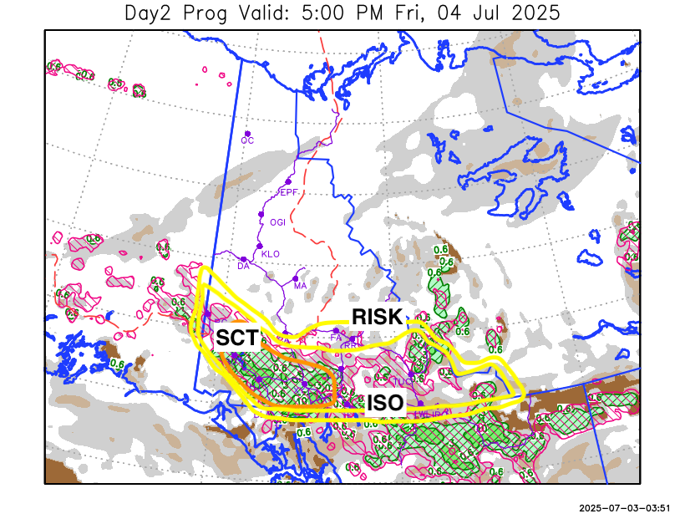

Forecast for | Friday | (Peak burning period and overnight)
Community | Clouds | Pcpn | POP | POL | Max Temp | Min RH | Min Temp | Max  RH | Wind Dir | Wind Speed
Old Crow | FEW |  | 0 |  | 26 | 24 | 13 | 58 | 90 | 10
Klondike Fc | SCT |  | 0 |  | 27 | 24 | 12 | 61 | 40 | 12
Mayo A | SCT |  | 0 |  | 25 | 28 | 14 | 62 | 20 | 13
Carmacks | SCT |  | 0 |  | 26 | 28 | 12 | 70 | 0 | 13
Faro | SCT | RW-/TRW- | 20 | RISK | 21 | 34 | 10 | 71 | 90 | 11
Ross River | BKN | RW-/TRW- | 20 | RISK | 23 | 30 | 8 | 74 | 110 | 10
Beaver Creek Town | BKN | RW-/TRW- | 30 | ISO | 25 | 30 | 10 | 73 | 180 | 11
Burwash A | BKN | RW-/TRW- | 70 | SCT | 18 | 58 | 10 | 86 | 320 | 12
Haines Junction | BKN | RW-/TRW- | 70 | SCT | 21 | 52 | 10 | 93 | 200 | 8
Whitehorse Auto | BKN | RW-/TRW- | 70 | SCT | 19 | 52 | 11 | 91 | 180 | 12
Teslin | BKN | RW-/TRW- | 60 | ISO | 17 | 58 | 10 | 92 | 250 | 7
Watson Lake | BKN | RW-/TRW- | 40 | ISO | 17 | 58 | 10 | 86 | 90 | 12

Forecast for |  |  | Saturday |  |  | (Peak burning period and overnight)
Community |  |  | Clouds |  |  | Pcpn |  | POP |  | POL |  | Max Temp |  | Min RH | Min Temp | Max  RH | Wind Dir | Wind Speed
Old Crow |  |  | FEW |  |  |  |  | 0 |  |  |  | 27 |  | 20 | 13 | 59 | 110 | 15
Klondike Fc |  |  | SCT |  |  |  |  | 0 |  |  |  | 27 |  | 23 | 14 | 68 | 110 | 10
Mayo A |  |  | BKN |  |  |  |  | 0 |  |  |  | 25 |  | 28 | 15 | 73 | 140 | 10
Carmacks |  |  | SCT |  |  | RW-/TRW- |  | 30 |  | ISO |  | 25 |  | 30 | 11 | 74 | 140 | 15
Faro |  |  | SCT |  |  | RW-/TRW- |  | 40 |  | ISO |  | 21 |  | 39 | 9 | 82 | 140 | 11
Ross River |  |  | SCT |  |  | RW-/TRW- |  | 40 |  | ISO |  | 23 |  | 34 | 8 | 80 | 140 | 11
Beaver Creek Town |  |  | BKN |  |  | RW-/TRW- |  | 40 |  | ISO |  | 25 |  | 33 | 9 | 80 | 110 | 12
Burwash A |  |  | SCT |  |  | RW-/TRW- |  | 40 |  | ISO |  | 20 |  | 45 | 8 | 83 | 140 | 15G30
Haines Junction |  |  | SCT |  |  | RW-/TRW- |  | 20 |  | RISK |  | 21 |  | 50 | 7 | 91 | 180 | 15G30
Whitehorse Auto |  |  | BKN |  |  | RW-/TRW- |  | 40 |  | ISO |  | 20 |  | 47 | 10 | 84 | 180 | 15
Teslin |  |  | SCT |  |  | RW-/TRW- |  | 30 |  | ISO |  | 20 |  | 40 | 10 | 84 | 220 | 12
Watson Lake |  |  | BKN |  |  |  |  | 10 |  |  |  | 19 |  | 43 | 11 | 79 | 110 | 11
3-Day Forecast Precipitation Totals from 13:00 Yesterday
OC | 0.0 |  | FA | 5.1 |  |  | JAK | 6.9
EPF | 0.0 |  | RR | 8.7 |  |  | TE | 5.4
ANT | 0.0 |  | BC | 1.9 |  |  | QUI | 11.0
DA | 0.0 |  | BCT | 4.6 |  |  | SWI | 12.1
FMI | 0.0 |  | BU | 8.9 |  |  | FL | 6.1
HEN | 0.0 |  | HJF | 9.8 |  |  | TUC | 15.0
BAR | 0.0 |  | RAI | 9.8 |  |  | HAS | 10.7
MA | 0.4 |  | CH | 7.6 |  |  | TC | 12.1
STW | 0.0 |  | BR | 4.1 |  |  | WL | 6.2
WIL | 0.3 |  | NU | 5.4 |  |  | PE | 0.4
XY | 6.3 |  | IRO | 12.3 |  |  | CA | 7.1
CC | 5.7 |  | ELK | 10.8 |  |  | DRU | 4.4
ATL | 4.6 |  | NA | NA |  |  | NA | NA
Matt Desorcy Meteorologist

Disclaimer : The information in these forecasts is collected and prepared for internal use by the Government of Yukon. The forecasts are specifically designed to meet the needs of the Wildland Fire Management and may not cover the requirements of other parties. Weather warnings or advisories are not included as part of the forecasts. Wildland Fire Management makes no representation and provides no warranty as to the accuracy of its weather forecasts. Any use the recipient chooses to make of the forecasts will be at its sole risk.

