YUKON WILDLAND FIRE MANAGEMENT WEATHER FORECAST - 9:00 AM ISSUE

4-Jul-2025
YESTERDAY'S VALUES
Community | Max  Temp  (°C) | Diff.  from  Normal | Min Temp  (°C) | Diff. from Normal | Pcpn  (mm) | Min RH | Max RH | L110 | L30
Old Crow | 25.0 | 4.1 | 10.7 | 2.0 | 0.0 | 24 | 85
Fort Mcpherson Airport | 24.1 |  | 10.6 |  | 0.0M | 34 | 82
Rock River Climate | 20.8 |  | 9.6 |  | 0.0 | 33 | 74
Eagle Plains Fire | 23.3 |  | 11.1 |  | 0.0 | 26 | 69
Antimony Creek | 26.9 |  | 6.6 |  | 0.0 | 22 | 86
Klondike Fc | 27.7 |  | 8.1 |  | 0.0 | 23 | 88
Forty Mile | 25.8 |  | 8.4 |  | 0.0 | 22 | 77
Henderson | 22.3 |  | 13.4 |  | 0.0 | 27 | 45
Barlow | 25.3 |  | 12.7 |  | 0.0 | 22 | 51
Mayo A | 25.4 | 2.7 | 15.2 | 6.1 | 0.0 | 23 | 43
Stewart Crossing | 26.7 |  | 14.8 |  | 0.0 | 22 | 58
Willow Creek | 25.3 |  | 9.4 |  | 0.3 | 22 | 72
Pelly Farm | 24.8 | 2.2 | 12.5 | 4.4 | 1.8 | 33 | 87
Carmacks | 25.4 |  | 11.2 |  | 1.6 | 28 | 92
Drury Creek | 23.1 |  | 9.7 |  | 0.0 | 37 | 89
Faro | 22.8 | 1.9 | 13.5 | 4.7 | 0.0 | 22 | 64
Ross River | 23.5 |  | 10.1 |  | 0.0 | 23 | 93
Macmillan Pass | 16.3 |  | 4.9 |  | 0.0 | 30 | 79
Beaver Creek A | 22.6 | 2.2 | 8.1 | 0.9 | 0.0 | 35 | 93
Beaver Creek Town | 23.9 |  | 7.4 |  | 0.0 | 32 | 95
Burwash A | 19.7 | 0.6 | 5.1 | -0.8 | 1.3M | 43 | 99
Haines Junction | 22.0 | 3.0 | 8.9 | 4.5 | 0.0 | 41 | 86
Rainbow | 20.1 |  | 7.8 |  | 0.0 | 44 | 85
Champagne | 20.9 |  | 10.3 |  | 0.3 | 32 | 86
Braeburn | 23.0 |  | 6.8 |  | 3.3 | 36 | 99
Nursery | 24.2 |  | 6.7 |  | 1.5 | 33 | 100
Whitehorse Auto | 19.2 | -1.0 | 9.3 | 2.2 | 0.0 | 41 | 88
Mount Sima | 17.9 |  | 8.9 |  | 0.8 | 45 | 95
Carcross | 16.9 |  | 6.7 |  | 2.3 | 53 | 99
Atlin | 18.6 |  | 8.7 |  | 0.2 | 48 | 92
Jakes Corner | 20.3 |  | 7.5 |  | 0.0 | 43 | 93
Teslin | 18.6 |  | 6.8 |  | 2.0 | 47 | 99
Quiet Lake | 20.5 |  | 7.8 |  | 0.9 | 41 | 95
Swift River | 18.0 |  | 4.2 |  | 1.8 | 47 | 99
Tuchitua | 23.8 |  | 6.9 |  | 0.0 | 29 | 100
Hasselburg | 19.1 |  | 8.5 |  | 0.0 | 42 | 88
Tom Creek | 18.8 |  | 7.6 |  | 0.0 | 43 | 94
Watson Lake | 18.9 | -2.1 | 7.2 | -1.3 | 0.2 | 36 | 87
Iron Creek | 20.8 |  | 3.0 |  | 0.0 | 38 | 99
Max Temp is the actual maximum temperature in °C from yesterday afternoon or evening.
Min Temp is the actual overnight minimum temperature in °C up until 6:00 AM this morning.
Diff. from Normal is the difference from the 30 year average max or min temperature.
Pcpn is the precipitation in mm since 13:00 yesterday.
Min RH is the minimum observed RH in % from yesterday afternoon or evening.
Max RH is the maximum observed overnight RH in % up until 6:00 AM this morning.
L110 is the actual number of lightning strikes within 110 km and in the Yukon for 24 hours ending at 06:00 AM this morning.
L30 is the actual number of lightning strikes within 30 km and in the Yukon for 24 hours ending at 06:00 AM this morning.
M is missing data. * denotes precipitation at stations that failed to report for at least part of the evening and overnight period.

SYNOPSIS:
Today: Ridging continues to build into central and northern Yukon. Temperatures in the mid to upper twenties under mainly sunny skies, with risk of crossovers as RHs drop into the 20-30% range in Tatchun, Klondike, and Northern Tutchone regions, as well as Beaver Creek district. Scattered morning showers become scattered convective showers/thundershowers in Kluane, Southern Lakes, and Tintina by afternoon. Temperatures remain cooler in the south, in the upper teens to low twenties with higher RHs. Winds light and rather variable in direction across the Territory.

Saturday: No significant change in the upper-air pattern as ridging remains in place through the central and northern Territory, while conditions stay more unsettled in the south with the risk of convective showers and thundershowers. Risk of showers and thundershowers includes the Tatchun region on Saturday as convection builds northwards slightly compared to today. Highs in the mid to upper twenties through central and northern Yukon with risk of crossovers (min RHs in the 20-30% range), while temperatures in the south remain in the upper teens to low twenties.

Sunday: An upper-low is forecast to develop in the Gulf of Alaska by Sunday, while upper-level ridging begins to weaken slightly in central and northern Yukon. Increasing cloud cover during the day across the southern half of the Yukon, with the risk of a few convective showers and thundershowers in eastern Tatchun and Beaver Creek district. Highs remain warmest through central and northern regions, in the mid- to upper twenties with risk of crossovers, as the ridge hangs on. Temperatures reach the low twenties in southern Yukon. Moderate south/southeast winds in parts of Kluane and Southern Lakes.

Monday: The upper-low begins to advance eastward into the Territory, bringing increased cloud cover and convective shower/thundershower activity, particularly to central Yukon. Moderate confidence in an overall downtrend in temperatures across central and northern Yukon through the first half of next week. Temperatures drop into the upper teens to low twenties through central regions while remaining in the upper teens to low twenties through southern Yukon. Low to mid-twenties in Old Crow.

Tuesday: Troughing in place across the Territory, leading to unsettled weather in the form of scattered showers and thundershowers, as well as a continued downtrend in temperatures through central and northern regions. Highs in the teens to low twenties through most regions, except cooler in Old Crow.

Forecast for | Friday | (Peak burning period and overnight)
Community | Clouds | Pcpn | POP | POL | Max Temp | Min RH | Min Temp | Max  RH | Wind Dir | Wind Speed
Old Crow | FEW |  | 0 |  | 27 | 22 | 13 | 59 | 90 | 10
Klondike Fc | SCT |  | 0 |  | 28 | 23 | 13 | 57 | 40 | 12
Mayo A | BKN |  | 0 |  | 26 | 25 | 16 | 57 | 20 | 13
Carmacks | BKN |  | 0 |  | 27 | 24 | 13 | 65 | 0 | 12
Faro | BKN |  | 10 |  | 22 | 25 | 11 | 64 | 20 | 11
Ross River | BKN |  | 10 |  | 24 | 24 | 9 | 69 | 110 | 10
Beaver Creek Town | BKN | RW-/TRW- | 30 | ISO | 26 | 29 | 11 | 70 | 180 | 12
Burwash A | BKN | RW-/TRW- | 70 | SCT | 19 | 55 | 10 | 85 | 340 | 10
Haines Junction | BKN | RW-/TRW- | 70 | SCT | 20 | 52 | 10 | 94 | 200 | 10
Whitehorse Auto | BKN | RW-/TRW- | 70 | SCT | 20 | 55 | 11 | 92 | 180 | 13
Teslin | BKN | RW-/TRW- | 70 | SCT | 18 | 62 | 11 | 92 | 250 | 8
Watson Lake | BKN | RW-/TRW- | 60 | SCT | 17 | 56 | 10 | 89 | 90 | 12
POP is probability of precipitation in %.
POL is probability of lightning in %.

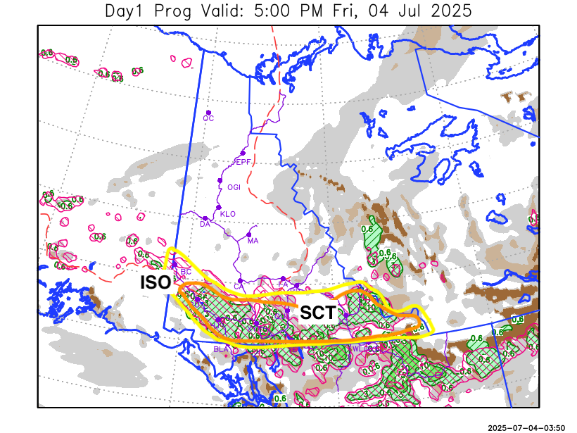
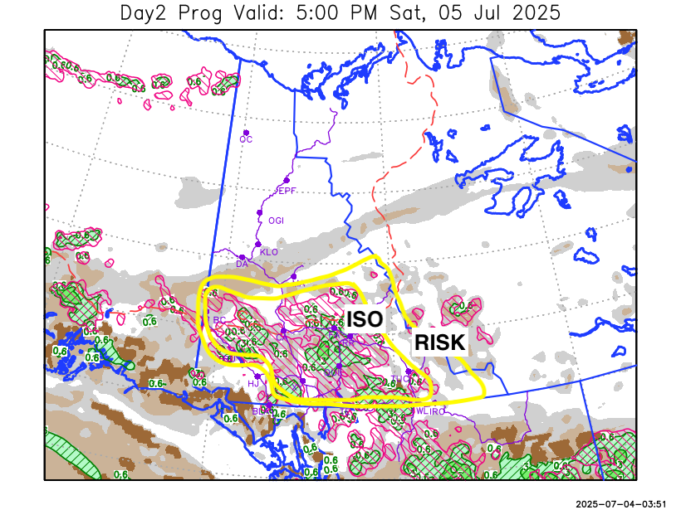

Forecast for | Saturday | (Peak burning period and overnight)
Community | Clouds | Pcpn | POP | POL | Max Temp | Min RH | Min Temp | Max  RH | Wind Dir | Wind Speed
Old Crow | FEW |  | 0 |  | 28 | 20 | 13 | 57 | 110 | 10
Klondike Fc | SCT |  | 0 |  | 28 | 23 | 14 | 64 | 100 | 10
Mayo A | SCT |  | 10 |  | 27 | 23 | 16 | 67 | 160 | 8
Carmacks | SCT | RW-/TRW- | 20 | ISO | 28 | 28 | 11 | 71 | 140 | 13
Faro | SCT | RW-/TRW- | 30 | ISO | 22 | 34 | 10 | 84 | 160 | 8
Ross River | SCT | RW-/TRW- | 30 | ISO | 24 | 30 | 8 | 82 | 180 | 11
Beaver Creek Town | SCT | RW-/TRW- | 30 | ISO | 26 | 29 | 9 | 78 | 110 | 12
Burwash A | SCT | RW-/TRW- | 20 | RISK | 20 | 40 | 7 | 82 | 140 | 15G30
Haines Junction | SCT |  | 10 |  | 21 | 40 | 6 | 89 | 180 | 15G30
Whitehorse Auto | SCT | RW-/TRW- | 40 | ISO | 20 | 45 | 10 | 86 | 200 | 15
Teslin | SCT | RW-/TRW- | 40 | ISO | 20 | 46 | 10 | 82 | 220 | 9
Watson Lake | BKN | RW-/TRW- | 30 | ISO | 20 | 42 | 12 | 80 | 110 | 11

Forecast for |  |  | Sunday |  |  | (Peak burning period and overnight)
Community |  |  | Clouds |  |  | Pcpn |  | POP |  | POL |  | Max Temp |  | Min RH | Min Temp | Max  RH | Wind Dir | Wind Speed
Old Crow |  |  | FEW |  |  |  |  | 0 |  |  |  | 29 |  | 18 | 16 | 53 | 250 | 8
Klondike Fc |  |  | FEW |  |  |  |  | 0 |  |  |  | 27 |  | 25 | 13 | 62 | 110 | 13
Mayo A |  |  | SCT |  |  |  |  | 0 |  |  |  | 26 |  | 27 | 15 | 69 | 180 | 10
Carmacks |  |  | SCT |  |  |  |  | 0 |  |  |  | 26 |  | 26 | 10 | 69 | 160 | 16
Faro |  |  | BKN |  |  | RW-/TRW- |  | 30 |  | RISK |  | 22 |  | 33 | 9 | 78 | 200 | 10
Ross River |  |  | BKN |  |  | RW-/TRW- |  | 20 |  | RISK |  | 24 |  | 28 | 8 | 73 | 200 | 12
Beaver Creek Town |  |  | BKN |  |  | RW-/TRW- |  | 40 |  | ISO |  | 24 |  | 33 | 7 | 84 | 270 | 10
Burwash A |  |  | SCT |  |  |  |  | 0 |  |  |  | 19 |  | 36 | 6 | 73 | 140 | 15G30
Haines Junction |  |  | BKN |  |  |  |  | 0 |  |  |  | 20 |  | 35 | 7 | 84 | 180 | 15G30
Whitehorse Auto |  |  | BKN |  |  |  |  | 0 |  |  |  | 20 |  | 35 | 9 | 78 | 180 | 15G30
Teslin |  |  | BKN |  |  |  |  | 0 |  |  |  | 19 |  | 40 | 9 | 79 | 200 | 15
Watson Lake |  |  | BKN |  |  | RW-/TRW- |  | 20 |  | RISK |  | 20 |  | 40 | 12 | 70 | 220 | 12
3-Day Forecast Precipitation Totals from 13:00 Yesterday
OC | 0.0 |  | FA | 1.2 |  |  | JAK | 5.6
EPF | 0.0 |  | RR | 1.0 |  |  | TE | 7.8
ANT | 0.0 |  | BC | 0.8 |  |  | QUI | 8.4
DA | 0.0 |  | BCT | 0.8 |  |  | SWI | 12.6
FMI | 0.0 |  | BU | 6.6 |  |  | FL | 4.0
HEN | 0.0 |  | HJF | 7.1 |  |  | TUC | 8.2
BAR | 0.0 |  | RAI | 6.5 |  |  | HAS | 7.8
MA | 0.0 |  | CH | 6.3 |  |  | TC | 4.8
STW | 0.0 |  | BR | 5.5 |  |  | WL | 5.6
WIL | 0.3 |  | NU | 9.0 |  |  | PE | 1.8
XY | 8.3 |  | IRO | 5.7 |  |  | CA | 1.6
CC | 6.8 |  | ELK | 6.3 |  |  | DRU | 2.4
ATL | 2.4 |  | NA | NA |  |  | NA | NA
Matt Desorcy Meteorologist

Disclaimer : The information in these forecasts is collected and prepared for internal use by the Government of Yukon. The forecasts are specifically designed to meet the needs of the Wildland Fire Management and may not cover the requirements of other parties. Weather warnings or advisories are not included as part of the forecasts. Wildland Fire Management makes no representation and provides no warranty as to the accuracy of its weather forecasts. Any use the recipient chooses to make of the forecasts will be at its sole risk.

