YUKON WILDLAND FIRE MANAGEMENT WEATHER FORECAST - 9:00 AM ISSUE

5-Jul-2025
YESTERDAY'S VALUES
Community | Max  Temp  (°C) | Diff.  from  Normal | Min Temp  (°C) | Diff. from Normal | Pcpn  (mm) | Min RH | Max RH | L110 | L30
Old Crow | 27.9 | 7.0 | 11.8 | 3.1 | 0.0 | 24 | 68 | 0 | 0
Fort Mcpherson Airport | 21.2 |  | 10.4 |  | 0.0 | 33 | 81 | 0 | 0
Rock River Climate | 18.4 |  | 9.7 |  | 0.0 | 35 | 65 | NA | NA
Eagle Plains Fire | 22.9 |  | 8.1 |  | 0.0 | 25 | 70 | 0 | 0
Antimony Creek | 27.4 |  | 5.5 |  | 0.0 | 17 | 82 | 0 | 0
Klondike Fc | 28.9 |  | 8.7 |  | 0.0 | 22 | 88 | 0 | 0
Forty Mile | 27.9 |  | 10.2 |  | 0.0 | 23 | 77 | 0 | 0
Henderson | 23.4 |  | 11.9 |  | 0.0 | 25 | 49 | 0 | 0
Barlow | 25.3 |  | 11.7 |  | 0.0 | 24 | 48 | 0 | 0
Mayo A | 25.2 | 2.5 | 10.4 | 1.2 | 0.0 | 22 | 52 | 0 | 0
Stewart Crossing | 26.2 |  | 11.7 |  | 0.0 | 22 | 60 | 0 | 0
Willow Creek | 25.8 |  | 7.6 |  | 0.0 | 21 | 74 | 0 | 0
Pelly Farm | 28.1 | 5.4 | 6.7 | -1.5 | 0.0 | 19 | 88 | 1 | 0
Carmacks | 28.0 |  | 10.9 |  | 0.0 | 23 | 85 | 25 | 0
Drury Creek | 25.6 |  | 9.2 |  | 0.0 | 21 | 86 | 21 | 0
Faro | 24.6 | 3.6 | 9.7 | 0.9 | 0.0 | 16 | 78 | 38 | 0
Ross River | 24.9 |  | 7.1 |  | 0.0 | 21 | 91 | 58 | 0
Macmillan Pass | 17.7 |  | 1.5 |  | 0.0 | 28 | 89 | 0 | 0
Beaver Creek A | 24.9 | 4.5 | 9.0 | 1.7 | 0.0M | 27 | 79 | 7 | 0
Beaver Creek Town | 25.5 |  | 8.9 |  | 0.0 | 24 | 85 | 7 | 0
Burwash A | 22.0 | 2.8 | 4.2 | -1.8 | 1.0M | 39 | 99 | 80 | 9
Haines Junction | 22.8 | 3.0 | 5.9 | 1.5 | 2.6 | 46 | 99 | 157 | 4
Rainbow | 21.7 |  | 7.5 |  | 3.9 | 46 | 100 | 174 | 2
Champagne | 22.5 |  | 6.1 |  | 1.8 | 42 | 100 | 269 | 45
Braeburn | 27.4 |  | 6.4 |  | 0.0 | 28 | 98 | 211 | 3
Nursery | 24.8 |  | 7.9 |  | 4.6 | 31 | 98 | 339 | 36
Whitehorse Auto | 22.1 | 1.8 | 7.7 | 0.5 | 4.4 | 39 | 97 | 349 | 67
Mount Sima | 18.8 |  | 6.8 |  | 12.6 | 54 | 99 | 340 | 60
Carcross | 19.6 |  | 3.2 |  | 20.6 | 50 | 100 | 240 | 30
Atlin | 19.5 |  | 9.3 |  | 15.8 | 45 | 97 | 93 | 0
Jakes Corner | 19.6 |  | 6.0 |  | 1.5 | 52 | 98 | 342 | 17
Teslin | 18.5 |  | 6.7 |  | 2.2 | 55 | 99 | 237 | 34
Quiet Lake | 21.2 |  | 4.2 |  | 1.6 | 45 | 99 | 311 | 51
Swift River | 18.3 |  | 6.9 |  | 6.8 | 54 | 99 | 182 | 0
Tuchitua | 23.3 |  | 5.0 |  | 2.1 | 29 | 100 | 222 | 19
Hasselburg | 21.2 |  | 7.4 |  | 0.8 | 37 | 99 | 262 | 20
Tom Creek | 20.0 |  | 7.5 |  | 2.3 | 53 | 100 | 198 | 61
Watson Lake | 17.9 | -3.1 | 10.0 | 1.4 | 1.2 | 50 | 86 | 186 | 31
Iron Creek | 21.3 |  | 5.2 |  | 1.8 | 47 | 100 | 140 | 2
Max Temp is the actual maximum temperature in °C from yesterday afternoon or evening.
Min Temp is the actual overnight minimum temperature in °C up until 6:00 AM this morning.
Diff. from Normal is the difference from the 30 year average max or min temperature.
Pcpn is the precipitation in mm since 13:00 yesterday.
Min RH is the minimum observed RH in % from yesterday afternoon or evening.
Max RH is the maximum observed overnight RH in % up until 6:00 AM this morning.
L110 is the actual number of lightning strikes within 110 km and in the Yukon for 24 hours ending at 06:00 AM this morning.
L30 is the actual number of lightning strikes within 30 km and in the Yukon for 24 hours ending at 06:00 AM this morning.
M is missing data. * denotes precipitation at stations that failed to report for at least part of the evening and overnight period.

SYNOPSIS:
Today: Upper ridging remains in place over the Yukon, with the core of the ridge over the northern Yukon. This is resulting in temperatures in the mid-upper twenties in most of the Yukon, with slightly cooler temperatures in the upper teens and low twenties in the southern Yukon. Cross overs are possible by this afternoon anywhere temperatures reach into the mid-twenties and likely where temperatures are in the upper twenties or higher. Spotty afternoon showers and thunderstorms are expected to develop across the southern half of the Yukon with daytime heating (see map below for risk areas). Otherwise, dry conditions are expected. Winds will be mostly light and variable today at 10-15 km/h or less but note slightly higher speeds forecast at Whitehorse and Mayo in the tabular forecast.

Sunday: Ridging starts to break down on Sunday with an upper low in the Gulf of Alaska approaching the southern Yukon. However, this will be a gradual process, with only slight changes to the weather on Sunday. Temperatures will remain warm in most of the Yukon, with widespread highs again in the mid to upper twenties, except in the southern part of the territory. Afternoon crossovers also remain possible where temperatures reach the mid-twenties or warmer. There is a risk of thunderstorms across the Klondike and Northern Tutchone regions. Farther south, a chance of rain showers exists as the upper low approaches. Winds will also be increasing across some regions with the approaching system and strengthening pressure gradient. Increasing south to southeast winds are expected in Whitehorse and Burwash – see the tabular forecast for more details.

Monday: The upper low in the Gulf of Alaska continues to push toward the coast, maintaining a trend toward slightly cooler and breezier weather in the southern Yukon. Farther north, warm conditions are expected to remain in the central and northern Yukon. There is likely to remain a risk of thunderstorms in the central Yukon with a chance of showers elsewhere.

Tuesday: The upper low reaches the BC coast, likely bringing cooler temperatures across the Yukon along with an increasing chance for rain. There is still uncertainty regarding where rain is most likely in the longer range.

Wednesday: The upper low shifts east, leaving the Yukon in a cooler west to northwest flow. This is expected to result in much cooler weather across the northern Yukon with near normal temperatures elsewhere in the teens to low twenties.

Forecast for | Saturday | (Peak burning period and overnight)
Community | Clouds | Pcpn | POP | POL | Max Temp | Min RH | Min Temp | Max  RH | Wind Dir | Wind Speed
Old Crow | FEW |  | 10 | 0 | 28 | 20 | 13 | 70 | 110 | 20
Klondike Fc | FEW |  | 10 | 0 | 30 | 20 | 14 | 80 | 110 | 10
Mayo A | FEW |  | 10 | 0 | 27 | 20 | 16 | 70 | 160 | 10
Carmacks | SCT | TRW-/RW- | 40 | 20 | 28 | 20 | 11 | 85 | 160 | 10
Faro | SCT | TRW-/RW- | 40 | 20 | 24 | 20 | 10 | 85 | 180 | 10
Ross River | SCT | TRW-/RW- | 40 | 20 | 24 | 20 | 8 | 85 | 160 | 10
Beaver Creek Town | SCT | TRW-/RW- | 40 | 20 | 26 | 25 | 8 | 85 | 220 | 10
Burwash A | SCT | TRW-/RW- | 30 | 10 | 22 | 35 | 7 | 90 | 140 | 20
Haines Junction | SCT | TRW-/RW- | 30 | 10 | 23 | 35 | 6 | 90 | 180 | 10
Whitehorse Auto | SCT | TRW-/RW- | 30 | 10 | 22 | 30 | 10 | 90 | 200 | 20
Teslin | BKN | TRW-/RW- | 30 | 10 | 19 | 50 | 9 | 95 | 220 | 15
Watson Lake | BKN | TRW-/RW- | 30 | 10 | 18 | 50 | 11 | 90 | 110 | 10
POP is probability of precipitation in %.
POL is probability of lightning in %.

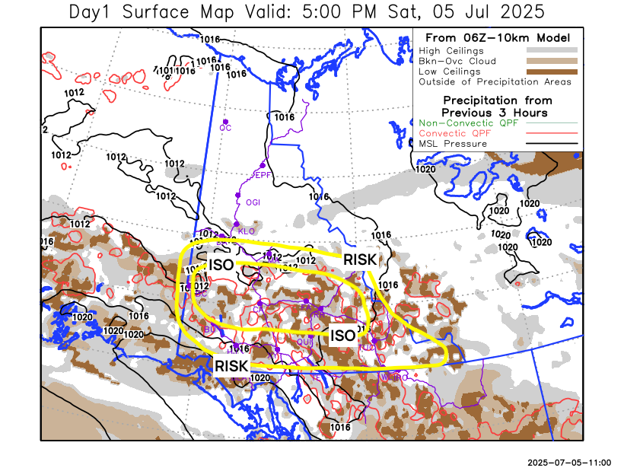
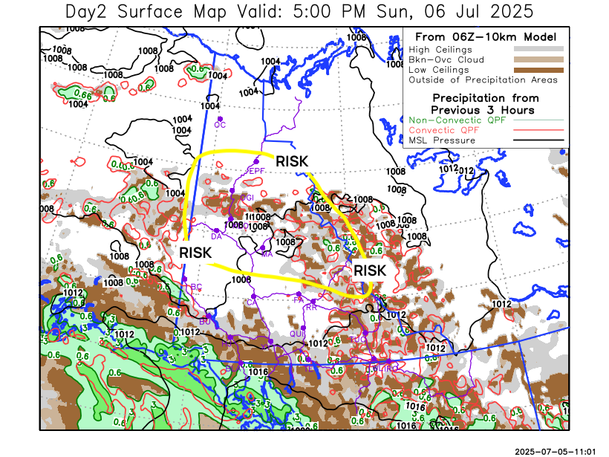

Forecast for | Sunday | (Peak burning period and overnight)
Community | Clouds | Pcpn | POP | POL | Max Temp | Min RH | Min Temp | Max  RH | Wind Dir | Wind Speed
Old Crow | FEW |  | 0 | 0 | 28 | 20 | 14 | 70 | 180 | 10
Klondike Fc | SCT | RW-/TRW- | 30 | 10 | 28 | 25 | 12 | 85 | 110 | 10
Mayo A | SCT | RW-/TRW- | 30 | 10 | 26 | 25 | 15 | 80 | 180 | 10
Carmacks | SCT |  | 20 | 0 | 26 | 25 | 10 | 80 | 160 | 20
Faro | SCT | RW- | 30 | 0 | 23 | 25 | 9 | 85 | 220 | 10
Ross River | SCT | RW- | 30 | 0 | 23 | 25 | 8 | 85 | 200 | 10
Beaver Creek Town | SCT |  | 10 | 0 | 24 | 25 | 8 | 85 | 140 | 10
Burwash A | SCT | RW- | 30 | 0 | 19 | 40 | 7 | 90 | 140 | 25G40
Haines Junction | SCT | RW- | 30 | 0 | 20 | 40 | 7 | 90 | 180 | 15
Whitehorse Auto | BKN | RW- | 40 | 0 | 20 | 35 | 9 | 90 | 160 | 20G35
Teslin | BKN | RW- | 30 | 0 | 19 | 45 | 9 | 90 | 180 | 20
Watson Lake | BKN | RW- | 40 | 0 | 20 | 45 | 11 | 90 | 220 | 15

Forecast for |  |  | Monday |  | (Peak burning period and overnight)
Community |  |  | Clouds |  | Pcpn |  | POP |  | POL |  | Max Temp |  | Min RH | Min Temp | Max  RH | Wind Dir | Wind Speed
Old Crow |  |  | FEW |  | RW- |  | 30 |  | 0 |  | 27 |  | 25 | 8 | 85 | 0 | 10
Klondike Fc |  |  | SCT |  | RW-/TRW- |  | 40 |  | 20 |  | 27 |  | 25 | 11 | 85 | 140 | 10
Mayo A |  |  | SCT |  | RW-/TRW- |  | 40 |  | 20 |  | 25 |  | 25 | 13 | 75 | 180 | 10
Carmacks |  |  | BKN |  |  |  | 20 |  | 0 |  | 23 |  | 30 | 8 | 80 | 180 | 15
Faro |  |  | BKN |  | RW- |  | 30 |  | 0 |  | 20 |  | 40 | 6 | 85 | 200 | 10
Ross River |  |  | BKN |  | RW- |  | 30 |  | 0 |  | 20 |  | 40 | 5 | 85 | 200 | 10
Beaver Creek Town |  |  | BKN |  |  |  | 20 |  | 0 |  | 20 |  | 35 | 5 | 85 | 250 | 10
Burwash A |  |  | BKN |  |  |  | 20 |  | 0 |  | 17 |  | 45 | 6 | 90 | 140 | 15
Haines Junction |  |  | BKN |  | RW- |  | 30 |  | 0 |  | 17 |  | 45 | 4 | 90 | 180 | 15
Whitehorse Auto |  |  | BKN |  | RW- |  | 30 |  | 0 |  | 17 |  | 40 | 6 | 85 | 180 | 20
Teslin |  |  | BKN |  | RW- |  | 40 |  | 0 |  | 17 |  | 45 | 6 | 85 | 200 | 15
Watson Lake |  |  | BKN |  | RW- |  | 50 |  | 0 |  | 18 |  | 45 | 8 | 85 | 220 | 15
3-Day Forecast Precipitation Totals from 13:00 Yesterday
OC | 0.0 |  | FA | 4.2 |  | JAK | 2.8
EPF | 0.4 |  | RR | 2.4 |  | TE | 5.1
ANT | 0.0 |  | BC | 6.2 |  | QUI | 5.8
DA | 0.0 |  | BCT | 6.2 |  | SWI | 13.6
FMI | 0.0 |  | BU | 1.7 |  | FL | 4.6
HEN | 0.0 |  | HJF | 2.9 |  | TUC | 6.2
BAR | 0.0 |  | RAI | 4.5 |  | HAS | 6.7
MA | 0.0 |  | CH | 2.3 |  | TC | 5.1
STW | 0.0 |  | BR | 1.7 |  | WL | 3.1
WIL | 0.3 |  | NU | 7.6 |  | PE | 0.0
XY | 7.3 |  | IRO | 3.7 |  | CA | 0.9
CC | 20.8 |  | ELK | 1.5 |  | DRU | 3.8
ATL | 16.2 |  | NA | NA |  | NA | NA
Scott Kehler Meteorologist

Disclaimer : The information in these forecasts is collected and prepared for internal use by the Government of Yukon. The forecasts are specifically designed to meet the needs of the Wildland Fire Management and may not cover the requirements of other parties. Weather warnings or advisories are not included as part of the forecasts. Wildland Fire Management makes no representation and provides no warranty as to the accuracy of its weather forecasts. Any use the recipient chooses to make of the forecasts will be at its sole risk.

