YUKON WILDLAND FIRE MANAGEMENT WEATHER FORECAST - 9:00 AM ISSUE

6-Jul-2025
YESTERDAY'S VALUES
Community | Max  Temp  (°C) | Diff.  from  Normal | Min Temp  (°C) | Diff. from Normal | Pcpn  (mm) | Min RH | Max RH | L110 | L30
Old Crow | 28.1 | 7.2 | 11.2 | 2.4 | 0.0 | 18 | 79 | 0 | 0
Fort Mcpherson Airport | 25.1 |  | 10.8 |  | 0.0M | 27 | 76 | 0 | 0
Rock River Climate | 21.1 |  | 11.2 |  | 0.0 | 28 | 53 | NA | NA
Eagle Plains Fire | 24.5 |  | 10.5 |  | 0.0 | 17 | 55 | 0 | 0
Antimony Creek | 28.2 |  | 8.8 |  | 0.0 | 18 | 84 | 0 | 0
Klondike Fc | 28.8 |  | 7.2 |  | 0.0 | 12 | 80 | 0 | 0
Forty Mile | 27.8 |  | 15.0 |  | 0.0 | 17 | 63 | 0 | 0
Henderson | 24.2 |  | 11.3 |  | 0.0 | 23 | 69 | 3 | 0
Barlow | 26.9 |  | 12.9 |  | 0.0 | 20 | 63 | 3 | 0
Mayo A | 26.4 | 3.6 | 9.3 | 0.0 | 0.0 | 17 | 78 | 9 | 0
Stewart Crossing | 26.1 |  | 12.5 |  | 0.0 | 24 | 73 | 12 | 0
Willow Creek | 27.2 |  | 5.5 |  | 1.8 | 24 | 99 | 27 | 0
Pelly Farm | 27.7 | 5.0 | 7.2 | -1.0 | 8.1 | 29 | 98 | 43 | 3
Carmacks | 27.6 |  | 8.7 |  | 0.0 | 27 | 80 | 85 | 3
Drury Creek | 25.6 |  | 8.1 |  | 0.0 | 30 | 94 | 47 | 17
Faro | 23.8 | 2.8 | 8.0 | -0.9 | 0.0 | 20 | 87 | 39 | 0
Ross River | 25.0 |  | 3.3 |  | 0.0 | 23 | 96 | 8 | 0
Macmillan Pass | 19.9 |  | 7.1 |  | 0.0 | 24 | 79 | 0 | 0
Beaver Creek A | 24.6 | 4.1 | 5.9 | -1.5 | 0.0 | 31 | 81 | 43 | 6
Beaver Creek Town | 26.6 |  | 8.6 |  | 0.0 | 25 | 80 | 43 | 6
Burwash A | 19.3 | 0.1 | 8.5 | 2.5 | 0.0M | 48 | 65 | 64 | 5
Haines Junction | 19.3 | -0.6 | 1.6 | -2.5 | 0.0 | 48 | 97 | 21 | 0
Rainbow | 19.0 |  | 7.4 |  | 0.0 | 49 | 82 | 11 | 0
Champagne | 20.3 |  | 3.4 |  | 0.0 | 45 | 89 | 18 | 1
Braeburn | 24.3 |  | 3.3 |  | 0.0 | 28 | 96 | 58 | 5
Nursery | 21.7 |  | 6.4 |  | 0.0 | 38 | 86 | 16 | 0
Whitehorse Auto | 18.8 | -1.5 | 8.6 | 1.3 | 0.0 | 48 | 72 | 10 | 0
Mount Sima | 14.8 |  | 5.5 |  | 0.0 | 61 | 76 | 9 | 0
Carcross | 18.8 |  | 2.4 |  | 0.0 | 44 | 98 | 1 | 0
Atlin | 18.7 |  | 5.6 |  | 0.0 | 41 | 85 | 0 | 0
Jakes Corner | 19.5 |  | 3.0 |  | 0.0 | 38 | 92 | 0 | 0
Teslin | 19.5 |  | 3.6 |  | 0.0 | 42 | 92 | 0 | 0
Quiet Lake | 22.9 |  | 3.8 |  | 0.3 | 41 | 95 | 3 | 0
Swift River | 18.7 |  | 3.0 |  | 0.5 | 43 | 98 | 0 | 0
Tuchitua | 21.5 |  | 4.8 |  | 1.4 | 39 | 100 | 0 | 0
Hasselburg | 19.0 |  | 8.7 |  | 9.2 | 48 | 99 | 0 | 0
Tom Creek | 16.2 |  | 8.8 |  | 4.9 | 61 | 99 | 0 | 0
Watson Lake | 18.0 | -3.1 | 10.3 | 1.7 | 0.0 | 50 | 84 | 0 | 0
Iron Creek | 20.0 |  | 3.6 |  | 0.0 | 47 | 100 | 0 | 0
Max Temp is the actual maximum temperature in °C from yesterday afternoon or evening.
Min Temp is the actual overnight minimum temperature in °C up until 6:00 AM this morning.
Diff. from Normal is the difference from the 30 year average max or min temperature.
Pcpn is the precipitation in mm since 13:00 yesterday.
Min RH is the minimum observed RH in % from yesterday afternoon or evening.
Max RH is the maximum observed overnight RH in % up until 6:00 AM this morning.
L110 is the actual number of lightning strikes within 110 km and in the Yukon for 24 hours ending at 06:00 AM this morning.
L30 is the actual number of lightning strikes within 30 km and in the Yukon for 24 hours ending at 06:00 AM this morning.
M is missing data. * denotes precipitation at stations that failed to report for at least part of the evening and overnight period.

SYNOPSIS:
Today: Ridging starts to break down today with an upper low in the Gulf of Alaska approaching the southern Yukon. However, this will only cause gradual changes to the weather pattern as we move into the week. Temperatures will remain warm in most of the Yukon today, with widespread highs again in the mid to upper twenties, except in the southern part of the territory, which will be cooler. Afternoon crossovers also remain possible where temperatures reach the mid-twenties or warmer. There is a risk of thunderstorms across the Klondike and Northern Tutchone regions. Farther south, a slight chance of rain showers exists late in the day and overnight as the upper low approaches. Stronger winds are also expected, especially in parts of the Kluane and Southern Lakes regions with the approaching system and strengthening pressure gradient – see the tabular forecast for more details.

Monday: The upper low in the Gulf of Alaska continues to push toward the coast, maintaining a cooling trend across most of the Yukon. Warmer weather will hang on a bit longer in the north, with Old Crow maintaining temperatures in the upper twenties for one more day. Elsewhere, highs mostly in the upper teens to low twenties with a few stations in the central Yukon reaching the mid-twenties. Cross overs generally unlikely, except where temperatures are in the mid-twenties or warmer. Higher winds remaining in some areas – especially Burwash, Whitehorse, and Carmacks with a stronger southeasterly flow ahead of the upper low – check the tabular forecast for more details. There is a broad risk of spotty rain showers across the Yukon, but these will be isolated and light, with most locations receiving little to no accumulation.

Tuesday: The upper low finally reaches the BC coast, continuing the trend to cooler temperatures across the Yukon along with an increasing chance for rain. Currently, there are two areas that appear most likely to receive higher chances for rain on Tuesday – the Klondike region, especially around Old Crow, and the Tintina region. However, this remains uncertain and will need to be refined in future outlooks. Winds shifting to westerly across many regions as the low shifts eastward.

Wednesday: The upper low shifts east, leaving most of the Yukon with normal mid-July temperatures and a westerly flow, except Old Crow which will be much cooler. Rain chances are likely to persist into Wednesday, especially in more eastern parts of the territory as the impacts of the upper low linger. However, details remain uncertain.

Thursday: Another upper low is forecast to approach the BC coast, keeping temperatures on the cooler side along with bringing a renewed chance of rain. The long-range forecast shows broad troughing persisting over the Yukon, likely resulting in normal to below-normal temperatures through mid-July along with more rain chances.

Forecast for | Sunday | (Peak burning period and overnight)
Community | Clouds | Pcpn | POP | POL | Max Temp | Min RH | Min Temp | Max  RH | Wind Dir | Wind Speed
Old Crow | FEW |  | 0 | 0 | 28 | 20 | 14 | 80 | 160 | 15
Klondike Fc | FEW | RW-/TRW- | 30 | 10 | 27 | 20 | 13 | 80 | 110 | 15
Mayo A | FEW | RW-/TRW- | 30 | 10 | 26 | 20 | 15 | 80 | 180 | 15
Carmacks | FEW |  | 10 | 0 | 26 | 25 | 11 | 80 | 160 | 20G30
Faro | FEW |  | 20 | 0 | 23 | 25 | 9 | 90 | 200 | 10
Ross River | FEW |  | 20 | 0 | 24 | 25 | 8 | 90 | 200 | 10
Beaver Creek Town | FEW |  | 10 | 0 | 25 | 25 | 8 | 85 | 270 | 10
Burwash A | SCT | RW- | 30 | 0 | 18 | 45 | 7 | 75 | 140 | 30G50
Haines Junction | SCT | RW- | 30 | 0 | 20 | 45 | 7 | 95 | 270 | 20G30
Whitehorse Auto | SCT | RW- | 30 | 0 | 19 | 35 | 10 | 90 | 160 | 25G40
Teslin | SCT | RW- | 40 | 0 | 19 | 35 | 10 | 95 | 160 | 20
Watson Lake | SCT | RW- | 40 | 0 | 20 | 45 | 11 | 90 | 220 | 15
POP is probability of precipitation in %.
POL is probability of lightning in %.

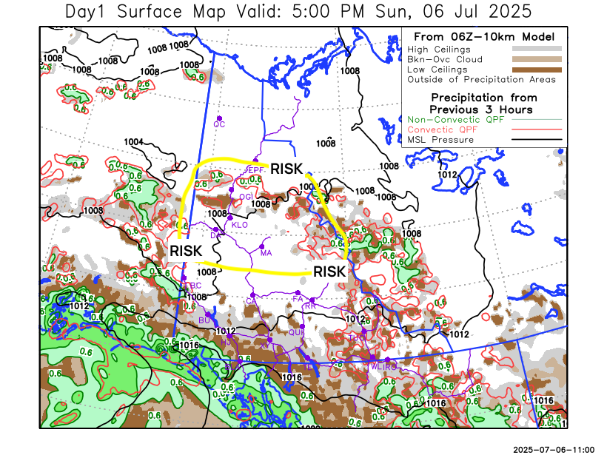
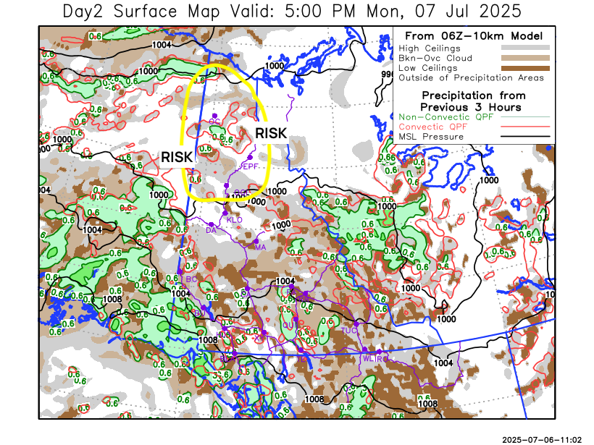
Forecast for | Monday | (Peak burning period and overnight)
Community | Clouds | Pcpn | POP | POL | Max Temp | Min RH | Min Temp | Max  RH | Wind Dir | Wind Speed
Old Crow | FEW | RW-/TRW- | 40 | 10 | 28 | 25 | 6 | 90 | 0 | 10
Klondike Fc | SCT | RW- | 30 | 0 | 25 | 30 | 11 | 85 | 160 | 15
Mayo A | SCT | RW- | 30 | 0 | 23 | 30 | 13 | 85 | 180 | 15
Carmacks | BKN | RW- | 50 | 0 | 23 | 30 | 8 | 90 | 160 | 20G30
Faro | BKN | RW- | 60 | 0 | 20 | 35 | 7 | 95 | 220 | 15
Ross River | BKN | RW- | 60 | 0 | 21 | 35 | 5 | 95 | 180 | 15
Beaver Creek Town | BKN | RW- | 40 | 0 | 21 | 30 | 5 | 90 | 270 | 10
Burwash A | BKN | RW- | 50 | 0 | 17 | 50 | 5 | 85 | 140 | 30G50
Haines Junction | BKN | RW- | 40 | 0 | 18 | 50 | 4 | 95 | 270 | 20G30
Whitehorse Auto | BKN | RW- | 50 | 0 | 17 | 45 | 7 | 90 | 180 | 25G35
Teslin | BKN | RW- | 60 | 0 | 17 | 50 | 7 | 95 | 220 | 15
Watson Lake | BKN | RW- | 50 | 0 | 19 | 45 | 9 | 95 | 220 | 15

Forecast for |  |  | Tuesday |  |  | (Peak burning period and overnight)
Community |  |  | Clouds |  |  | Pcpn | POP |  | POL |  | Max Temp |  | Min RH | Min Temp | Max  RH | Wind Dir | Wind Speed
Old Crow |  |  | OVC |  |  | R- | 70 |  | 0 |  | 15 |  | 55 | 0 | 95 | 20 | 25
Klondike Fc |  |  | BKN |  |  | RW- | 50 |  | 0 |  | 24 |  | 30 | 12 | 95 | 270 | 20
Mayo A |  |  | SCT |  |  | RW- | 50 |  | 0 |  | 23 |  | 30 | 13 | 90 | 250 | 20
Carmacks |  |  | SCT |  |  |  | 20 |  | 0 |  | 23 |  | 30 | 10 | 85 | 270 | 15
Faro |  |  | BKN |  |  | RW- | 50 |  | 0 |  | 18 |  | 50 | 7 | 95 | 250 | 20
Ross River |  |  | BKN |  |  | RW- | 50 |  | 0 |  | 18 |  | 50 | 6 | 95 | 270 | 20
Beaver Creek Town |  |  | SCT |  |  |  | 20 |  | 0 |  | 21 |  | 40 | 6 | 85 | 290 | 20
Burwash A |  |  | BKN |  |  |  | 20 |  | 0 |  | 17 |  | 45 | 8 | 80 | 290 | 20
Haines Junction |  |  | BKN |  |  |  | 20 |  | 0 |  | 18 |  | 45 | 5 | 95 | 270 | 20G30
Whitehorse Auto |  |  | BKN |  |  | RW- | 30 |  | 0 |  | 17 |  | 35 | 8 | 90 | 250 | 20
Teslin |  |  | OVC |  |  | RW- | 60 |  | 0 |  | 17 |  | 45 | 6 | 95 | 220 | 15
Watson Lake |  |  | OVC |  |  | R- | 70 |  | 0 |  | 16 |  | 50 | 7 | 95 | 250 | 15
3-Day Forecast Precipitation Totals from 13:00 Yesterday
OC | 6.7 |  | FA | 5.1 |  | JAK | 3.2
EPF | 1.5 |  | RR | 4.5 |  | TE | 4.7
ANT | 0.3 |  | BC | 9.7 |  | QUI | 5.1
DA | 0.0 |  | BCT | 9.7 |  | SWI | 7.6
FMI | 0.5 |  | BU | 3.5 |  | FL | 6.5
HEN | 0.2 |  | HJF | 1.2 |  | TUC | 5.6
BAR | 0.6 |  | RAI | 2.3 |  | HAS | 13.4
MA | 1.4 |  | CH | 2.0 |  | TC | 9.0
STW | 1.1 |  | BR | 0.4 |  | WL | 4.4
WIL | 2.9 |  | NU | 1.3 |  | PE | 8.9
XY | 1.8 |  | IRO | 2.8 |  | CA | 1.3
CC | 2.2 |  | ELK | 2.8 |  | DRU | 4.1
ATL | 4.3 |  | NA | NA |  | NA | NA
Scott Kehler Meteorologist

Disclaimer : The information in these forecasts is collected and prepared for internal use by the Government of Yukon. The forecasts are specifically designed to meet the needs of the Wildland Fire Management and may not cover the requirements of other parties. Weather warnings or advisories are not included as part of the forecasts. Wildland Fire Management makes no representation and provides no warranty as to the accuracy of its weather forecasts. Any use the recipient chooses to make of the forecasts will be at its sole risk.

