YUKON WILDLAND FIRE MANAGEMENT WEATHER FORECAST - 9:00 AM ISSUE

14-Jul-2025
YESTERDAY'S VALUES
Community | Max  Temp  (°C) | Diff.  from  Normal | Min Temp  (°C) | Diff. from Normal | Pcpn  (mm) | Min RH | Max RH | L110 | L30
Old Crow | 23.3 | 2.4 | 8.3 | -0.6 | 0.0 | 33 | 88 | 0 | 0
Fort Mcpherson Airport | 24.9 |  | 12.3 |  | 0.0 | 31 | 81 | 0 | 0
Rock River Climate | 21.2M |  | 11.9M |  | 0.0M | 31M | 64M | NA | NA
Eagle Plains Fire | 24.1 |  | 16.2 |  | 0.0 | 26 | 49 | 0 | 0
Antimony Creek | 27.1 |  | 11.3 |  | 0.0 | 19 | 72 | 6 | 0
Klondike Fc | 28 |  | 10 |  | 0.0 | 18 | 93 | 6 | 0
Forty Mile | 26.3 |  | 11.5 |  | 0.0 | 29 | 80 | 6 | 0
Henderson | 24.0 |  | 15.9 |  | 0.0 | 30 | 54 | 6 | 0
Barlow | 25.7 |  | 15.0 |  | 0.0 | 21 | 58 | 6 | 0
Mayo A | 25.4 | 2.5 | 10.2 | 0.6 | 0.0 | 30 | 85 | 0 | 0
Stewart Crossing | 27.0 |  | 13.7 |  | 0.0 | 20 | 60 | 0 | 0
Willow Creek | 26.5 |  | 6.9 |  | 0.0 | 19 | 90 | 0 | 0
Pelly Farm | 27.9 | 5.1 | 8.3 | -0.3 | 0.0 | 23 | 96 | 7 | 0
Carmacks | 27.8 |  | 10.7 |  | 0.0 | 31 | 81 | 24 | 1
Drury Creek | 24.2 |  | 7.9 |  | 0.0 | 39 | 95 | 10 | 0
Faro | 23.2 | 2.1 | 7.9 | -1.3 | 0.0 | 33 | 92 | 10 | 0
Ross River | 25.2 |  | 5.0 |  | 0.3 | 29 | 98 | 3 | 0
Macmillan Pass | 18.0 |  | 5.2 |  | 0.0 | 27 | 76 | 9 | 0
Beaver Creek A | 25.4 | 4.8 | 9.2 | 1.5 | 0.0 | 31 | 82 | 4 | 0
Beaver Creek Town | 26.9 |  | 8.2 |  | 0.0 | 25 | 86 | 4 | 0
Burwash A | 22.4 | 2.9 | 3.3 | -3.2 | 0.0M | 40 | 97 | 6 | 0
Haines Junction | 26.5 | 6.8 | 6.4 | 0.8 | 0.6 | 32 | 97 | 9 | 4
Rainbow | 24.5 |  | 10.9 |  | 0.0 | 34 | 81 | 6 | 1
Champagne | 24.8 |  | 6.8 |  | 0.0 | 32 | 94 | 12 | 0
Braeburn | 25.7 |  | 5.3 |  | 1.6 | 32 | 98 | 25 | 1
Nursery | 25.4 |  | 4.6 |  | 0.0 | 29 | 98 | 5 | 0
Whitehorse Auto | 23.2 | 2.7 | 11.6 | 3.8 | 0.0 | 29 | 68 | 3 | 0
Mount Sima | 21.4 |  | 11.9 |  | 0.0 | 32 | 67 | 3 | 0
Carcross | 23.0M |  | 5.5M |  | 0.0M | 31M | 95M | 0 | 0
Atlin | 20.8 |  | 7.6 |  | 0.0 | 35 | 84 | 0 | 0
Jakes Corner | 23.5 |  | 7.2 |  | 0.0 | 27 | 86 | 1 | 0
Teslin | 22.2 |  | 7.9 |  | 0.0 | 30 | 93 | 1 | 0
Quiet Lake | 25.9 |  | 5.9 |  | 0.3 | 29 | 98 | 3 | 1
Swift River | 22.0 |  | 3.7 |  | 0.0 | 30 | 97 | 0 | 0
Tuchitua | 23.0 |  | 1.4 |  | 4.3 | 35 | 100 | 9 | 1
Hasselburg | 21.8 |  | 6.0 |  | 0.8 | 33 | 98 | 9 | 1
Tom Creek | 22.2 |  | 8.6 |  | 0.0 | 33 | 96 | 8 | 0
Watson Lake | 22.2 | 0.9 | 7.6 | -1.4 | 0.0 | 28 | 90 | 8 | 0
Iron Creek | 23.8M |  | 4.2M |  | 0.3 | 28M | 100M | 9 | 0
Max Temp is the actual maximum temperature in °C from yesterday afternoon or evening.
Min Temp is the actual overnight minimum temperature in °C up until 6:00 AM this morning.
Diff. from Normal is the difference from the 30 year average max or min temperature.
Pcpn is the precipitation in mm since 13:00 yesterday.
Min RH is the minimum observed RH in % from yesterday afternoon or evening.
Max RH is the maximum observed overnight RH in % up until 6:00 AM this morning.
L110 is the actual number of lightning strikes within 110 km and in the Yukon for 24 hours ending at 06:00 AM this morning.
L30 is the actual number of lightning strikes within 30 km and in the Yukon for 24 hours ending at 06:00 AM this morning.
M is missing data. * denotes precipitation at stations that failed to report for at least part of the evening and overnight period.

SYNOPSIS:
Today: Ridging remains in place across the Yukon today, but an approaching shortwave trough will help trigger widespread showers and thunderstorms. The best chance for heavier storms will be in the Klondike and Northern Tutchone regions, though thunder is possible almost everywhere except the southernmost parts of the Kluane and Southern Lakes regions. Significant lightning activity is expected, and locally heavy downpours may accompany the storms. Synoptic winds this afternoon will be 10–20 km/h across most regions, but breezier conditions are likely at Old Crow (see tabular forecast for details). As storms develop, wind speeds and directions will become more erratic, with frequent gusts and sudden shifts. Highs will generally range from the low to upper twenties, with cross-overs possible where readings reach the upper twenties. Tonight, as the shortwave trough pushes into the Yukon, a band of steadier light to moderate rain will move through the southern Klondike, Northern Tutchone, Kluane, and Southern Lakes regions—late tonight into tomorrow morning.

Tuesday: Upper‐level ridging remains in place, but with the shortwave trough moving through, rain and chances of thunderstorms will continue. Rain may persist Tuesday morning across parts of the Kluane, Southern Lakes, Tatchun, and Northern Tutchone regions. Thunderstorms are most likely in these same areas—especially across central and southeastern Yukon (see thunder map below for risk areas). Synoptic winds will increase from the west to northwest at around 20 km/h in most regions; see the tabular forecast for details. Thunderstorm outflows will again produce erratic wind shifts and gusts. Temperatures will trend downward, with highs mostly in the upper teens to low twenties and cross‐over temperatures unlikely.

Wednesday: Weak ridging continues across the Yukon, but another shortwave trough may bring additional rain chances. At present, the central Yukon (Klondike and Northern Tutchone) appears most likely to see rainfall, though details will become clearer over the next few days. Otherwise, temperatures should range from the upper teens to low twenties, with cross-overs unlikely, and winds remaining light.

Thursday: Ridging weakens late in the week, with perhaps only weak ridging persisting over the southern Yukon. A drying trend is expected, with only light showers possible and near normal temperatures mostly in the low twenties.

Friday: Little change for Friday with perhaps some weak ridging but otherwise normal weather. There may be a slight chance of showers or thunderstorms.

Forecast for | Monday | (Peak burning period and overnight)
Community | Clouds | Pcpn | POP | POL | Max Temp | Min RH | Min Temp | Max  RH | Wind Dir | Wind Speed
Old Crow | SCT | TRW-/RW- | 40 | 40 | 26 | 30 | 15 | 90 | 250 | 25G40
Klondike Fc | BKN | TRW/R | 80 | 60 | 27 | 25 | 14 | 95 | 270 | 15
Mayo A | BKN | TRW/RW | 60 | 60 | 26 | 30 | 17 | 95 | 220 | 15
Carmacks | BKN | TRW/RW | 70 | 20 | 29 | 30 | 12 | 95 | 290 | 15
Faro | BKN | TRW-/RW- | 40 | 20 | 26 | 30 | 12 | 90 | 220 | 10
Ross River | BKN | TRW-/RW- | 40 | 20 | 27 | 25 | 10 | 90 | 220 | 10
Beaver Creek Town | BKN | TRW-/R | 80 | 10 | 26 | 25 | 8 | 95 | 290 | 10
Burwash A | BKN | R- | 70 | 0 | 22 | 40 | 10 | 95 | 290 | 10
Haines Junction | SCT | R- | 60 | 0 | 23 | 30 | 9 | 95 | 200 | 15
Whitehorse Auto | SCT | R- | 50 | 0 | 25 | 25 | 12 | 95 | 180 | 15
Teslin | SCT |  | 20 | 0 | 24 | 25 | 12 | 90 | 220 | 15
Watson Lake | SCT |  | 30 | 10 | 25 | 25 | 15 | 90 | 250 | 10
POP is probability of precipitation in %.
POL is probability of lightning in %.

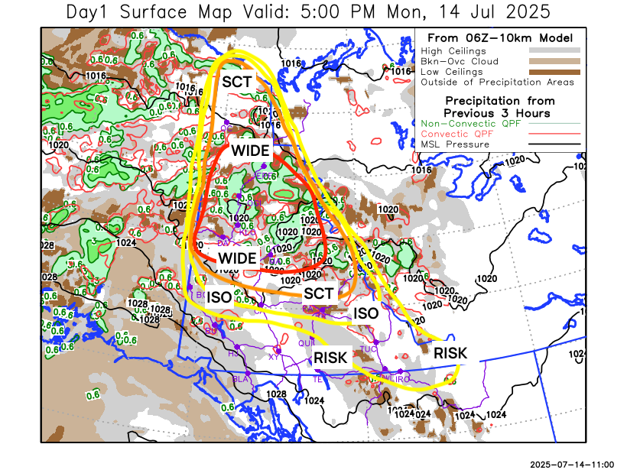
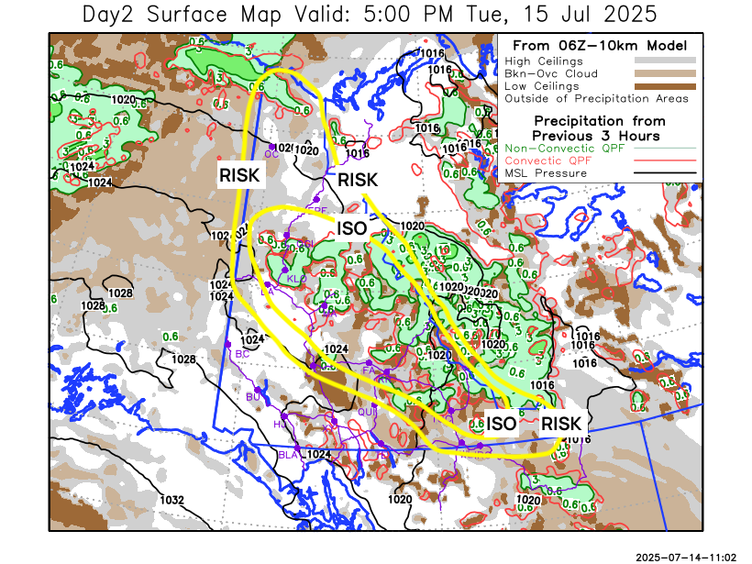

Forecast for | Tuesday | (Peak burning period and overnight)
Community | Clouds | Pcpn | POP | POL | Max Temp | Min RH | Min Temp | Max  RH | Wind Dir | Wind Speed
Old Crow | SCT | TRW-/RW- | 30 | 10 | 22 | 40 | 12 | 90 | 250 | 25G40
Klondike Fc | SCT | TRW-/RW- | 70 | 20 | 23 | 35 | 13 | 95 | 290 | 20
Mayo A | BKN | TRW-/RW- | 80 | 20 | 22 | 40 | 16 | 95 | 290 | 15
Carmacks | SCT | TRW-/RW- | 80 | 10 | 22 | 30 | 12 | 95 | 290 | 20
Faro | BKN | TRW-/RW- | 70 | 20 | 21 | 45 | 10 | 95 | 290 | 20
Ross River | BKN | TRW-/RW- | 70 | 20 | 22 | 45 | 9 | 95 | 290 | 20
Beaver Creek Town | SCT | R- | 80 | 0 | 23 | 30 | 9 | 95 | 320 | 15
Burwash A | SCT | RW- | 50 | 0 | 19 | 45 | 10 | 95 | 320 | 15
Haines Junction | BKN | RW- | 50 | 0 | 22 | 40 | 10 | 95 | 290 | 15
Whitehorse Auto | BKN | R- | 70 | 0 | 20 | 40 | 12 | 95 | 320 | 20
Teslin | BKN | RW- | 40 | 10 | 20 | 45 | 11 | 95 | 290 | 15
Watson Lake | BKN | TRW-/RW- | 50 | 20 | 21 | 40 | 12 | 90 | 290 | 20

Forecast for |  |  | Wednesday |  |  | (Peak burning period and overnight)
Community |  |  | Clouds |  |  | Pcpn | POP |  | POL |  | Max Temp |  | Min RH | Min Temp | Max  RH | Wind Dir | Wind Speed
Old Crow |  |  | SCT |  |  | RW- | 30 |  | 0 |  | 20 |  | 40 | 12 | 85 | 250 | 20
Klondike Fc |  |  | SCT |  |  | R- | 60 |  | 0 |  | 23 |  | 30 | 13 | 95 | Vrb | 10
Mayo A |  |  | BKN |  |  | R- | 60 |  | 0 |  | 22 |  | 40 | 14 | 95 | Vrb | 10
Carmacks |  |  | BKN |  |  | RW- | 50 |  | 0 |  | 25 |  | 30 | 13 | 85 | 340 | 10
Faro |  |  | BKN |  |  | RW- | 50 |  | 10 |  | 22 |  | 45 | 11 | 90 | Vrb | 10
Ross River |  |  | BKN |  |  | RW- | 50 |  | 10 |  | 23 |  | 45 | 10 | 90 | Vrb | 10
Beaver Creek Town |  |  | BKN |  |  | RW- | 50 |  | 0 |  | 24 |  | 30 | 10 | 90 | Vrb | 10
Burwash A |  |  | BKN |  |  | RW- | 50 |  | 0 |  | 22 |  | 40 | 10 | 90 | 320 | 10
Haines Junction |  |  | BKN |  |  | RW- | 50 |  | 0 |  | 21 |  | 35 | 9 | 90 | 270 | 10
Whitehorse Auto |  |  | BKN |  |  | RW- | 50 |  | 0 |  | 22 |  | 30 | 14 | 85 | 320 | 10
Teslin |  |  | SCT |  |  | RW- | 50 |  | 0 |  | 22 |  | 40 | 13 | 85 | 340 | 10
Watson Lake |  |  | SCT |  |  | RW- | 50 |  | 10 |  | 24 |  | 40 | 14 | 85 | 140 | 10
3-Day Forecast Precipitation Totals from 13:00 Yesterday
OC | 0.0 |  | FA | 4.6 |  | JAK | 0.6
EPF | 5.5 |  | RR | 3.8 |  | TE | 0.3
ANT | 4.9 |  | BC | 1.9 |  | QUI | 1.0
DA | 4.8 |  | BCT | 1.9 |  | SWI | 1.0
FMI | 7.9 |  | BU | 5.3 |  | FL | 2.6
HEN | 5.0 |  | HJF | 1.8 |  | TUC | 6.6
BAR | 9.0 |  | RAI | 0.6 |  | HAS | 1.7
MA | 9.0 |  | CH | 1.8 |  | TC | 1.1
STW | 6.8 |  | BR | 10.4 |  | WL | 0.7
WIL | 9.1 |  | NU | 3.4 |  | PE | 7.8
XY | 2.2 |  | IRO | 1.2 |  | CA | 12.0
CC | 0.6 |  | ELK | 3.7 |  | DRU | 6.7
ATL | 0.1 |  | NA | NA |  | NA | NA
Scott Kehler Meteorologist

Disclaimer : The information in these forecasts is collected and prepared for internal use by the Government of Yukon. The forecasts are specifically designed to meet the needs of the Wildland Fire Management and may not cover the requirements of other parties. Weather warnings or advisories are not included as part of the forecasts. Wildland Fire Management makes no representation and provides no warranty as to the accuracy of its weather forecasts. Any use the recipient chooses to make of the forecasts will be at its sole risk.

