YUKON WILDLAND FIRE MANAGEMENT WEATHER FORECAST - 9:00 AM ISSUE

15-Jul-2025
YESTERDAY'S VALUES
Community | Max  Temp  (°C) | Diff.  from  Normal | Min Temp  (°C) | Diff. from Normal | Pcpn  (mm) | Min RH | Max RH | L110 | L30
Old Crow | 24.5 | 3.6 | 13.0 | 4.1 | 0.0 | 37 | 86 | 48 | 1
Fort Mcpherson Airport | 27.3 |  | 15.9 |  | 0.0 | 34 | 68 | 29 | 0
Rock River Climate | 21.5 |  | 10.9 |  | 0.8 | 40 | 92 | NA | NA
Eagle Plains Fire | 23.4 |  | 12.4 |  | 15.9 | 35 | 86 | 139 | 26
Antimony Creek | 27.3 |  | 11.5 |  | 8.6 | 30 | 100 | 330 | 41
Klondike Fc | 29.6 |  | 13.0 |  | 2.1 | 25 | 97 | 313 | 22
Forty Mile | 25.1 |  | 11.5 |  | 4.0 | 36 | 99 | 133 | 11
Henderson | 23.4 |  | 9.0 |  | 6.7 | 38 | 98 | 307 | 10
Barlow | 25.0 |  | 10.6 |  | 9.9 | 36 | 100 | 369 | 69
Mayo A | 25.0 | 2.1 | 12.2 | 2.6 | 1.0 | 35 | 94 | 516 | 1
Stewart Crossing | 24.1 |  | 12.2 |  | 6.5 | 39 | 99 | 345 | 2
Willow Creek | 27.0 |  | 10.9 |  | 0.6 | 30 | 97 | 371 | 29
Pelly Farm | 25.6 | 2.8 | 11.6 | 3.0 | 0.9 | 39 | 97 | 456 | 25
Carmacks | 29.6 |  | 12.0 |  | 1.1 | 23 | 98 | 152 | 2
Drury Creek | 27.0 |  | 13.6 |  | 0.0 | 27 | 79 | 82 | 0
Faro | 26.7 | 5.6 | 13.2 | 4.0 | 0.0 | 23 | 73 | 154 | 3
Ross River | 28.8 |  | 9.7 |  | 0.0 | 23 | 93 | 255 | 10
Macmillan Pass | 19.6 |  | 5.7 |  | 0.4 | 42 | 99 | 288 | 45
Beaver Creek A | 22.9 | 2.3 | 9.8 | 2.1 | 0.3 | 40 | 75 | 155 | 3
Beaver Creek Town | 24.0 |  | 11.4 |  | 0.0 | 32 | 72 | 154 | 3
Burwash A | 21.4 | 1.9 | 9.8 | 3.3 | 1.2M | 42 | 97 | 134 | 1
Haines Junction | 22.7 | 3.3 | 8.4 | 2.9 | 0.0 | 38 | 93 | 8 | 0
Rainbow | 23.4 |  | 9.0 |  | 0.0 | 34 | 89 | 1 | 0
Champagne | 24.8 |  | 11.1 |  | 0.0 | 26 | 64 | 0 | 0
Braeburn | 27.4 |  | 11.4 |  | 0.0 | 24 | 85 | 30 | 0
Nursery | 28.1 |  | 13.1 |  | 0.0 | 25 | 65 | 0 | 0
Whitehorse Auto | 25.4 | 4.8 | 11.2 | 3.4 | 0.0 | 26 | 69 | 0 | 0
Mount Sima | 22.1 |  | 11.0 |  | 0.0 | 31 | 59 | 0 | 0
Carcross | 24.4 |  | 9.2 |  | 0.0 | 30 | 83 | 0 | 0
Atlin | 24.1 |  | 11.6 |  | 0.0 | 25 | 65 | 0 | 0
Jakes Corner | 26.7 |  | 9.5 |  | 0.0 | 25 | 77 | 0 | 0
Teslin | 25.1 |  | 10.3 |  | 0.0 | 25 | 73 | 0 | 0
Quiet Lake | 27.7 |  | 9.2 |  | 0.0 | 25 | 82 | 1 | 0
Swift River | 25.4 |  | 8.1 |  | 0.0 | 26 | 85 | 3 | 0
Tuchitua | 26.7 |  | 7.5 |  | 0.0 | 30 | 99 | 39 | 0
Hasselburg | 25.1 |  | 9.5 |  | 0.0 | 33 | 86 | 6 | 3
Tom Creek | 25.8 |  | 12.5 |  | 0.0 | 27 | 69 | 4 | 0
Watson Lake | 25.7 | 4.4 | 13.0 | 3.9 | 0.0 | 26 | 76 | 4 | 0
Iron Creek | 27.2 |  | 9.3 |  | 0.0 | 22 | 99 | 0 | 0
Max Temp is the actual maximum temperature in °C from yesterday afternoon or evening.
Min Temp is the actual overnight minimum temperature in °C up until 6:00 AM this morning.
Diff. from Normal is the difference from the 30 year average max or min temperature.
Pcpn is the precipitation in mm since 13:00 yesterday.
Min RH is the minimum observed RH in % from yesterday afternoon or evening.
Max RH is the maximum observed overnight RH in % up until 6:00 AM this morning.
L110 is the actual number of lightning strikes within 110 km and in the Yukon for 24 hours ending at 06:00 AM this morning.
L30 is the actual number of lightning strikes within 30 km and in the Yukon for 24 hours ending at 06:00 AM this morning.
M is missing data. * denotes precipitation at stations that failed to report for at least part of the evening and overnight period.

SYNOPSIS:
Today: A weak upper-level disturbance will continue to round the ridge today, bringing unsettled conditions with scattered to broken cloud cover to a large area of the Territory. Light rain in place this morning across parts of Northern Tutchone and the southern Klondike. Isolated to scattered showers develop across most of the Yukon by this afternoon/evening, except in the Old Crow and Beaver Creek districts where drier conditions will prevail. Slight risk of thundershowers across the eastern half of the Yukon and into central regions of the Territory. Synoptic winds become moderate west to northwest at around 15-20 km/h in most regions, except gustier in Old Crow. Temperatures trend downward, with highs mostly in the low twenties and crossovers unlikely as RHs generally remain above 30%.

Wednesday: Weak ridging in place across the Yukon, but another shortwave trough rounding the ridge may bring additional scattered shower chances, particularly to Northern Tutchone, Tatchun, and Tintina. Scattered to broken cloud cover across the Territory. Temperatures in the low to mid-twenties throughout the Yukon with RHs generally 30% or higher through most regions, except in the Haines Junction district where RHs may drop into the 20-30%.

Thursday: Ridging weakens late in the week, with perhaps only weak ridging persisting over the southern Klondike and Kluane region. As a result of the ridge weakening, scattered convective showers possible late in the day through most regions under partly cloudy to broken skies. Highs in the low to mid-twenties with RHs in the 30-40% range across most of the Territory.

Friday: Ridging rebuilds across the southern half of the Yukon, resulting in drier conditions and temperatures in the mid to upper twenties. Central Yukon will find itself located on the fringe of the ridge again, with highs in the mid-twenties with a slight risk of convective showers/thundershowers. Cooler in the northern Territory and more unsettled with chance of rain in Old Crow.

Saturday: The ridge weakens, leading to increased cloud cover across the southern half of the Yukon and a slight cooling trend. Increased cloud cover also expected across central Yukon, with a risk of showers and highs in the low to mid-twenties. Old Crow district remains cool and unsettled.

Forecast for | Tuesday | (Peak burning period and overnight)
Community | Clouds | Pcpn | POP | POL | Max Temp | Min RH | Min Temp | Max  RH | Wind Dir | Wind Speed
Old Crow | BKN |  | 10 |  | 22 | 42 | 11 | 80 | 240 | 25G40
Klondike Fc | BKN | R-/TRW- | 60 | RISK | 21 | 50 | 13 | 81 | 290 | 15
Mayo A | OVC | R-/TRW- | 70 | RISK | 21 | 60 | 16 | 89 | 270 | 15
Carmacks | BKN | RW- | 30 |  | 22 | 45 | 13 | 76 | 290 | 15
Faro | BKN | RW-/TRW- | 40 | RISK | 21 | 50 | 10 | 91 | 290 | 15
Ross River | BKN | RW-/TRW- | 40 | RISK | 22 | 47 | 9 | 85 | 290 | 15
Beaver Creek Town | BKN |  | 0 |  | 22 | 38 | 10 | 63 | 320 | 13
Burwash A | BKN | RW- | 20 |  | 20 | 48 | 11 | 77 | 320 | 12
Haines Junction | BKN | RW- | 30 |  | 23 | 30 | 10 | 80 | 290 | 8
Whitehorse Auto | BKN | RW- | 40 |  | 20 | 50 | 12 | 81 | 300 | 13
Teslin | BKN | RW-/TRW- | 30 | RISK | 20 | 43 | 12 | 80 | 290 | 15
Watson Lake | BKN | RW-/TRW- | 20 | RISK | 22 | 35 | 13 | 79 | 290 | 14
POP is probability of precipitation in %.
POL is probability of lightning in %.

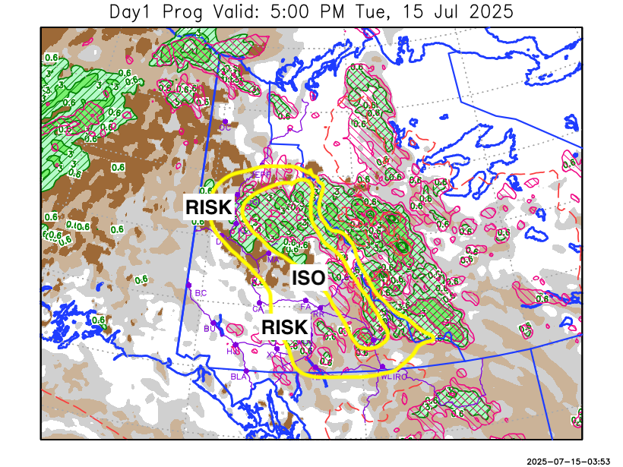
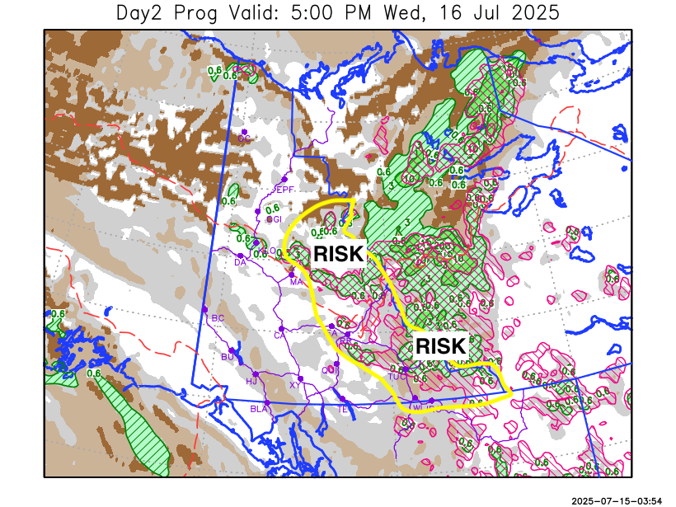

Forecast for | Wednesday | (Peak burning period and overnight)
Community | Clouds | Pcpn | POP | POL | Max Temp | Min RH | Min Temp | Max  RH | Wind Dir | Wind Speed
Old Crow | BKN |  | 0 |  | 19 | 46 | 11 | 75 | 250 | 12
Klondike Fc | BKN | RW- | 20 |  | 23 | 40 | 13 | 74 | 290 | 6
Mayo A | BKN | RW- | 20 |  | 23 | 47 | 14 | 83 | 40 | 3
Carmacks | BKN |  | 0 |  | 24 | 35 | 14 | 72 | 320 | 7
Faro | BKN | RW-/TRW- | 20 | RISK | 22 | 46 | 10 | 80 | 290 | 11
Ross River | BKN | RW-/TRW- | 20 | RISK | 24 | 40 | 9 | 81 | 290 | 10
Beaver Creek Town | BKN |  | 0 |  | 23 | 35 | 10 | 67 | 90 | 10
Burwash A | BKN |  | 0 |  | 21 | 42 | 10 | 73 | 110 | 10
Haines Junction | BKN |  | 0 |  | 24 | 26 | 8 | 85 | 200 | 12
Whitehorse Auto | BKN |  | 0 |  | 23 | 37 | 13 | 72 | 340 | 8
Teslin | BKN |  | 0 |  | 23 | 38 | 13 | 75 | 250 | 8
Watson Lake | BKN | RW-/TRW- | 30 | RISK | 24 | 37 | 13 | 82 | 270 | 11

Forecast for |  |  | Thursday |  |  | (Peak burning period and overnight)
Community |  |  | Clouds |  |  | Pcpn |  | POP |  | POL |  | Max Temp |  | Min RH | Min Temp | Max  RH | Wind Dir | Wind Speed
Old Crow |  |  | BKN |  |  | RW- |  | 20 |  |  |  | 21 |  | 46 | 11 | 83 | 70 | 10
Klondike Fc |  |  | BKN |  |  | RW-/TRW- |  | 30 |  | RISK |  | 25 |  | 39 | 14 | 81 | 320 | 10
Mayo A |  |  | BKN |  |  | RW-/TRW- |  | 30 |  | RISK |  | 24 |  | 41 | 15 | 81 | 0 | 6
Carmacks |  |  | BKN |  |  | RW- |  | 20 |  |  |  | 25 |  | 36 | 14 | 78 | 20 | 7
Faro |  |  | BKN |  |  | RW-/TRW- |  | 30 |  | RISK |  | 22 |  | 43 | 11 | 85 | 320 | 10
Ross River |  |  | BKN |  |  | RW-/TRW- |  | 30 |  | RISK |  | 24 |  | 38 | 10 | 83 | 290 | 10
Beaver Creek Town |  |  | BKN |  |  | RW- |  | 20 |  |  |  | 24 |  | 40 | 10 | 79 | 290 | 12
Burwash A |  |  | BKN |  |  | RW- |  | 20 |  |  |  | 20 |  | 48 | 11 | 85 | 0 | 11
Haines Junction |  |  | BKN |  |  | RW- |  | 20 |  |  |  | 22 |  | 32 | 9 | 88 | 200 | 14
Whitehorse Auto |  |  | BKN |  |  | RW- |  | 20 |  |  |  | 21 |  | 44 | 12 | 83 | 270 | 10
Teslin |  |  | BKN |  |  |  |  | 10 |  |  |  | 22 |  | 39 | 12 | 80 | 250 | 8
Watson Lake |  |  | BKN |  |  | RW-/TRW- |  | 20 |  | RISK |  | 24 |  | 34 | 15 | 76 | 220 | 10
3-Day Forecast Precipitation Totals from 13:00 Yesterday
OC | 0.0 |  | FA | 3.6 |  |  | JAK | 0.5
EPF | 16.7 |  | RR | 2.1 |  |  | TE | 0.1
ANT | 9.8 |  | BC | 0.3 |  |  | QUI | 0.8
DA | 2.8 |  | BCT | 0.0 |  |  | SWI | 1.5
FMI | 6.2 |  | BU | 1.6 |  |  | FL | 5.0
HEN | 7.5 |  | HJF | 0.7 |  |  | TUC | 3.9
BAR | 12.4 |  | RAI | 0.6 |  |  | HAS | 2.2
MA | 5.7 |  | CH | 1.2 |  |  | TC | 0.4
STW | 8.6 |  | BR | 2.1 |  |  | WL | 0.3
WIL | 1.6 |  | NU | 1.6 |  |  | PE | 1.0
XY | 1.2 |  | IRO | 1.8 |  |  | CA | 1.5
CC | 0.6 |  | ELK | 4.2 |  |  | DRU | 5.5
ATL | 0.1 |  | NA | NA |  |  | NA | NA
Matt Desorcy Meteorologist

Disclaimer : The information in these forecasts is collected and prepared for internal use by the Government of Yukon. The forecasts are specifically designed to meet the needs of the Wildland Fire Management and may not cover the requirements of other parties. Weather warnings or advisories are not included as part of the forecasts. Wildland Fire Management makes no representation and provides no warranty as to the accuracy of its weather forecasts. Any use the recipient chooses to make of the forecasts will be at its sole risk.

