YUKON WILDLAND FIRE MANAGEMENT WEATHER FORECAST - 9:00 AM ISSUE

16-Jul-2025
YESTERDAY'S VALUES
Community | Max  Temp  (°C) | Diff.  from  Normal | Min Temp  (°C) | Diff. from Normal | Pcpn  (mm) | Min RH | Max RH | L110 | L30
Old Crow | 20.4 | -0.5 | 11.4 | 2.5 | 0.2 | 40 | 86 | 0 | 0
Fort Mcpherson Airport | 26.3 |  | 15.5 |  | 0.0M | 32 | 59 | 0 | 0
Rock River Climate | 17.9 |  | 7.9 |  | 0.0 | 51 | 90 | NA | NA
Eagle Plains Fire | 19.1 |  | 8.7 |  | 0.0 | 47 | 90 | 0 | 0
Antimony Creek | 21.0 |  | 11.2 |  | 0.0 | 45 | 85 | 0 | 0
Klondike Fc | 22.4 |  | 12.7 |  | 0.3 | 41 | 87 | 0 | 0
Forty Mile | 19.6 |  | 8.3 |  | 0.0 | 45 | 97 | 0 | 0
Henderson | 17.1 |  | 9.6 |  | 0.3 | 56 | 81 | 0 | 0
Barlow | 19.2 |  | 10.0 |  | 0.0 | 53 | 85 | 0 | 0
Mayo A | 18.1 | -4.8 | 12.4 | 2.8 | 0.8 | 69 | 96 | 0 | 0
Stewart Crossing | 19.6 |  | 13.1 |  | 0.0 | 59 | 80 | 0 | 0
Willow Creek | 18.2 |  | 9.8 |  | 0.0 | 57 | 94 | 0 | 0
Pelly Farm | 21.2 | -1.6 | 12.0 | 3.4 | 0.0 | 44 | 86 | 0 | 0
Carmacks | 21.8 |  | 12.5 |  | 0.0 | 43 | 81 | 1 | 0
Drury Creek | 22.4 |  | 10.7 |  | 0.0 | 39 | 93 | 0 | 0
Faro | 19.5 | -1.6 | 12.9 | 3.7 | 0.0 | 41 | 75 | 6 | 0
Ross River | 22.4 |  | 8.4 |  | 0.0 | 35 | 93 | 23 | 0
Macmillan Pass | 16.5 |  | 8.0 |  | 0.6 | 57 | 99 | 20 | 0
Beaver Creek A | 19.9 | -0.7 | 9.5 | 1.7 | 0.0 | 41 | 73 | 0 | 0
Beaver Creek Town | 20.9 |  | 10.6 |  | 0.0 | 35 | 70 | 0 | 0
Burwash A | 20.2 | 0.7 | 10.9 | 4.4 | 0.0M | 38 | 76 | 1 | 0
Haines Junction | 23.5 | 4.1 | 9.2 | 4.4 | 0.0 | 38 | 82 | 5 | 0
Rainbow | 22.1 |  | 8.2 |  | 0.0 | 39 | 90 | 5 | 1
Champagne | 21.3 |  | 6.4 |  | 6.4 | 41 | 100 | 6 | 3
Braeburn | 21.3 |  | 9.4 |  | 1.1 | 40 | 95 | 6 | 1
Nursery | 22.1 |  | 6.6 |  | 0.8 | 44 | 99 | 6 | 0
Whitehorse Auto | 19.7 | -0.9 | 8.8 | 0.9 | 0.6 | 43 | 98 | 5 | 0
Mount Sima | 15.0 |  | 10.9 |  | 0.0 | 46 | 76 | 5 | 0
Carcross | 20.2 |  | 6.8 |  | 0.0 | 44 | 95 | 0 | 0
Atlin | 19.8 |  | 6.8 |  | 1.2 | 48 | 97 | 0 | 0
Jakes Corner | 19.8 |  | 6.7 |  | 1.6 | 42 | 98 | 0 | 0
Teslin | 15.7 |  | 7.1 |  | 0.2 | 56 | 98 | 2 | 0
Quiet Lake | 21.3 |  | 9.0 |  | 0.0 | 40 | 87 | 4 | 0
Swift River | 20.2 |  | 5.0 |  | 0.3 | 41 | 99 | 11 | 0
Tuchitua | 25.9 |  | 5.6 |  | 0.0 | 26 | 100 | 141 | 13
Hasselburg | 24.3 |  | 10.0 |  | 0.0 | 28 | 86 | 80 | 19
Tom Creek | 24.0 |  | 8.7 |  | 0.0 | 28 | 93 | 57 | 3
Watson Lake | 24.1 | 2.8 | 7.7 | -1.4 | 0.0 | 27 | 91 | 30 | 3
Iron Creek | 25.7 |  | 5.0 |  | 0.0 | 26 | 99 | 12 | 0
Max Temp is the actual maximum temperature in °C from yesterday afternoon or evening.
Min Temp is the actual overnight minimum temperature in °C up until 6:00 AM this morning.
Diff. from Normal is the difference from the 30 year average max or min temperature.
Pcpn is the precipitation in mm since 13:00 yesterday.
Min RH is the minimum observed RH in % from yesterday afternoon or evening.
Max RH is the maximum observed overnight RH in % up until 6:00 AM this morning.
L110 is the actual number of lightning strikes within 110 km and in the Yukon for 24 hours ending at 06:00 AM this morning.
L30 is the actual number of lightning strikes within 30 km and in the Yukon for 24 hours ending at 06:00 AM this morning.
M is missing data. * denotes precipitation at stations that failed to report for at least part of the evening and overnight period.

SYNOPSIS:
Today: Weak ridging in place across the Yukon, but a shortwave trough rounding the ridge may bring additional scattered convective shower/thundershower chances to Northern Tutchone, eastern Tatchun, and Tintina. A mix of sun and cloud cover across most of the Territory, except broken skies in Tintina. Temperatures in the low to mid-twenties throughout the Yukon with min RHs generally 25-35% through most regions. Winds light and variable in direction.

Thursday: Ridging weakens slightly, with perhaps only weak ridging persisting over the southern Klondike and Kluane regions. As a result of the ridge weakening, isolated convective showers/thundershowers possible late in the day through most regions under partly cloudy to broken skies. Highs in the low to mid-twenties with minimum RHs in the 25-35% range across most of the Territory, driest in the Haines Junction district. Winds light and variable in direction except moderate NE in Old Crow.

Friday: Ridging rebuilds across the southern half of the Yukon, resulting in drier conditions and temperatures in the mid to upper twenties. Central Yukon will find itself located on the fringe of the ridge, with highs in the mid-twenties with a slight risk of convective showers/thundershowers, particularly in the southern Klondike and Beaver Creek district. Cooler in the northern Territory and more unsettled with chance of rain in Old Crow. Winds remain light and variable, except moderate NE in Old Crow.

Saturday: The ridge breaks down, particularly through central Yukon where showers/light rain has the potential to return to the region, combined with a notable cooling trend. Although there is the potential for more organized rains in central Yukon, uncertainty still exists regarding the placement of these rains. Highs remain warmer in southern Yukon, in the mid-twenties, combined with scattered cloud cover as the ridge hangs on in the south. Cool and unsettled in Old Crow.

Sunday: The disturbance passing through central Yukon moves off and upper-level ridging rebuilds across most of the Territory (except for potentially unsettled conditions in Tintina). This will lead to clearing skies early in the day and drier/warmer conditions for most of the Territory.

Forecast for | Wednesday | (Peak burning period and overnight)
Community | Clouds | Pcpn | POP | POL | Max Temp | Min RH | Min Temp | Max  RH | Wind Dir | Wind Speed
Old Crow | BKN |  | 0 |  | 19 | 45 | 12 | 73 | 220 | 10
Klondike Fc | BKN | RW-/TRW- | 20 | RISK | 24 | 38 | 13 | 75 | 70 | 5
Mayo A | BKN | RW-/TRW- | 30 | RISK | 22 | 43 | 14 | 85 | 40 | 6
Carmacks | BKN |  | 10 |  | 25 | 35 | 14 | 74 | 320 | 5
Faro | BKN | RW-/TRW- | 40 | RISK | 22 | 37 | 10 | 81 | 290 | 10
Ross River | BKN | RW-/TRW- | 40 | RISK | 23 | 37 | 8 | 83 | 290 | 8
Beaver Creek Town | BKN |  | 0 |  | 24 | 34 | 11 | 65 | 110 | 10
Burwash A | BKN |  | 0 |  | 22 | 35 | 11 | 69 | 110 | 8
Haines Junction | BKN |  | 0 |  | 24 | 30 | 9 | 81 | 200 | 15
Whitehorse Auto | BKN |  | 0 |  | 23 | 34 | 14 | 69 | 340 | 7
Teslin | BKN |  | 10 |  | 22 | 36 | 13 | 76 | 320 | 8
Watson Lake | BKN | RW-/TRW- | 30 | RISK | 23 | 37 | 12 | 85 | 290 | 8
POP is probability of precipitation in %.
POL is probability of lightning in %.

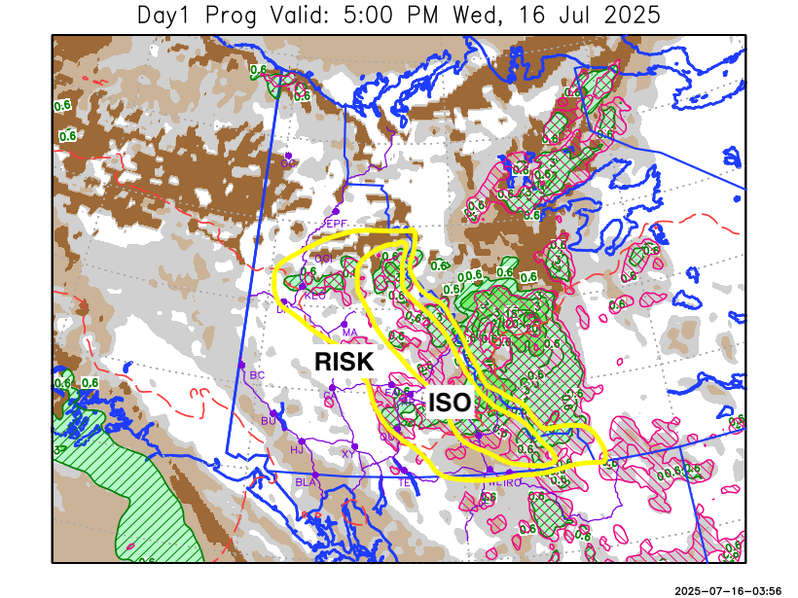
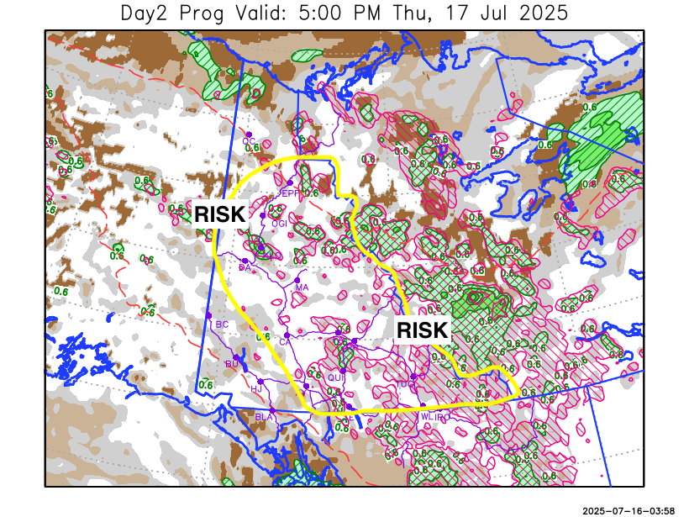

Forecast for | Thursday | (Peak burning period and overnight)
Community | Clouds | Pcpn | POP | POL | Max Temp | Min RH | Min Temp | Max  RH | Wind Dir | Wind Speed
Old Crow | BKN |  | 0 |  | 22 | 40 | 10 | 84 | 20 | 18
Klondike Fc | SCT | RW-/TRW- | 20 | RISK | 25 | 35 | 13 | 84 | 320 | 8
Mayo A | SCT | RW-/TRW- | 20 | RISK | 24 | 38 | 15 | 83 | 320 | 6
Carmacks | SCT | RW-/TRW- | 20 | RISK | 26 | 34 | 13 | 76 | 340 | 8
Faro | SCT | RW-/TRW- | 20 | RISK | 23 | 35 | 11 | 82 | 320 | 8
Ross River | SCT | RW-/TRW- | 20 | RISK | 25 | 35 | 10 | 79 | 290 | 8
Beaver Creek Town | BKN |  | 0 |  | 25 | 34 | 11 | 76 | 320 | 8
Burwash A | BKN | RW- | 20 |  | 20 | 43 | 11 | 83 | 340 | 10
Haines Junction | SCT |  | 0 |  | 25 | 26 | 10 | 84 | 200 | 12
Whitehorse Auto | SCT | RW-/TRW- | 20 | RISK | 23 | 35 | 13 | 77 | 270 | 11
Teslin | SCT | RW-/TRW- | 20 | RISK | 23 | 35 | 13 | 78 | 270 | 6
Watson Lake | SCT | RW-/TRW- | 20 | RISK | 24 | 34 | 14 | 75 | 270 | 6

Forecast for |  |  | Friday |  |  | (Peak burning period and overnight)
Community |  |  | Clouds |  |  | Pcpn |  | POP |  | POL |  | Max Temp |  | Min RH | Min Temp | Max  RH | Wind Dir | Wind Speed
Old Crow |  |  | BKN |  |  | RW-/TRW- |  | 40 |  | RISK |  | 18 |  | 55 | 8 | 85 | 20 | 18
Klondike Fc |  |  | BKN |  |  | RW-/TRW- |  | 40 |  | ISO |  | 27 |  | 35 | 14 | 87 | 40 | 5
Mayo A |  |  | BKN |  |  | RW-/TRW- |  | 20 |  | RISK |  | 25 |  | 38 | 17 | 78 | 40 | 5
Carmacks |  |  | SCT |  |  |  |  | 0 |  |  |  | 28 |  | 30 | 14 | 69 | 160 | 7
Faro |  |  | SCT |  |  | RW-/TRW- |  | 20 |  | RISK |  | 24 |  | 35 | 12 | 74 | 250 | 7
Ross River |  |  | SCT |  |  | RW-/TRW- |  | 20 |  | RISK |  | 26 |  | 34 | 10 | 75 | 220 | 8
Beaver Creek Town |  |  | BKN |  |  | RW-/TRW- |  | 40 |  | ISO |  | 26 |  | 35 | 10 | 83 | 290 | 10
Burwash A |  |  | BKN |  |  | RW- |  | 30 |  |  |  | 23 |  | 34 | 11 | 80 | 140 | 12
Haines Junction |  |  | SCT |  |  |  |  | 0 |  |  |  | 26 |  | 25 | 9 | 84 | 180 | 16
Whitehorse Auto |  |  | SCT |  |  |  |  | 0 |  |  |  | 25 |  | 30 | 13 | 78 | 200 | 10
Teslin |  |  | SCT |  |  |  |  | 0 |  |  |  | 24 |  | 33 | 13 | 77 | 200 | 6
Watson Lake |  |  | SCT |  |  | RW-/TRW- |  | 20 |  | RISK |  | 25 |  | 31 | 14 | 78 | 110 | 7
3-Day Forecast Precipitation Totals from 13:00 Yesterday
OC | 0.2 |  | FA | 1.5 |  |  | JAK | 1.6
EPF | 1.1 |  | RR | 0.8 |  |  | TE | 0.2
ANT | 0.5 |  | BC | 0.0 |  |  | QUI | 0.6
DA | 0.3 |  | BCT | 0.0 |  |  | SWI | 2.1
FMI | 0.1 |  | BU | 0.8 |  |  | FL | 3.0
HEN | 0.3 |  | HJF | 0.0 |  |  | TUC | 1.9
BAR | 0.5 |  | RAI | 0.0 |  |  | HAS | 0.8
MA | 1.5 |  | CH | 6.4 |  |  | TC | 0.8
STW | 0.4 |  | BR | 1.1 |  |  | WL | 0.2
WIL | 0.3 |  | NU | 0.8 |  |  | PE | 0.0
XY | 0.6 |  | IRO | 2.8 |  |  | CA | 0.0
CC | 0.2 |  | ELK | 9.1 |  |  | DRU | 1.6
ATL | 1.2 |  | NA | NA |  |  | NA | NA
Matt Desorcy Meteorologist

Disclaimer : The information in these forecasts is collected and prepared for internal use by the Government of Yukon. The forecasts are specifically designed to meet the needs of the Wildland Fire Management and may not cover the requirements of other parties. Weather warnings or advisories are not included as part of the forecasts. Wildland Fire Management makes no representation and provides no warranty as to the accuracy of its weather forecasts. Any use the recipient chooses to make of the forecasts will be at its sole risk.

