YUKON WILDLAND FIRE MANAGEMENT WEATHER FORECAST - 9:00 AM ISSUE

17-Jul-2025
YESTERDAY'S VALUES
Community | Max  Temp  (°C) | Diff.  from  Normal | Min Temp  (°C) | Diff. from Normal | Pcpn  (mm) | Min RH | Max RH | L110 | L30
Old Crow | 20.0 | -0.8 | 8.0 | -0.8 | 0.0 | 41 | 90 | 0 | 0
Fort Mcpherson Airport | 21.0 |  | 11.4 |  | 0.0 | 43 | 82 | 0 | 0
Rock River Climate | 15.5 |  | 9.7 |  | 0.0 | 49 | 74 | NA | NA
Eagle Plains Fire | 17.5 |  | 9.8 |  | 0.0 | 47 | 76 | 0 | 0
Antimony Creek | 24.2 |  | 4.6 |  | 0.0 | 30 | 98 | 0 | 0
Klondike Fc | 25.4 |  | 7.9 |  | 0.0 | 28 | 89 | 0 | 0
Forty Mile | 22.8 |  | 12.6 |  | 0.0 | 32 | 83 | 0 | 0
Henderson | 19.8 |  | 12.8 |  | 0.0 | 33 | 62 | 0 | 0
Barlow | 21.8 |  | 11.9 |  | 0.0 | 35 | 72 | 0 | 0
Mayo A | 21.3 | -1.6 | 9.9 | 0.3 | 0.0 | 43 | 91 | 0 | 0
Stewart Crossing | 23.3 |  | 10.9 |  | 0.0 | 33 | 90 | 0 | 0
Willow Creek | 22.0 |  | 9.1 |  | 0.0 | 36 | 85 | 0 | 0
Pelly Farm | 24.2 | 1.4 | 9.5 | 0.9 | 0.0 | 34 | 89 | 0 | 0
Carmacks | 24.8 |  | 11.7 |  | 0.0 | 34 | 84 | 0 | 0
Drury Creek | 23.3 |  | 10.7 |  | 1.0 | 32 | 90 | 0 | 0
Faro | 21.8 | 0.7 | 9.6 | 0.4 | 0.2 | 33 | 86 | 12 | 0
Ross River | 23.9 |  | 10.3 |  | 0.0 | 32 | 90 | 49 | 1
Macmillan Pass | 14.5 |  | 5.6 |  | 4.8 | 65 | 100 | 5 | 0
Beaver Creek A | 23.6 | 3.0 | 8.2 | 0.5 | 0.0 | 33 | 78 | 0 | 0
Beaver Creek Town | 24.2 |  | 7.7 |  | 0.0 | 29 | 83 | 0 | 0
Burwash A | 20.3 | 0.8 | 4.4 | -2.1 | 0.0 | 45 | 90 | 0 | 0
Haines Junction | 23.4 | 3.5 | 9.1 | 4.3 | 0.0 | 38 | 72 | 0 | 0
Rainbow | 23.8 |  | 8.5 |  | 0.0 | 36 | 80 | 0 | 0
Champagne | 24.3 |  | 9.6 |  | 0.0 | 26 | 77 | 0 | 0
Braeburn | 22.8 |  | 7.8 |  | 0.0 | 35 | 89 | 0 | 0
Nursery | 23.7 |  | 5.0 |  | 0.0 | 34 | 96 | 1 | 0
Whitehorse Auto | 22.2 | 1.6 | 8.8 | 0.9 | 0.0 | 36 | 78 | 2 | 0
Mount Sima | 19.1 |  | 11.0 |  | 0.3 | 45 | 71 | 2 | 0
Carcross | 24.5 |  | 7.0 |  | 0.0 | 31 | 94 | 1 | 0
Atlin | 23.1 |  | 8.7 |  | 0.2 | 32 | 77 | 0 | 0
Jakes Corner | 24.2 |  | 7.6 |  | 0.0 | 31 | 93 | 2 | 0
Teslin | 21.2 |  | 10.2 |  | 0.0 | 39 | 90 | 2 | 0
Quiet Lake | 21.4 |  | 10.0 |  | 2.6 | 45 | 93 | 4 | 1
Swift River | 20.9 |  | 9.5 |  | 0.0 | 39 | 89 | 7 | 0
Tuchitua | 21.5 |  | 8.3 |  | 1.5 | 46 | 100 | 34 | 0
Hasselburg | 20.9 |  | 9.5 |  | 9.5 | 41 | 99 | 25 | 3
Tom Creek | 21.5 |  | 10.2 |  | 0.0 | 43 | 97 | 48 | 11
Watson Lake | 21.2 | -0.2 | 11.7 | 2.6 | 0.0 | 35 | 85 | 42 | 10
Iron Creek | 25.4 |  | 6.6 |  | 2.6 | 37 | 100 | 51 | 6
Max Temp is the actual maximum temperature in °C from yesterday afternoon or evening.
Min Temp is the actual overnight minimum temperature in °C up until 6:00 AM this morning.
Diff. from Normal is the difference from the 30 year average max or min temperature.
Pcpn is the precipitation in mm since 13:00 yesterday.
Min RH is the minimum observed RH in % from yesterday afternoon or evening.
Max RH is the maximum observed overnight RH in % up until 6:00 AM this morning.
L110 is the actual number of lightning strikes within 110 km and in the Yukon for 24 hours ending at 06:00 AM this morning.
L30 is the actual number of lightning strikes within 30 km and in the Yukon for 24 hours ending at 06:00 AM this morning.
M is missing data. * denotes precipitation at stations that failed to report for at least part of the evening and overnight period.

SYNOPSIS:
Today: Ridging weakens slightly, with perhaps only weak ridging persisting over the southern Klondike and Kluane regions. As a result of the ridge weakening, isolated convective showers/thundershowers possible late in the day through most regions under scattered to broken skies. Highs in the low to mid-twenties with minimum RHs in the 25-35% range across most of the Territory, driest in the Haines Junction district, western Tatchun, and southern Klondike. Winds light and variable in direction except becoming moderate NE in Old Crow by late in the day. Winds may be briefly gusty near any convective cells.

Friday: Ridging rebuilds across the southern half of the Yukon, resulting in temperatures in the mid to upper twenties. Central Yukon will find itself located on the fringe of the ridge, with a risk of convective showers/thundershowers, particularly in the southern Klondike and Beaver Creek district. Slight risk of convective showers/thundershowers in most other regions, though the risk is lower compared to today with the ridging in place. Cooler in the northern Territory with winds remaining moderate NE. Elsewhere, winds generally light and variable.

Saturday: The ridge briefly breaks down through central Yukon where showers/light rain has the potential to return to the region, combined with a cooling trend. Although there is the potential for organized rains in central Yukon in association with a passing upper-wave, uncertainty still exists regarding the placement of these rains. This disturbance and the associated unsettled weather is forecast to slide southeastward by Saturday night, into Northern Tutchone, eastern Tatchun, and Tintina. Highs remain warmer in southern Yukon, in the mid-twenties, combined with scattered cloud cover as the ridge hangs on in the south.

Sunday: Other than bringing lingering shower activity and cloud cover to the Tintina region, the disturbance passing through central Yukon on Saturday moves off by Sunday and upper-level ridging rebuilds across most of the Territory. This will lead to clearing skies by mid-day and drier/warmer conditions for most of the Territory.

Monday: Upper-level ridging remains in place for most of the day, keeping conditions warm. However, by late-day, convective showers and thundershowers are possible in the Klondike and Northern Tutchone regions as an approaching upper-wave begins to break down the ridge across the northern half of the Yukon.

Forecast for | Thursday | (Peak burning period and overnight)
Community | Clouds | Pcpn | POP | POL | Max Temp | Min RH | Min Temp | Max  RH | Wind Dir | Wind Speed
Old Crow | BKN | RW- | 20 |  | 22 | 38 | 10 | 83 | 20 | 15
Klondike Fc | SCT | RW-/TRW- | 20 | RISK | 25 | 30 | 12 | 82 | 340 | 8
Mayo A | BKN | RW-/TRW- | 30 | ISO | 24 | 37 | 16 | 77 | 340 | 7
Carmacks | SCT | RW-/TRW- | 20 | RISK | 26 | 30 | 13 | 74 | 340 | 8
Faro | SCT | RW-/TRW- | 30 | ISO | 23 | 32 | 11 | 80 | 320 | 9
Ross River | SCT | RW-/TRW- | 30 | ISO | 25 | 32 | 10 | 78 | 290 | 8
Beaver Creek Town | SCT |  | 10 |  | 25 | 33 | 11 | 72 | 320 | 9
Burwash A | BKN |  | 10 |  | 20 | 42 | 11 | 83 | 320 | 8
Haines Junction | SCT |  | 10 |  | 25 | 31 | 10 | 85 | 220 | 13
Whitehorse Auto | SCT | RW-/TRW- | 20 | RISK | 23 | 37 | 13 | 80 | 270 | 11
Teslin | SCT | RW-/TRW- | 30 | ISO | 22 | 39 | 12 | 84 | 270 | 6
Watson Lake | SCT | RW-/TRW- | 20 | ISO | 23 | 34 | 13 | 80 | 320 | 5
POP is probability of precipitation in %.
POL is probability of lightning in %.

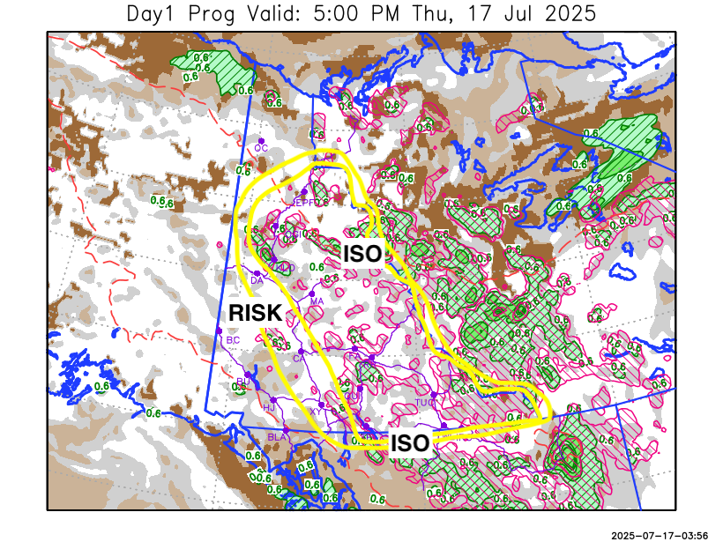
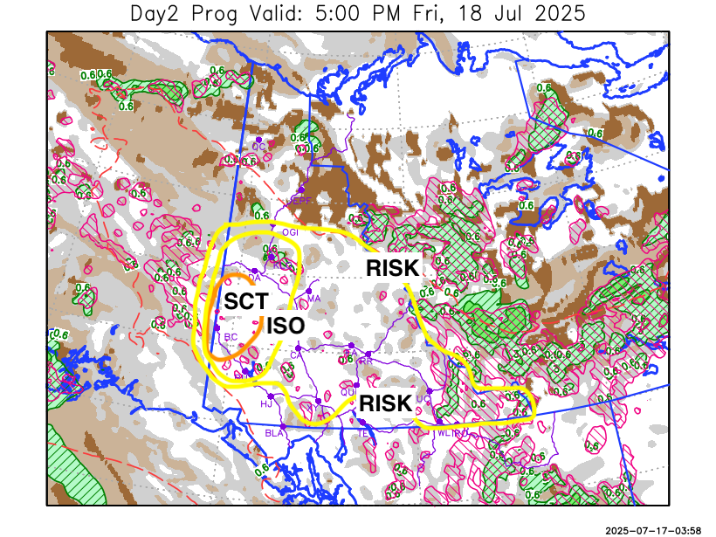

Forecast for | Friday | (Peak burning period and overnight)
Community | Clouds | Pcpn | POP | POL | Max Temp | Min RH | Min Temp | Max  RH | Wind Dir | Wind Speed
Old Crow | BKN | RW- | 20 |  | 19 | 55 | 9 | 83 | 40 | 16
Klondike Fc | BKN | RW-/TRW- | 30 | ISO | 27 | 27 | 15 | 78 | 0 | 6
Mayo A | BKN | RW-/TRW- | 20 | RISK | 25 | 30 | 16 | 77 | 20 | 7
Carmacks | BKN | RW-/TRW- | 20 | RISK | 28 | 28 | 15 | 75 | 20 | 5
Faro | BKN | RW-/TRW- | 20 | RISK | 25 | 30 | 12 | 75 | 290 | 8
Ross River | BKN | RW-/TRW- | 20 | RISK | 26 | 30 | 10 | 74 | 320 | 7
Beaver Creek Town | BKN | RW-/TRW- | 60 | SCT | 27 | 30 | 11 | 87 | 290 | 11
Burwash A | SCT | RW-/TRW- | 30 | ISO | 23 | 35 | 12 | 81 | 110 | 11
Haines Junction | FEW |  | 0 |  | 27 | 28 | 9 | 84 | 200 | 14
Whitehorse Auto | SCT | RW-/TRW- | 20 | RISK | 25 | 34 | 14 | 78 | 220 | 8
Teslin | SCT |  | 10 |  | 24 | 34 | 14 | 79 | 220 | 6
Watson Lake | SCT | RW-/TRW- | 20 | RISK | 25 | 32 | 14 | 80 | 110 | 7

Forecast for |  |  | Saturday |  |  | (Peak burning period and overnight)
Community |  |  | Clouds |  |  | Pcpn |  | POP |  | POL |  | Max Temp |  | Min RH | Min Temp | Max  RH | Wind Dir | Wind Speed
Old Crow |  |  | SCT |  |  |  |  | 0 |  |  |  | 20 |  | 42 | 8 | 77 | 90 | 10
Klondike Fc |  |  | BKN |  |  | R-/TRW- |  | 60 |  | RISK |  | 22 |  | 50 | 12 | 85 | 320 | 7
Mayo A |  |  | BKN |  |  | R-/TRW- |  | 60 |  | RISK |  | 22 |  | 53 | 13 | 82 | 0 | 11
Carmacks |  |  | BKN |  |  | RW-/TRW- |  | 30 |  | ISO |  | 23 |  | 45 | 14 | 86 | 320 | 10
Faro |  |  | BKN |  |  | RW-/TRW- |  | 60 |  | SCT |  | 22 |  | 49 | 11 | 89 | 320 | 8
Ross River |  |  | BKN |  |  | RW-/TRW- |  | 60 |  | SCT |  | 25 |  | 44 | 10 | 87 | 290 | 10
Beaver Creek Town |  |  | BKN |  |  | R- |  | 40 |  |  |  | 24 |  | 40 | 10 | 79 | 320 | 16
Burwash A |  |  | BKN |  |  | R- |  | 40 |  |  |  | 22 |  | 48 | 12 | 82 | 320 | 12
Haines Junction |  |  | BKN |  |  | RW- |  | 20 |  |  |  | 26 |  | 33 | 11 | 81 | 200 | 11
Whitehorse Auto |  |  | BKN |  |  | RW- |  | 20 |  |  |  | 24 |  | 35 | 14 | 78 | 320 | 15
Teslin |  |  | BKN |  |  |  |  | 0 |  |  |  | 24 |  | 34 | 13 | 77 | 250 | 8
Watson Lake |  |  | BKN |  |  | RW-/TRW- |  | 40 |  | ISO |  | 24 |  | 39 | 14 | 82 | 340 | 7
3-Day Forecast Precipitation Totals from 13:00 Yesterday
OC | 1.2 |  | FA | 2.1 |  |  | JAK | 0.1
EPF | 0.0 |  | RR | 1.2 |  |  | TE | 0.0
ANT | 1.1 |  | BC | 4.9 |  |  | QUI | 4.1
DA | 2.0 |  | BCT | 4.9 |  |  | SWI | 3.3
FMI | 2.1 |  | BU | 3.6 |  |  | FL | 1.5
HEN | 2.2 |  | HJF | 0.0 |  |  | TUC | 2.9
BAR | 1.8 |  | RAI | 0.0 |  |  | HAS | 10.3
MA | 0.5 |  | CH | 0.0 |  |  | TC | 0.4
STW | 1.3 |  | BR | 0.7 |  |  | WL | 0.3
WIL | 1.3 |  | NU | 0.0 |  |  | PE | 1.9
XY | 0.0 |  | IRO | 5.5 |  |  | CA | 1.6
CC | 0.3 |  | ELK | 8.2 |  |  | DRU | 4.3
ATL | 0.2 |  | NA | NA |  |  | NA | NA
Matt Desorcy Meteorologist

Disclaimer : The information in these forecasts is collected and prepared for internal use by the Government of Yukon. The forecasts are specifically designed to meet the needs of the Wildland Fire Management and may not cover the requirements of other parties. Weather warnings or advisories are not included as part of the forecasts. Wildland Fire Management makes no representation and provides no warranty as to the accuracy of its weather forecasts. Any use the recipient chooses to make of the forecasts will be at its sole risk.

