YUKON WILDLAND FIRE MANAGEMENT WEATHER FORECAST - 9:00 AM ISSUE

18-Jul-2025
YESTERDAY'S VALUES
Community | Max  Temp  (°C) | Diff.  from  Normal | Min Temp  (°C) | Diff. from Normal | Pcpn  (mm) | Min RH | Max RH | L110 | L30
Old Crow | 22.4 | 1.6 | 11.9 | 3.1 | 0.0 | 36 | 85 | 0 | 0
Fort Mcpherson Airport | 24.1 |  | 12.9 |  | 0.0 | 40 | 87 | 0 | 0
Rock River Climate | 17.3 |  | 9.1 |  | 0.0 | 43 | 96 | - | -
Eagle Plains Fire | 18.7 |  | 10.6 |  | 0.0 | 46 | 89 | 0 | 0
Antimony Creek | 25.9 |  | 6.0 |  | 0.0 | 29 | 98 | 0 | 0
Klondike Fc | 26.3 |  | M |  | 0.0* | 32 | M | 0 | 0
Forty Mile | 23.7 |  | 8.9 |  | 0.0 | 38 | 96 | 0 | 0
Henderson | 23.0 |  | 12.6 |  | 0.0 | 35 | 70 | 0 | 0
Barlow | 24.0 |  | 11.9 |  | 0.0 | 31 | 76 | 0 | 0
Mayo A | 24.2 | 1.3 | 12.5 | 2.9 | 0.0 | 34 | 81 | 0 | 0
Stewart Crossing | 25.5 |  | 12.8 |  | 0.0 | 28 | 82 | 0 | 0
Willow Creek | 24.0 |  | 11.0 |  | 0.5 | 34 | 86 | 0 | 0
Pelly Farm | 25.9 | 3.1 | 11.9 | 3.3 | 0.0 | 33 | 85 | 0 | 0
Carmacks | 27.8 |  | 13.0 |  | 0.0 | 27 | 83 | 0 | 0
Drury Creek | 23.3 |  | 12.2 |  | 0.5 | 37 | 89 | 1 | 0
Faro | 23.0 | 1.9 | 12.2 | 3.0 | 0.0 | 31 | 78 | 1 | 1
Ross River | 24.5 |  | 9.3 |  | 0.6 | 35 | 96 | 1 | 0
Macmillan Pass | 17.4 |  | 6.2 |  | 0.4 | 43 | 92 | 0 | 0
Beaver Creek A | 24.8 | 4.2 | 7.7 | 0.0 | 0.0 | 33 | 86 | 0 | 0
Beaver Creek Town | 25.7 |  | 8.0 |  | 0.0 | 24 | 87 | 0 | 0
Burwash A | 23.4 | 3.9 | 6.3 | -0.2 | 0.2* | 36 | 96 | 0 | 0
Haines Junction | 24.8 | 4.6 | 6.2 | 1.4 | 1.3 | 36 | 97 | 0 | 0
Rainbow | 24.7 |  | 8.4 |  | 0.0 | 33 | 96 | 0 | 0
Champagne | 24.6 |  | 6.1 |  | 0.0 | 31 | 93 | 0 | 0
Braeburn | 26.1 |  | 8.1 |  | 0.0 | 27 | 95 | 1 | 0
Nursery | 27.7 |  | 7.0 |  | 0.3 | 22 | 99 | 1 | 0
Whitehorse Auto | 24.6 | 4.0 | 10.3 | 2.4 | 0.0 | 25 | 82 | 1 | 0
Mount Sima | 22.4 |  | 12.5 |  | 0.0 | 29 | 71 | 1 | 0
Carcross | 22.9 |  | 9.0 |  | 0.0 | 32 | 89 | 0 | 0
Atlin | 23.2 |  | 7.6 |  | 0.0 | 30 | 83 | 0 | 0
Jakes Corner | 25.5 |  | 9.3 |  | 0.0 | 23 | 87 | 1 | 0
Teslin | 23.5 |  | 7.4 |  | 2.4 | 34 | 99 | 3 | 0
Quiet Lake | 26.3 |  | 10.1 |  | 1.5 | 34 | 93 | 2 | 0
Swift River | 24.3 |  | 4.8 |  | 3.9 | 27 | 99 | 13 | 2
Tuchitua | 24.1 |  | 2.1 |  | 0.0 | 34 | 99 | 19 | 0
Hasselburg | 22.1 |  | 8.2 |  | 4.9 | 39 | 94 | 17 | 1
Tom Creek | 21.8 |  | 8.9 |  | 0.3 | 45 | 99 | 46 | 2
Watson Lake | 21.9 | 0.5 | 9.0 | -0.1 | 0.0 | 32 | 88 | 48 | 2
Iron Creek | 23.4 |  | 5.6 |  | 0.0 | 44 | 100 | 81 | 0
Max Temp is the actual maximum temperature in °C from yesterday afternoon or evening.
Min Temp is the actual overnight minimum temperature in °C up until 6:00 AM this morning.
Diff. from Normal is the difference from the 30 year average max or min temperature.
Pcpn is the precipitation in mm since 13:00 yesterday.
Min RH is the minimum observed RH in % from yesterday afternoon or evening.
Max RH is the maximum observed overnight RH in % up until 6:00 AM this morning.
L110 is the actual number of lightning strikes within 110 km and in the Yukon for 24 hours ending at 06:00 AM this morning.
L30 is the actual number of lightning strikes within 30 km and in the Yukon for 24 hours ending at 06:00 AM this morning.
M is missing data. * denotes precipitation at stations that failed to report for at least part of the evening and overnight period.

SYNOPSIS:
Today: Ridging reestablishes itself across the southern half of the Yukon, resulting in temperatures in the mid to upper twenties through central and southern regions. Minimum RHs in the 25-35% range across central and southern Yukon, leading to a slight risk of crossovers. Slight risk of convective showers/thundershowers building in by late afternoon/evening through most regions, with highest POPs in the Beaver Creek district where an isolated lightning risk is in place. Cooler in the Old Crow district with winds remaining moderate NE. Elsewhere, winds generally light and variable.

Saturday: The upper wave that was expected to pass through central Yukon on Saturday is now forecast to pass further east, resulting in somewhat warmer temperatures previously anticipated through central regions, and lower coverage of rainfall. Eastern Tatchun and Tintina are still expected to see the effects of this disturbance however, with scattered showers/thundershowers forecast to develop during the afternoon/evening, becoming light rain in Tintina overnight. Highs in the mid-twenties across the Territory, with min RHs in the upper twenties to low thirties (except higher in the southeast). Synoptic winds light NE in the Klondike and Northern Tutchone, light W-NW for locations further south.

Sunday: Upper-level ridging rebuilds across most of the Territory by Sunday, except for in the Tintina region where conditions will remain more unsettled and cooler. The ridge reestablishing itself in the Yukon will lead to highs in the mid to upper twenties with min RHs in the 25-35% range, except cooler with better moisture in Tintina. Other than in Tintina, mainly sunny to scattered cloud cover expected with only a slight risk of a convective shower/thundershower in Kluane.

Monday: Upper-level ridging remains in place for most of the day, keeping conditions warm. However, by late-day, increasing cloud cover and convective showers/thundershowers are possible in the Klondike and Northern Tutchone regions as an approaching upper-wave begins to break down the ridge across the northern half of the Yukon. Conditions remain warm and dry across southern Yukon with highs in the mid to upper twenties and slight risk of crossovers.

Tuesday: Moderate confidence in a downtrend as the upper-level ridge breaks down. This will result in cooler conditions in the Territory and unsettled weather with risk of showers and increased cloud cover.

Forecast for | Friday | (Peak burning period and overnight)
Community | Clouds | Pcpn | POP | POL | Max Temp | Min RH | Min Temp | Max  RH | Wind Dir | Wind Speed
Old Crow | BKN | RW-/TRW- | 30 | RISK | 19 | 45 | 8 | 83 | 20 | 18
Klondike Fc | BKN | RW-/TRW- | 20 | RISK | 26 | 29 | 15 | 77 | 20 | 7
Mayo A | BKN | RW-/TRW- | 20 | RISK | 25 | 31 | 17 | 71 | 20 | 8
Carmacks | BKN | RW-/TRW- | 20 | RISK | 27 | 27 | 15 | 70 | 0 | 5
Faro | BKN | RW-/TRW- | 30 | RISK | 24 | 30 | 12 | 73 | 320 | 8
Ross River | BKN | RW-/TRW- | 30 | RISK | 26 | 29 | 11 | 73 | 320 | 9
Beaver Creek Town | BKN | RW-/TRW- | 40 | ISO | 26 | 30 | 12 | 84 | 270 | 10
Burwash A | BKN | RW-/TRW- | 20 | RISK | 24 | 33 | 13 | 83 | 110 | 10
Haines Junction | SCT | RW-/TRW- | 20 | RISK | 27 | 28 | 11 | 79 | 200 | 14
Whitehorse Auto | BKN | RW-/TRW- | 30 | RISK | 25 | 30 | 15 | 78 | 340 | 8
Teslin | SCT | RW-/TRW- | 20 | RISK | 24 | 34 | 14 | 76 | 220 | 7
Watson Lake | SCT | RW-/TRW- | 20 | RISK | 24 | 31 | 15 | 76 | 290 | 11
POP is probability of precipitation in %.
POL is probability of lightning in %.

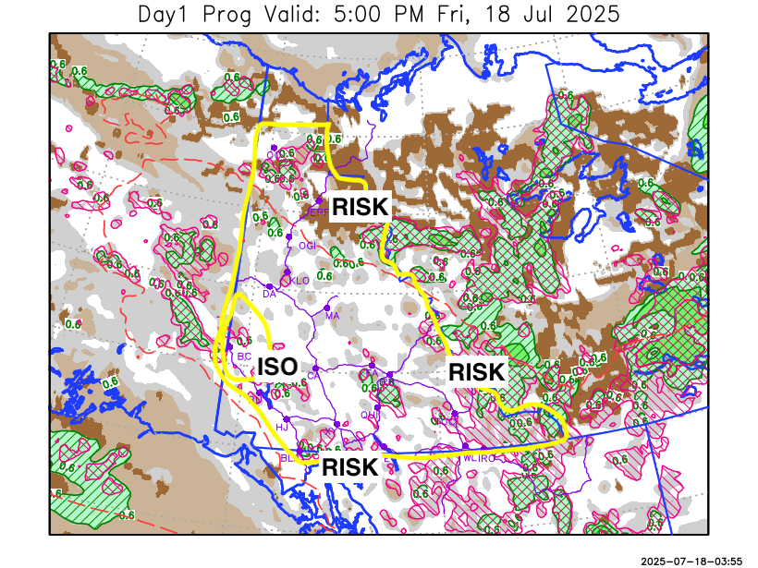
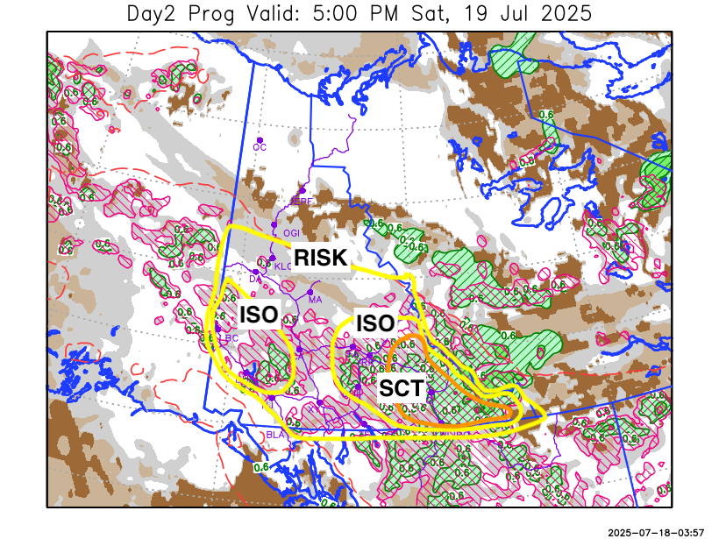

Forecast for | Saturday | (Peak burning period and overnight)
Community | Clouds | Pcpn | POP | POL | Max Temp | Min RH | Min Temp | Max  RH | Wind Dir | Wind Speed
Old Crow | FEW |  | 0 |  | 20 | 36 | 8 | 77 | 90 | 12
Klondike Fc | BKN | RW-/TRW- | 20 | RISK | 26 | 32 | 14 | 76 | 70 | 10
Mayo A | BKN | RW-/TRW- | 20 | RISK | 24 | 34 | 14 | 74 | 20 | 10
Carmacks | BKN | RW-/TRW- | 30 | RISK | 26 | 31 | 15 | 78 | 340 | 10
Faro | BKN | RW-/TRW- | 30 | ISO | 23 | 38 | 11 | 85 | 290 | 11
Ross River | BKN | RW-/TRW- | 30 | ISO | 25 | 35 | 10 | 86 | 320 | 10
Beaver Creek Town | BKN | RW-/TRW- | 30 | ISO | 25 | 35 | 12 | 84 | 290 | 10
Burwash A | BKN | RW-/TRW- | 30 | ISO | 23 | 40 | 13 | 82 | 340 | 10
Haines Junction | BKN | RW-/TRW- | 20 | RISK | 26 | 30 | 12 | 76 | 220 | 11
Whitehorse Auto | BKN | RW-/TRW- | 20 | RISK | 24 | 35 | 15 | 78 | 320 | 14
Teslin | BKN | RW-/TRW- | 20 | RISK | 23 | 37 | 14 | 80 | 270 | 8
Watson Lake | BKN | RW-/TRW- | 60 | SCT | 24 | 40 | 14 | 85 | 270 | 8

Forecast for |  |  | Sunday |  |  | (Peak burning period and overnight)
Community |  |  | Clouds |  |  | Pcpn |  | POP |  | POL |  | Max Temp |  | Min RH | Min Temp | Max  RH | Wind Dir | Wind Speed
Old Crow |  |  | SCT |  |  |  |  | 0 |  |  |  | 23 |  | 30 | 12 | 71 | 140 | 10
Klondike Fc |  |  | BKN |  |  |  |  | 10 |  |  |  | 27 |  | 30 | 15 | 80 | 270 | 7
Mayo A |  |  | SCT |  |  |  |  | 0 |  |  |  | 25 |  | 31 | 15 | 71 | 340 | 7
Carmacks |  |  | SCT |  |  | RW-/TRW- |  | 20 |  | RISK |  | 27 |  | 30 | 15 | 79 | 340 | 10
Faro |  |  | SCT |  |  | RW-/TRW- |  | 20 |  | RISK |  | 24 |  | 32 | 11 | 71 | 320 | 11
Ross River |  |  | SCT |  |  | RW-/TRW- |  | 20 |  | RISK |  | 26 |  | 32 | 9 | 71 | 320 | 10
Beaver Creek Town |  |  | BKN |  |  | RW-/TRW- |  | 20 |  | RISK |  | 26 |  | 36 | 12 | 77 | 320 | 8
Burwash A |  |  | BKN |  |  | RW-/TRW- |  | 20 |  | RISK |  | 24 |  | 40 | 13 | 79 | 0 | 8
Haines Junction |  |  | SCT |  |  |  |  | 10 |  |  |  | 28 |  | 28 | 12 | 76 | 220 | 8
Whitehorse Auto |  |  | SCT |  |  |  |  | 10 |  |  |  | 25 |  | 33 | 15 | 77 | 340 | 13
Teslin |  |  | SCT |  |  |  |  | 10 |  |  |  | 24 |  | 35 | 14 | 80 | 340 | 8
Watson Lake |  |  | BKN |  |  | R-/TRW- |  | 60 |  | ISO |  | 20 |  | 50 | 10 | 87 | 110 | 14
3-Day Forecast Precipitation Totals from 13:00 Yesterday
OC | 0.0 |  | FA | 1.8 |  |  | JAK | 0.1
EPF | 0.0 |  | RR | 1.8 |  |  | TE | 2.4
ANT | 1.6 |  | BC | 5.7 |  |  | QUI | 4.1
DA | 2.6 |  | BCT | 5.7 |  |  | SWI | 6.5
FMI | 0.2 |  | BU | 5.0 |  |  | FL | 4.6
HEN | 3.3 |  | HJF | 1.3 |  |  | TUC | 3.6
BAR | 1.9 |  | RAI | 0.0 |  |  | HAS | 7.0
MA | 0.1 |  | CH | 0.1 |  |  | TC | 4.3
STW | 0.5 |  | BR | 0.9 |  |  | WL | 5.6
WIL | 1.4 |  | NU | 1.6 |  |  | PE | 2.6
XY | 1.3 |  | IRO | 5.4 |  |  | CA | 1.7
CC | 0.3 |  | ELK | 8.6 |  |  | DRU | 3.0
ATL | 0.0 |  | NA | NA |  |  | NA | NA
Matt Desorcy Meteorologist

Disclaimer : The information in these forecasts is collected and prepared for internal use by the Government of Yukon. The forecasts are specifically designed to meet the needs of the Wildland Fire Management and may not cover the requirements of other parties. Weather warnings or advisories are not included as part of the forecasts. Wildland Fire Management makes no representation and provides no warranty as to the accuracy of its weather forecasts. Any use the recipient chooses to make of the forecasts will be at its sole risk.

