YUKON WILDLAND FIRE MANAGEMENT WEATHER FORECAST - 9:00 AM ISSUE

19-Jul-2025
YESTERDAY'S VALUES
Community | Max  Temp  (°C) | Diff.  from  Normal | Min Temp  (°C) | Diff. from Normal | Pcpn  (mm) | Min RH | Max RH | L110 | L30
Old Crow | 18.2 | -2.5 | 8.8 | 0.0 | 0.0 | 56 | 89 | 0 | 0
Fort Mcpherson Airport | 15.2 |  | 9.6 |  | 0.7 | 68 | 87 | 0 | 0
Rock River Climate | 12.1 |  | 7.0 |  | 0.0 | 77 | 95 | - | -
Eagle Plains Fire | 21.1 |  | 7.4 |  | 0.0 | 46 | 93 | 0 | 0
Antimony Creek | 26.7 |  | 7.6 |  | 0.0 | 30 | 97 | 0 | 0
Klondike Fc | 29.6 |  | 9,1 |  | 0.0 | 25 | 96 | 0 | 0
Forty Mile | 26.6 |  | 13.2 |  | 0.0 | 29 | 88 | 0 | 0
Henderson | 24.2 |  | 14.1 |  | 0.0 | 33 | 68 | 0 | 0
Barlow | 25.2 |  | 13.7 |  | 0.0 | 30 | 76 | 0 | 0
Mayo A | 24.8 | 1.9 | 16.9 | 7.4 | 0.5 | 36 | 61 | 0 | 0
Stewart Crossing | 26.6 |  | 15.6 |  | 0.0 | 29 | 70 | 0 | 0
Willow Creek | 27.1 |  | 13.5 |  | 0.0 | 29 | 85 | 0 | 0
Pelly Farm | 28.2 | 5.4 | 13.7 | 5.1 | 3.6 | 27 | 91 | 0 | 0
Carmacks | 26.9 |  | 13.1 |  | 2.5 | 32 | 76 | 0 | 0
Drury Creek | 23.2 |  | 12.8 |  | 0.0 | 41 | 89 | 0 | 0
Faro | 23.4 | 2.3 | 13.2 | 4.0 | 0.0 | 33 | 79 | 0 | 0
Ross River | 25.9 |  | 10.9 |  | 0.0 | 29 | 90 | 0 | 0
Macmillan Pass | 19.3 |  | 7.2 |  | 0.0 | 36 | 92 | 0 | 0
Beaver Creek A | 24.3 | 3.8 | 10.2 | 2.5 | 0.4 | 39 | 93 | 0 | 0
Beaver Creek Town | 27.9 |  | 10.8 |  | 3.3 | 27 | 97 | 0 | 0
Burwash A | 24.1 | 4.6 | 12.5 | 6.0 | 0.0 | 37 | 75 | 0 | 0
Haines Junction | 27.5 | 7.9 | 9.0 | 3.4 | 0.0 | 30 | 82 | 0 | 0
Rainbow | 25.2 |  | 8.1 |  | 0.0 | 36 | 96 | 0 | 0
Champagne | 26.4 |  | 12.1 |  | 0.0 | 27 | 82 | 0 | 0
Braeburn | 25.9 |  | 10.1 |  | 0.0 | 26 | 91 | 0 | 0
Nursery | 26.6 |  | 10.0 |  | 0.0 | 29 | 91 | 0 | 0
Whitehorse Auto | 24.8 | 4.2 | 13.3 | 5.4 | 0.0 | 29 | 70 | 0 | 0
Mount Sima | 23.0 |  | 14.5 |  | 0.0 | 35 | 59 | 0 | 0
Carcross | 26.9 |  | 11.2 |  | 0.0 | 28 | 83 | 0 | 0
Atlin | 25.4 |  | 12.5 |  | 0.0 | 33 | 80 | 0 | 0
Jakes Corner | 25.4 |  | 11.6 |  | 0.0 | 25 | 81 | 0 | 0
Teslin | 25.3 |  | 10.4 |  | 0.0 | 30 | 91 | 0 | 0
Quiet Lake | 26.3 |  | 11.8 |  | 0.0 | 29 | 86 | 0 | 0
Swift River | 25.1 |  | 9.5 |  | 0.0 | 29 | 91 | 0 | 0
Tuchitua | 26.0 |  | 10.3 |  | 0.0 | 30 | 99 | 0 | 0
Hasselburg | 24.1 |  | 11.3 |  | 0.0 | 30 | 87 | 0 | 0
Tom Creek | 25.6 |  | 12.8 |  | 0.0 | 29 | 84 | 0 | 0
Watson Lake | 24.9 | 3.5 | 12.0 | 2.9 | 0.0 | 27 | 78 | 0 | 0
Iron Creek | 26.6 |  | 8.6 |  | 1.8 | 32 | 100 | 0 | 0
Max Temp is the actual maximum temperature in °C from yesterday afternoon or evening.
Min Temp is the actual overnight minimum temperature in °C up until 6:00 AM this morning.
Diff. from Normal is the difference from the 30 year average max or min temperature.
Pcpn is the precipitation in mm since 13:00 yesterday.
Min RH is the minimum observed RH in % from yesterday afternoon or evening.
Max RH is the maximum observed overnight RH in % up until 6:00 AM this morning.
L110 is the actual number of lightning strikes within 110 km and in the Yukon for 24 hours ending at 06:00 AM this morning.
L30 is the actual number of lightning strikes within 30 km and in the Yukon for 24 hours ending at 06:00 AM this morning.
M is missing data. * denotes precipitation at stations that failed to report for at least part of the evening and overnight period.

SYNOPSIS:
Today: Eastern Tatchun and Tintina are expected to see the effects of a disturbance glancing by the region, producing scattered showers/thundershowers during the afternoon and evening, becoming light rain in Tintina overnight. Further west through Southern Lakes, Kluane, western Tatchun, and southern Klondike slight risk of afternoon pop-up showers and thundershowers, though POPs are low under weak upper-level ridging. A mix of sun and cloud expected in Northern Tutchone and northern Yukon. Temperatures in the mid-twenties (with a couple upper twenties) across the Territory, with min RHs in the upper twenties to low thirties. Cooler with higher RHs in Old Crow. Synoptic winds light N-NE in the Klondike and Northern Tutchone, light W-NW for locations further south.

Sunday: Upper-level ridging rebuilds across most of the Territory by Sunday, except for in the Tintina region where conditions will remain more unsettled and cooler. The ridge reestablishing itself in the Yukon will lead to highs in the mid to upper twenties with min RHs in the 25-35% range, except cooler with better moisture in Tintina. Other than in Tintina, mainly sunny to scattered cloud cover expected with only a slight risk of a convective shower/thundershower in Kluane and Southern Lakes. Synoptic winds light E-NE in the Klondike and Northern Tutchone, light W-NW for locations further south.

Monday: Upper-level ridging remains in place for most of the day, keeping conditions warm. However, by late-day, increasing cloud cover and convective showers/thundershowers are possible in the Klondike and Northern Tutchone regions as an approaching upper-wave begins to break down the ridge across the northern half of the Yukon. Conditions remain warm and dry across Tatchun, Kluane, Southern Lakes, with highs in the mid to upper twenties and slight risk of crossovers. Cloud cover and precipitation gradually advances eastwards overnight Monday into Tuesday as the ridge breaks down.

Tuesday: Moderate to high confidence remains in a downtrend as the upper-level ridge breaks down. This will result in cooler conditions throughout the Territory, unsettled weather with risk of showers, and increased cloud cover through all regions of the Yukon.

Wednesday: Troughing remains in place across the Yukon, keeping the pattern cool and unsettled. Highs in the teens to low twenties with cloud cover/risk of showers through most regions. Potential for more organized rainfall, though there is significant uncertainty as to where these will occur.

Forecast for | Saturday | (Peak burning period and overnight)
Community | Clouds | Pcpn | POP | POL | Max Temp | Min RH | Min Temp | Max  RH | Wind Dir | Wind Speed
Old Crow | FEW |  | 0 |  | 20 | 42 | 8 | 77 | 60 | 12
Klondike Fc | BKN | RW-/TRW- | 20 | RISK | 27 | 24 | 15 | 74 | 40 | 7
Mayo A | BKN |  | 0 |  | 24 | 36 | 15 | 69 | 20 | 10
Carmacks | BKN | RW-/TRW- | 20 | RISK | 27 | 31 | 15 | 73 | 340 | 11
Faro | BKN | RW-/TRW- | 40 | ISO | 24 | 34 | 12 | 75 | 320 | 10
Ross River | BKN | RW-/TRW- | 40 | ISO | 25 | 34 | 11 | 73 | 320 | 12
Beaver Creek Town | BKN | RW-/TRW- | 30 | ISO | 26 | 35 | 12 | 82 | 290 | 10
Burwash A | BKN | RW-/TRW- | 30 | ISO | 24 | 37 | 13 | 81 | 320 | 8
Haines Junction | BKN | RW-/TRW- | 20 | ISO | 28 | 28 | 12 | 75 | 220 | 8
Whitehorse Auto | BKN | RW-/TRW- | 30 | ISO | 25 | 32 | 16 | 78 | 320 | 10
Teslin | BKN | RW-/TRW- | 20 | ISO | 25 | 35 | 15 | 78 | 270 | 8
Watson Lake | SCT | RW-/TRW- | 30 | ISO | 25 | 34 | 15 | 79 | 270 | 10
POP is probability of precipitation in %.
POL is probability of lightning in %.

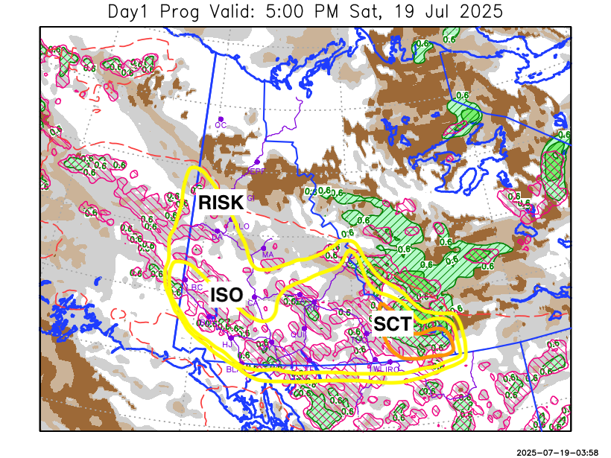
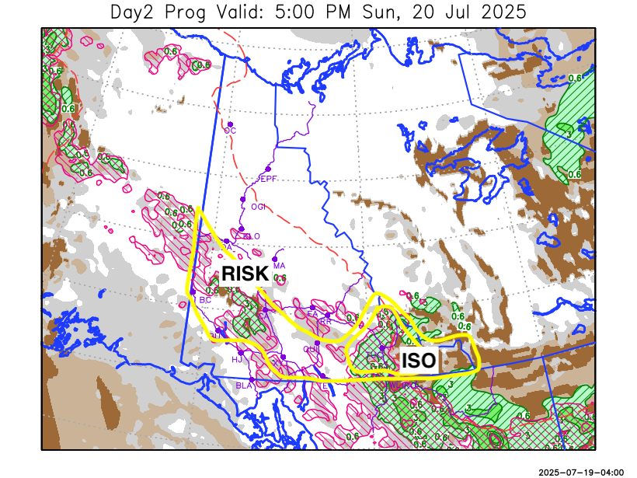

Forecast for | Sunday | (Peak burning period and overnight)
Community | Clouds | Pcpn | POP | POL | Max Temp | Min RH | Min Temp | Max  RH | Wind Dir | Wind Speed
Old Crow | SCT |  | 0 |  | 22 | 31 | 11 | 67 | 130 | 10
Klondike Fc | SCT |  | 10 |  | 28 | 24 | 15 | 75 | 90 | 6
Mayo A | SCT |  | 0 |  | 26 | 31 | 14 | 70 | 40 | 8
Carmacks | BKN | RW-/TRW- | 20 | RISK | 27 | 35 | 14 | 80 | 320 | 8
Faro | SCT |  | 10 |  | 25 | 30 | 11 | 65 | 320 | 12
Ross River | SCT |  | 10 |  | 26 | 30 | 9 | 68 | 320 | 12
Beaver Creek Town | BKN | RW-/TRW- | 20 | RISK | 26 | 36 | 12 | 79 | 290 | 7
Burwash A | BKN | RW-/TRW- | 20 | RISK | 23 | 41 | 13 | 80 | 320 | 9
Haines Junction | SCT |  | 10 |  | 28 | 28 | 13 | 74 | 250 | 7
Whitehorse Auto | SCT | RW-/TRW- | 20 | RISK | 25 | 36 | 16 | 76 | 340 | 13
Teslin | SCT | RW-/TRW- | 20 | RISK | 25 | 36 | 15 | 81 | 320 | 8
Watson Lake | BKN | R-/TRW- | 60 | ISO | 21 | 50 | 11 | 85 | 110 | 15

Forecast for |  |  | Monday |  |  | (Peak burning period and overnight)
Community |  |  | Clouds |  |  | Pcpn |  | POP |  | POL |  | Max Temp |  | Min RH | Min Temp | Max  RH | Wind Dir | Wind Speed
Old Crow |  |  | BKN |  |  | RW-/TRW- |  | 30 |  | RISK |  | 21 |  | 55 | 12 | 84 | 220 | 16
Klondike Fc |  |  | BKN |  |  | RW-/TRW- |  | 60 |  | SCT |  | 23 |  | 56 | 13 | 87 | 290 | 12
Mayo A |  |  | BKN |  |  | RW-/TRW- |  | 30 |  | RISK |  | 26 |  | 40 | 16 | 89 | 290 | 10
Carmacks |  |  | BKN |  |  | RW-/TRW- |  | 30 |  | RISK |  | 28 |  | 35 | 15 | 85 | 320 | 8
Faro |  |  | BKN |  |  | R-/RW- |  | 40 |  |  |  | 25 |  | 30 | 13 | 84 | 290 | 7
Ross River |  |  | BKN |  |  | R-/RW- |  | 40 |  |  |  | 26 |  | 29 | 11 | 81 | 250 | 6
Beaver Creek Town |  |  | BKN |  |  | RW-/TRW- |  | 30 |  | RISK |  | 26 |  | 40 | 11 | 80 | 320 | 15G30
Burwash A |  |  | BKN |  |  | RW- |  | 30 |  |  |  | 25 |  | 38 | 13 | 89 | 340 | 12
Haines Junction |  |  | SCT |  |  |  |  | 0 |  |  |  | 30 |  | 23 | 14 | 74 | 290 | 12
Whitehorse Auto |  |  | BKN |  |  |  |  | 10 |  |  |  | 27 |  | 30 | 16 | 80 | 320 | 10
Teslin |  |  | SCT |  |  |  |  | 10 |  |  |  | 26 |  | 34 | 15 | 79 | 90 | 8
Watson Lake |  |  | BKN |  |  |  |  | 0 |  |  |  | 22 |  | 40 | 13 | 79 | 140 | 10
3-Day Forecast Precipitation Totals from 13:00 Yesterday
OC | 0.5 |  | FA | 1.2 |  |  | JAK | 0.3
EPF | 0.0 |  | RR | 0.1 |  |  | TE | 0.9
ANT | 1.0 |  | BC | 2.7 |  |  | QUI | 2.5
DA | 1.3 |  | BCT | 5.6 |  |  | SWI | 2.9
FMI | 1.8 |  | BU | 3.2 |  |  | FL | 2.7
HEN | 3.2 |  | HJF | 0.3 |  |  | TUC | 5.7
BAR | 0.5 |  | RAI | 0.0 |  |  | HAS | 4.8
MA | 0.5 |  | CH | 0.6 |  |  | TC | 4.7
STW | 0.2 |  | BR | 1.2 |  |  | WL | 4.0
WIL | 0.4 |  | NU | 2.8 |  |  | PE | 5.1
XY | 2.0 |  | IRO | 6.9 |  |  | CA | 3.4
CC | 2.0 |  | ELK | 6.5 |  |  | DRU | 3.4
ATL | 0.3 |  | NA | NA |  |  | NA | NA
Matt Desorcy Meteorologist

Disclaimer : The information in these forecasts is collected and prepared for internal use by the Government of Yukon. The forecasts are specifically designed to meet the needs of the Wildland Fire Management and may not cover the requirements of other parties. Weather warnings or advisories are not included as part of the forecasts. Wildland Fire Management makes no representation and provides no warranty as to the accuracy of its weather forecasts. Any use the recipient chooses to make of the forecasts will be at its sole risk.

