YUKON WILDLAND FIRE MANAGEMENT WEATHER FORECAST - 9:00 AM ISSUE

28-Jul-2025
YESTERDAY'S VALUES
Community | Max  Temp  (°C) | Diff.  from  Normal | Min Temp  (°C) | Diff. from Normal | Pcpn  (mm) | Min RH | Max RH | L110 | L30
Old Crow | 22.2 | 2.2 | 5.7 | -2.5 | 0.0 | 29 | 90 | 0 | 0
Fort Mcpherson Airport | 15.0 |  | 6.1 |  | 0.0 | 57 | 95 | 0 | 0
Rock River Climate | 16.0 |  | 6.6 |  | 0.0 | 46 | 87 | NA | NA
Eagle Plains Fire | 17.7 |  | 7.1 |  | 0.0 | 41 | 90 | 0 | 0
Antimony Creek | 26.8 |  | 5.5 |  | 0.0 | 33 | 98 | 21 | 0
Klondike Fc | 29.3 |  | 9.4 |  | 0.5 | 25 | 94 | 30 | 1
Forty Mile | 26.8 |  | 9.6 |  | 0.0 | 31 | 96 | 35 | 0
Henderson | 23.3 |  | 15.5 |  | 0.0 | 34 | 58 | 53 | 0
Barlow | 25.8 |  | 12.3 |  | 0.0 | 29 | 76 | 7 | 0
Mayo A | 26.1 | 3.7 | 9.7 | 0.6 | 0.0 | 30 | 89 | 0 | 0
Stewart Crossing | 27.4 |  | 12.1 |  | 0.0 | 24 | 79 | 3 | 0
Willow Creek | 26.7 |  | 7.5 |  | 0.0 | 27 | 95 | 8 | 0
Pelly Farm | 27.7 | 5.3 | 7.6 | -0.5 | 0.0 | 26 | 98 | 30 | 0
Carmacks | 27.8 |  | 10.1 |  | 0.0 | 32 | 90 | 27 | 0
Drury Creek | 24.7 |  | 7.4 |  | 0.0 | 33 | 96 | 3 | 0
Faro | 24.3 | 3.6 | 8.1 | -0.6 | 0.0 | 31M | 100M | 2 | 0
Ross River | 25.4 |  | 5.0 |  | 0.0 | 27 | 98 | 0 | 0
Macmillan Pass | 19.9 |  | 6.5 |  | 0.0 | 30 | 88 | 0 | 0
Beaver Creek A | 26.1 | 6.0 | 6.8 | -0.4 | 0.0 | 30 | 92 | 84 | 1
Beaver Creek Town | 27.3 |  | 6.0 |  | 0.0 | 29 | 94 | 84 | 2
Burwash A | 23.6M | 4.3 | 3.9M | -2.4 | 0.0M | 33M | 88M | 55 | 0
Haines Junction | 27.8 | 7.6 | 9.0 | 4.8 | 0.0 | 29 | 89 | 14 | 0
Rainbow | 26.9 |  | 10.4 |  | 0.0 | 30 | 87 | 16 | 0
Champagne | 25.5 |  | 5.4 |  | 0.0 | 27 | 94 | 25 | 0
Braeburn | 26.9 |  | 6.4 |  | 0.3 | 29 | 98 | 26 | 3
Nursery | 25.7 |  | 4.9 |  | 0.0 | 29 | 98 | 23 | 4
Whitehorse Auto | 24.9 | 4.5 | 8.8 | 0.9 | 0.2 | 33 | 87 | 23 | 1
Mount Sima | 21.5 |  | 12.8 |  | 0.0 | 39 | 69 | 23 | 6
Carcross | 23.8 |  | 6.8 |  | 0.0 | 37 | 97 | 14 | 0
Atlin | 23.0 |  | 12.2 |  | 0.0 | 49 | 81 | 5 | 0
Jakes Corner | 25.2 |  | 7.6 |  | 6.3 | 38 | 98 | 13 | 1
Teslin | 23.0 |  | 8.1 |  | 0.0 | 36 | 96 | 3 | 0
Quiet Lake | 26.5 |  | 7.1 |  | 0.0 | 33 | 98 | 5 | 0
Swift River | 21.6 |  | 6.8 |  | 0.0 | 39 | 93 | 0 | 0
Tuchitua | 19.5 |  | 0.6 |  | 0.0 | 46 | 98 | 0 | 0
Hasselburg | 18.8 |  | 6.3 |  | 0.0 | 48 | 97 | 0 | 0
Tom Creek | 17.9 |  | 7.5 |  | 0.0 | 49 | 96 | 0 | 0
Watson Lake | 19.6 | -1.6 | 7.0 | -1.9 | 0.0 | 44 | 94 | 0 | 0
Iron Creek | 20.9 |  | 2.5 |  | 0.0 | 43 | 99 | 0 | 0
Max Temp is the actual maximum temperature in °C from yesterday afternoon or evening.
Min Temp is the actual overnight minimum temperature in °C up until 6:00 AM this morning.
Diff. from Normal is the difference from the 30 year average max or min temperature.
Pcpn is the precipitation in mm since 13:00 yesterday.
Min RH is the minimum observed RH in % from yesterday afternoon or evening.
Max RH is the maximum observed overnight RH in % up until 6:00 AM this morning.
L110 is the actual number of lightning strikes within 110 km and in the Yukon for 24 hours ending at 06:00 AM this morning.
L30 is the actual number of lightning strikes within 30 km and in the Yukon for 24 hours ending at 06:00 AM this morning.
M is missing data. * denotes precipitation at stations that failed to report for at least part of the evening and overnight period.

SYNOPSIS:
Today: Troughing advances into the central and northern Territory, namely the Klondike and Northern Tutchone regions, producing scattered convective showers and thundershowers by afternoon. The southern half of the Yukon will remain under an upper-level ridge which will suppress convection for the most part, with only a slight risk of a pop-up shower or thundershower further south. Highs climb into the mid- to upper twenties across the Yukon with RHs in the 25-35% range, except low-20s in the Haines Junction district. Winds light throughout the Yukon except moderate southwest in the Old Crow district.

Tuesday: Troughing continues to impact central and northern Yukon on Tuesday, bringing cloud cover, scattered showers and the risk of thundershowers. Highest POPs in the Klondike and Northern Tutchone, though low POPs also exist in Tatchun. Increasing cloud cover across the southern half of the Yukon by late in the day as an upper low in the Gulf of Alaska slowly inches eastward, pushing up cloud cover into the region. Highs climb into the mid-twenties for most of the Territory, except cooler in Old Crow. Min RHs 30% or higher for most locations, except upper-20s possible in the Haines Junction district.

Wednesday: Upper-level troughing continues to bring scattered to broken skies and unsettled weather to central and northern Territory, in the form of scattered showers with a risk of afternoon/evening thundershowers. The upper-low in the Gulf slowly advances eastward, spreading scattered cloud cover and a few showers across Southern Lakes and Kluane. Ridging hangs on in Tintina, keeping conditions drier and warmer. Highs in the low to mid-twenties except teens in Old Crow.

Thursday: The upper-low in the Gulf of Alaska will drive Yukon’s weather by the late-week, bringing scattered to broken skies across central and southern Yukon as well as scattered shower activity. No indications of any steadier rains at this point, but the overall trend will be towards unsettled across the southern half of the Territory. Highs in the upper teens to low twenties across central and southern regions. Quieter weather in the Old Crow district with highs in the upper teens.

Friday: Little change in the upper-air pattern as an upper-low in the Gulf of Alaska continues to impact the southern half of the Territory, bringing shower/thundershower activity and scattered to broken cloud cover. Old Crow remains drier.

Forecast for | Monday | (Peak burning period and overnight)
Community | Clouds | Pcpn | POP | POL | Max Temp | Min RH | Min Temp | Max  RH | Wind Dir | Wind Speed
Old Crow | BKN | RW-/TRW- | 60 | SCT | 24 | 38 | 13 | 92 | 220 | 20
Klondike Fc | BKN | RW-/TRW- | 40 | SCT | 27 | 30 | 14 | 81 | 220 | 7
Mayo A | BKN | RW-/TRW- | 40 | SCT | 26 | 32 | 17 | 81 | 220 | 8
Carmacks | SCT | RW-/TRW- | 20 | RISK | 28 | 29 | 14 | 72 | 180 | 10
Faro | SCT | RW-/TRW- | 30 | RISK | 24 | 34 | 12 | 78 | 220 | 9
Ross River | SCT | RW-/TRW- | 30 | RISK | 26 | 31 | 10 | 80 | 200 | 6
Beaver Creek Town | BKN | RW-/TRW- | 30 | RISK | 27 | 30 | 10 | 78 | 220 | 8
Burwash A | SCT | RW-/TRW- | 20 | RISK | 24 | 29 | 11 | 65 | 180 | 10
Haines Junction | FEW |  | 0 |  | 28 | 22 | 10 | 72 | 200 | 14
Whitehorse Auto | SCT | RW-/TRW- | 20 | RISK | 25 | 35 | 14 | 76 | 180 | 10
Teslin | SCT |  | 10 |  | 25 | 31 | 14 | 73 | 160 | 6
Watson Lake | FEW |  | 0 |  | 24 | 31 | 13 | 74 | 90 | 6
POP is probability of precipitation in %.
POL is probability of lightning in %.

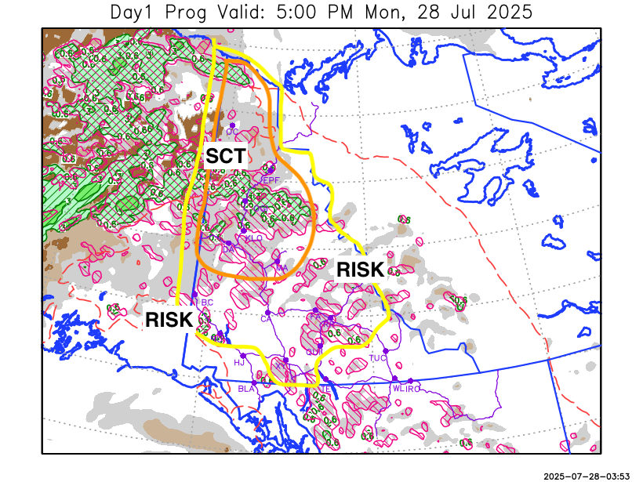
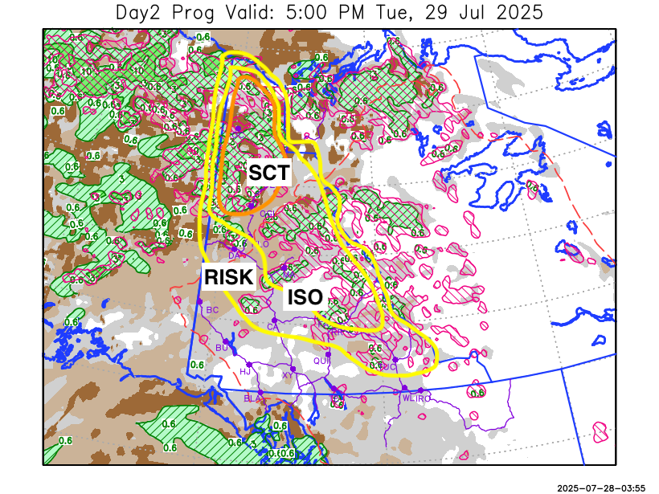

Forecast for | Tuesday | (Peak burning period and overnight)
Community | Clouds | Pcpn | POP | POL | Max Temp | Min RH | Min Temp | Max  RH | Wind Dir | Wind Speed
Old Crow | BKN | R-/TRW- | 60 | SCT | 19 | 66 | 12 | 89 | 220 | 15G30
Klondike Fc | OVC | RW-/TRW- | 30 | RISK | 24 | 42 | 14 | 84 | 270 | 10
Mayo A | BKN | RW-/TRW- | 40 | ISO | 25 | 40 | 16 | 85 | 220 | 10
Carmacks | BKN | RW-/TRW- | 30 | RISK | 27 | 33 | 14 | 76 | 180 | 16
Faro | BKN | RW-/TRW- | 30 | ISO | 24 | 36 | 12 | 83 | 220 | 11
Ross River | BKN | RW-/TRW- | 30 | ISO | 26 | 34 | 10 | 80 | 200 | 11
Beaver Creek Town | BKN | RW- | 20 |  | 25 | 35 | 11 | 76 | 290 | 13
Burwash A | SCT |  | 10 |  | 23 | 32 | 11 | 74 | 160 | 12
Haines Junction | SCT |  | 0 |  | 25 | 30 | 10 | 89 | 180 | 15G30
Whitehorse Auto | SCT |  | 0 |  | 24 | 39 | 13 | 82 | 180 | 15
Teslin | BKN |  | 10 |  | 23 | 41 | 13 | 79 | 220 | 13
Watson Lake | BKN |  | 0 |  | 25 | 38 | 14 | 81 | 200 | 12

Forecast for |  |  | Wednesday |  | (Peak burning period and overnight)
Community |  |  | Clouds |  | Pcpn |  | POP |  | POL |  | Max Temp |  | Min RH | Min Temp | Max  RH | Wind Dir | Wind Speed
Old Crow |  |  | BKN |  | R-/TRW- |  | 40 |  | RISK |  | 17 |  | 56 | 8 | 88 | 250 | 20
Klondike Fc |  |  | BKN |  | RW-/TRW- |  | 30 |  | RISK |  | 22 |  | 46 | 12 | 91 | 270 | 7
Mayo A |  |  | BKN |  | RW-/TRW- |  | 40 |  | RISK |  | 22 |  | 50 | 16 | 87 | 220 | 8
Carmacks |  |  | BKN |  | RW-/TRW- |  | 30 |  | RISK |  | 25 |  | 38 | 13 | 84 | 180 | 10
Faro |  |  | SCT |  |  |  | 10 |  |  |  | 23 |  | 41 | 11 | 82 | 220 | 8
Ross River |  |  | SCT |  |  |  | 10 |  |  |  | 24 |  | 38 | 10 | 79 | 200 | 12
Beaver Creek Town |  |  | BKN |  | RW-/TRW- |  | 60 |  | ISO |  | 23 |  | 43 | 9 | 88 | 290 | 9
Burwash A |  |  | BKN |  | RW- |  | 30 |  |  |  | 22 |  | 42 | 11 | 85 | 140 | 14
Haines Junction |  |  | BKN |  |  |  | 10 |  |  |  | 25 |  | 35 | 10 | 90 | 180 | 15
Whitehorse Auto |  |  | SCT |  |  |  | 10 |  |  |  | 23 |  | 40 | 13 | 80 | 180 | 16
Teslin |  |  | BKN |  | RW-/TRW- |  | 40 |  | RISK |  | 23 |  | 41 | 13 | 84 | 220 | 7
Watson Lake |  |  | BKN |  |  |  | 10 |  |  |  | 26 |  | 34 | 15 | 81 | 70 | 6
3-Day Forecast Precipitation Totals from 13:00 Yesterday
OC | 5.7 |  | FA | 1.8 |  | JAK | 6.3
EPF | 3.5 |  | RR | 1.1 |  | TE | 0.3
ANT | 2.7 |  | BC | 1.3 |  | QUI | 1.2
DA | 2.8 |  | BCT | 1.3 |  | SWI | 0.9
FMI | 4.5 |  | BU | 0.6 |  | FL | 0.6
HEN | 3.7 |  | HJF | 0.0 |  | TUC | 0.0
BAR | 3.5 |  | RAI | 0.0 |  | HAS | 0.3
MA | 3.8 |  | CH | 0.0 |  | TC | 0.3
STW | 4.6 |  | BR | 0.3 |  | WL | 0.0
WIL | 3.7 |  | NU | 0.0 |  | PE | 4.5
XY | 0.3 |  | IRO | 0.0 |  | CA | 0.8
CC | 0.0 |  | ELK | 0.0 |  | DRU | 1.1
ATL | 0.2 |  | NA | NA |  | NA | NA
Matt Desorcy Meteorologist

Disclaimer : The information in these forecasts is collected and prepared for internal use by the Government of Yukon. The forecasts are specifically designed to meet the needs of the Wildland Fire Management and may not cover the requirements of other parties. Weather warnings or advisories are not included as part of the forecasts. Wildland Fire Management makes no representation and provides no warranty as to the accuracy of its weather forecasts. Any use the recipient chooses to make of the forecasts will be at its sole risk.

