YUKON WILDLAND FIRE MANAGEMENT WEATHER FORECAST - 9:00 AM ISSUE

30-Jul-2025
YESTERDAY'S VALUES
Community | Max  Temp  (°C) | Diff.  from  Normal | Min Temp  (°C) | Diff. from Normal | Pcpn  (mm) | Min RH | Max RH | L110 | L30
Old Crow | 20.8 | 1.1 | 13.7 | 5.8 | 2.6 | 57 | 94 | 5 | 0
Fort Mcpherson Airport | 25.2 |  | 17.2 |  | 0.0M | 44 | 68 | 0 | 0
Rock River Climate | 17.5 |  | 10.6 |  | 4.2 | 66 | 99 | - | -
Eagle Plains Fire | 19.9 |  | 12.0 |  | 0.0 | 47 | 82 | 1 | 0
Antimony Creek | 24.3 |  | 9.7 |  | 0.3 | 39 | 99 | 29 | 0
Klondike Fc | 25.8 |  | 11.8 |  | 0.0 | 36 | 93 | 17 | 0
Forty Mile | 19.9 |  | 12.1 |  | 1.4 | 60 | 98 | 6 | 2
Henderson | 22.5 |  | 12.6 |  | 0.0 | 37 | 81 | 31 | 0
Barlow | 24.3 |  | 12.4 |  | 1.1 | 41 | 80 | 49 | 4
Mayo A | 26.3 | 4.1 | 11.6 | 2.7 | 0.0 | 34 | 89 | 88 | 2
Stewart Crossing | 27.5 |  | 13.2 |  | 0.6 | 28 | 92 | 62 | 3
Willow Creek | 26.0 |  | 10.7 |  | 1.1 | 32 | 97 | 56 | 5
Pelly Farm | 28.3 | 6.0 | 13.0 | 5.1 | 3.6 | 29 | 97 | 43 | 0
Carmacks | 29.0 |  | 12.7 |  | 0.0 | 25 | 75 | 14 | 0
Drury Creek | 28.6 |  | 11.8 |  | 0.0 | 23 | 91 | 21 | 0
Faro | 25.2 | 4.6 | 13.8 | 5.3 | 0.0 | 36M | 95M | 23 | 0
Ross River | 26.4 |  | 11.0 |  | 3.2 | 29 | 99 | 58 | 9
Macmillan Pass | 21.8 |  | 8.3 |  | 2.4 | 36 | 99 | 45 | 1
Beaver Creek A | 24.8 | 4.8 | 10.9 | 3.8 | 0.0 | 32 | 79 | 1 | 0
Beaver Creek Town | 25.4 |  | 10.9 |  | 0.0 | 29 | 84 | 1 | 0
Burwash A | 25.5M | 6.3 | M |  | 0.0M | 24M | M | 1 | 0
Haines Junction | 27.0 | 6.6 | 8.0 | 2.8 | 0.0 | 30 | 94 | 0 | 0
Rainbow | 26.7 |  | 11.9 |  | 0.0 | 31 | 84 | 0 | 0
Champagne | 25.7 |  | 9.5 |  | 0.0 | 31 | 87 | 0 | 0
Braeburn | 28.8 |  | 9.0 |  | 0.0 | 26 | 91 | 0 | 0
Nursery | 26.0 |  | 6.8 |  | 0.0 | 31 | 97 | 0 | 0
Whitehorse Auto | 24.3 | 3.9 | 12.0 | 4.2 | 0.0 | 35 | 77 | 0 | 0
Mount Sima | 22.1 |  | 10.5 |  | 0.0 | 39 | 78 | 0 | 0
Carcross | 23.6 |  | 11.5 |  | 0.0 | 41 | 90 | 0 | 0
Atlin | 22.1 |  | 12.5 |  | 0.0 | 42 | 85 | 0 | 0
Jakes Corner | 25.7 |  | 11.3 |  | 0.0 | 29 | 84 | 0 | 0
Teslin | 23.7 |  | 10.9 |  | 0.0 | 40 | 93 | 1 | 0
Quiet Lake | 26.1 |  | 12.8 |  | 0.0 | 35 | 86 | 15 | 0
Swift River | 25.5 |  | 7.0 |  | 2.8 | 33 | 99 | 27 | 0
Tuchitua | 29.2 |  | 6.7 |  | 0.0 | 25 | 99 | 60 | 0
Hasselburg | 25.0 |  | 9.2 |  | 1.1 | 35 | 99 | 51 | 16
Tom Creek | 26.1 |  | 11.4 |  | 0.0 | 32 | 94 | 22 | 0
Watson Lake | 27.1 | 6.0 | 11.2 | 2.5 | 0.2 | 26 | 95 | 17 | 0
Iron Creek | 28.9 |  | 7.9 |  | 0.0 | 28 | 98 | 0 | 0
Max Temp is the actual maximum temperature in °C from yesterday afternoon or evening.
Min Temp is the actual overnight minimum temperature in °C up until 6:00 AM this morning.
Diff. from Normal is the difference from the 30 year average max or min temperature.
Pcpn is the precipitation in mm since 13:00 yesterday.
Min RH is the minimum observed RH in % from yesterday afternoon or evening.
Max RH is the maximum observed overnight RH in % up until 6:00 AM this morning.
L110 is the actual number of lightning strikes within 110 km and in the Yukon for 24 hours ending at 06:00 AM this morning.
L30 is the actual number of lightning strikes within 30 km and in the Yukon for 24 hours ending at 06:00 AM this morning.
M is missing data. * denotes precipitation at stations that failed to report for at least part of the evening and overnight period.

SYNOPSIS:
Today: Upper-level troughing continues to bring broken skies and unsettled weather to central and northern Territory, in the form of scattered showers with a risk of afternoon/evening thundershowers. The upper-low in the Gulf slowly creeps eastward, producing scattered cloud cover and a few isolated to scattered showers/thundershowers across Southern Lakes, Kluane, Tatchun, and Tintina late in the day. Highs in the mid-twenties except upper teens in Old Crow. RHs generally 30% or higher.

Thursday: The upper-low in the Gulf of Alaska will drive Yukon’s weather by the late-week, bringing scattered to broken skies across central and southern Yukon as well as scattered shower and thundershower activity. Intermittent light rain in the Beaver Creek district with embedded thunder. Highs in the low to mid-twenties across central and southern regions. Quieter weather in the Old Crow district as the unsettled weather and associated cloud cover clears out by afternoon, with highs in the upper teens. Winds generally light and variable, except gustier near any convective cells.

Friday: Little change in the upper-air pattern as an upper-low in the Gulf of Alaska continues to impact the southern half of the Territory, bringing shower/thundershower activity and scattered to broken cloud cover. Steadier rains possible in the Beaver Creek district with moderate rainfall amounts of 5-15 mm. Highs in the upper teens to low twenties through central and southern Yukon. Old Crow remains sunnier with highs in the low twenties. Gusty southerly winds in Southern Lakes and Haines Junction district.

Saturday: Upper-low continues to slowly drift eastward into the Territory but weakening over the weekend. Rain ends in the Beaver Creek district. Scattered cloud cover with a slight risk of a convective shower or thundershower through most of central and southern Yukon, but shower coverage will generally be on a downtrend as the upper-low weakens. Highs in the upper teens to low twenties.

Sunday: The upper-level low continues to churn across the southern half of the Yukon, bringing variable cloud cover and the risk of scattered convective showers/thundershowers to most regions. Old Crow remains drier and sunnier, though a cooling trend into the teens is likely for the northern Territory.

Forecast for | Wednesday | (Peak burning period and overnight)
Community | Clouds | Pcpn | POP | POL | Max Temp | Min RH | Min Temp | Max  RH | Wind Dir | Wind Speed
Old Crow | BKN | R-/TRW- | 60 | RISK | 19 | 55 | 7 | 86 | 20 | 15G30
Klondike Fc | BKN | RW-/TRW- | 30 | RISK | 23 | 40 | 13 | 89 | 340 | 8
Mayo A | BKN | RW-/TRW- | 40 | ISO | 23 | 45 | 16 | 89 | 220 | 7
Carmacks | BKN | RW-/TRW- | 30 | ISO | 27 | 32 | 14 | 82 | 160 | 12
Faro | BKN | RW-/TRW- | 30 | RISK | 23 | 43 | 12 | 83 | 220 | 10
Ross River | SCT | RW-/TRW- | 30 | RISK | 25 | 36 | 10 | 82 | 200 | 11
Beaver Creek Town | BKN | RW/TRW | 60 | SCT | 25 | 38 | 11 | 89 | 290 | 10
Burwash A | BKN | RW-/TRW- | 40 | ISO | 24 | 36 | 12 | 82 | 140 | 15G30
Haines Junction | SCT | RW-/TRW- | 20 | RISK | 25 | 34 | 10 | 89 | 180 | 15
Whitehorse Auto | SCT | RW-/TRW- | 30 | RISK | 24 | 37 | 14 | 77 | 180 | 15
Teslin | SCT | RW-/TRW- | 30 | RISK | 23 | 40 | 14 | 78 | 320 | 8
Watson Lake | BKN | RW-/TRW- | 30 | RISK | 26 | 30 | 16 | 78 | 220 | 7
POP is probability of precipitation in %.
POL is probability of lightning in %.

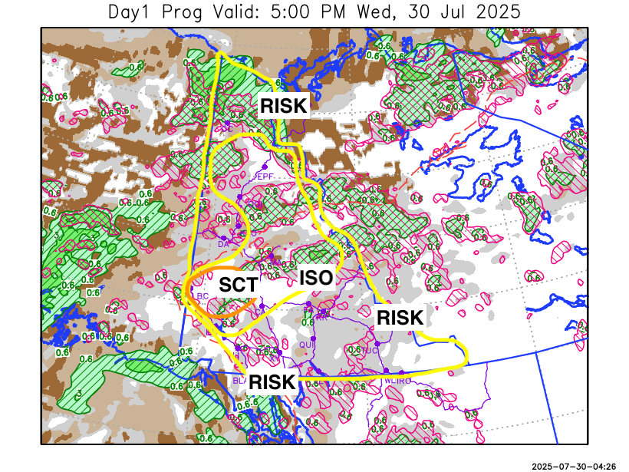
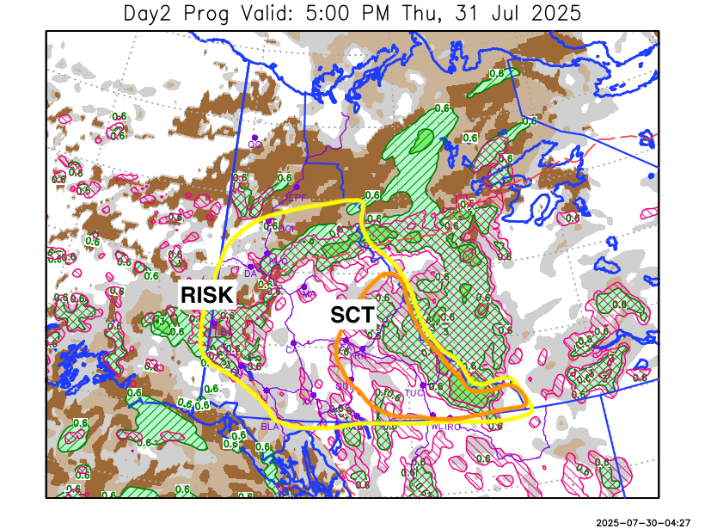

Forecast for | Thursday | (Peak burning period and overnight)
Community | Clouds | Pcpn | POP | POL | Max Temp | Min RH | Min Temp | Max  RH | Wind Dir | Wind Speed
Old Crow | FEW |  | 0 |  | 16 | 54 | 6 | 92 | 70 | 11
Klondike Fc | BKN | RW-/TRW- | 40 | RISK | 23 | 42 | 12 | 85 | 20 | 8
Mayo A | BKN | RW-/TRW- | 40 | RISK | 24 | 44 | 15 | 87 | 20 | 7
Carmacks | BKN | RW-/TRW- | 40 | RISK | 28 | 31 | 14 | 90 | 140 | 8
Faro | BKN | RW/TRW | 60 | SCT | 24 | 44 | 12 | 91 | 140 | 10
Ross River | BKN | RW/TRW | 60 | SCT | 26 | 40 | 11 | 92 | 110 | 10
Beaver Creek Town | OVC | R-/TRW- | 70 | RISK | 19 | 67 | 10 | 91 | 320 | 12
Burwash A | BKN | R-/TRW- | 40 | RISK | 21 | 46 | 11 | 89 | 140 | 13
Haines Junction | BKN | RW-/TRW- | 30 | RISK | 25 | 30 | 10 | 86 | 200 | 12
Whitehorse Auto | BKN | RW-/TRW- | 30 | RISK | 24 | 35 | 14 | 85 | 180 | 13
Teslin | BKN | RW-/TRW- | 40 | RISK | 25 | 40 | 14 | 88 | 200 | 8
Watson Lake | BKN | RW/TRW | 70 | SCT | 27 | 37 | 14 | 89 | 110 | 8

Forecast for |  |  | Friday |  |  | (Peak burning period and overnight)
Community |  |  | Clouds |  |  | Pcpn |  | POP |  | POL |  | Max Temp |  | Min RH | Min Temp | Max  RH | Wind Dir | Wind Speed
Old Crow |  |  | CLR |  |  |  |  | 0 |  |  |  | 22 |  | 36 | 9 | 83 | 90 | 10
Klondike Fc |  |  | BKN |  |  | RW-/TRW- |  | 60 |  | ISO |  | 23 |  | 48 | 13 | 92 | 110 | 8
Mayo A |  |  | BKN |  |  | RW-/TRW- |  | 60 |  | ISO |  | 22 |  | 58 | 14 | 90 | 140 | 7
Carmacks |  |  | SCT |  |  | RW-/TRW- |  | 60 |  | ISO |  | 24 |  | 40 | 10 | 85 | 160 | 15
Faro |  |  | BKN |  |  | RW-/TRW- |  | 60 |  | ISO |  | 21 |  | 58 | 10 | 86 | 220 | 10
Ross River |  |  | BKN |  |  | RW-/TRW- |  | 60 |  | ISO |  | 24 |  | 47 | 8 | 85 | 180 | 10
Beaver Creek Town |  |  | BKN |  |  | R/TRW |  | 80 |  | RISK |  | 19 |  | 72 | 7 | 90 | 270 | 12
Burwash A |  |  | SCT |  |  | RW-/TRW- |  | 40 |  | RISK |  | 19 |  | 40 | 7 | 79 | 160 | 15G35
Haines Junction |  |  | FEW |  |  | RW-/TRW- |  | 20 |  | RISK |  | 22 |  | 35 | 7 | 91 | 180 | 15G30
Whitehorse Auto |  |  | SCT |  |  | RW-/TRW- |  | 20 |  | RISK |  | 20 |  | 37 | 9 | 80 | 180 | 15G30
Teslin |  |  | SCT |  |  | RW-/TRW- |  | 40 |  | ISO |  | 20 |  | 45 | 11 | 82 | 250 | 12
Watson Lake |  |  | SCT |  |  | RW-/TRW- |  | 60 |  | SCT |  | 22 |  | 50 | 13 | 89 | 160 | 8
3-Day Forecast Precipitation Totals from 13:00 Yesterday
OC | 4.9 |  | FA | 7.1 |  |  | JAK | 4.5
EPF | 11.2 |  | RR | 10.3 |  |  | TE | 5.5
ANT | 4.0 |  | BC | 15.7 |  |  | QUI | 8.0
DA | 3.0 |  | BCT | 15.7 |  |  | SWI | 8.6
FMI | 4.4 |  | BU | 6.1 |  |  | FL | 7.4
HEN | 5.4 |  | HJF | 2.0 |  |  | TUC | 8.2
BAR | 6.9 |  | RAI | 2.7 |  |  | HAS | 11.4
MA | 6.2 |  | CH | 3.5 |  |  | TC | 7.0
STW | 7.8 |  | BR | 5.7 |  |  | WL | 6.9
WIL | 9.5 |  | NU | 3.7 |  |  | PE | 14.2
XY | 3.8 |  | IRO | 7.0 |  |  | CA | 5.3
CC | 2.5 |  | ELK | 8.5 |  |  | DRU | 6.4
ATL | 3.1 |  | NA | NA |  |  | NA | NA
Matt Desorcy Meteorologist

Disclaimer : The information in these forecasts is collected and prepared for internal use by the Government of Yukon. The forecasts are specifically designed to meet the needs of the Wildland Fire Management and may not cover the requirements of other parties. Weather warnings or advisories are not included as part of the forecasts. Wildland Fire Management makes no representation and provides no warranty as to the accuracy of its weather forecasts. Any use the recipient chooses to make of the forecasts will be at its sole risk.

