YUKON WILDLAND FIRE MANAGEMENT WEATHER FORECAST - 9:00 AM ISSUE

31-Jul-2025
YESTERDAY'S VALUES
Community | Max  Temp  (°C) | Diff.  from  Normal | Min Temp  (°C) | Diff. from Normal | Pcpn  (mm) | Min RH | Max RH | L110 | L30
Old Crow | 15.6 | -4.0 | 6.9 | -0.9 | 1.4 | 67 | 87 | 4 | 0
Fort Mcpherson Airport | 21.9 |  | 6.3 |  | 7.8 | 51 | 97 | 0 | 0
Rock River Climate | 17.9 |  | 3.6 |  | 9.8 | 51 | 99 | - | -
Eagle Plains Fire | 20.7 |  | 7.0 |  | 29.5 | 46 | 99 | 3 | 0
Antimony Creek | 23.2 |  | 7.6 |  | 1.3 | 42 | 100 | 94 | 2
Klondike Fc | 23.3 |  | 10.5 |  | 0.0 | 38 | 97 | 113 | 1
Forty Mile | 21.0 |  | 11.1 |  | 11.9 | 51 | 99 | 65 | 29
Henderson | 20.6 |  | 9.6 |  | 7.8 | 42 | 97 | 161 | 15
Barlow | 22.0 |  | 11.8 |  | 4.2 | 46 | 98 | 211 | 4
Mayo A | 22.8 | 0.6 | 13.2 | 4.4 | 9.4 | 47 | 94 | 305 | 37
Stewart Crossing | 22.8 |  | 12.6 |  | 5.9 | 37 | 99 | 313 | 22
Willow Creek | 22.3 |  | 11.0 |  | 11.5 | 46 | 99 | 343 | 84
Pelly Farm | 24.5 | 2.3 | 10.2 | 2.4 | 5.2 | 42 | 99 | 349 | 42
Carmacks | 28.1 |  | 10.9 |  | 0.0 | 31 | 82 | 161 | 0
Drury Creek | 26.6 |  | 10.6 |  | 0.0 | 32 | 96 | 25 | 2
Faro | 24.5 | 4.0 | 9.3 | 0.9 | 3.8 | 42M | 100M | 45 | 3
Ross River | 26.1 |  | 8.2 |  | 0.0 | 35 | 99 | 34 | 2
Macmillan Pass | 18.9 |  | 5.4 |  | 5.4 | 54 | 100 | 109 | 26
Beaver Creek A | 22.4 | 2.5 | 11.3 | 4.3 | 2.3 | 40 | 100 | 178 | 43
Beaver Creek Town | 23.7 |  | 11.8 |  | 3.3 | 34 | 98 | 170 | 37
Burwash A | 23.2M | 4.1 | M |  | 0.0M | 37M | M | 75 | 0
Haines Junction | 26.3 | 6.1 | 9.3 | 3.9 | 0.0 | 36 | 93 | 0 | 0
Rainbow | 25.0 |  | 12.7 |  | 0.0 | 37 | 85 | 0 | 0
Champagne | 25.5 |  | 6.7 |  | 0.0 | 34 | 95 | 0 | 0
Braeburn | 26.0 |  | 5.8 |  | 1.0 | 31 | 98 | 5 | 0
Nursery | 25.2 |  | 8.4 |  | 0.6 | 38 | 98 | 0 | 0
Whitehorse Auto | 24.2 | 3.9 | 12.7 | 4.9 | 0.0 | 32 | 70 | 0 | 0
Mount Sima | 22.5 |  | 10.4 |  | 0.0 | 35 | 75 | 0 | 0
Carcross | 24.6 |  | 11.0 |  | 0.0 | 38 | 87 | 1 | 0
Atlin | 24.4 |  | 13.1 |  | 0.0 | 39 | 77 | 1 | 0
Jakes Corner | 25.4 |  | 11.4 |  | 0.5 | 34 | 92 | 3 | 0
Teslin | 24.9 |  | 10.1 |  | 0.8 | 35 | 99 | 21 | 1
Quiet Lake | 26.0 |  | 9.6 |  | 0.0 | 38 | 94 | 28 | 0
Swift River | 25.3 |  | 7.6 |  | 0.3 | 33 | 97 | 84 | 0
Tuchitua | 27.7 |  | 7.1 |  | 0.3 | 34 | 100 | 160 | 4
Hasselburg | 26.1 |  | 11.1 |  | 1.3 | 32 | 99 | 139 | 18
Tom Creek | 26.6 |  | 12.2 |  | 0.0 | 32 | 89 | 189 | 23
Watson Lake | 27.5 | 6.5 | 12.4 | 3.7 | 1.0 | 28 | 95 | 189 | 28
Iron Creek | 30.3 |  | 8.2 |  | 1.0 | 28 | 100 | 130 | 42
Max Temp is the actual maximum temperature in °C from yesterday afternoon or evening.
Min Temp is the actual overnight minimum temperature in °C up until 6:00 AM this morning.
Diff. from Normal is the difference from the 30 year average max or min temperature.
Pcpn is the precipitation in mm since 13:00 yesterday.
Min RH is the minimum observed RH in % from yesterday afternoon or evening.
Max RH is the maximum observed overnight RH in % up until 6:00 AM this morning.
L110 is the actual number of lightning strikes within 110 km and in the Yukon for 24 hours ending at 06:00 AM this morning.
L30 is the actual number of lightning strikes within 30 km and in the Yukon for 24 hours ending at 06:00 AM this morning.
M is missing data. * denotes precipitation at stations that failed to report for at least part of the evening and overnight period.

SYNOPSIS:
Today: The upper-low in the Gulf of Alaska will drive Yukon’s weather over the next few days, bringing scattered to broken skies across central and southern Yukon as well as scattered shower and thundershower activity. Patchy light rain in the Beaver Creek district possible, with embedded thunder. Highs in the low to mid-twenties across central and southern regions. Quieter weather in the Old Crow district as the unsettled weather and associated cloud cover clears out, with highs in the teens. Winds light and variable, except gustier near any convective cells. A few storms may become strong to severe in Tintina and eastern Tatchun this afternoon/evening, producing heavy downpours and strong winds.

Friday: Little change in the upper-air pattern as an upper-low in the Gulf of Alaska continues to impact the southern half of the Territory, spinning up shower/thundershower activity and scattered to broken cloud cover. Steadier rains likely in the Beaver Creek district with moderate rainfall amounts of 5-15 mm (today and Friday combined). Highs in the upper teens to low twenties through central and southern Yukon, though a few mid-twenties are possible in central Yukon. Old Crow remains sunnier with highs in the low twenties. Gusty southerly winds in Southern Lakes and Haines Junction district.

Saturday: Upper-low continues to slowly drift eastward into the Territory but weakens by Saturday. Rain ends in the Beaver Creek district. Scattered cloud cover with a slight risk of a convective shower or thundershower in southeast Yukon and Beaver Creek district, but shower coverage will generally be on a downtrend across the Territory as the upper-low weakens. Highs in the upper teens to low twenties. Mid-twenties possible in the Old Crow district under sunny skies.

Sunday: The upper-level low continues to churn across the southern half of the Yukon, bringing variable cloud cover and the risk of scattered late-day convective showers/thundershowers, particularly to Kluane, Southern Lakes, and Tintina. Drier and sunnier through the Klondike and Northern Tutchone as highs climb into the low to mid-twenties.

Monday: No significant change to the upper-air pattern as an upper-level low lingers, producing variable cloud cover across the Territory, highs in the upper teens to low twenties, as well as the chance of scattered showers across the southern half of the Yukon.

Forecast for | Thursday | (Peak burning period and overnight)
Community | Clouds | Pcpn | POP | POL | Max Temp | Min RH | Min Temp | Max  RH | Wind Dir | Wind Speed
Old Crow | FEW |  | 0 |  | 16 | 52 | 6 | 92 | 70 | 12
Klondike Fc | BKN | RW-/TRW- | 30 | RISK | 23 | 40 | 12 | 86 | 20 | 10
Mayo A | BKN | RW-/TRW- | 40 | ISO | 23 | 46 | 15 | 89 | 20 | 8
Carmacks | BKN | RW-/TRW- | 20 | RISK | 27 | 30 | 14 | 80 | 160 | 10
Faro | BKN | RW-/TRW- | 40 | SCT | 23 | 45 | 12 | 87 | 200 | 6
Ross River | BKN | RW-/TRW- | 60 | SCT | 26 | 38 | 11 | 87 | 180 | 6
Beaver Creek Town | OVC | R-/TRW- | 70 | ISO | 20 | 58 | 10 | 93 | 290 | 13
Burwash A | BKN | RW-/TRW- | 30 | RISK | 21 | 40 | 10 | 82 | 140 | 15G30
Haines Junction | BKN | RW-/TRW- | 20 | RISK | 24 | 28 | 10 | 82 | 180 | 13
Whitehorse Auto | BKN | RW-/TRW- | 30 | RISK | 24 | 31 | 14 | 82 | 180 | 14
Teslin | SCT | RW-/TRW- | 40 | ISO | 23 | 40 | 14 | 82 | 200 | 8
Watson Lake | SCT | RW/TRW | 60 | SCT | 27 | 35 | 14 | 88 | 160 | 7
POP is probability of precipitation in %.
POL is probability of lightning in %.

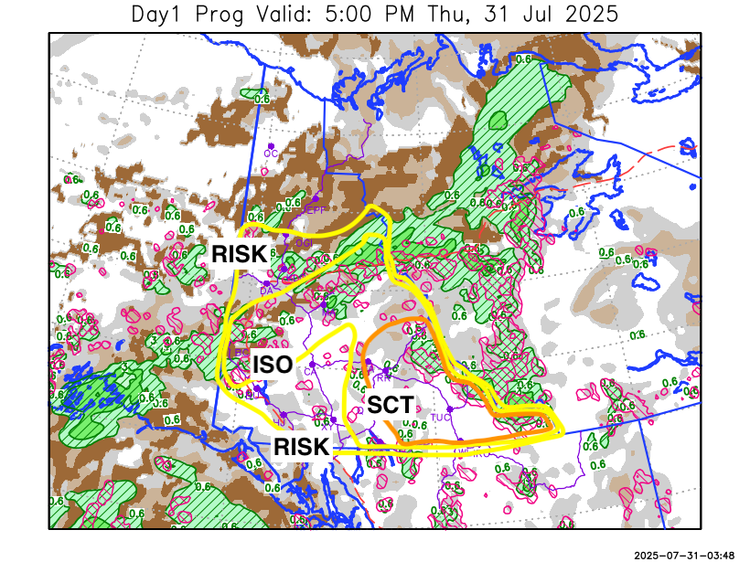
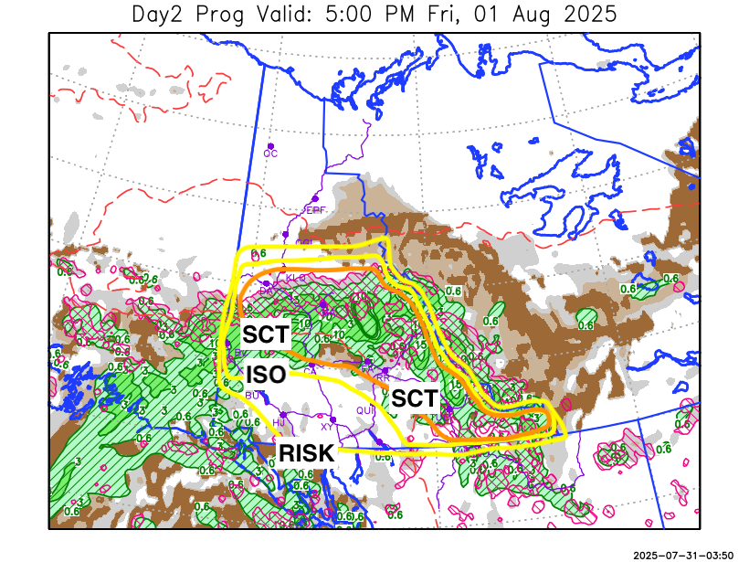

Forecast for | Friday | (Peak burning period and overnight)
Community | Clouds | Pcpn | POP | POL | Max Temp | Min RH | Min Temp | Max  RH | Wind Dir | Wind Speed
Old Crow | CLR |  | 0 |  | 21 | 36 | 8 | 81 | 70 | 10
Klondike Fc | BKN | RW-/TRW- | 40 | SCT | 25 | 37 | 13 | 90 | 110 | 10
Mayo A | BKN | RW-/TRW- | 60 | SCT | 23 | 51 | 14 | 85 | 140 | 8
Carmacks | SCT | RW-/TRW- | 40 | SCT | 24 | 45 | 9 | 78 | 160 | 15
Faro | SCT | RW-/TRW- | 60 | SCT | 20 | 65 | 8 | 86 | 220 | 11
Ross River | SCT | RW-/TRW- | 60 | SCT | 24 | 48 | 7 | 86 | 220 | 11
Beaver Creek Town | BKN | R/TRW | 80 | ISO | 19 | 69 | 7 | 91 | 220 | 7
Burwash A | SCT | RW-/TRW- | 40 | RISK | 19 | 40 | 7 | 74 | 140 | 20G35
Haines Junction | SCT | RW-/TRW- | 30 | RISK | 21 | 33 | 7 | 89 | 180 | 15G30
Whitehorse Auto | SCT | RW-/TRW- | 40 | RISK | 20 | 37 | 9 | 79 | 180 | 15G30
Teslin | SCT | RW-/TRW- | 60 | RISK | 20 | 46 | 11 | 79 | 220 | 10
Watson Lake | SCT | RW-/TRW- | 40 | SCT | 23 | 45 | 13 | 83 | 200 | 8

Forecast for |  |  | Saturday |  |  | (Peak burning period and overnight)
Community |  |  | Clouds |  |  | Pcpn |  | POP |  | POL |  | Max Temp |  | Min RH | Min Temp | Max  RH | Wind Dir | Wind Speed
Old Crow |  |  | CLR |  |  |  |  | 0 |  |  |  | 24 |  | 31 | 12 | 79 | 90 | 9
Klondike Fc |  |  | SCT |  |  | RW- |  | 20 |  |  |  | 23 |  | 43 | 11 | 83 | 140 | 10
Mayo A |  |  | SCT |  |  |  |  | 0 |  |  |  | 22 |  | 38 | 13 | 77 | 180 | 9
Carmacks |  |  | SCT |  |  |  |  | 0 |  |  |  | 25 |  | 30 | 10 | 69 | 160 | 15
Faro |  |  | SCT |  |  | RW-/TRW- |  | 30 |  | RISK |  | 21 |  | 45 | 10 | 81 | 180 | 6
Ross River |  |  | SCT |  |  | RW-/TRW- |  | 30 |  | RISK |  | 23 |  | 39 | 8 | 81 | 140 | 7
Beaver Creek Town |  |  | SCT |  |  | RW-/TRW- |  | 40 |  | RISK |  | 21 |  | 50 | 7 | 83 | 270 | 10
Burwash A |  |  | SCT |  |  | RW-/TRW- |  | 30 |  | RISK |  | 19 |  | 33 | 8 | 75 | 140 | 15G30
Haines Junction |  |  | SCT |  |  |  |  | 0 |  |  |  | 22 |  | 29 | 6 | 79 | 180 | 14
Whitehorse Auto |  |  | SCT |  |  |  |  | 0 |  |  |  | 20 |  | 35 | 10 | 71 | 160 | 13
Teslin |  |  | SCT |  |  |  |  | 0 |  |  |  | 21 |  | 38 | 10 | 74 | 270 | 6
Watson Lake |  |  | SCT |  |  | RW-/TRW- |  | 30 |  | RISK |  | 23 |  | 38 | 13 | 84 | 320 | 6
3-Day Forecast Precipitation Totals from 13:00 Yesterday
OC | 1.4 |  | FA | 13.9 |  |  | JAK | 4.9
EPF | 31.1 |  | RR | 8.8 |  |  | TE | 4.6
ANT | 11.2 |  | BC | 18.9 |  |  | QUI | 7.6
DA | 9.0 |  | BCT | 19.9 |  |  | SWI | 4.8
FMI | 19.1 |  | BU | 2.4 |  |  | FL | 8.4
HEN | 17.7 |  | HJF | 1.2 |  |  | TUC | 7.9
BAR | 15.0 |  | RAI | 1.4 |  |  | HAS | 10.3
MA | 21.4 |  | CH | 1.8 |  |  | TC | 10.2
STW | 14.2 |  | BR | 2.9 |  |  | WL | 10.9
WIL | 20.6 |  | NU | 3.3 |  |  | PE | 13.4
XY | 3.4 |  | IRO | 14.0 |  |  | CA | 3.5
CC | 1.4 |  | ELK | 13.4 |  |  | DRU | 9.9
ATL | 1.9 |  | NA | NA |  |  | NA | NA
Matt Desorcy Meteorologist

Disclaimer : The information in these forecasts is collected and prepared for internal use by the Government of Yukon. The forecasts are specifically designed to meet the needs of the Wildland Fire Management and may not cover the requirements of other parties. Weather warnings or advisories are not included as part of the forecasts. Wildland Fire Management makes no representation and provides no warranty as to the accuracy of its weather forecasts. Any use the recipient chooses to make of the forecasts will be at its sole risk.

