YUKON WILDLAND FIRE MANAGEMENT WEATHER FORECAST - 9:00 AM ISSUE

1-Aug-2025
YESTERDAY'S VALUES
Community | Max  Temp  (°C) | Diff.  from  Normal | Min Temp  (°C) | Diff. from Normal | Pcpn  (mm) | Min RH | Max RH | L110 | L30
Old Crow | 17.1 | -2.4 | 5.1 | -2.6 | 0.2 | 45 | 99 | 0 | 0
Fort Mcpherson Airport | 14.5 |  | 5.7 |  | 0.0 | 61 | 97 | 0 | 0
Rock River Climate | 10.2 |  | 5.0 |  | 0.0 | 78 | 93 | - | -
Eagle Plains Fire | 12.3 |  | 6.2 |  | 0.0 | 77 | 99 | 0 | 0
Antimony Creek | 24.3 |  | 8.5 |  | 0.0 | 38 | 97 | 4 | 0
Klondike Fc | 25.8 |  | 10.4 |  | 0.0 | 31 | 90 | 2 | 0
Forty Mile | 21.6 |  | 7.4 |  | 0.0 | 46 | 99 | 0 | 0
Henderson | 19.3 |  | 12.1 |  | 0.0 | 50 | 81 | 21 | 0
Barlow | 23.4 |  | 12.8 |  | 4.1 | 46 | 92 | 42 | 1
Mayo A | 23.8 | 1.7 | 13.0 | 4.3 | 0.0 | 47 | 92 | 122 | 6
Stewart Crossing | 25.1 |  | 11.6 |  | 0.8 | 40 | 99 | 120 | 25
Willow Creek | 24.5 |  | 10.9 |  | 1.0 | 39 | 98 | 124 | 17
Pelly Farm | 26.1 | 4.0 | 10.2 | 2.5 | 0.0 | 39 | 98 | 92 | 3
Carmacks | 26.8 |  | 10.4 |  | 0.0 | 30 | 84 | 29 | 0
Drury Creek | 24.9 |  | 8.5 |  | 0.0 | 37 | 96 | 131 | 0
Faro | 23.4 | 3.0 | 9.8 | 1.5 | 0.0 | 45M | 92M | 279 | 11
Ross River | 26.5 |  | 9.6 |  | 0.0 | 36 | 98 | 485 | 5
Macmillan Pass | 21.3 |  | 6.3 |  | 0.2 | 41 | 99 | 651 | 7
Beaver Creek A | 17.5 | -2.3 | 9.8 | 3.0 | 0.0M | 65 | 100 | 6 | 0
Beaver Creek Town | 18.2 |  | 9.9 |  | 0.0 | 62 | 97 | 6 | 0
Burwash A | 20.7M | 1.6 | 1.9M | -4.1 | 0.0M | 41M | 92M | 4 | 0
Haines Junction | 23.1 | 3.3 | 5.4 | 0.0 | 0.0 | 40 | 91 | 0 | 0
Rainbow | 23.2 |  | 7.5 |  | 0.0 | 33 | 86 | 0 | 0
Champagne | 23.4 |  | 5.0 |  | 0.0 | 31 | 87 | 0 | 0
Braeburn | 24.6 |  | 4.7 |  | 0.0 | 36 | 97 | 2 | 0
Nursery | 24.3 |  | 3.9 |  | 0.0 | 30 | 98 | 0 | 0
Whitehorse Auto | 22.3 | 2.0 | 8.4 | 0.6 | 0.0 | 31 | 81 | 0 | 0
Mount Sima | 19.6 |  | 11.9 |  | 0.0 | 37 | 58 | 0 | 0
Carcross | 22.5 |  | 9.3 |  | 0.8 | 33 | 98 | 0 | 0
Atlin | 22.6 |  | 11.1 |  | 1.2 | 36 | 94 | 0 | 0
Jakes Corner | 23.5 |  | 8.2 |  | 0.0 | 35 | 90 | 0 | 0
Teslin | 22.8 |  | 8.1 |  | 0.0 | 40 | 95 | 15 | 0
Quiet Lake | 27.0 |  | 8.9 |  | 0.0 | 42 | 95 | 23 | 0
Swift River | 26.2 |  | 10.2 |  | 3.1 | 33 | 99 | 234 | 7
Tuchitua | 30.1 |  | 6.8 |  | 0.0 | 23 | 98 | 745 | 12
Hasselburg | 27.1 |  | 10.4 |  | 0.5 | 30 | 97 | 550 | 83
Tom Creek | 27.4 |  | 10.1 |  | 0.0 | 32 | 98 | 480 | 16
Watson Lake | 28.1 | 7.1 | 12.3 | 3.7 | 1.0 | 30 | 98 | 423 | 34
Iron Creek | 29.2 |  | 9.3 |  | 1.6 | 31 | 100 | 589 | 34
Max Temp is the actual maximum temperature in °C from yesterday afternoon or evening.
Min Temp is the actual overnight minimum temperature in °C up until 6:00 AM this morning.
Diff. from Normal is the difference from the 30 year average max or min temperature.
Pcpn is the precipitation in mm since 13:00 yesterday.
Min RH is the minimum observed RH in % from yesterday afternoon or evening.
Max RH is the maximum observed overnight RH in % up until 6:00 AM this morning.
L110 is the actual number of lightning strikes within 110 km and in the Yukon for 24 hours ending at 06:00 AM this morning.
L30 is the actual number of lightning strikes within 30 km and in the Yukon for 24 hours ending at 06:00 AM this morning.
M is missing data. * denotes precipitation at stations that failed to report for at least part of the evening and overnight period.

SYNOPSIS:
Today: The upper-low located in the Gulf of Alaska continues to impact the southern half of the Territory, spinning up shower/thunderstorm activity and scattered to broken cloud cover. A broken band of showers and thunderstorms is forecast to advance from south to north throughout the day, reaching central Yukon by late afternoon. Heavy downpours and gusty winds are possible with any thunderstorm activity. Highs in the upper teens to low twenties in southern Yukon, while conditions expected to heat out in central Yukon into the mid-twenties ahead of the arrival of the band of showers/thunderstorms late in the day. Old Crow remains sunnier with highs in the low twenties. Gusty southerly winds during the afternoon/evening in Southern Lakes and Haines Junction district.

Saturday: Upper-low continues to slowly creep eastward but weakens by Saturday. Scattered cloud cover or mainly sunny skies in the Territory, with a slight risk of an isolated convective shower or thundershower in southeast Yukon and Beaver Creek district but shower coverage will generally be on a downtrend across the Territory as the upper-low weakens. Highs in the upper teens to low twenties. Mid-twenties possible in the Old Crow district under sunny skies.

Sunday: The upper-level low continues to churn across the southern half of the Yukon, bringing variable cloud cover and the risk of scattered late-day convective showers/thundershowers, particularly to Kluane, Southern Lakes, and Tintina. Highs in the upper teens to low twenties in southern Yukon. Drier and sunnier through the Klondike and Northern Tutchone as highs climb into the mid-twenties with RHs in the 25-35% range.

Monday: The upper-level low advances into the Yukon, bringing a continued chance of unsettled weather across the southern half of the Territory, particularly in Tatchun, Southern Lakes, and Tintina where steadier light rains are possible. Warmest and driest in central Yukon (southern Klondike/Mayo district) where a mix of sun and cloud is expected throughout the day with highs in the low to mid-twenties. Becoming more unsettled in Old Crow.

Tuesday: Troughing develops in the northern Yukon, bringing unsettled weather to the Old Crow district. A more zonal flow is expected across central and southern regions resulting in variable cloud cover and a slight risk of a passing shower with seasonal temperatures.

Forecast for | Friday | (Peak burning period and overnight)
Community | Clouds | Pcpn | POP | POL | Max Temp | Min RH | Min Temp | Max  RH | Wind Dir | Wind Speed
Old Crow | CLR |  | 0 |  | 22 | 30 | 8 | 77 | 90 | 10
Klondike Fc | BKN | RW/TRW | 60 | SCT | 27 | 32 | 13 | 92 | 90 | 10
Mayo A | SCT | RW/TRW | 60 | SCT | 25 | 45 | 14 | 90 | 140 | 10
Carmacks | SCT | RW/TRW | 60 | SCT | 24 | 40 | 10 | 75 | 160 | 15
Faro | SCT | RW/TRW | 60 | SCT | 23 | 50 | 8 | 84 | 200 | 12
Ross River | SCT | RW/TRW | 60 | SCT | 25 | 44 | 7 | 82 | 200 | 12
Beaver Creek Town | BKN | RW/TRW | 70 | SCT | 20 | 52 | 7 | 87 | 220 | 10
Burwash A | SCT | RW-/TRW- | 70 | ISO | 18 | 46 | 7 | 78 | 160 | 15G30
Haines Junction | SCT | RW-/TRW- | 70 | ISO | 20 | 35 | 7 | 89 | 180 | 15G30
Whitehorse Auto | FEW | RW-/TRW- | 70 | ISO | 20 | 38 | 9 | 80 | 180 | 15G30
Teslin | SCT | RW-/TRW- | 60 | ISO | 20 | 43 | 11 | 80 | 250 | 12
Watson Lake | SCT | RW-/TRW- | 40 | ISO | 23 | 48 | 13 | 82 | 220 | 8
POP is probability of precipitation in %.
POL is probability of lightning in %.

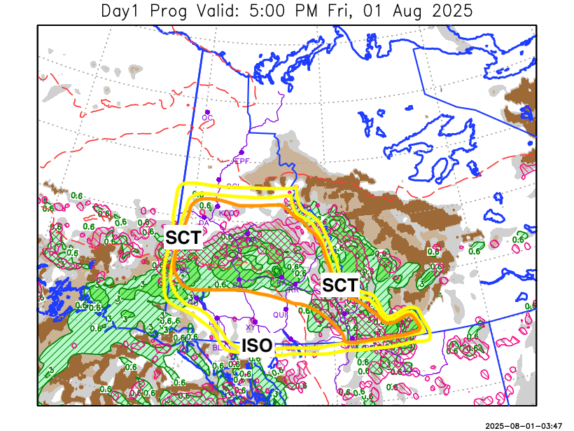
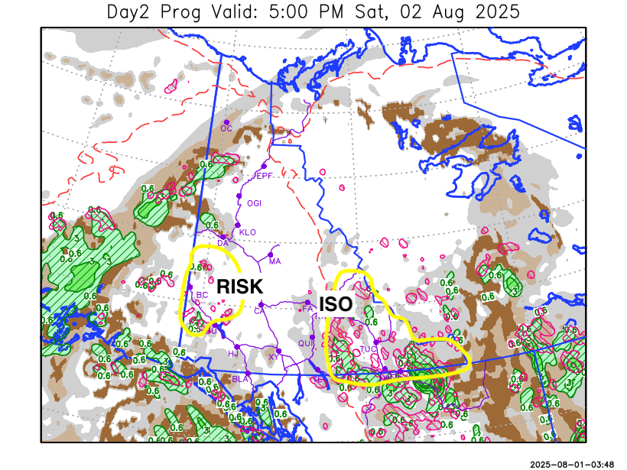

Forecast for | Saturday | (Peak burning period and overnight)
Community | Clouds | Pcpn | POP | POL | Max Temp | Min RH | Min Temp | Max  RH | Wind Dir | Wind Speed
Old Crow | SCT |  | 0 |  | 23 | 30 | 12 | 79 | 220 | 8
Klondike Fc | SCT | RW- | 20 |  | 22 | 47 | 10 | 85 | 180 | 12
Mayo A | FEW |  | 0 |  | 22 | 39 | 13 | 76 | 180 | 8
Carmacks | SCT |  | 0 |  | 24 | 28 | 10 | 69 | 160 | 12
Faro | SCT |  | 0 |  | 21 | 40 | 9 | 74 | 200 | 8
Ross River | SCT |  | 0 |  | 23 | 33 | 8 | 74 | 270 | 8
Beaver Creek Town | SCT | RW-/TRW- | 30 | RISK | 21 | 45 | 7 | 81 | 270 | 8
Burwash A | SCT |  | 10 |  | 19 | 36 | 8 | 79 | 140 | 15
Haines Junction | SCT |  | 0 |  | 22 | 30 | 6 | 84 | 180 | 13
Whitehorse Auto | SCT |  | 0 |  | 21 | 31 | 9 | 71 | 160 | 13
Teslin | SCT |  | 2 |  | 21 | 35 | 11 | 67 | 250 | 8
Watson Lake | BKN | RW-/TRW- | 40 | ISO | 22 | 43 | 13 | 81 | 270 | 10

Forecast for |  |  | Sunday |  |  | (Peak burning period and overnight)
Community |  |  | Clouds |  |  | Pcpn |  | POP |  | POL |  | Max Temp |  | Min RH | Min Temp | Max  RH | Wind Dir | Wind Speed
Old Crow |  |  | SCT |  |  |  |  | 10 |  |  |  | 25 |  | 32 | 14 | 69 | 250 | 15
Klondike Fc |  |  | SCT |  |  |  |  | 0 |  |  |  | 24 |  | 35 | 11 | 78 | 250 | 8
Mayo A |  |  | SCT |  |  |  |  | 10 |  |  |  | 23 |  | 35 | 13 | 76 | 270 | 6
Carmacks |  |  | BKN |  |  | RW-/TRW- |  | 30 |  | RISK |  | 25 |  | 29 | 12 | 72 | 270 | 6
Faro |  |  | BKN |  |  | RW-/TRW- |  | 60 |  | RISK |  | 21 |  | 38 | 10 | 86 | 290 | 7
Ross River |  |  | BKN |  |  | RW-/TRW- |  | 60 |  | RISK |  | 23 |  | 35 | 8 | 88 | 270 | 7
Beaver Creek Town |  |  | BKN |  |  | RW-/TRW- |  | 30 |  | RISK |  | 22 |  | 44 | 7 | 79 | 270 | 10
Burwash A |  |  | BKN |  |  | RW-/TRW- |  | 60 |  | RISK |  | 18 |  | 42 | 9 | 90 | 20 | 10
Haines Junction |  |  | BKN |  |  | RW-/TRW- |  | 60 |  | RISK |  | 22 |  | 27 | 9 | 90 | 200 | 13
Whitehorse Auto |  |  | BKN |  |  | RW-/TRW- |  | 60 |  | RISK |  | 18 |  | 40 | 10 | 92 | 220 | 10
Teslin |  |  | BKN |  |  | RW-/TRW- |  | 60 |  | RISK |  | 19 |  | 45 | 10 | 86 | 220 | 11
Watson Lake |  |  | BKN |  |  | RW-/TRW- |  | 60 |  | SCT |  | 21 |  | 45 | 10 | 87 | 220 | 10
3-Day Forecast Precipitation Totals from 13:00 Yesterday
OC | 0.2 |  | FA | 6.2 |  |  | JAK | 2.2
EPF | 0.8 |  | RR | 3.0 |  |  | TE | 2.1
ANT | 7.9 |  | BC | 12.8 |  |  | QUI | 4.0
DA | 9.1 |  | BCT | 12.8 |  |  | SWI | 8.2
FMI | 7.8 |  | BU | 3.9 |  |  | FL | 6.1
HEN | 7.7 |  | HJF | 3.7 |  |  | TUC | 6.2
BAR | 10.5 |  | RAI | 3.2 |  |  | HAS | 6.9
MA | 8.2 |  | CH | 2.4 |  |  | TC | 6.4
STW | 9.2 |  | BR | 2.8 |  |  | WL | 7.7
WIL | 10.7 |  | NU | 2.6 |  |  | PE | 7.7
XY | 2.5 |  | IRO | 10.0 |  |  | CA | 4.9
CC | 2.8 |  | ELK | 15.7 |  |  | DRU | 6.7
ATL | 2.7 |  | NA | NA |  |  | NA | NA
Matt Desorcy Meteorologist

Disclaimer : The information in these forecasts is collected and prepared for internal use by the Government of Yukon. The forecasts are specifically designed to meet the needs of the Wildland Fire Management and may not cover the requirements of other parties. Weather warnings or advisories are not included as part of the forecasts. Wildland Fire Management makes no representation and provides no warranty as to the accuracy of its weather forecasts. Any use the recipient chooses to make of the forecasts will be at its sole risk.

