YUKON WILDLAND FIRE MANAGEMENT WEATHER FORECAST - 9:00 AM ISSUE

3-Aug-2025
YESTERDAY'S VALUES
Community | Max  Temp  (°C) | Diff.  from  Normal | Min Temp  (°C) | Diff. from Normal | Pcpn  (mm) | Min RH | Max RH | L110 | L30
Old Crow | 23.6 | 4.4 | 9.7 | 2.2 | 0.0 | 36 | 97 | 6 | 0
Fort Mcpherson Airport | 25.3 |  | 10.1 |  | 0.1M | 31 | 91 | 0 | 0
Rock River Climate | 19.7 |  | 12.4 |  | 0.0 | 45 | 72 | NA | NA
Eagle Plains Fire | 23.5 |  | 12.9 |  | 0.0 | 39 | 70 | 68 | 0
Antimony Creek | 23.4 |  | 1.8 |  | 0.0 | 29 | 98 | 0 | 0
Klondike Fc | 25.4 |  | 3.3 |  | 1.4 | 28 | 99 | 0 | 0
Forty Mile | 21.3 |  | 5.6 |  | 0.0 | 40 | 99 | 0 | 0
Henderson | 20.2 |  | 9.9 |  | 0.0 | 37 | 75 | 0 | 0
Barlow | 22.0 |  | 8.4 |  | 0.0 | 31 | 80 | 0 | 0
Mayo A | 22.5 | 0.7 | 8.5 | 0.0 | 0.0 | 32 | 80 | 1 | 0
Stewart Crossing | 23.6 |  | 5.6 |  | 0.0 | 27 | 94 | 0 | 0
Willow Creek | 22.3 |  | 3.5 |  | 0.0 | 27 | 94 | 0 | 0
Pelly Farm | 24.9 | 3.0 | 3.4 | -4.1 | 0.0 | 24 | 94 | 0 | 0
Carmacks | 24.1 |  | 5.5 |  | 0.0 | 23 | 77 | 0 | 0
Drury Creek | 24.3 |  | 4.8 |  | 0.0 | 25 | 92 | 1 | 0
Faro | 23.3 | 3.1 | 6.2 | -1.9 | 0.0 | 36M | 96M | 26 | 0
Ross River | 26.1 |  | 1.4 |  | 0.0 | 22 | 97 | 24 | 0
Macmillan Pass | 20.9 |  | 4.8 |  | 1.6 | 31 | 97 | 29 | 0
Beaver Creek A | 20.6 | 0.9 | 3.0 | -3.6 | 0.0 | 39 | 99 | 7 | 0
Beaver Creek Town | 21.1 |  | 3.5 |  | 0.0 | 37 | 96 | 7 | 0
Burwash A | 19.4M | 0.4 | 6.9M | 1.0 | 0.0M | 32M | 81M | 4 | 0
Haines Junction | 21.9 | 2.6 | 1.8 | -2.3 | 0.0 | 33 | 95 | 0 | 0
Rainbow | 20.6 |  | 5.2 |  | 0.0 | 34 | 95 | 0 | 0
Champagne | 21.1 |  | -0.2 |  | 0.0 | 29 | 94 | 0 | 0
Braeburn | 23.9 |  | 0.7 |  | 0.0 | 24 | 97 | 0 | 0
Nursery | 22.5 |  | 0.3 |  | 0.0 | 25 | 97 | 0 | 0
Whitehorse Auto | 20.8 | 0.6 | 5.0 | -2.7 | 0.0 | 26 | 81 | 0 | 0
Mount Sima | 16.8 |  | 6.9 |  | 0.0 | 35 | 64 | 0 | 0
Carcross | 20.9 |  | 3.7 |  | 0.0 | 32 | 88 | 0 | 0
Atlin | 20.6 |  | 8.3 |  | 0.0 | 34 | 71 | 0 | 0
Jakes Corner | 22.0 |  | 5.3 |  | 0.0 | 26 | 87 | 0 | 0
Teslin | 20.8 |  | 10.3 |  | 0.0 | 31 | 72 | 0 | 0
Quiet Lake | 25.8 |  | 5.4 |  | 0.0 | 30 | 88 | 0 | 0
Swift River | 22.2 |  | 4.6 |  | 0.0 | 30 | 97 | 0 | 0
Tuchitua | 25.6 |  | 4.8 |  | 0.0 | 33 | 100 | 58 | 4
Hasselburg | 23.4 |  | 8.4 |  | 0.0 | 32 | 91 | 27 | 0
Tom Creek | 22.4 |  | 8.9 |  | 0.3 | 41 | 99 | 30 | 0
Watson Lake | 23.1 | 2.3 | 10.6 | 2.2 | 0.8 | 36 | 98 | 23 | 0
Iron Creek | 25.5 |  | 8.0 |  | 1.0 | 40 | 100 | 80 | 8
Max Temp is the actual maximum temperature in °C from yesterday afternoon or evening.
Min Temp is the actual overnight minimum temperature in °C up until 6:00 AM this morning.
Diff. from Normal is the difference from the 30 year average max or min temperature.
Pcpn is the precipitation in mm since 13:00 yesterday.
Min RH is the minimum observed RH in % from yesterday afternoon or evening.
Max RH is the maximum observed overnight RH in % up until 6:00 AM this morning.
L110 is the actual number of lightning strikes within 110 km and in the Yukon for 24 hours ending at 06:00 AM this morning.
L30 is the actual number of lightning strikes within 30 km and in the Yukon for 24 hours ending at 06:00 AM this morning.
M is missing data. * denotes precipitation at stations that failed to report for at least part of the evening and overnight period.

SYNOPSIS:
Today: The upper trough remains over the Yukon, leading to more unsettled weather in many parts of the territory. Convective showers and thunderstorms will develop across most regions, with the most widespread activity in the Tintina, Tatchun, and Southern Lakes regions. The highest chance of rain will occur from evening into the overnight period. Temperatures will generally stay in the upper teens to low twenties, with a few locations reaching the mid-twenties. Crossovers are unlikely. Winds will be mostly light at around 10 km/h or less, though Old Crow and Burwash may see slightly stronger winds.

Monday: Upper troughing remains in place with the best chance of rain continuing in the morning across the Tatchun, Tintina, and Southern Lakes. Elsewhere, a chance of rain showers and risk of thunderstorms through the day along with temperatures mainly in the low twenties and cross overs unlikely. Winds west to northwest 10-20 km/h in most regions.

Tuesday: Upper troughing begins to weaken. A chance of rain showers is likely to persist in many regions, but temperatures may increase slightly.

Wednesday: Ridging starts to rebuild across the Yukon, resulting in climbing temperatures. However, there is still likely to be a chance of convective showers or thunderstorms across many regions.

Thursday: Ridging continues to build across the Yukon, resulting in warmer temperatures and lower chances of rain. There may be some isolated convective showers and thunderstorms in the afternoon and evening, but little active weather is expected.

Forecast for | Sunday | (Peak burning period and overnight)
Community | Clouds | Pcpn | POP | POL | Max Temp | Min RH | Min Temp | Max  RH | Wind Dir | Wind Speed
Old Crow | FEW | RW-/TRW- | 30 | 10 | 25 | 35 | 14 | 95 | 250 | 20G30
Klondike Fc | FEW | RW-/TRW- | 40 | 20 | 24 | 30 | 11 | 95 | 290 | 10
Mayo A | FEW | RW-/TRW- | 30 | 10 | 23 | 30 | 14 | 80 | 270 | 10
Carmacks | SCT | RW-/TRW- | 50 | 10 | 26 | 25 | 12 | 85 | 270 | 10
Faro | BKN | RW-/TRW- | 60 | 10 | 21 | 35 | 9 | 95 | 270 | 10
Ross River | BKN | RW-/TRW- | 60 | 10 | 24 | 30 | 8 | 95 | 270 | 10
Beaver Creek Town | SCT | RW-/TRW- | 30 | 10 | 22 | 35 | 8 | 95 | 270 | 10
Burwash A | BKN | RW- | 60 | 0 | 18 | 35 | 9 | 90 | 130 | 20
Haines Junction | BKN | RW- | 60 | 0 | 22 | 35 | 8 | 95 | 250 | 15
Whitehorse Auto | BKN | RW- | 60 | 10 | 19 | 30 | 11 | 95 | 250 | 10
Teslin | BKN | TRW-/R- | 80 | 20 | 19 | 30 | 10 | 95 | 220 | 10
Watson Lake | BKN | TRW-/R- | 80 | 20 | 21 | 35 | 10 | 95 | 220 | 10
POP is probability of precipitation in %.
POL is probability of lightning in %.

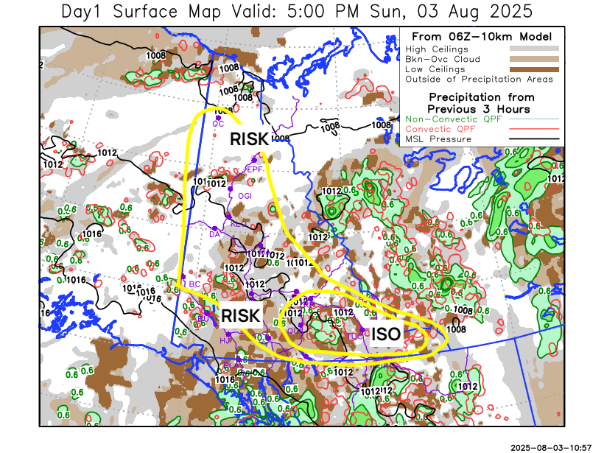
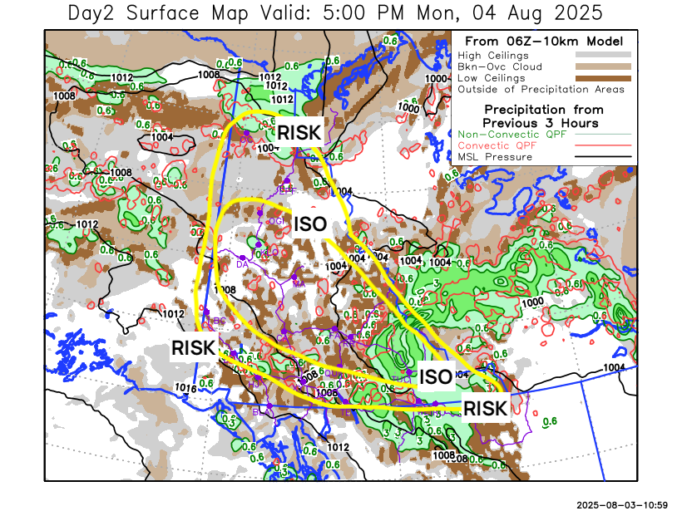

Forecast for | Monday | (Peak burning period and overnight)
Community | Clouds | Pcpn | POP | POL | Max Temp | Min RH | Min Temp | Max  RH | Wind Dir | Wind Speed
Old Crow | BKN | TRW-/RW- | 60 | 10 | 22 | 35 | 3 | 95 | 20 | 25G40
Klondike Fc | SCT | TRW-/RW- | 50 | 20 | 25 | 35 | 12 | 95 | 290 | 15
Mayo A | SCT | TRW-/RW- | 50 | 20 | 23 | 35 | 13 | 95 | 320 | 15
Carmacks | SCT | TRW-/RW- | 40 | 20 | 24 | 35 | 12 | 90 | 320 | 15
Faro | BKN | TRW-/R- | 70 | 20 | 19 | 45 | 9 | 95 | 290 | 15
Ross River | BKN | TRW-/R- | 70 | 20 | 20 | 45 | 8 | 95 | 290 | 15
Beaver Creek Town | SCT | TRW-/RW- | 40 | 10 | 23 | 40 | 8 | 95 | 290 | 15
Burwash A | BKN | TRW-/RW- | 60 | 10 | 18 | 50 | 9 | 90 | 290 | 15
Haines Junction | BKN | TRW-/RW- | 60 | 10 | 21 | 50 | 8 | 95 | 270 | 15
Whitehorse Auto | BKN | TRW-/RW- | 70 | 10 | 17 | 40 | 11 | 95 | 270 | 20
Teslin | OVC | TRW-/R- | 80 | 10 | 16 | 50 | 10 | 95 | 250 | 15
Watson Lake | OVC | TRW-/R- | 90 | 20 | 16 | 50 | 10 | 95 | 250 | 20

Forecast for |  |  | Tuesday |  | (Peak burning period and overnight)
Community |  |  | Clouds |  | Pcpn |  | POP |  | POL |  | Max Temp |  | Min RH | Min Temp | Max  RH | Wind Dir | Wind Speed
Old Crow |  |  | BKN |  | RW- |  | 40 |  | 0 |  | 15 |  | 45 | 4 | 95 | 140 | 15
Klondike Fc |  |  | SCT |  | TRW-/RW- |  | 40 |  | 10 |  | 23 |  | 35 | 11 | 95 | 290 | 10
Mayo A |  |  | SCT |  | TRW-/RW- |  | 40 |  | 10 |  | 22 |  | 40 | 14 | 95 | 270 | 10
Carmacks |  |  | SCT |  | TRW-/RW- |  | 40 |  | 10 |  | 26 |  | 30 | 12 | 85 | 290 | 10
Faro |  |  | SCT |  | TRW-/RW- |  | 40 |  | 10 |  | 20 |  | 35 | 10 | 90 | 290 | 10
Ross River |  |  | SCT |  | TRW-/RW- |  | 40 |  | 10 |  | 23 |  | 30 | 8 | 90 | 290 | 10
Beaver Creek Town |  |  | SCT |  | TRW-/RW- |  | 30 |  | 10 |  | 24 |  | 35 | 9 | 95 | 320 | 10
Burwash A |  |  | SCT |  |  |  | 20 |  | 0 |  | 20 |  | 40 | 10 | 85 | 320 | 10
Haines Junction |  |  | SCT |  |  |  | 20 |  | 0 |  | 24 |  | 35 | 10 | 90 | 270 | 15
Whitehorse Auto |  |  | SCT |  |  |  | 20 |  | 0 |  | 21 |  | 30 | 12 | 85 | 320 | 15
Teslin |  |  | BKN |  | TRW-/RW- |  | 30 |  | 10 |  | 18 |  | 45 | 10 | 95 | 250 | 10
Watson Lake |  |  | BKN |  | TRW-/RW- |  | 30 |  | 10 |  | 18 |  | 50 | 10 | 95 | 270 | 10
3-Day Forecast Precipitation Totals from 13:00 Yesterday
OC | 8.7 |  | FA | 9.7 |  | JAK | 11.2
EPF | 9.0 |  | RR | 8.8 |  | TE | 10.7
ANT | 0.2 |  | BC | 0.7 |  | QUI | 9.8
DA | 0.2 |  | BCT | 0.7 |  | SWI | 24.2
FMI | 2.4 |  | BU | 12.5 |  | FL | 25.4
HEN | 0.3 |  | HJF | 6.1 |  | TUC | 24.9
BAR | 0.8 |  | RAI | 7.8 |  | HAS | 18.8
MA | 1.7 |  | CH | 12.1 |  | TC | 22.6
STW | 1.1 |  | BR | 9.5 |  | WL | 21.0
WIL | 1.4 |  | NU | 11.8 |  | PE | 1.4
XY | 12.3 |  | IRO | 19.1 |  | CA | 3.3
CC | 9.4 |  | ELK | 7.6 |  | DRU | 9.4
ATL | 12.0 |  | NA | NA |  | NA | NA
Scott Kehler Meteorologist

Disclaimer : The information in these forecasts is collected and prepared for internal use by the Government of Yukon. The forecasts are specifically designed to meet the needs of the Wildland Fire Management and may not cover the requirements of other parties. Weather warnings or advisories are not included as part of the forecasts. Wildland Fire Management makes no representation and provides no warranty as to the accuracy of its weather forecasts. Any use the recipient chooses to make of the forecasts will be at its sole risk.

