YUKON WILDLAND FIRE MANAGEMENT WEATHER FORECAST - 9:00 AM ISSUE

11-Aug-2025
YESTERDAY'S VALUES
Community | Max  Temp  (°C) | Diff.  from  Normal | Min Temp  (°C) | Diff. from Normal | Pcpn  (mm) | Min RH | Max RH | L110 | L30
Old Crow | 20.9 | 3.0 | 11.4 | 5.1 | 4.2 | 45 | 97 | 10 | 0
Fort Mcpherson Airport | 25.4 |  | 8.2 |  | 3.7 | 37 | 97 | 15 | 0
Rock River Climate | 18.7 |  | 9.7 |  | 9.4 | 52 | 99 | - | -
Eagle Plains Fire | 19.5 |  | 9.6 |  | 7.0 | 55 | 100 | 85 | 4
Antimony Creek | 21.0 |  | 5.8 |  | 1.3 | 39 | 100 | 227 | 39
Klondike Fc | 22.7 |  | 8.9 |  | 6.9 | 42 | 99 | 230 | 31
Forty Mile | 22.3 |  | 9.6 |  | 2.4 | 41 | 99 | 125 | 13
Henderson | 19.7 |  | 7.6 |  | 8.4 | 42 | 97 | 216 | 18
Barlow | 21.1 |  | 7.0 |  | 3.3 | 44 | 99 | 203 | 5
Mayo A | 21.9 | 1.1 | 8.2 | 0.8 | 7.0 | 49 | 96 | 121 | 29
Stewart Crossing | 22.5 |  | 8.2 |  | 1.9 | 44 | 99 | 155 | 20
Willow Creek | 24.0 |  | 9.2 |  | 4.6 | 33 | 98 | 137 | 16
Pelly Farm | 25.3 | 4.3 | 7.1 | 0.7 | 1.3 | 29 | 95 | 147 | 11
Carmacks | 26.3 |  | 10.4 |  | 0.0 | 28 | 77 | 52 | 0
Drury Creek | 23.1 |  | 6.9 |  | 0.8 | 40 | 96 | 12 | 0
Faro | 21.4 | 2.0 | 8.9 | 1.8 | 2.4 | 45M | 95M | 0 | 0
Ross River | 23.4 |  | 6.7 |  | 0.0 | 32 | 97 | 0 | 0
Macmillan Pass | 15.6 |  | 7.3 |  | 0.2 | 54 | 94 | 0 | 0
Beaver Creek A | 21.8 | 3.0 | 4.6 | -0.9 | 0.0 | 27 | 97 | 31 | 0
Beaver Creek Town | 22.5 |  | 5.0 |  | 0.0 | 27 | 94 | 26 | 0
Burwash A | 22.5 | 4.2 | 4.7 | -0.3 | 0.0 | 32 | 71 | 4 | 0
Haines Junction | 23.4 | 3.7 | 5.7 | 1.7 | 0.0 | 32 | 89 | 0 | 0
Rainbow | 21.3 |  | 11.8 |  | 0.0 | 38 | 67 | 0 | 0
Champagne | 22.1 |  | 12.0 |  | 0.0 | 38 | 71 | 0 | 0
Braeburn | 24.6 |  | 10.1 |  | 0.0 | 31 | 69 | 0 | 0
Nursery | 22.5 |  | 5.9 |  | 0.0 | 31 | 92 | 0 | 0
Whitehorse Auto | 21.3 | 1.8 | 11.2 | 4.1 | 0.0 | 36 | 73 | 0 | 0
Mount Sima | 16.8 |  | 9.3 |  | 0.0 | 41 | 74 | 0 | 0
Carcross | 20.3 |  | 12.3 |  | 0.0 | 48 | 80 | 0 | 0
Atlin | 20.2 |  | 13.2 |  | 0.0 | 49 | 69 | 0 | 0
Jakes Corner | 19.1 |  | 10.0 |  | 0.3 | 48 | 83 | 0 | 0
Teslin | 18.2 |  | 9.3 |  | 0.4 | 51 | 93 | 0 | 0
Quiet Lake | 21.3 |  | 11.4 |  | 0.0 | 57 | 82 | 0 | 0
Swift River | 15.8 |  | 10.0 |  | 0.9 | 73 | 95 | 0 | 0
Tuchitua | 20.5 |  | 9.5 |  | 0.3 | 47 | 99 | 0 | 0
Hasselburg | 19.7 |  | 8.6 |  | 0.0 | 45 | 95 | 0 | 0
Tom Creek | 19.2 |  | 8.4 |  | 0.0 | 60 | 97 | 0 | 0
Watson Lake | 19.1 | -1.0 | 12.2 | 4.6 | 0.2 | 57 | 84 | 0 | 0
Iron Creek | 20.5 |  | 9.8 |  | 0.0 | 56 | 98 | 0 | 0
Max Temp is the actual maximum temperature in °C from yesterday afternoon or evening.
Min Temp is the actual overnight minimum temperature in °C up until 6:00 AM this morning.
Diff. from Normal is the difference from the 30 year average max or min temperature.
Pcpn is the precipitation in mm since 13:00 yesterday.
Min RH is the minimum observed RH in % from yesterday afternoon or evening.
Max RH is the maximum observed overnight RH in % up until 6:00 AM this morning.
L110 is the actual number of lightning strikes within 110 km and in the Yukon for 24 hours ending at 06:00 AM this morning.
L30 is the actual number of lightning strikes within 30 km and in the Yukon for 24 hours ending at 06:00 AM this morning.
M is missing data. * denotes precipitation at stations that failed to report for at least part of the evening and overnight period.

SYNOPSIS:
Today: An upper-level wave is expected to advance into the Yukon today keeping conditions rather unsettled, producing widespread cloud cover and shower activity in the Territory. The only exception is in the Old Crow district where POPs are lower with only a slight risk of showers. Risk of thundershowers by afternoon through most of central and southern Yukon, apart from the Tintina region and Beaver Creek district. Highs in the teens to low twenties with RHs generally 40% or higher, except 30-40% range in the Haines Junction district. Winds become moderate northwest, gusting up to 25-30 km/h late in the day into the overnight hours.

Tuesday: The upper-level disturbance is expected to linger in eastern Yukon, bringing cloud cover, lingering showers, and patchy light rains to Tintina and eastern Tatchun. Ridging begins to build into the western half of the Territory on Tuesday, leading to sunnier skies from Mayo/Carmacks and westward. Highs in the upper teens to low twenties with RHs 30% or higher. Winds weakening throughout the day.

Wednesday: A weak ridge will shift into the Yukon, leading to a mix of sun and cloud across most of the region and highs warming into the low to mid-twenties. No notable precipitation expected on Wednesday. Winds shift to light to moderate southeasterly. Minimum RHs generally in the 30-40% range.

Thursday: The ridge begins to gradually break down by Thursday, leading to increased cloud cover across the western half of the Territory as well as a slight risk of isolated shower/thundershower activity. Temperatures expected to be in the upper teens to low twenties.

Friday: Troughing located in Alaska/Gulf of Alaska is expected to push cloud cover and showers into south-central and southwest Yukon, while variable cloudiness is generally expected through the remainder of the Yukon. Highs remain in the upper teens to low twenties.

Forecast for | Monday | (Peak burning period and overnight)
Community | Clouds | Pcpn | POP | POL | Max Temp | Min RH | Min Temp | Max  RH | Wind Dir | Wind Speed
Old Crow | BKN | RW- | 20 |  | 16 | 60 | 8 | 88 | 230 | 16
Klondike Fc | SCT | RW-/TRW- | 30 | RISK | 18 | 55 | 8 | 90 | 320 | 10G25
Mayo A | BKN | RW-/TRW- | 40 | ISO | 19 | 54 | 12 | 87 | 340 | 10
Carmacks | BKN | RW/TRW- | 60 | ISO | 20 | 50 | 10 | 86 | 320 | 10G25
Faro | BKN | RW/TRW- | 70 | ISO | 18 | 56 | 9 | 95 | 320 | 10
Ross River | BKN | RW/TRW- | 70 | ISO | 21 | 49 | 8 | 91 | 320 | 11
Beaver Creek Town | BKN | R-/RW- | 60 |  | 14 | 69 | 4 | 87 | 290 | 15G30
Burwash A | BKN | R-/TRW- | 80 | RISK | 17 | 45 | 7 | 91 | 290 | 15G30
Haines Junction | BKN | R-/TRW- | 80 | RISK | 21 | 35 | 8 | 89 | 320 | 15G30
Whitehorse Auto | OVC | R-/TRW- | 80 | RISK | 17 | 50 | 11 | 94 | 320 | 16
Teslin | BKN | R-/TRW- | 70 | RISK | 16 | 73 | 11 | 94 | 200 | 10
Watson Lake | BKN | R-/RW- | 80 |  | 16 | 70 | 10 | 94 | 250 | 8
POP is probability of precipitation in %.
POL is probability of lightning in %.

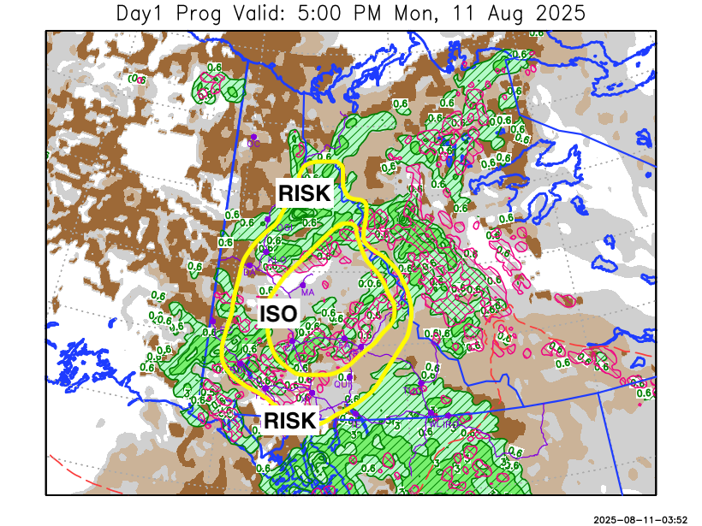
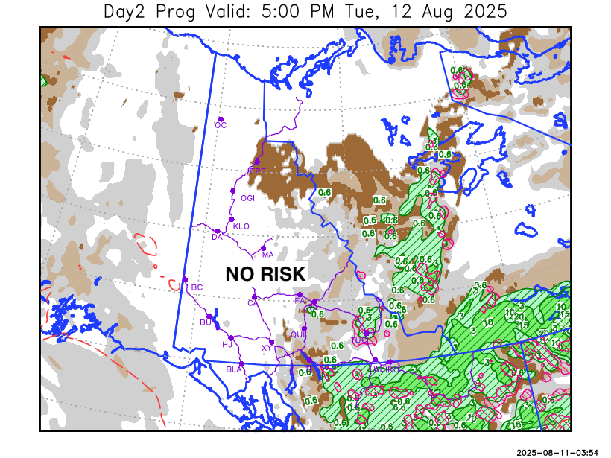

Forecast for | Tuesday | (Peak burning period and overnight)
Community | Clouds | Pcpn | POP | POL | Max Temp | Min RH | Min Temp | Max  RH | Wind Dir | Wind Speed
Old Crow | FEW |  | 0 |  | 20 | 38 | 8 | 84 | 220 | 13
Klondike Fc | FEW |  | 0 |  | 23 | 36 | 9 | 84 | 90 | 6
Mayo A | SCT |  | 0 |  | 21 | 46 | 12 | 86 | 0 | 8
Carmacks | FEW |  | 0 |  | 23 | 43 | 9 | 87 | 160 | 8
Faro | SCT | R-/RW- | 20 |  | 19 | 53 | 8 | 89 | 340 | 9
Ross River | BKN | R-/RW- | 30 |  | 20 | 55 | 7 | 88 | 320 | 9
Beaver Creek Town | SCT |  | 0 |  | 22 | 40 | 6 | 79 | 110 | 15
Burwash A | FEW |  | 0 |  | 19 | 40 | 7 | 82 | 160 | 10
Haines Junction | FEW |  | 0 |  | 22 | 35 | 7 | 85 | 180 | 8
Whitehorse Auto | SCT |  | 0 |  | 18 | 55 | 9 | 90 | 160 | 12
Teslin | SCT | R-/RW- | 30 |  | 17 | 65 | 10 | 91 | 320 | 12
Watson Lake | BKN | R-/RW- | 70 |  | 17 | 67 | 9 | 90 | 70 | 10

Forecast for |  |  | Wednesday |  |  | (Peak burning period and overnight)
Community |  |  | Clouds |  |  | Pcpn | POP |  | POL |  | Max Temp |  | Min RH | Min Temp | Max  RH | Wind Dir | Wind Speed
Old Crow |  |  | SCT |  |  |  | 0 |  |  |  | 23 |  | 35 | 11 | 79 | 220 | 9
Klondike Fc |  |  | SCT |  |  |  | 0 |  |  |  | 24 |  | 35 | 12 | 74 | 90 | 12
Mayo A |  |  | SCT |  |  |  | 0 |  |  |  | 24 |  | 38 | 14 | 75 | 140 | 8
Carmacks |  |  | SCT |  |  |  | 0 |  |  |  | 25 |  | 35 | 11 | 76 | 140 | 13
Faro |  |  | SCT |  |  |  | 10 |  |  |  | 21 |  | 45 | 9 | 81 | 140 | 13
Ross River |  |  | SCT |  |  |  | 10 |  |  |  | 23 |  | 43 | 7 | 81 | 140 | 11
Beaver Creek Town |  |  | SCT |  |  |  | 0 |  |  |  | 23 |  | 34 | 8 | 69 | 140 | 10
Burwash A |  |  | SCT |  |  |  | 0 |  |  |  | 21 |  | 32 | 8 | 67 | 140 | 16
Haines Junction |  |  | SCT |  |  |  | 0 |  |  |  | 24 |  | 29 | 7 | 79 | 180 | 11
Whitehorse Auto |  |  | SCT |  |  |  | 0 |  |  |  | 22 |  | 40 | 11 | 80 | 140 | 10G25
Teslin |  |  | SCT |  |  |  | 0 |  |  |  | 20 |  | 43 | 10 | 84 | 140 | 12
Watson Lake |  |  | SCT |  |  |  | 10 |  |  |  | 19 |  | 42 | 10 | 78 | 140 | 8
3-Day Forecast Precipitation Totals from 13:00 Yesterday
OC | 4.5 |  | FA | 8.9 |  | JAK | 13.8
EPF | 12.6 |  | RR | 8.2 |  | TE | 13.3
ANT | 3.1 |  | BC | 3.8 |  | QUI | 7.5
DA | 8.7 |  | BCT | 3.8 |  | SWI | 19.5
FMI | 5.2 |  | BU | 7.1 |  | FL | 8.3
HEN | 10.0 |  | HJF | 12.4 |  | TUC | 9.0
BAR | 5.4 |  | RAI | 12.0 |  | HAS | 8.7
MA | 11.1 |  | CH | 11.7 |  | TC | 10.9
STW | 5.5 |  | BR | 7.9 |  | WL | 11.6
WIL | 8.7 |  | NU | 11.0 |  | PE | 6.0
XY | 12.6 |  | IRO | 12.8 |  | CA | 4.7
CC | 11.6 |  | ELK | 20.7 |  | DRU | 6.6
ATL | 17.9 |  | NA | NA |  | NA | NA
Matt Desorcy Meteorologist

Disclaimer : The information in these forecasts is collected and prepared for internal use by the Government of Yukon. The forecasts are specifically designed to meet the needs of the Wildland Fire Management and may not cover the requirements of other parties. Weather warnings or advisories are not included as part of the forecasts. Wildland Fire Management makes no representation and provides no warranty as to the accuracy of its weather forecasts. Any use the recipient chooses to make of the forecasts will be at its sole risk.

