YUKON WILDLAND FIRE MANAGEMENT WEATHER FORECAST - 9:00 AM ISSUE

12-Aug-2025
YESTERDAY'S VALUES
Community | Max  Temp  (°C) | Diff.  from  Normal | Min Temp  (°C) | Diff. from Normal | Pcpn  (mm) | Min RH | Max RH | L110 | L30
Old Crow | 17.5 | -0.2 | 5.7 | -0.5 | 0.0 | 54 | 92 | 0 | 0
Fort Mcpherson Airport | 13.8 |  | 8.2 |  | 0.0 | 72 | 97 | 0 | 0
Rock River Climate | 10.5 |  | 7.0 |  | 3.8 | 93 | 100 | - | -
Eagle Plains Fire | 9.8 |  | 7.6 |  | 4.5 | 88 | 100 | 0 | 0
Antimony Creek | 17.9 |  | 3.2 |  | 0.8 | 54 | 98 | 5 | 0
Klondike Fc | 18.6 |  | 3.8 |  | 0.0 | 51 | 97 | 3 | 0
Forty Mile | 14.3 |  | 3.8 |  | 0.0 | 59 | 98 | 0 | 0
Henderson | 14.7 |  | 5.2 |  | 0.3 | 59 | 90 | 9 | 0
Barlow | 16.4 |  | 4.5 |  | 3.1 | 61 | 96 | 37 | 0
Mayo A | 17.0 | -3.7 | 7.8 | 0.5 | 13.7 | 67 | 90 | 75 | 20
Stewart Crossing | 18.2 |  | 10.2 |  | 0.0 | 52 | 84 | 71 | 7
Willow Creek | 19.6 |  | 7.7 |  | 1.3 | 50 | 93 | 95 | 4
Pelly Farm | 21.2 | 0.3 | 9.1 | 2.8 | 0.6 | 42 | 90 | 138 | 12
Carmacks | 21.8 |  | 9.7 |  | 0.0 | 43 | 87 | 112 | 28
Drury Creek | 20.3 |  | 5.7 |  | 0.0 | 42 | 96 | 52 | 3
Faro | 19.9 | 0.6 | 9.5 | 2.6 | 0.0 | 47M | 100M | 12 | 0
Ross River | 22.1 |  | 9.2 |  | 9.3 | 33 | 98 | 2 | 0
Macmillan Pass | 15.2 |  | 6.6 |  | 9.0 | 56 | 98 | 0 | 0
Beaver Creek A | 12.8 | -5.9 | 0.6 | -4.8 | 0.0 | 57 | 99 | 11 | 0
Beaver Creek Town | 13.4 |  | 1.6 |  | 0.0 | 57 | 94 | 11 | 0
Burwash A | 18.2 | 0.0 | 4.0 | -0.9 | 0.0M | 46 | 88 | 101 | 0
Haines Junction | 22.8 | 2.5 | 7.0 | 4.1 | 0.3 | 36 | 92 | 108 | 30
Rainbow | 21.7 |  | 6.9 |  | 13.8 | 39 | 99 | 107 | 36
Champagne | 19.8 |  | 5.9 |  | 10.2 | 38 | 98 | 86 | 5
Braeburn | 15.9 |  | 4.7 |  | 10.7 | 53 | 99 | 95 | 0
Nursery | 19.2 |  | 8.4 |  | 7.8 | 47 | 99 | 39 | 0
Whitehorse Auto | 16.7 | -2.7 | 8.5 | 1.5 | 11.0 | 57 | 97 | 25 | 0
Mount Sima | 13.4 |  | 6.5 |  | 12.6 | 62 | 99 | 27 | 0
Carcross | 16.5 |  | 9.1 |  | 3.7 | 60 | 99 | 0 | 0
Atlin | 13.2 |  | 9.8 |  | 2.8 | 85 | 98 | 0 | 0
Jakes Corner | 15.8 |  | 9.0 |  | 9.5 | 66 | 96 | 0 | 0
Teslin | 14.1 |  | 8.6 |  | 1.4 | 75 | 99 | 0 | 0
Quiet Lake | 17.7 |  | 8.2 |  | 10.7 | 57 | 99 | 1 | 0
Swift River | 13.1 |  | 9.1 |  | 4.6 | 74 | 99 | 0 | 0
Tuchitua | 19.5 |  | 7.6 |  | 2.9 | 49 | 100 | 0 | 0
Hasselburg | 15.5 |  | 9.7 |  | 0.8 | 57 | 96 | 0 | 0
Tom Creek | 15.1 |  | 7.7 |  | 1.6 | 69 | 100 | 0 | 0
Watson Lake | 16.5 | -3.5 | 8.2 | 0.7 | 6.8 | 61 | 98 | 0 | 0
Iron Creek | 18.4 |  | 4.1 |  | 2.7 | 56 | 99 | 0 | 0
Max Temp is the actual maximum temperature in °C from yesterday afternoon or evening.
Min Temp is the actual overnight minimum temperature in °C up until 6:00 AM this morning.
Diff. from Normal is the difference from the 30 year average max or min temperature.
Pcpn is the precipitation in mm since 13:00 yesterday.
Min RH is the minimum observed RH in % from yesterday afternoon or evening.
Max RH is the maximum observed overnight RH in % up until 6:00 AM this morning.
L110 is the actual number of lightning strikes within 110 km and in the Yukon for 24 hours ending at 06:00 AM this morning.
L30 is the actual number of lightning strikes within 30 km and in the Yukon for 24 hours ending at 06:00 AM this morning.
M is missing data. * denotes precipitation at stations that failed to report for at least part of the evening and overnight period.

SYNOPSIS:
Today: A departing low-pressure system is expected to linger in eastern Yukon, bringing cloud cover and patchy showers (including very slight risk of lightning) to Tintina and eastern Tatchun. Ridging begins to build into the western half of the Territory today, leading to sunnier skies from Mayo/Carmacks and westward through Kluane and the Klondike. Highs in the upper teens to low twenties with RHs 30% or higher – driest conditions in the Haines Junction district where RHs drop into the low thirties. Northwest winds weakening throughout the day, becoming light and variable in most regions by evening.

Wednesday: A weak ridge will shift into the Yukon, leading to a mix of sun and cloud across most of the region and highs warming into the low to mid-twenties (warmest in Northern Tutchone, western Tatchun, and the Klondike). No notable precipitation expected on Wednesday. Winds shift to light to moderate southeasterly. Minimum RHs generally in the 30-40% range, except mid-20s in the Haines Junction district.

Thursday: The ridge begins to gradually break down by Thursday, leading to increased cloud cover across the western half of the Territory as well as a slight risk of isolated shower/thundershower activity late in the day. Mainly sunny skies hang on across eastern Yukon. Temperatures expected to be in the low twenties with minimum RHs 30-40%.

Friday: Troughing located in Alaska/Gulf of Alaska is expected to push cloud cover and scattered showers into the Klondike, Kluane, and Southern Lakes. Some uncertainty exists as to how far east into the Territory the cloud cover and showers will extend. Variable cloudiness is generally expected through the eastern half of the Yukon at this point. Highs in the upper teens to low twenties except cooler in Old Crow.

Saturday: An upper-level low develops in the Gulf of Alaska, bringing continued cloud cover and shower activity to southern and western Yukon. Shower activity will be rather disorganized, producing spotty light rainfall amounts through affected regions. Northern Tutchone, Tatchun, and Tintina to see a few sunny breaks, located furthest away from the upper-level low. Highs in the upper teens to low twenties except cooler (low teens) in Old Crow.

Forecast for | Tuesday | (Peak burning period and overnight)
Community | Clouds | Pcpn | POP | POL | Max Temp | Min RH | Min Temp | Max  RH | Wind Dir | Wind Speed
Old Crow | FEW |  | 0 |  | 21 | 38 | 9 | 84 | 220 | 14
Klondike Fc | CLR |  | 0 |  | 22 | 40 | 9 | 85 | 90 | 6
Mayo A | SCT |  | 0 |  | 21 | 45 | 12 | 88 | 90 | 7
Carmacks | SCT |  | 0 |  | 22 | 44 | 9 | 89 | 340 | 10
Faro | BKN | R-/RW- | 40 |  | 17 | 70 | 8 | 92 | 0 | 8
Ross River | BKN | R-/RW- | 60 |  | 18 | 68 | 7 | 92 | 340 | 9
Beaver Creek Town | CLR |  | 0 |  | 21 | 40 | 4 | 81 | 100 | 12
Burwash A | CLR |  | 0 |  | 19 | 40 | 7 | 78 | 160 | 10
Haines Junction | CLR |  | 0 |  | 23 | 32 | 7 | 88 | 180 | 7
Whitehorse Auto | SCT |  | 10 |  | 18 | 50 | 10 | 92 | 0 | 13
Teslin | BKN | R-/RW- | 60 |  | 16 | 70 | 10 | 95 | 340 | 11
Watson Lake | BKN | R-/RW- | 40 |  | 16 | 67 | 9 | 90 | 40 | 9
POP is probability of precipitation in %.
POL is probability of lightning in %.

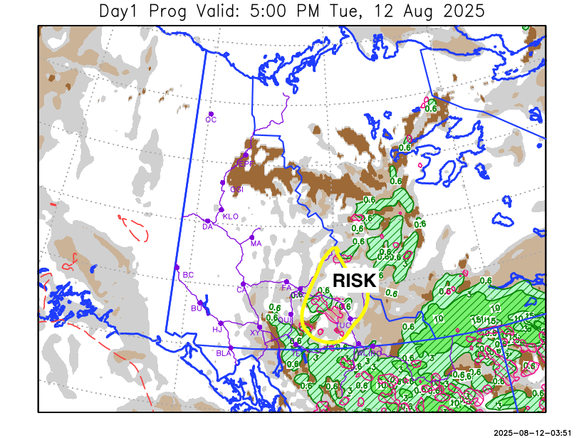
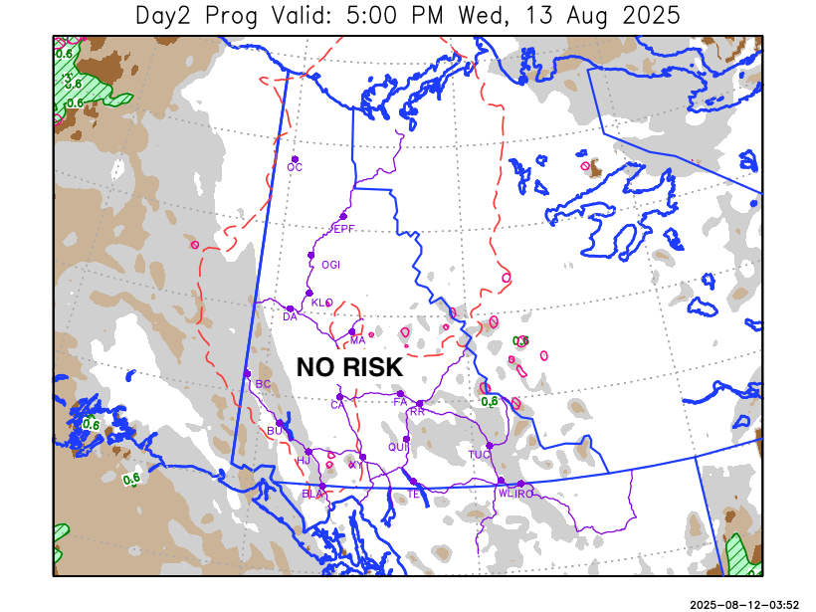

Forecast for | Wednesday | (Peak burning period and overnight)
Community | Clouds | Pcpn | POP | POL | Max Temp | Min RH | Min Temp | Max  RH | Wind Dir | Wind Speed
Old Crow | FEW |  | 0 |  | 24 | 33 | 11 | 80 | 180 | 7
Klondike Fc | SCT |  | 0 |  | 25 | 36 | 11 | 76 | 90 | 12
Mayo A | SCT |  | 0 |  | 24 | 41 | 14 | 79 | 90 | 8
Carmacks | SCT |  | 0 |  | 26 | 35 | 11 | 77 | 140 | 16
Faro | SCT |  | 10 |  | 20 | 52 | 8 | 84 | 140 | 15
Ross River | SCT |  | 10 |  | 22 | 48 | 6 | 84 | 140 | 10
Beaver Creek Town | BKN |  | 0 |  | 22 | 35 | 7 | 71 | 110 | 8
Burwash A | BKN |  | 0 |  | 20 | 35 | 8 | 67 | 140 | 17
Haines Junction | BKN |  | 0 |  | 24 | 26 | 7 | 81 | 180 | 12
Whitehorse Auto | SCT |  | 0 |  | 21 | 40 | 11 | 81 | 140 | 15G30
Teslin | SCT |  | 0 |  | 20 | 44 | 10 | 86 | 110 | 12
Watson Lake | SCT |  | 0 |  | 19 | 41 | 8 | 80 | 140 | 8

Forecast for |  |  | Thursday |  | (Peak burning period and overnight)
Community |  |  | Clouds |  | Pcpn |  | POP |  | POL |  | Max Temp |  | Min RH | Min Temp | Max  RH | Wind Dir | Wind Speed
Old Crow |  |  | BKN |  | RW-/TRW- |  | 20 |  | RISK |  | 23 |  | 37 | 10 | 77 | 270 | 12
Klondike Fc |  |  | BKN |  | RW-/TRW- |  | 20 |  | RISK |  | 23 |  | 38 | 13 | 74 | 110 | 10
Mayo A |  |  | BKN |  |  |  | 10 |  |  |  | 23 |  | 40 | 14 | 75 | 90 | 11
Carmacks |  |  | BKN |  |  |  | 10 |  |  |  | 24 |  | 36 | 12 | 75 | 140 | 15
Faro |  |  | SCT |  |  |  | 10 |  |  |  | 20 |  | 46 | 9 | 76 | 110 | 15
Ross River |  |  | SCT |  |  |  | 10 |  |  |  | 22 |  | 42 | 6 | 78 | 110 | 10
Beaver Creek Town |  |  | BKN |  | RW- |  | 20 |  |  |  | 20 |  | 43 | 7 | 83 | 290 | 12
Burwash A |  |  | BKN |  |  |  | 0 |  |  |  | 18 |  | 36 | 9 | 75 | 140 | 8
Haines Junction |  |  | BKN |  |  |  | 0 |  |  |  | 22 |  | 30 | 9 | 79 | 180 | 10
Whitehorse Auto |  |  | BKN |  | RW-/TRW- |  | 20 |  | RISK |  | 21 |  | 40 | 12 | 77 | 140 | 15
Teslin |  |  | BKN |  | RW-/TRW- |  | 20 |  | RISK |  | 21 |  | 40 | 11 | 84 | 140 | 11
Watson Lake |  |  | SCT |  |  |  | 0 |  |  |  | 20 |  | 36 | 11 | 68 | 110 | 12
3-Day Forecast Precipitation Totals from 13:00 Yesterday
OC | 0.0 |  | FA | 1.9 |  | JAK | 10.1
EPF | 4.5 |  | RR | 12.6 |  | TE | 2.7
ANT | 0.8 |  | BC | 0.0 |  | QUI | 12.0
DA | 0.0 |  | BCT | 0.0 |  | SWI | 8.9
FMI | 0.0 |  | BU | 0.0 |  | FL | 3.4
HEN | 0.3 |  | HJF | 0.3 |  | TUC | 7.0
BAR | 3.1 |  | RAI | 13.8 |  | HAS | 4.9
MA | 13.7 |  | CH | 10.2 |  | TC | 6.2
STW | 0.0 |  | BR | 10.7 |  | WL | 11.5
WIL | 1.3 |  | NU | 7.8 |  | PE | 0.6
XY | 11.1 |  | IRO | 8.1 |  | CA | 0.0
CC | 3.8 |  | ELK | 15.3 |  | DRU | 0.7
ATL | 3.9 |  | NA | NA |  | NA | NA
Matt Desorcy Meteorologist

Disclaimer : The information in these forecasts is collected and prepared for internal use by the Government of Yukon. The forecasts are specifically designed to meet the needs of the Wildland Fire Management and may not cover the requirements of other parties. Weather warnings or advisories are not included as part of the forecasts. Wildland Fire Management makes no representation and provides no warranty as to the accuracy of its weather forecasts. Any use the recipient chooses to make of the forecasts will be at its sole risk.

