YUKON WILDLAND FIRE MANAGEMENT WEATHER FORECAST - 9:00 AM ISSUE

14-Aug-2025
YESTERDAY'S VALUES
Community | Max  Temp  (°C) | Diff.  from  Normal | Min Temp  (°C) | Diff. from Normal | Pcpn  (mm) | Min RH | Max RH | L110 | L30
Old Crow | 25.7 | 8.4 | 7.9 | 2.0 | 0.0 | 27 | 91 | 0 | 0
Fort Mcpherson Airport | 25.7 |  | 9.6 |  | 0.0 | 32 | 92 | 0 | 0
Rock River Climate | 21.4 |  | 11.9 |  | 0.0 | 32 | 64 | NA | NA
Eagle Plains Fire | 23.3 |  | 13.6 |  | 0.0 | 31 | 54 | 0 | 0
Antimony Creek | 22.8 |  | 8.7 |  | 0.0 | 37 | 91 | 0 | 0
Klondike Fc | 23.2 |  | 9.1 |  | 0.0 | 34 | 91 | 0 | 0
Forty Mile | 22.8 |  | 6.9 |  | 0.0 | 35 | 99 | 0 | 0
Henderson | 19.7 |  | 11.4 |  | 0.0 | 38 | 64 | 0 | 0
Barlow | 22.4 |  | 13.0 |  | 0.0 | 37 | 61 | 0 | 0
Mayo A | 23.1 | 2.8 | 7.1 | 0.1 | 0.0 | 33 | 92 | 0 | 0
Stewart Crossing | 23.0 |  | 9.1 |  | 0.0 | 31 | 84 | 0 | 0
Willow Creek | 23.0 |  | 6.7 |  | 0.0 | 32 | 94 | 0 | 0
Pelly Farm | 25.1 | 4.5 | 7.7 | 1.7 | 0.0 | 29 | 87 | 0 | 0
Carmacks | 26.7 |  | 6.5 |  | 0.0 | 24 | 82 | 0 | 0
Drury Creek | 23.5 |  | 4.6 |  | 0.0 | 30 | 93 | 0 | 0
Faro | 20.6 | 1.6 | 6.5 | -0.1 | 0.0 | 47M | 96M | 0 | 0
Ross River | 22.4 |  | 0.4 |  | 0.0 | 37 | 97 | 0 | 0
Macmillan Pass | 15.7 |  | 3.0 |  | 0.0 | 50 | 96 | 0 | 0
Beaver Creek A | 21.4 | 3.0 | 5.7 | 0.6 | 0.0 | 37 | 90 | 0 | 0
Beaver Creek Town | 22.3 |  | 7.1 |  | 0.0 | 32 | 90 | 0 | 0
Burwash A | 20.9 | 2.9 | 4.7 | 0.0 | 0.0 | 35 | 62 | 0 | 0
Haines Junction | 23.7 | 4.8 | 0.6 | -3.8 | 0.0 | 29 | 92 | 0 | 0
Rainbow | 22.6 |  | 8.1 |  | 0.0 | 33 | 86 | 0 | 0
Champagne | 24.1 |  | 0.4 |  | 0.0 | 29 | 97 | 0 | 0
Braeburn | 23.5 |  | 2.3 |  | 0.0 | 28 | 97 | 0 | 0
Nursery | 22.7 |  | 2.2 |  | 0.0 | 33 | 96 | 0 | 0
Whitehorse Auto | 21.0 | 1.8 | 9.8 | 3.0 | 0.0 | 36 | 74 | 0 | 0
Mount Sima | 18.1 |  | 7.9 |  | 0.0 | 42 | 76 | 0 | 0
Carcross | 20.2 |  | 5.1 |  | 0.0 | 39 | 98 | 0 | 0
Atlin | 20.1 |  | 7.8 |  | 0.0 | 42 | 89 | 0 | 0
Jakes Corner | 22.7 |  | 5.1 |  | 0.0 | 32 | 93 | 0 | 0
Teslin | 19.9 |  | 5.3 |  | 0.0 | 35 | 95 | 0 | 0
Quiet Lake | 24.4 |  | 3.9 |  | 0.0 | 36 | 98 | 0 | 0
Swift River | 17.7 |  | 2.5 |  | 0.0 | 44 | 97 | 0 | 0
Tuchitua | 20.0 |  | -0.5 |  | 0.3 | 44 | 99 | 0 | 0
Hasselburg | 19.5 |  | 4.7 |  | 0.0 | 39 | 98 | 0 | 0
Tom Creek | 19.1 |  | 6.2 |  | 0.0 | 39 | 96 | 0 | 0
Watson Lake | 17.4 | -2.4 | 5.6 | -1.7 | 0.0 | 41 | 97 | 0 | 0
Iron Creek | 21.1 |  | 2.7 |  | 0.0 | 39 | 100 | 0 | 0
Max Temp is the actual maximum temperature in °C from yesterday afternoon or evening.
Min Temp is the actual overnight minimum temperature in °C up until 6:00 AM this morning.
Diff. from Normal is the difference from the 30 year average max or min temperature.
Pcpn is the precipitation in mm since 13:00 yesterday.
Min RH is the minimum observed RH in % from yesterday afternoon or evening.
Max RH is the maximum observed overnight RH in % up until 6:00 AM this morning.
L110 is the actual number of lightning strikes within 110 km and in the Yukon for 24 hours ending at 06:00 AM this morning.
L30 is the actual number of lightning strikes within 30 km and in the Yukon for 24 hours ending at 06:00 AM this morning.
M is missing data. * denotes precipitation at stations that failed to report for at least part of the evening and overnight period.

SYNOPSIS:
Today: The ridge begins to gradually break down by Thursday, leading to increased cloud cover across the western half of the Territory. In addition to this, a slight risk of isolated showers/thundershowers exist late in the day through the Klondike as well as parts of Southern Lakes. Mainly sunny skies hang on across the eastern half of the Yukon. Temperatures expected to be in the low to mid-twenties with minimum RHs 30-40%, except upper-20s RHs in the Haines Junction district. Winds moderate southeast through most regions.

Friday: Troughing located in Alaska/Gulf of Alaska is expected to push cloud cover and scattered showers/thundershowers into the Klondike, Kluane, and Southern Lakes. Steadier light rains possible across Kluane Friday evening, lasting into the overnight hours, amounting to 5-10 mm. Variable cloudiness is generally expected through the eastern half of the Yukon with no notable precipitation, though skies will become cloudy in Tintina by the evening. Warmest in central Yukon where mid-twenties are possible, while highs in the upper teens to low twenties are forecast elsewhere (coolest in the Beaver Creek district). Winds moderate east-southeasterly across most of the Territory, except moderate northwest in Kluane and the Klondike.

Saturday: An upper-level low deepens off the BC coast, bringing mainly cloudy skies to southern Yukon and a few isolated showers, particularly in the Kluane region and locations along the BC border where confidence is highest for light rain. The remainder of the Territory is expected to remain relatively dry under variable cloudiness. Highs in the teens to low twenties except mid-twenties likely in central Yukon. No change in the winds from Friday as moderate winds remain, out of the east-southeast for most regions except the western regions of the Territory.

Sunday: No significant change to the overall pattern as cloud cover remains in place through southern Yukon with showers/patchy light rains and highs in the teens to low twenties. Highs in the low to mid-twenties expected in central Yukon with the risk of a few late-day convective showers/thundershowers possible in Tatchun and Northern Tutchone.

Monday: Highs in the teens to low twenties throughout the Yukon with variable cloud cover during the day. Risk of light scattered showers develops across a broad area of the Territory.

Forecast for | Thursday | (Peak burning period and overnight)
Community | Clouds | Pcpn | POP | POL | Max Temp | Min RH | Min Temp | Max  RH | Wind Dir | Wind Speed
Old Crow | BKN | RW-/TRW- | 30 | RISK | 24 | 33 | 11 | 83 | 0 | 8
Klondike Fc | BKN | RW-/TRW- | 30 | RISK | 24 | 34 | 12 | 81 | 110 | 12
Mayo A | BKN |  | 0 |  | 24 | 33 | 14 | 68 | 140 | 11
Carmacks | SCT |  | 10 |  | 26 | 30 | 12 | 68 | 140 | 13
Faro | SCT |  | 0 |  | 22 | 33 | 8 | 73 | 110 | 15
Ross River | SCT |  | 0 |  | 23 | 32 | 6 | 78 | 110 | 11
Beaver Creek Town | OVC | RW- | 20 |  | 20 | 38 | 8 | 80 | 290 | 13
Burwash A | BKN | RW- | 20 |  | 20 | 30 | 9 | 73 | 140 | 12
Haines Junction | BKN |  | 0 |  | 23 | 28 | 9 | 69 | 180 | 12
Whitehorse Auto | BKN |  | 10 |  | 21 | 38 | 12 | 74 | 140 | 15G30
Teslin | BKN | RW-/TRW- | 20 | RISK | 21 | 38 | 12 | 77 | 110 | 14
Watson Lake | SCT |  | 0 |  | 20 | 33 | 10 | 67 | 110 | 14
POP is probability of precipitation in %.
POL is probability of lightning in %.

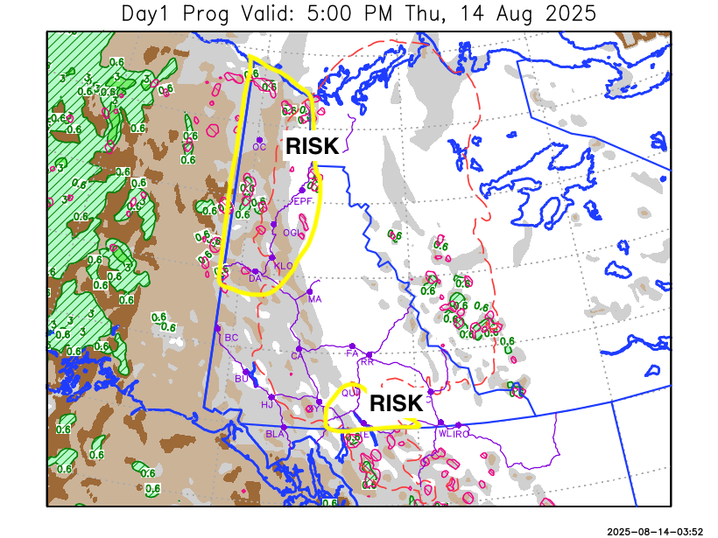
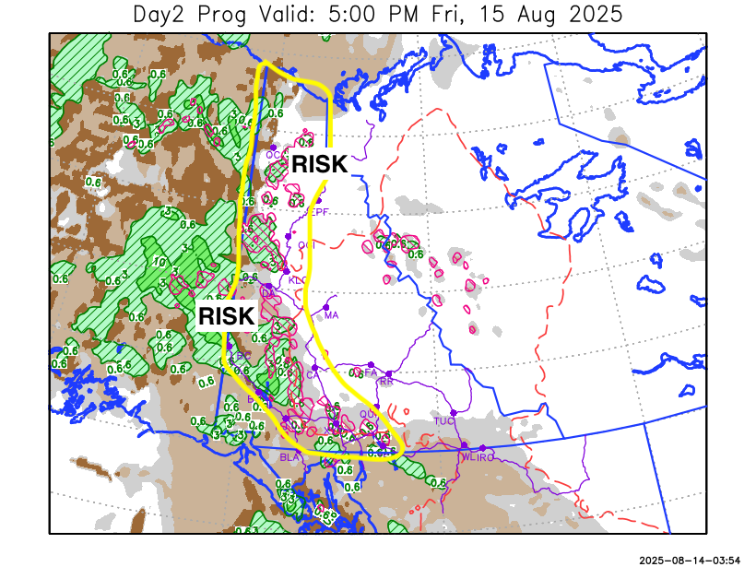

Forecast for | Friday | (Peak burning period and overnight)
Community | Clouds | Pcpn | POP | POL | Max Temp | Min RH | Min Temp | Max  RH | Wind Dir | Wind Speed
Old Crow | BKN | RW-/TRW- | 30 | RISK | 18 | 52 | 5 | 86 | 0 | 20G35
Klondike Fc | BKN | RW-/TRW- | 30 | RISK | 24 | 40 | 10 | 85 | 340 | 10
Mayo A | SCT |  | 0 |  | 24 | 30 | 13 | 65 | 70 | 13
Carmacks | BKN | RW-/TRW- | 20 | RISK | 27 | 32 | 12 | 69 | 90 | 15
Faro | SCT |  | 0 |  | 22 | 32 | 10 | 66 | 110 | 15G30
Ross River | SCT |  | 0 |  | 23 | 33 | 8 | 69 | 110 | 14
Beaver Creek Town | OVC | R/TRW- | 70 | RISK | 13 | 73 | 3 | 94 | 290 | 20G35
Burwash A | OVC | R/TRW- | 80 | RISK | 16 | 58 | 6 | 94 | 320 | 15
Haines Junction | OVC | R-/TRW- | 60 | RISK | 21 | 39 | 11 | 91 | 340 | 11
Whitehorse Auto | BKN | RW-/TRW- | 30 | RISK | 21 | 40 | 14 | 72 | 90 | 15G30
Teslin | BKN | RW-/TRW- | 20 | RISK | 20 | 42 | 13 | 70 | 70 | 15G30
Watson Lake | BKN |  | 0 |  | 21 | 33 | 12 | 63 | 90 | 15G35

Forecast for |  |  | Saturday |  |  | (Peak burning period and overnight)
Community |  |  | Clouds |  |  | Pcpn | POP |  | POL |  | Max Temp |  | Min RH | Min Temp | Max  RH | Wind Dir | Wind Speed
Old Crow |  |  | BKN |  |  |  | 0 |  |  |  | 15 |  | 53 | 5 | 86 | 20 | 15G30
Klondike Fc |  |  | BKN |  |  |  | 10 |  |  |  | 24 |  | 37 | 10 | 84 | 320 | 11
Mayo A |  |  | BKN |  |  |  | 0 |  |  |  | 24 |  | 30 | 13 | 77 | 90 | 13
Carmacks |  |  | BKN |  |  |  | 0 |  |  |  | 25 |  | 35 | 12 | 81 | 70 | 10
Faro |  |  | BKN |  |  |  | 0 |  |  |  | 20 |  | 40 | 9 | 78 | 110 | 15G30
Ross River |  |  | BKN |  |  |  | 10 |  |  |  | 21 |  | 40 | 7 | 80 | 110 | 15
Beaver Creek Town |  |  | OVC |  |  | R-/RW- | 60 |  |  |  | 12 |  | 80 | 3 | 94 | 290 | 15G30
Burwash A |  |  | OVC |  |  | R-/RW- | 80 |  |  |  | 11 |  | 81 | 7 | 95 | 320 | 15G30
Haines Junction |  |  | OVC |  |  | R-/RW- | 60 |  |  |  | 18 |  | 65 | 10 | 92 | 340 | 16
Whitehorse Auto |  |  | OVC |  |  | R-/RW- | 40 |  |  |  | 18 |  | 54 | 12 | 84 | 90 | 15G30
Teslin |  |  | OVC |  |  | R-/RW- | 30 |  |  |  | 18 |  | 55 | 11 | 87 | 70 | 15G30
Watson Lake |  |  | BKN |  |  | R-/RW- | 30 |  |  |  | 17 |  | 51 | 11 | 86 | 90 | 15G35
3-Day Forecast Precipitation Totals from 13:00 Yesterday
OC | 2.9 |  | FA | 0.0 |  | JAK | 0.7
EPF | 0.0 |  | RR | 0.0 |  | TE | 0.5
ANT | 0.0 |  | BC | 11.3 |  | QUI | 1.5
DA | 0.8 |  | BCT | 11.3 |  | SWI | 1.0
FMI | 5.8 |  | BU | 10.8 |  | FL | 0.0
HEN | 1.3 |  | HJF | 7.5 |  | TUC | 0.4
BAR | 0.0 |  | RAI | 4.7 |  | HAS | 1.1
MA | 0.0 |  | CH | 1.5 |  | TC | 0.1
STW | 0.3 |  | BR | 0.0 |  | WL | 0.1
WIL | 0.0 |  | NU | 0.4 |  | PE | 0.2
XY | 0.6 |  | IRO | 0.5 |  | CA | 0.1
CC | 3.5 |  | ELK | 1.3 |  | DRU | 0.3
ATL | 3.3 |  | NA | NA |  | NA | NA
Matt Desorcy Meteorologist

Disclaimer : The information in these forecasts is collected and prepared for internal use by the Government of Yukon. The forecasts are specifically designed to meet the needs of the Wildland Fire Management and may not cover the requirements of other parties. Weather warnings or advisories are not included as part of the forecasts. Wildland Fire Management makes no representation and provides no warranty as to the accuracy of its weather forecasts. Any use the recipient chooses to make of the forecasts will be at its sole risk.

