YUKON WILDLAND FIRE MANAGEMENT WEATHER FORECAST - 9:00 AM ISSUE

15-Aug-2025
YESTERDAY'S VALUES
Community | Max  Temp  (°C) | Diff.  from  Normal | Min Temp  (°C) | Diff. from Normal | Pcpn  (mm) | Min RH | Max RH | L110 | L30
Old Crow | 24.9 | 7.8 | 8.1 | 2.4 | 10.6 | 30 | 95 | 76 | 16
Fort Mcpherson Airport | 27.5 |  | 8.0 |  | 0.0M | 30 | 89 | 7 | 0
Rock River Climate | 22.8 |  | 13.0 |  | 1.0 | 30 | 76 | NA | NA
Eagle Plains Fire | 24.9 |  | 10.0 |  | 0.0 | 26 | 88 | 6 | 0
Antimony Creek | 23.5 |  | 6.7 |  | 0.0 | 31 | 97 | 0 | 0
Klondike Fc | 25.1 |  | 9.2 |  | 0.0 | 28 | 96 | 5 | 0
Forty Mile | 22.4 |  | 9.8 |  | 1.4 | 39 | 99 | 17 | 0
Henderson | 18.9 |  | 9.0 |  | 0.0 | 39 | 91 | 1 | 0
Barlow | 23.3 |  | 10.1 |  | 0.0 | 31 | 80 | 0 | 0
Mayo A | 22.9 | 2.7 | 11.6 | 4.7 | 0.0 | 33 | 70 | 0 | 0
Stewart Crossing | 23.5 |  | 12.8 |  | 0.0 | 30 | 75 | 0 | 0
Willow Creek | 22.9 |  | 11.0 |  | 0.0 | 33 | 83 | 0 | 0
Pelly Farm | 24.6 | 4.1 | 9.9 | 4.0 | 0.0 | 27 | 85 | 0 | 0
Carmacks | 27.4 |  | 10.2 |  | 0.0 | 22 | 65 | 0 | 0
Drury Creek | 22.9 |  | 2.8 |  | 0.0 | 29 | 93 | 0 | 0
Faro | 21.5 | 2.7 | 3.1 | -3.4 | 0.0 | 37M | 100M | 0 | 0
Ross River | 23.0 |  | -0.4 |  | 0.0 | 27 | 97 | 0 | 0
Macmillan Pass | 18.4 |  | 2.7 |  | 0.0 | 33 | 91 | 0 | 0
Beaver Creek A | 19.5 | 1.2 | 10.3 | 5.4 | 0.2 | 40 | 83 | 1 | 0
Beaver Creek Town | 20.0 |  | 10.1 |  | 0.3 | 35 | 90 | 1 | 0
Burwash A | 20.7 | 2.8 | 0.5 | -4.0 | 0.0M | 33 | 84 | 0 | 0
Haines Junction | 23.4 | 4.3 | 2.3 | -2.0 | 0.0 | 32 | 91 | 0 | 0
Rainbow | 21.8 |  | 5.1 |  | 0.0 | 33 | 90 | 0 | 0
Champagne | 22.7 |  | 0.5 |  | 0.0 | 29 | 95 | 0 | 0
Braeburn | 23.0 |  | 5.0 |  | 0.0 | 28 | 97 | 0 | 0
Nursery | 23.3 |  | 3.3 |  | 0.0 | 30 | 97 | 0 | 0
Whitehorse Auto | 21.4 | 2.3 | 7.6 | 0.9 | 0.0 | 32 | 87 | 0 | 0
Mount Sima | 19.1 |  | 10.2 |  | 0.0 | 33 | 70 | 0 | 0
Carcross | 22.0 |  | 3.4 |  | 0.0 | 32 | 96 | 0 | 0
Atlin | 20.5 |  | 9.3 |  | 0.0 | 40 | 85 | 0 | 0
Jakes Corner | 21.1 |  | 6.5 |  | 0.0 | 39 | 93 | 0 | 0
Teslin | 21.5 |  | 6.1 |  | 0.0 | 34 | 97 | 0 | 0
Quiet Lake | 23.6 |  | 6.0 |  | 0.0 | 28 | 89 | 0 | 0
Swift River | 21.1 |  | 4.6 |  | 0.8 | 35 | 98 | 0 | 0
Tuchitua | 21.0 |  | -1.3 |  | 0.0 | 35 | 98 | 0 | 0
Hasselburg | 19.9 |  | 5.6 |  | 0.0 | 36 | 87 | 0 | 0
Tom Creek | 20.2 |  | 6.5 |  | 0.0 | 32 | 90 | 0 | 0
Watson Lake | 20.9 | 1.3 | 6.6 | -0.6 | 0.0 | 32 | 93 | 0 | 0
Iron Creek | 22.5 |  | 2.2 |  | 0.0 | 31 | 99 | 0 | 0
Max Temp is the actual maximum temperature in °C from yesterday afternoon or evening.
Min Temp is the actual overnight minimum temperature in °C up until 6:00 AM this morning.
Diff. from Normal is the difference from the 30 year average max or min temperature.
Pcpn is the precipitation in mm since 13:00 yesterday.
Min RH is the minimum observed RH in % from yesterday afternoon or evening.
Max RH is the maximum observed overnight RH in % up until 6:00 AM this morning.
L110 is the actual number of lightning strikes within 110 km and in the Yukon for 24 hours ending at 06:00 AM this morning.
L30 is the actual number of lightning strikes within 30 km and in the Yukon for 24 hours ending at 06:00 AM this morning.
M is missing data. * denotes precipitation at stations that failed to report for at least part of the evening and overnight period.

SYNOPSIS:
Today: Troughing located in Alaska/Gulf of Alaska is expected to push cloud cover and scattered showers/thundershowers into the Klondike, Kluane, and Southern Lakes by afternoon. Steadier light rains possible across Kluane this evening, lasting into the overnight hours, amounting to 5-15 mm. Partly to mainly sunny skies are generally expected through the eastern half of the Yukon with no notable precipitation, though skies will become cloudy in Tintina by the evening. Warmest in central Yukon where mid-twenties are possible, while highs in the upper teens to low twenties are forecast elsewhere (coolest in the Beaver Creek district). Min RHs in the upper-20s to low-30s in Northern Tutchone and Tatchun, higher elsewhere. Slight risk of crossovers in the Mayo and Carmacks districts. Winds moderate east-southeasterly across most of the Territory, except moderate northwest in Kluane and the Klondike.

Saturday: An upper low deepens off the BC coast, pushing mainly cloudy skies into southern Yukon and showers/patchy light rains. Highest POPs in Kluane and Southern Lakes where additional light rainfall accumulations are expected. The central and northern Territory is expected to remain relatively dry under variable cloudiness. Highs in the teens to low twenties, except mid-twenties possible in central Yukon. Slight risk of crossovers in the Mayo district. No change in the winds from today as moderate east winds remain for most regions, except northwest winds in western Yukon.

Sunday: No significant change to the overall pattern as cloud cover remains in place through southern Yukon with scattered showers/patchy light rains. Highs in the teens to low twenties, warmest conditions in central Yukon. No crossovers expected.

Monday: Highs in the teens to low twenties throughout the Yukon with broken cloud cover across most regions during the day. Risk of scattered showers develops across a broad area of central and southern Yukon.

Tuesday: No significant change to the large-scale pattern as weak troughing persists, leading to the risk of isolated to scattered showers across a broad area of the Yukon. Highs in the teens to low twenties.

Forecast for | Friday | (Peak burning period and overnight)
Community | Clouds | Pcpn | POP | POL | Max Temp | Min RH | Min Temp | Max  RH | Wind Dir | Wind Speed
Old Crow | BKN | RW-/TRW- | 40 | RISK | 17 | 57 | 5 | 85 | 20 | 15G25
Klondike Fc | BKN | RW-/TRW- | 30 | RISK | 23 | 43 | 10 | 88 | 320 | 12
Mayo A | SCT |  | 0 |  | 24 | 25 | 13 | 68 | 40 | 12
Carmacks | SCT |  | 0 |  | 26 | 27 | 12 | 70 | 90 | 13
Faro | SCT |  | 0 |  | 21 | 30 | 9 | 67 | 110 | 15G30
Ross River | SCT |  | 0 |  | 24 | 30 | 7 | 71 | 110 | 15
Beaver Creek Town | OVC | R/TRW- | 80 | RISK | 13 | 73 | 3 | 94 | 290 | 20G35
Burwash A | OVC | R/TRW- | 80 | RISK | 18 | 52 | 7 | 95 | 320 | 17
Haines Junction | BKN | R-/TRW- | 60 | RISK | 23 | 34 | 10 | 90 | 340 | 10
Whitehorse Auto | BKN | RW-/TRW- | 30 | RISK | 22 | 32 | 13 | 76 | 90 | 15G30
Teslin | BKN | RW- | 20 |  | 21 | 40 | 13 | 75 | 70 | 15G30
Watson Lake | SCT | RW- | 20 |  | 21 | 31 | 12 | 67 | 90 | 20G40
POP is probability of precipitation in %.
POL is probability of lightning in %.

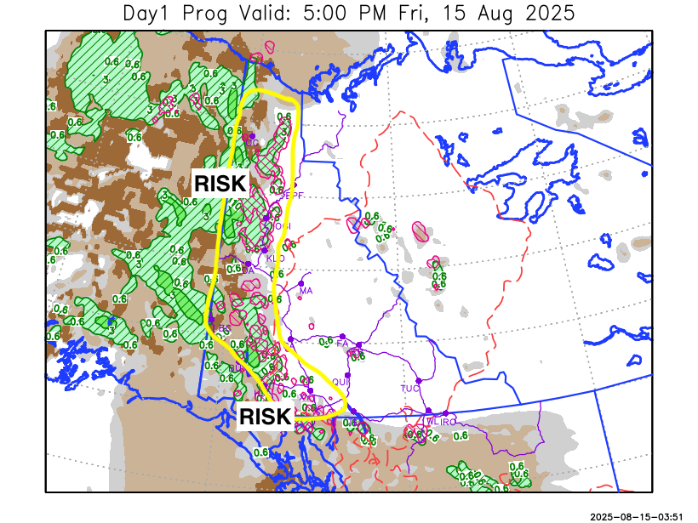
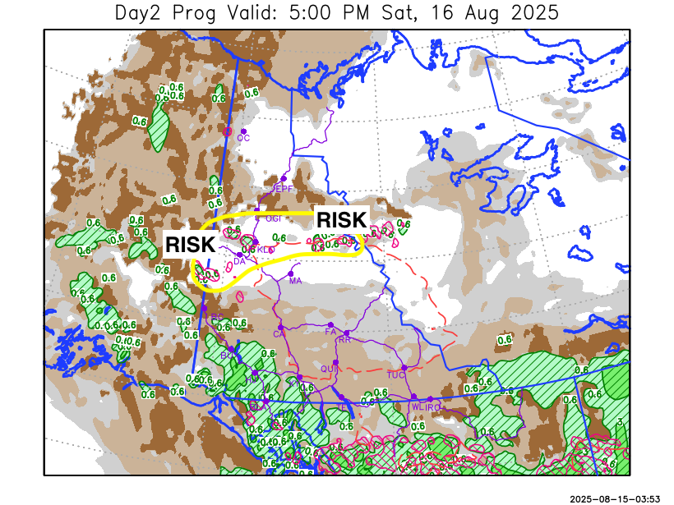

Forecast for | Saturday | (Peak burning period and overnight)
Community | Clouds | Pcpn | POP | POL | Max Temp | Min RH | Min Temp | Max  RH | Wind Dir | Wind Speed
Old Crow | BKN |  | 0 |  | 14 | 55 | 5 | 87 | 20 | 15G30
Klondike Fc | BKN | RW-/TRW- | 20 | RISK | 24 | 38 | 9 | 82 | 340 | 12
Mayo A | BKN |  | 0 |  | 24 | 25 | 13 | 76 | 70 | 13
Carmacks | BKN |  | 0 |  | 24 | 33 | 12 | 80 | 70 | 10
Faro | BKN |  | 0 |  | 20 | 40 | 9 | 81 | 90 | 15
Ross River | BKN |  | 10 |  | 22 | 45 | 7 | 83 | 90 | 13
Beaver Creek Town | OVC | R-/RW- | 60 |  | 11 | 80 | 4 | 95 | 290 | 15G30
Burwash A | OVC | R-/RW- | 80 |  | 11 | 80 | 7 | 96 | 320 | 15G30
Haines Junction | OVC | R-/RW- | 70 |  | 15 | 72 | 9 | 94 | 320 | 13
Whitehorse Auto | OVC | R-/RW- | 60 |  | 17 | 55 | 12 | 90 | 70 | 13
Teslin | OVC | R-/RW- | 60 |  | 16 | 57 | 12 | 89 | 70 | 15G30
Watson Lake | OVC | R-/RW- | 40 |  | 16 | 56 | 10 | 92 | 90 | 15G30

Forecast for |  |  | Sunday |  |  | (Peak burning period and overnight)
Community |  |  | Clouds |  |  | Pcpn | POP |  | POL |  | Max Temp |  | Min RH | Min Temp | Max  RH | Wind Dir | Wind Speed
Old Crow |  |  | BKN |  |  |  | 0 |  |  |  | 15 |  | 54 | 6 | 84 | 320 | 10
Klondike Fc |  |  | BKN |  |  |  | 0 |  |  |  | 20 |  | 48 | 9 | 84 | 290 | 15
Mayo A |  |  | BKN |  |  |  | 0 |  |  |  | 22 |  | 39 | 12 | 80 | 320 | 10
Carmacks |  |  | BKN |  |  | RW- | 20 |  |  |  | 22 |  | 44 | 10 | 83 | 320 | 13
Faro |  |  | BKN |  |  | RW- | 20 |  |  |  | 19 |  | 50 | 9 | 90 | 0 | 6
Ross River |  |  | BKN |  |  | RW- | 20 |  |  |  | 20 |  | 50 | 8 | 88 | 90 | 5
Beaver Creek Town |  |  | OVC |  |  | R-/RW- | 20 |  |  |  | 13 |  | 75 | 4 | 94 | 290 | 16
Burwash A |  |  | OVC |  |  | R-/RW- | 60 |  |  |  | 14 |  | 70 | 7 | 95 | 320 | 15
Haines Junction |  |  | OVC |  |  | R-/RW- | 60 |  |  |  | 17 |  | 67 | 9 | 94 | 320 | 11
Whitehorse Auto |  |  | OVC |  |  | R-/RW- | 60 |  |  |  | 16 |  | 62 | 11 | 94 | 320 | 9
Teslin |  |  | OVC |  |  | R-/RW- | 70 |  |  |  | 14 |  | 68 | 9 | 95 | 220 | 8
Watson Lake |  |  | OVC |  |  | R-/RW- | 70 |  |  |  | 14 |  | 75 | 9 | 94 | 270 | 8
3-Day Forecast Precipitation Totals from 13:00 Yesterday
OC | 12.8 |  | FA | 0.4 |  | JAK | 4.9
EPF | 0.6 |  | RR | 1.2 |  | TE | 4.7
ANT | 0.6 |  | BC | 12.9 |  | QUI | 5.2
DA | 1.0 |  | BCT | 13.0 |  | SWI | 8.6
FMI | 4.0 |  | BU | 17.7 |  | FL | 3.3
HEN | 1.9 |  | HJF | 15.4 |  | TUC | 4.6
BAR | 0.4 |  | RAI | 14.6 |  | HAS | 9.6
MA | 0.0 |  | CH | 6.5 |  | TC | 5.3
STW | 0.3 |  | BR | 1.0 |  | WL | 5.8
WIL | 0.6 |  | NU | 4.2 |  | PE | 1.2
XY | 5.1 |  | IRO | 9.4 |  | CA | 0.4
CC | 11.1 |  | ELK | 11.7 |  | DRU | 0.2
ATL | 16.3 |  | NA | NA |  | NA | NA
Matt Desorcy Meteorologist

Disclaimer : The information in these forecasts is collected and prepared for internal use by the Government of Yukon. The forecasts are specifically designed to meet the needs of the Wildland Fire Management and may not cover the requirements of other parties. Weather warnings or advisories are not included as part of the forecasts. Wildland Fire Management makes no representation and provides no warranty as to the accuracy of its weather forecasts. Any use the recipient chooses to make of the forecasts will be at its sole risk.

