YUKON WILDLAND FIRE MANAGEMENT WEATHER FORECAST - 9:00 AM ISSUE

16-Aug-2025
YESTERDAY'S VALUES
Community | Max  Temp  (°C) | Diff.  from  Normal | Min Temp  (°C) | Diff. from Normal | Pcpn  (mm) | Min RH | Max RH | L110 | L30
Old Crow | 14.0 | -2.9 | 4.5 | -1.0 | 0.8 | 67 | 92 | 1 | 0
Fort Mcpherson Airport | 10.8 |  | 5.9 |  | 0.0M | 74 | 88 | 0 | 0
Rock River Climate | 14.4 |  | 4.2 |  | 0.0 | 60 | 96 | NA | NA
Eagle Plains Fire | 21.4 |  | 3.7 |  | 0.0 | 49 | 98 | 33 | 0
Antimony Creek | 21.2 |  | 5.9 |  | 0.0 | 42 | 98 | 63 | 0
Klondike Fc | 21.1 |  | 6.4 |  | 0.6 | 51 | 98 | 72 | 0
Forty Mile | 14.7 |  | 10.1 |  | 0.0 | 72 | 92 | 56 | 0
Henderson | 16.7 |  | 7.0 |  | 0.8 | 57 | 98 | 72 | 1
Barlow | 22.5 |  | 6.4 |  | 1.1 | 38 | 99 | 17 | 0
Mayo A | 23.7 | 3.7 | 7.9 | 1.2 | 0.0 | 26 | 81 | 0 | 0
Stewart Crossing | 23.9 |  | 10.4 |  | 0.0 | 26 | 89 | 1 | 0
Willow Creek | 24.5 |  | 5.2 |  | 0.0 | 21 | 93 | 0 | 0
Pelly Farm | 24.3 | 4.0 | 10.1 | 4.4 | 0.0 | 31 | 87 | 86 | 0
Carmacks | 27.0 |  | 9.2 |  | 0.0 | 23 | 81 | 13 | 0
Drury Creek | 25.7 |  | 5.3 |  | 0.0 | 20 | 86 | 0 | 0
Faro | 23.1 | 4.4 | 6.7 | 0.3 | 0.0 | 33M | 97M | 0 | 0
Ross River | 24.7 |  | 0.1 |  | 0.0 | 25 | 96 | 0 | 0
Macmillan Pass | 19.6 |  | 1.7 |  | 0.0 | 28 | 86 | 0 | 0
Beaver Creek A | 10.5 | -7.7 | 4.1 | -0.7 | 4.4 | 81 | 100 | 29 | 0
Beaver Creek Town | 10.5 |  | 4.6 |  | 3.3 | 82 | 95 | 27 | 0
Burwash A | 16.7 | -1.1 | 5.1 | 0.7 | 2.1M | 57 | 96 | 39 | 0
Haines Junction | 23.8 | 5.1 | 9.8 | 6.6 | 0.6 | 35 | 86 | 20 | 4
Rainbow | 23.2 |  | 9.8 |  | 5.1 | 33 | 95 | 19 | 6
Champagne | 22.7 |  | 10.9 |  | 0.3 | 27 | 89 | 16 | 0
Braeburn | 24.9 |  | 9.8 |  | 0.0 | 23 | 88 | 2 | 0
Nursery | 24.5 |  | 10.2 |  | 0.3 | 30 | 95 | 2 | 0
Whitehorse Auto | 21.1 | 2.2 | 11.4 | 4.8 | 2.0 | 38 | 89 | 1 | 0
Mount Sima | 19.9 |  | 9.9 |  | 0.6 | 35 | 84 | 1 | 0
Carcross | 22.2 |  | 10.7 |  | 2.1 | 33 | 99 | 0 | 0
Atlin | 20.8 |  | 11.8 |  | 1.2 | 43 | 94 | 0 | 0
Jakes Corner | 23.2 |  | 10.7 |  | 0.3 | 31 | 93 | 0 | 0
Teslin | 22.8 |  | 11.7 |  | 0.2 | 28 | 90 | 0 | 0
Quiet Lake | 24.1 |  | 14.0 |  | 0.0 | 24 | 57 | 0 | 0
Swift River | 20.8 |  | 11.9 |  | 0.0 | 31 | 79 | 0 | 0
Tuchitua | 24.2 |  | 0.8 |  | 0.0 | 19 | 99 | 0 | 0
Hasselburg | 22.3 |  | 10.9 |  | 0.0 | 21 | 57 | 0 | 0
Tom Creek | 21.0 |  | 10.3 |  | 0.0 | 30 | 68 | 0 | 0
Watson Lake | 22.8 | 3.3 | 13.5 | 6.5 | 0.0 | 23 | 53 | 0 | 0
Iron Creek | 25.0 |  | 9.2 |  | 0.0 | 21 | 81 | 0 | 0
Max Temp is the actual maximum temperature in °C from yesterday afternoon or evening.
Min Temp is the actual overnight minimum temperature in °C up until 6:00 AM this morning.
Diff. from Normal is the difference from the 30 year average max or min temperature.
Pcpn is the precipitation in mm since 13:00 yesterday.
Min RH is the minimum observed RH in % from yesterday afternoon or evening.
Max RH is the maximum observed overnight RH in % up until 6:00 AM this morning.
L110 is the actual number of lightning strikes within 110 km and in the Yukon for 24 hours ending at 06:00 AM this morning.
L30 is the actual number of lightning strikes within 30 km and in the Yukon for 24 hours ending at 06:00 AM this morning.
M is missing data. * denotes precipitation at stations that failed to report for at least part of the evening and overnight period.

SYNOPSIS:
Today: An upper-level trough is in place across the Yukon. A cold front extends west to east through the Klondike and Northern Tutchone regions, serving as the focus for convective showers and thunderstorms this afternoon and evening. Elsewhere, light rain showers are expected across the southern Yukon, mainly in the Kluane, Southern Lakes, and Tintina regions. Some showers are also possible around Old Crow. High temperatures will generally be in the teens, but clearer skies in parts of the southern Klondike, Northern Tutchone, and Tatchun regions will allow values to climb into the low to mid twenties. Crossovers are unlikely. Winds will be mostly easterly, shifting to west/northwest in the far western Yukon—see the tabular forecast for details.

Sunday: The upper trough remains in place across the Yukon. Mostly quiet weather is expected, with lingering showers in the southern and southeastern Yukon, including the Kluane, Tatchun, Southern Lakes, and Tintina regions. The highest chance of rain will be in the Tintina region. High temperatures will range from the upper teens to low twenties, with crossovers unlikely. Winds will be light from the northwest at 10–15 km/h—see the tabular forecast for details.

Monday: Little change is expected in the upper pattern, with troughing persisting. Showers may continue across the southern Yukon, but the probability of precipitation will decrease as activity becomes light and isolated. Elsewhere, dry and quiet conditions are expected, with highs in the upper teens to low twenties. No crossovers are expected. Winds will be mostly west to northwest around 10 km/h.

Tuesday: Upper troughing begins to weaken, but the overall pattern remains largely unchanged. A broad and slight chance of isolated showers or thundershowers is expected, with temperatures near normal (highs in the teens to low twenties).

Wednesday: Weak ridging begins to build into the Yukon. Aside from a slight chance of convective showers or thundershowers, little active weather is expected.

Forecast for | Saturday | (Peak burning period and overnight)
Community | Clouds | Pcpn | POP | POL | Max Temp | Min RH | Min Temp | Max  RH | Wind Dir | Wind Speed
Old Crow | BKN | RW- | 30 | 0 | 13 | 65 | 6 | 95 | 20 | 20
Klondike Fc | SCT | RW-/TRW- | 50 | 10 | 24 | 40 | 8 | 90 | 0 | 20
Mayo A | SCT | RW-/TRW- | 0 | 10 | 25 | 25 | 13 | 85 | 70 | 20
Carmacks | BKN | RW- | 30 | 0 | 25 | 25 | 12 | 85 | Vrb | 10
Faro | BKN |  | 40 | 0 | 21 | 35 | 9 | 95 | 110 | 15
Ross River | BKN |  | 40 | 0 | 23 | 30 | 7 | 95 | 110 | 15
Beaver Creek Town | OVC | RW- | 50 | 0 | 12 | 70 | 4 | 95 | 290 | 15
Burwash A | OVC | RW | 80 | 0 | 13 | 65 | 8 | 95 | 320 | 15
Haines Junction | OVC | RW | 80 | 0 | 18 | 45 | 10 | 95 | 0 | 15
Whitehorse Auto | OVC | RW | 80 | 0 | 18 | 50 | 13 | 95 | 120 | 15
Teslin | OVC | RW | 80 | 0 | 17 | 55 | 12 | 95 | 70 | 15
Watson Lake | OVC | RW | 80 | 0 | 16 | 50 | 11 | 95 | 90 | 20
POP is probability of precipitation in %.
POL is probability of lightning in %.

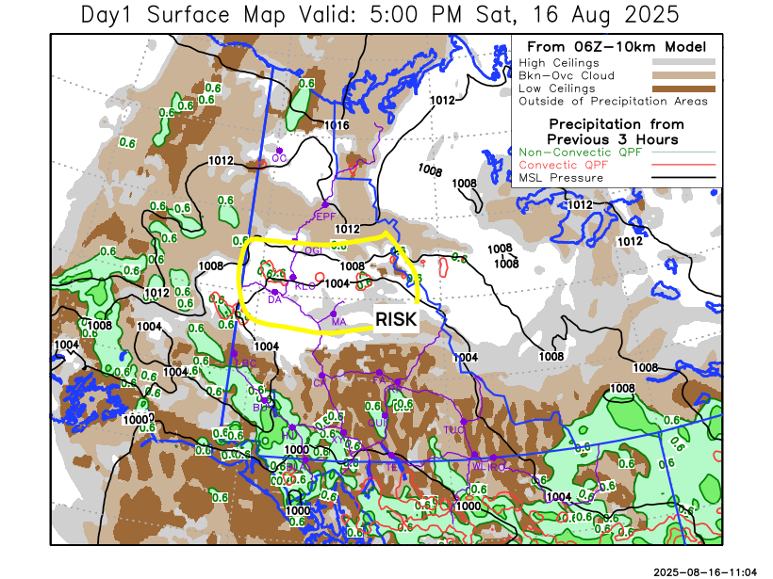
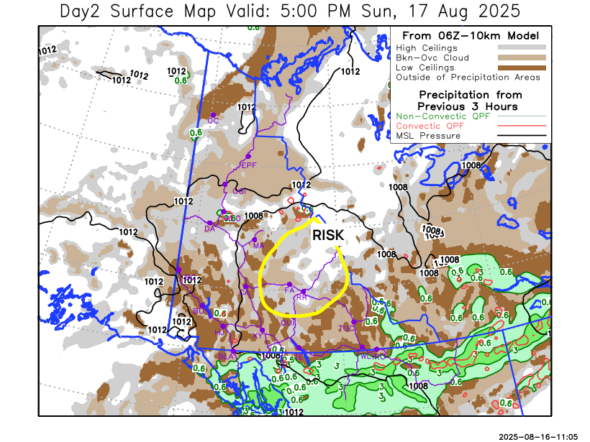
Forecast for | Sunday | (Peak burning period and overnight)
Community | Clouds | Pcpn | POP | POL | Max Temp | Min RH | Min Temp | Max  RH | Wind Dir | Wind Speed
Old Crow | BKN |  | 10 | 0 | 14 | 65 | 7 | 90 | 0 | 10
Klondike Fc | SCT |  | 20 | 0 | 22 | 45 | 7 | 90 | 310 | 15
Mayo A | SCT |  | 2 | 0 | 23 | 35 | 11 | 85 | 310 | 10
Carmacks | SCT | RW- | 30 | 0 | 23 | 35 | 11 | 85 | 310 | 15
Faro | BKN | RW- | 50 | 10 | 20 | 45 | 9 | 95 | Vrb | 10
Ross River | BKN | RW- | 50 | 10 | 22 | 40 | 8 | 95 | Vrb | 10
Beaver Creek Town | BKN | RW- | 40 | 0 | 15 | 65 | 4 | 94 | Vrb | 5
Burwash A | BKN | RW- | 50 | 0 | 15 | 55 | 8 | 95 | 330 | 10
Haines Junction | BKN | RW- | 60 | 0 | 19 | 50 | 9 | 95 | 320 | 10
Whitehorse Auto | BKN | RW- | 50 | 0 | 18 | 45 | 12 | 95 | 310 | 15
Teslin | OVC | RW- | 70 | 0 | 16 | 65 | 10 | 95 | Vrb | 5
Watson Lake | OVC | RW | 90 | 0 | 14 | 70 | 9 | 95 | Vrb | 5

Forecast for |  |  | Monday |  | (Peak burning period and overnight)
Community |  |  | Clouds |  | Pcpn |  | POP |  | POL |  | Max Temp |  | Min RH | Min Temp | Max  RH | Wind Dir | Wind Speed
Old Crow |  |  | BKN |  |  |  | 20 |  | 0 |  | 18 |  | 45 | 9 | 95 | 220 | 20
Klondike Fc |  |  | BKN |  |  |  | 10 |  | 0 |  | 21 |  | 40 | 9 | 90 | 290 | 10
Mayo A |  |  | SCT |  |  |  | 10 |  | 0 |  | 21 |  | 40 | 12 | 90 | 250 | 10
Carmacks |  |  | SCT |  |  |  | 10 |  | 0 |  | 23 |  | 35 | 11 | 90 | 320 | 10
Faro |  |  | SCT |  | TRW-/RW- |  | 30 |  | 10 |  | 18 |  | 45 | 8 | 90 | 270 | 10
Ross River |  |  | SCT |  | TRW-/RW- |  | 30 |  | 10 |  | 21 |  | 40 | 6 | 95 | 270 | 10
Beaver Creek Town |  |  | BKN |  |  |  | 10 |  | 0 |  | 20 |  | 45 | 7 | 95 | 20 | 5
Burwash A |  |  | BKN |  |  |  | 10 |  | 0 |  | 17 |  | 55 | 8 | 95 | 340 | 10
Haines Junction |  |  | BKN |  |  |  | 10 |  | 0 |  | 21 |  | 45 | 8 | 95 | 270 | 15
Whitehorse Auto |  |  | BKN |  | RW- |  | 30 |  | 0 |  | 18 |  | 45 | 11 | 95 | 320 | 10
Teslin |  |  | BKN |  | TRW-/RW- |  | 50 |  | 10 |  | 15 |  | 60 | 9 | 95 | 200 | 10
Watson Lake |  |  | OVC |  | TRW-/RW- |  | 50 |  | 10 |  | 16 |  | 65 | 9 | 95 | 220 | 10
3-Day Forecast Precipitation Totals from 13:00 Yesterday
OC | 0.9 |  | FA | 2.1 |  | JAK | 7.0
EPF | 0.0 |  | RR | 1.1 |  | TE | 6.9
ANT | 0.7 |  | BC | 7.3 |  | QUI | 5.1
DA | 0.8 |  | BCT | 6.2 |  | SWI | 12.8
FMI | 0.1 |  | BU | 9.7 |  | FL | 3.4
HEN | 2.0 |  | HJF | 8.4 |  | TUC | 4.8
BAR | 1.1 |  | RAI | 11.2 |  | HAS | 7.8
MA | 0.2 |  | CH | 3.7 |  | TC | 6.2
STW | 0.2 |  | BR | 1.3 |  | WL | 7.5
WIL | 0.0 |  | NU | 3.6 |  | PE | 0.0
XY | 6.7 |  | IRO | 9.8 |  | CA | 0.5
CC | 12.2 |  | ELK | 15.7 |  | DRU | 1.7
ATL | 23.2 |  | NA | NA |  | NA | NA
Scott Kehler Meteorologist

Disclaimer : The information in these forecasts is collected and prepared for internal use by the Government of Yukon. The forecasts are specifically designed to meet the needs of the Wildland Fire Management and may not cover the requirements of other parties. Weather warnings or advisories are not included as part of the forecasts. Wildland Fire Management makes no representation and provides no warranty as to the accuracy of its weather forecasts. Any use the recipient chooses to make of the forecasts will be at its sole risk.

