YUKON WILDLAND FIRE MANAGEMENT WEATHER FORECAST - 9:00 AM ISSUE

24-Aug-2025
YESTERDAY'S VALUES
Community | Max  Temp  (°C) | Diff.  from  Normal | Min Temp  (°C) | Diff. from Normal | Pcpn  (mm) | Min RH | Max RH | L110 | L30
Old Crow | 15.4 | 0.2 | 11.0 | 6.9 | 0.4 | 67 | 95 | 0 | 0
Fort Mcpherson Airport | 20.9 |  | 8.2 |  | 5.9 | 45 | 97 | 0 | 0
Rock River Climate | 14.8 |  | 9.6 |  | 10.2 | 59 | 100 | NA | NA
Eagle Plains Fire | 16.2 |  | 12.9 |  | 0.3 | 50 | 68 | 0 | 0
Antimony Creek | 22.1 |  | 9.9 |  | 0.0 | 38 | 91 | 0 | 0
Klondike Fc | 21.9 |  | 10.1 |  | 0.0 | 39 | 94 | 0 | 0
Forty Mile | 13.8 |  | 10.5 |  | 0.9 | 85 | 100 | 0 | 0
Henderson | 18.1 |  | 12.4 |  | 0.0 | 41 | 56 | 0 | 0
Barlow | 20.0 |  | 11.4 |  | 0.0 | 42 | 75 | 0 | 0
Mayo A | 20.6 | 2.2 | 9.6 | 4.2 | 0.0 | 43 | 88 | 0 | 0
Stewart Crossing | 22.5 |  | 11.5 |  | 0.0 | 36 | 72 | 0 | 0
Willow Creek | 22.2 |  | 7.1 |  | 0.0 | 38 | 90 | 0 | 0
Pelly Farm | 23.8 | 4.9 | 7.7 | 3.3 | 0.0 | 36 | 96 | 0 | 0
Carmacks | 27.1 |  | 11.0 |  | 0.0 | 32 | 78 | 0 | 0
Drury Creek | 24.2 |  | 7.5 |  | 0.0 | 37 | 96 | 0 | 0
Faro | 23.6 | 6.3 | 8.0 | 2.8 | 0.0 | 49M | 100M | 0 | 0
Ross River | 24.6 |  | 5.6 |  | 0.0 | 37 | 99 | 0 | 0
Macmillan Pass | 15.6 |  | 9.0 |  | 0.0 | 51 | 75 | 0 | 0
Beaver Creek A | 21.3 | 4.4 | 8.1 | 4.7 | 0.0M | 42 | 92 | 0 | 0
Beaver Creek Town | 22.5 |  | 7.7 |  | 0.0 | 37 | 94 | 0 | 0
Burwash A | 23.0 | 6.4 | 3.7 | 0.5 | 0.0M | 40 | 97 | 0 | 0
Haines Junction | 26.0 | 8.5 | 5.1 | 2.8 | 0.0 | 34 | 98 | 0 | 0
Rainbow | 24.6 |  | 10.9 |  | 0.0 | 37 | 86 | 0 | 0
Champagne | 24.7 |  | 5.8 |  | 0.0 | 34 | 94 | 0 | 0
Braeburn | 26.8 |  | 5.9 |  | 0.0 | 30 | 94 | 0 | 0
Nursery | 26.6 |  | 1.8 |  | 0.0 | 31 | 97 | 0 | 0
Whitehorse Auto | 25.7 | 8.1 | 7.4 | 1.8 | 0.0 | 29 | 85 | 0 | 0
Mount Sima | 22.7 |  | 11.4 |  | 0.0 | 34 | 64 | 0 | 0
Carcross | 25.0 |  | 6.9 |  | 0.0 | 32 | 94 | 0 | 0
Atlin | 24.4 |  | 7.9 |  | 0.0 | 33 | 87 | 0 | 0
Jakes Corner | 25.2 |  | 5.6 |  | 0.0 | 28 | 90 | 0 | 0
Teslin | 24.6 |  | 5.8 |  | 0.0 | 32 | 96 | 0 | 0
Quiet Lake | 25.2 |  | 5.8 |  | 0.0 | 34 | 95 | 0 | 0
Swift River | 24.9 |  | 3.5 |  | 0.0 | 31 | 98 | 0 | 0
Tuchitua | 26.1 |  | 2.7 |  | 0.0 | 30 | 99 | 0 | 0
Hasselburg | 25.4 |  | 5.9 |  | 0.0 | 29 | 96 | 0 | 0
Tom Creek | 24.9 |  | 11.0 |  | 0.0 | 35 | 79 | 0 | 0
Watson Lake | 25.9 | 7.7 | 7.4 | 1.5 | 0.0 | 33 | 95 | 0 | 0
Iron Creek | 26.2 |  | 3.9 |  | 0.0 | 33 | 99 | 0 | 0
Max Temp is the actual maximum temperature in °C from yesterday afternoon or evening.
Min Temp is the actual overnight minimum temperature in °C up until 6:00 AM this morning.
Diff. from Normal is the difference from the 30 year average max or min temperature.
Pcpn is the precipitation in mm since 13:00 yesterday.
Min RH is the minimum observed RH in % from yesterday afternoon or evening.
Max RH is the maximum observed overnight RH in % up until 6:00 AM this morning.
L110 is the actual number of lightning strikes within 110 km and in the Yukon for 24 hours ending at 06:00 AM this morning.
L30 is the actual number of lightning strikes within 30 km and in the Yukon for 24 hours ending at 06:00 AM this morning.
M is missing data. * denotes precipitation at stations that failed to report for at least part of the evening and overnight period.

SYNOPSIS:
Today: Ridging is in place across the southern Yukon today, bringing warm and dry conditions. Farther north, an Arctic cold front extends through the Old Crow region, resulting in cooler temperatures and a chance of rain. The best chance of rain will be between Old Crow and Dawson. Across the southern and central Yukon, high temperatures will reach the low to mid-twenties, while Old Crow will remain much cooler with a high in the low teens. Crossovers are unlikely in all regions. Winds will generally be from the south to southwest at 10–20 km/h, but from the northeast at Old Crow.

Monday: Little change is expected in the pattern for Monday, with ridging persisting across the southern and central Yukon, while conditions remain cooler north of an Arctic front in the Old Crow region. There will be a chance of showers again around Old Crow, but otherwise warm and dry weather is anticipated in the rest of the territory. High temperatures will generally be in the low to mid-twenties, with a few locations possibly reaching the upper twenties. Old Crow will be cooler, with highs in the mid to upper teens. Crossovers are unlikely. Winds will increase from the southwest across most regions – see the tabular forecast for details.

Tuesday: Ridging will build farther north, bringing a warmer air mass back to Old Crow. Temperatures across the territory will be in the low to mid-twenties, with no precipitation expected. Crossovers are unlikely. Winds will remain from the south to southwest across most regions, but Old Crow will be much windier with westerly winds of 40 km/h, gusting to 60 km/h.

Wednesday: Ridging is expected to remain in place through mid-week. Slightly above-normal temperatures in the low to mid-twenties are forecast with no precipitation.

Thursday: Pattern continues to remain the same, with weak ridging. Slightly above-normal temperatures remain with no precipitation expected.

Forecast for | Sunday | (Peak burning period and overnight)
Community | Clouds | Pcpn | POP | POL | Max Temp | Min RH | Min Temp | Max  RH | Wind Dir | Wind Speed
Old Crow | OVC | RW- | 50 | 0 | 11 | 70 | 7 | 95 | 40 | 20
Klondike Fc | BKN | RW- | 30 | 0 | 24 | 35 | 13 | 95 | 220 | 10
Mayo A | BKN |  | 0 | 0 | 25 | 35 | 16 | 90 | 220 | 15
Carmacks | FEW |  | 0 | 0 | 27 | 30 | 11 | 80 | 180 | 10
Faro | FEW |  | 0 | 0 | 23 | 45 | 10 | 95 | 250 | 10
Ross River | FEW |  | 0 | 0 | 26 | 35 | 8 | 95 | 250 | 10
Beaver Creek Town | FEW |  | 0 | 0 | 27 | 35 | 9 | 95 | 270 | 10
Burwash A | FEW |  | 0 | 0 | 22 | 40 | 9 | 95 | 140 | 15
Haines Junction | FEW |  | 0 | 0 | 23 | 30 | 8 | 95 | 270 | 20
Whitehorse Auto | CLR |  | 0 | 0 | 24 | 30 | 10 | 85 | 220 | 15
Teslin | CLR |  | 0 | 0 | 24 | 30 | 10 | 90 | 220 | 15
Watson Lake | CLR |  | 0 | 0 | 25 | 30 | 11 | 90 | 270 | 5
POP is probability of precipitation in %.
POL is probability of lightning in %.

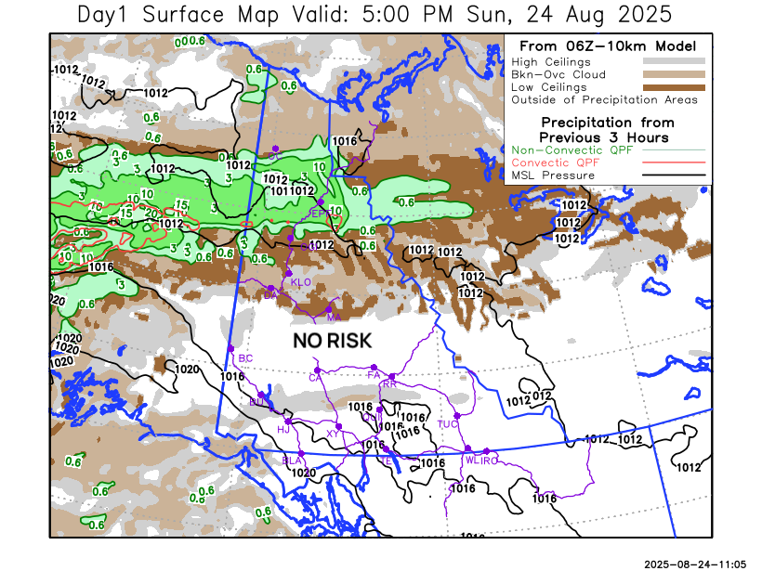
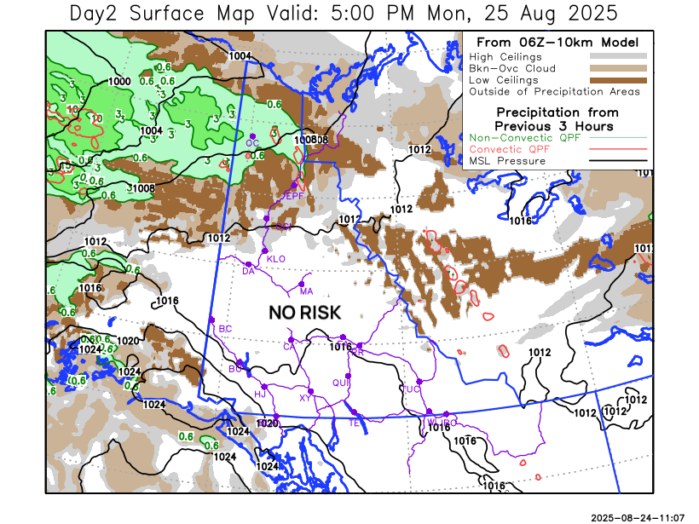
Forecast for | Monday | (Peak burning period and overnight)
Community | Clouds | Pcpn | POP | POL | Max Temp | Min RH | Min Temp | Max  RH | Wind Dir | Wind Speed
Old Crow | OVC | RW- | 40 | 0 | 16 | 70 | 9 | 95 | 220 | 30G50
Klondike Fc | SCT |  | 20 | 0 | 25 | 35 | 11 | 95 | 220 | 20
Mayo A | SCT |  | 20 | 0 | 25 | 35 | 13 | 85 | 180 | 15
Carmacks | FEW |  | 0 | 0 | 26 | 30 | 10 | 85 | 180 | 15
Faro | FEW |  | 0 | 0 | 23 | 40 | 9 | 85 | 250 | 15
Ross River | FEW |  | 0 | 0 | 26 | 35 | 7 | 85 | 220 | 15
Beaver Creek Town | FEW |  | 0 | 0 | 27 | 30 | 6 | 90 | 220 | 15
Burwash A | FEW |  | 0 | 0 | 22 | 40 | 7 | 95 | 140 | 20
Haines Junction | FEW |  | 0 | 0 | 23 | 40 | 7 | 95 | 270 | 20
Whitehorse Auto | FEW |  | 0 | 0 | 23 | 35 | 9 | 90 | 180 | 15
Teslin | CLR |  | 0 | 0 | 22 | 35 | 9 | 90 | 220 | 15
Watson Lake | CLR |  | 0 | 0 | 24 | 35 | 11 | 85 | 270 | 10

Forecast for |  |  | Tuesday |  |  | (Peak burning period and overnight)
Community |  |  | Clouds |  |  | Pcpn | POP |  | POL |  | Max Temp |  | Min RH | Min Temp | Max  RH | Wind Dir | Wind Speed
Old Crow |  |  | SCT |  |  | RW- | 30 |  | 0 |  | 19 |  | 50 | 10 | 90 | 220 | 40G60
Klondike Fc |  |  | FEW |  |  |  | 20 |  | 0 |  | 25 |  | 35 | 11 | 85 | 200 | 15
Mayo A |  |  | FEW |  |  |  | 20 |  | 0 |  | 25 |  | 35 | 13 | 85 | 220 | 15
Carmacks |  |  | FEW |  |  |  | 0 |  | 0 |  | 25 |  | 35 | 10 | 80 | 180 | 15
Faro |  |  | FEW |  |  |  | 0 |  | 0 |  | 23 |  | 40 | 9 | 85 | 180 | 15
Ross River |  |  | FEW |  |  |  | 0 |  | 0 |  | 26 |  | 35 | 7 | 85 | 200 | 15
Beaver Creek Town |  |  | FEW |  |  |  | 0 |  | 0 |  | 25 |  | 35 | 7 | 85 | 270 | 15
Burwash A |  |  | FEW |  |  |  | 0 |  | 0 |  | 22 |  | 35 | 9 | 90 | 140 | 20
Haines Junction |  |  | FEW |  |  |  | 0 |  | 0 |  | 23 |  | 35 | 7 | 90 | 270 | 20
Whitehorse Auto |  |  | FEW |  |  |  | 0 |  | 0 |  | 23 |  | 35 | 11 | 80 | 160 | 20
Teslin |  |  | CLR |  |  |  | 0 |  | 0 |  | 23 |  | 35 | 10 | 80 | 160 | 15
Watson Lake |  |  | CLR |  |  |  | 0 |  | 0 |  | 25 |  | 30 | 12 | 80 | 200 | 10
3-Day Forecast Precipitation Totals from 13:00 Yesterday
OC | 9.9 |  | FA | 0.0 |  | JAK | 0.0
EPF | 13.3 |  | RR | 0.0 |  | TE | 0.0
ANT | 0.2 |  | BC | 0.0 |  | QUI | 0.0
DA | 0.1 |  | BCT | 0.0 |  | SWI | 0.0
FMI | 2.8 |  | BU | 0.0 |  | FL | 0.0
HEN | 0.0 |  | HJF | 0.0 |  | TUC | 0.0
BAR | 0.0 |  | RAI | 0.0 |  | HAS | 0.0
MA | 0.0 |  | CH | 0.0 |  | TC | 0.0
STW | 0.0 |  | BR | 0.0 |  | WL | 0.0
WIL | 0.0 |  | NU | 0.0 |  | PE | 0.0
XY | 0.0 |  | IRO | 0.0 |  | CA | 0.0
CC | 0.0 |  | ELK | 0.0 |  | DRU | 0.0
ATL | 0.0 |  | NA | NA |  | NA | NA
Scott Kehler Meteorologist

Disclaimer : The information in these forecasts is collected and prepared for internal use by the Government of Yukon. The forecasts are specifically designed to meet the needs of the Wildland Fire Management and may not cover the requirements of other parties. Weather warnings or advisories are not included as part of the forecasts. Wildland Fire Management makes no representation and provides no warranty as to the accuracy of its weather forecasts. Any use the recipient chooses to make of the forecasts will be at its sole risk.

