YUKON WILDLAND FIRE MANAGEMENT WEATHER FORECAST - 9:00 AM ISSUE

25-Aug-2025
YESTERDAY'S VALUES
Community | Max  Temp  (°C) | Diff.  from  Normal | Min Temp  (°C) | Diff. from Normal | Pcpn  (mm) | Min RH | Max RH | L110 | L30
Old Crow | 11.0 | -3.9 | 5.5 | 1.6 | 0.8 | 65 | 100 | 0 | 0
Fort Mcpherson Airport | 8.5 |  | 5.4 |  | 2.8 | 67 | 98 | 0 | 0
Rock River Climate | 9.6 |  | 2.5 |  | 8.8 | 84 | 100 | NA | NA
Eagle Plains Fire | 12.8 |  | 4.3 |  | 21.4 | 69 | 100 | 0 | 0
Antimony Creek | 23.6 |  | 10.6 |  | 0.3 | 38 | 99 | 0 | 0
Klondike Fc | 24.6 |  | 11.9 |  | 0.6 | 36 | 99 | 0 | 0
Forty Mile | 18.0 |  | 11.3 |  | 1.6 | 59 | 100 | 0 | 0
Henderson | 22.4 |  | 11.8 |  | 0.0 | 38 | 87 | 0 | 0
Barlow | 21.9 |  | 12.0 |  | 0.0 | 40 | 87 | 0 | 0
Mayo A | 24.3 | 6.1 | 12.0 | 6.8 | 0.0 | 37 | 86 | 0 | 0
Stewart Crossing | 25.8 |  | 14.0 |  | 0.3 | 30 | 89 | 0 | 0
Willow Creek | 26.1 |  | 10.6 |  | 0.0 | 30 | 88 | 0 | 0
Pelly Farm | 28.0 | 9.3 | 10.2 | 6.0 | 0.0 | 27 | 96 | 0 | 0
Carmacks | 28.8 |  | 11.1 |  | 0.0 | 25 | 71 | 0 | 0
Drury Creek | 25.7 |  | 9.7 |  | 0.0 | 34 | 89 | 0 | 0
Faro | 25.0 | 7.9 | 11.4 | 6.4 | 0.0 | 40M | 98M | 0 | 0
Ross River | 25.8 |  | 6.7 |  | 0.0 | 33 | 98 | 0 | 0
Macmillan Pass | 20.0 |  | 8.8 |  | 0.0 | 38 | 83 | 0 | 0
Beaver Creek A | 25.4 | 8.6 | 9.7 | 6.5 | 0.0 | 35 | 85 | 0 | 0
Beaver Creek Town | 26.3 |  | 10.2 |  | 0.0 | 33 | 89 | 0 | 0
Burwash A | 22.7 | 6.3 | 6.8 | 3.8 | 0.0M | 42 | 79 | 0 | 0
Haines Junction | 24.8 | 7.4 | 3.9 | 1.7 | 0.0 | 32 | 97 | 0 | 0
Rainbow | 23.6 |  | 9.4 |  | 0.0 | 32 | 83 | 0 | 0
Champagne | 24.6 |  | 10.8 |  | 0.0 | 26 | 75 | 0 | 0
Braeburn | 26.7 |  | 6.7 |  | 0.0 | 25 | 91 | 0 | 0
Nursery | 26.5 |  | 2.0 |  | 0.0 | 26 | 96 | 0 | 0
Whitehorse Auto | 24.8 | 7.4 | 6.6 | 1.1 | 0.0 | 24 | 84 | 0 | 0
Mount Sima | 21.9 |  | 10.1 |  | 0.0 | 25 | 68 | 0 | 0
Carcross | 23.9 |  | 7.5 |  | 0.0 | 28 | 95 | 0 | 0
Atlin | 23.6 |  | 7.1 |  | 0.0 | 35 | 88 | 0 | 0
Jakes Corner | 25.6 |  | 5.3 |  | 0.0 | 23 | 92 | 0 | 0
Teslin | 24.7 |  | 6.0 |  | 0.0 | 25 | 94 | 0 | 0
Quiet Lake | 27.0 |  | 4.6 |  | 0.0 | 33 | 94 | 0 | 0
Swift River | 24.5 |  | 3.2 |  | 0.0 | 24 | 98 | 0 | 0
Tuchitua | 27.2 |  | -0.4 |  | 0.0 | 25 | 98 | 0 | 0
Hasselburg | 25.4 |  | 3.7 |  | 0.0 | 23 | 93 | 0 | 0
Tom Creek | 25.1 |  | 8.7 |  | 0.0 | 25 | 85 | 0 | 0
Watson Lake | 26.3 | 8.3 | 6.6 | 0.8 | 0.0 | 23 | 90 | 0 | 0
Iron Creek | 27.1 |  | 2.3 |  | 0.0 | 23 | 99 | 0 | 0
Max Temp is the actual maximum temperature in °C from yesterday afternoon or evening.
Min Temp is the actual overnight minimum temperature in °C up until 6:00 AM this morning.
Diff. from Normal is the difference from the 30 year average max or min temperature.
Pcpn is the precipitation in mm since 13:00 yesterday.
Min RH is the minimum observed RH in % from yesterday afternoon or evening.
Max RH is the maximum observed overnight RH in % up until 6:00 AM this morning.
L110 is the actual number of lightning strikes within 110 km and in the Yukon for 24 hours ending at 06:00 AM this morning.
L30 is the actual number of lightning strikes within 30 km and in the Yukon for 24 hours ending at 06:00 AM this morning.
M is missing data. * denotes precipitation at stations that failed to report for at least part of the evening and overnight period.

SYNOPSIS:
Today: Little change is expected in the pattern for today, with ridging persisting across southern and central Yukon, while conditions remain somewhat cooler in the Old Crow region. There will be a chance of light rain late today into tonight around Old Crow, but otherwise warm and dry weather is anticipated in the rest of the territory. High temperatures will generally be in the mid-twenties, with a few locations possibly reaching the upper twenties. Old Crow will be cooler, with highs in the teens. Crossovers are unlikely, with minimum RHs in the upper-20s to low-30s for most of central and southern Yukon. Winds light to moderate south/southwest across most regions, except gusty in Old Crow late today into tonight.

Tuesday: Ridging will build farther north, bringing a warmer air mass back to Old Crow. Temperatures across the territory will be in the mid-twenties, with no precipitation expected. Crossovers are unlikely as minimum RHs will be in the upper-20s to low-30s. Winds remain from the south to southwest across most regions, but Old Crow will be much windier with southwesterly winds of 30 km/h, gusting to 50 km/h.

Wednesday: Ridging is expected to remain in place through the mid-week, with very similar conditions compared to Tuesday. Highs in the mid-twenties (except low twenties in Old Crow) combined with RHs in the low-30s. Winds remain out of the south/southwest through most of the Territory, but increase slightly in intensity for most locations, with gusts of up to 30-40 km/h possible in Kluane and the northern Klondike.

Thursday: The core of the upper-level ridge shifts eastward slightly. The ridge shifting eastward will allow for scattered to broken cloud cover to make its way into western Yukon, with a chance of light rain in Old Crow Thursday night. Highs in the low to mid-twenties across the Territory except teens in Old Crow.

Friday: No significant change in the upper-air pattern compared to Thursday, though troughing will begin to encroach on western Yukon by Friday. Highs remain in the low to mid-twenties in the Territory except cooler in Old Crow. Scattered to broken cloud cover across the western half of the Yukon, while eastern regions will remain under mainly sunny skies. Slight risk of isolated showers in the Klondike.

Forecast for | Monday | (Peak burning period and overnight)
Community | Clouds | Pcpn | POP | POL | Max Temp | Min RH | Min Temp | Max  RH | Wind Dir | Wind Speed
Old Crow | BKN | R- | 70 |  | 17 | 65 | 13 | 90 | 220 | 20G40
Klondike Fc | SCT |  | 0 |  | 25 | 35 | 11 | 81 | 180 | 11
Mayo A | SCT |  | 0 |  | 25 | 36 | 14 | 82 | 220 | 12
Carmacks | FEW |  | 0 |  | 26 | 32 | 10 | 80 | 160 | 10
Faro | FEW |  | 0 |  | 24 | 33 | 9 | 81 | 250 | 8
Ross River | FEW |  | 0 |  | 26 | 33 | 7 | 84 | 200 | 7
Beaver Creek Town | FEW |  | 0 |  | 26 | 33 | 6 | 80 | 220 | 8
Burwash A | FEW |  | 0 |  | 23 | 37 | 8 | 80 | 140 | 15
Haines Junction | FEW |  | 0 |  | 23 | 34 | 8 | 95 | 180 | 14
Whitehorse Auto | FEW |  | 0 |  | 23 | 34 | 9 | 84 | 180 | 12
Teslin | CLR |  | 0 |  | 23 | 36 | 9 | 82 | 200 | 8
Watson Lake | CLR |  | 0 |  | 24 | 32 | 11 | 76 | 270 | 11
POP is probability of precipitation in %.
POL is probability of lightning in %.

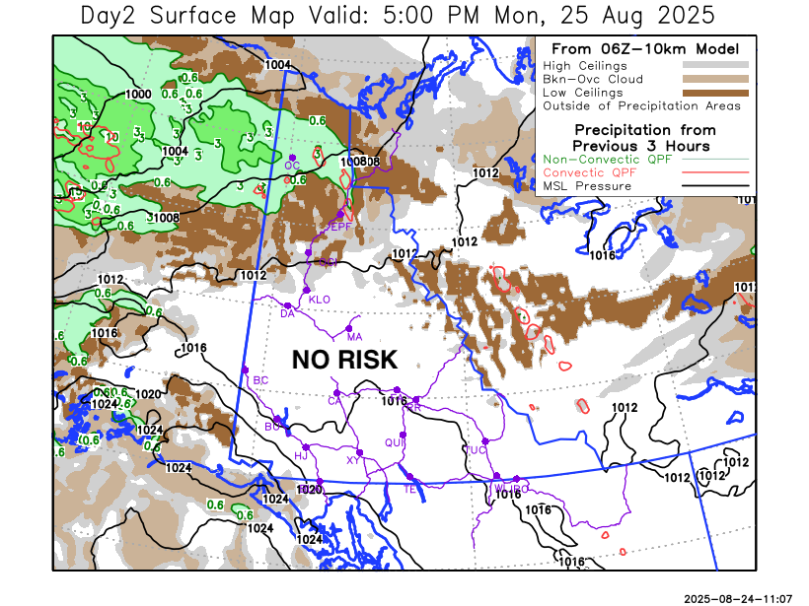
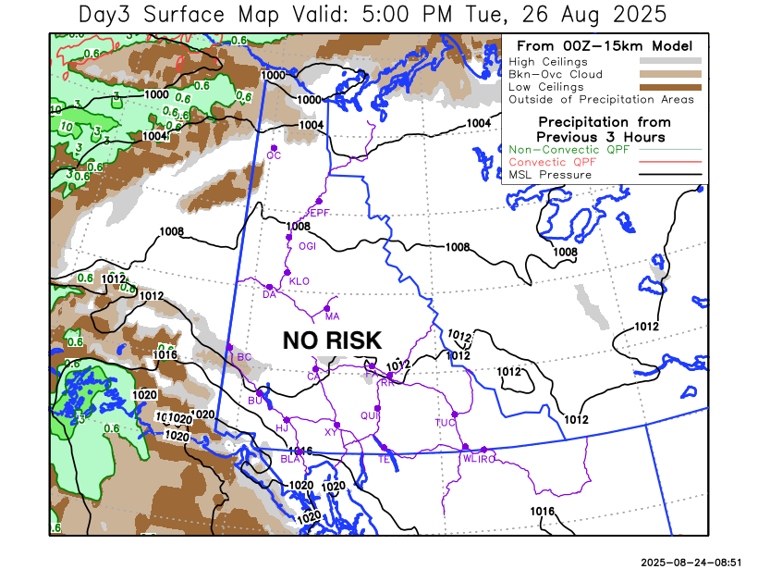

Forecast for | Tuesday | (Peak burning period and overnight)
Community | Clouds | Pcpn | POP | POL | Max Temp | Min RH | Min Temp | Max  RH | Wind Dir | Wind Speed
Old Crow | BKN |  | 0 |  | 19 | 55 | 11 | 79 | 220 | 25G50
Klondike Fc | SCT |  | 0 |  | 24 | 31 | 11 | 76 | 220 | 12
Mayo A | SCT |  | 0 |  | 24 | 33 | 13 | 76 | 220 | 10
Carmacks | SCT |  | 0 |  | 25 | 32 | 10 | 75 | 160 | 10
Faro | FEW |  | 0 |  | 23 | 34 | 9 | 74 | 180 | 9
Ross River | FEW |  | 0 |  | 25 | 32 | 7 | 79 | 200 | 8
Beaver Creek Town | SCT |  | 0 |  | 25 | 30 | 7 | 75 | 220 | 8
Burwash A | SCT |  | 0 |  | 22 | 33 | 8 | 77 | 160 | 15
Haines Junction | SCT |  | 0 |  | 23 | 30 | 8 | 90 | 180 | 16
Whitehorse Auto | FEW |  | 0 |  | 24 | 32 | 11 | 77 | 160 | 11
Teslin | FEW |  | 0 |  | 24 | 31 | 10 | 73 | 160 | 8
Watson Lake | CLR |  | 0 |  | 25 | 30 | 11 | 74 | 200 | 8

Forecast for |  |  | Wednesday |  |  | (Peak burning period and overnight)
Community |  |  | Clouds |  |  | Pcpn | POP |  | POL |  | Max Temp |  | Min RH | Min Temp | Max  RH | Wind Dir | Wind Speed
Old Crow |  |  | BKN |  |  |  | 0 |  |  |  | 20 |  | 48 | 10 | 82 | 220 | 20G40
Klondike Fc |  |  | SCT |  |  |  | 10 |  |  |  | 24 |  | 32 | 11 | 74 | 140 | 11
Mayo A |  |  | SCT |  |  |  | 10 |  |  |  | 24 |  | 33 | 13 | 79 | 140 | 10
Carmacks |  |  | SCT |  |  |  | 0 |  |  |  | 26 |  | 31 | 10 | 82 | 180 | 10
Faro |  |  | SCT |  |  |  | 0 |  |  |  | 23 |  | 38 | 9 | 82 | 220 | 13
Ross River |  |  | SCT |  |  |  | 0 |  |  |  | 25 |  | 35 | 7 | 83 | 220 | 8
Beaver Creek Town |  |  | SCT |  |  |  | 10 |  |  |  | 25 |  | 28 | 7 | 67 | 220 | 15G30
Burwash A |  |  | SCT |  |  |  | 0 |  |  |  | 22 |  | 35 | 8 | 76 | 160 | 16
Haines Junction |  |  | SCT |  |  |  | 0 |  |  |  | 23 |  | 36 | 9 | 93 | 200 | 15G30
Whitehorse Auto |  |  | SCT |  |  |  | 0 |  |  |  | 25 |  | 32 | 11 | 87 | 200 | 14
Teslin |  |  | FEW |  |  |  | 0 |  |  |  | 25 |  | 34 | 11 | 85 | 220 | 11
Watson Lake |  |  | FEW |  |  |  | 0 |  |  |  | 26 |  | 32 | 14 | 73 | 250 | 8
3-Day Forecast Precipitation Totals from 13:00 Yesterday
OC | 2.4 |  | FA | 0.0 |  | JAK | 0.0
EPF | 21.5 |  | RR | 0.0 |  | TE | 0.0
ANT | 0.3 |  | BC | 0.0 |  | QUI | 0.0
DA | 0.0 |  | BCT | 0.0 |  | SWI | 0.0
FMI | 1.6 |  | BU | 0.0 |  | FL | 0.0
HEN | 0.0 |  | HJF | 0.0 |  | TUC | 0.0
BAR | 0.0 |  | RAI | 0.0 |  | HAS | 0.0
MA | 0.0 |  | CH | 0.0 |  | TC | 0.0
STW | 0.3 |  | BR | 0.0 |  | WL | 0.0
WIL | 0.0 |  | NU | 0.0 |  | PE | 0.0
XY | 0.0 |  | IRO | 0.0 |  | CA | 0.0
CC | 0.0 |  | ELK | 0.0 |  | DRU | 0.0
ATL | 0.0 |  | NA | NA |  | NA | NA
Matt Desorcy Meteorologist

Disclaimer : The information in these forecasts is collected and prepared for internal use by the Government of Yukon. The forecasts are specifically designed to meet the needs of the Wildland Fire Management and may not cover the requirements of other parties. Weather warnings or advisories are not included as part of the forecasts. Wildland Fire Management makes no representation and provides no warranty as to the accuracy of its weather forecasts. Any use the recipient chooses to make of the forecasts will be at its sole risk.

