YUKON WILDLAND FIRE MANAGEMENT WEATHER FORECAST - 9:00 AM ISSUE

26-Aug-2025
YESTERDAY'S VALUES
Community | Max  Temp  (°C) | Diff.  from  Normal | Min Temp  (°C) | Diff. from Normal | Pcpn  (mm) | Min RH | Max RH | L110 | L30
Old Crow | 18.2 | 3.5 | 13.2 | 9.4 | 2.4 | 61 | 96 | 0 | 0
Fort Mcpherson Airport | 21.0 |  | 17.5 |  | 0.1M | 54 | 63 | 0 | 0
Rock River Climate | 15.1 |  | 11.2 |  | 2.4 | 70 | 87 | NA | NA
Eagle Plains Fire | 19.5 |  | 16.4 |  | 0.0 | 50 | 59 | 0 | 0
Antimony Creek | 25.3 |  | 4.9 |  | 0.0 | 37 | 99 | 0 | 0
Klondike Fc | 26.6 |  | 5.9 |  | 0.0 | 34 | 93 | 0 | 0
Forty Mile | 23.9 |  | 10.7 |  | 0.0 | 41 | 87 | 0 | 0
Henderson | 22.0 |  | 14.1 |  | 0.0 | 38 | 62 | 0 | 0
Barlow | 24.2 |  | 13.4 |  | 0.0 | 37 | 73 | 0 | 0
Mayo A | 25.1 | 7.1 | 10.2 | 5.2 | 0.0 | 38 | 90 | 0 | 0
Stewart Crossing | 26.7 |  | 14.3 |  | 0.0 | 34 | 64 | 0 | 0
Willow Creek | 25.5 |  | 6.9 |  | 0.0 | 35 | 92 | 0 | 0
Pelly Farm | 27.9 | 9.4 | 7.2 | 3.1 | 0.0 | 32 | 97 | 0 | 0
Carmacks | 29.1 |  | 9.1 |  | 0.0 | 27 | 79 | 0 | 0
Drury Creek | 24.6 |  | 4.8 |  | 0.0 | 34 | 96 | 0 | 0
Faro | 25.5 | 8.6 | 6.2 | 1.4 | 0.0 | 32M | 95M | 0 | 0
Ross River | 26.4 |  | 2.6 |  | 0.0 | 28 | 98 | 0 | 0
Macmillan Pass | 19.0 |  | 5.1 |  | 0.0 | 47 | 97 | 0 | 0
Beaver Creek A | 25.1 | 8.5 | 3.8 | 0.7 | 0.0 | 33 | 91 | 0 | 0
Beaver Creek Town | 25.9 |  | 4.3 |  | 0.0 | 28 | 93 | 0 | 0
Burwash A | 21.8 | 5.6 | 1.1 | -1.8 | 0.0 | 40 | 95 | 0 | 0
Haines Junction | 22.1 | 6.1 | 2.4 | 0.0 | 0.0 | 41 | 98 | 0 | 0
Rainbow | 20.7 |  | 8.1 |  | 0.0 | 45 | 86 | 0 | 0
Champagne | 22.7 |  | 9.8 |  | 0.0 | 37 | 79 | 0 | 0
Braeburn | 26.7 |  | 3.0 |  | 0.0 | 27 | 96 | 0 | 0
Nursery | 25.1 |  | 2.8 |  | 0.0 | 31 | 97 | 0 | 0
Whitehorse Auto | 23.3 | 6.1 | 9.1 | 3.8 | 0.0 | 33 | 78 | 0 | 0
Mount Sima | 20.0 |  | 10.2 |  | 0.0 | 39 | 63 | 0 | 0
Carcross | 21.5 |  | 3.2 |  | 0.0 | 42 | 97 | 0 | 0
Atlin | 22.1 |  | 6.1 |  | 0.0 | 33 | 91 | 0 | 0
Jakes Corner | 23.6 |  | 4.6 |  | 0.0 | 34 | 92 | 0 | 0
Teslin | 22.9 |  | 5.1 |  | 0.0 | 33 | 97 | 0 | 0
Quiet Lake | 25.1 |  | 4.0 |  | 0.0 | 33 | 95 | 0 | 0
Swift River | 23.3 |  | 0.5 |  | 0.0 | 29 | 97 | 0 | 0
Tuchitua | 26.8 |  | 0.1 |  | 0.0 | 29 | 98 | 0 | 0
Hasselburg | 25.1 |  | 6.6 |  | 0.0 | 30 | 89 | 0 | 0
Tom Creek | 24.1 |  | 8.8 |  | 0.0 | 31 | 80 | 0 | 0
Watson Lake | 25.0 | 7.2 | 6.6 | 1.0 | 0.0 | 26 | 92 | 0 | 0
Iron Creek | 26.1 |  | 1.6 |  | 0.0 | 27 | 98 | 0 | 0
Max Temp is the actual maximum temperature in °C from yesterday afternoon or evening.
Min Temp is the actual overnight minimum temperature in °C up until 6:00 AM this morning.
Diff. from Normal is the difference from the 30 year average max or min temperature.
Pcpn is the precipitation in mm since 13:00 yesterday.
Min RH is the minimum observed RH in % from yesterday afternoon or evening.
Max RH is the maximum observed overnight RH in % up until 6:00 AM this morning.
L110 is the actual number of lightning strikes within 110 km and in the Yukon for 24 hours ending at 06:00 AM this morning.
L30 is the actual number of lightning strikes within 30 km and in the Yukon for 24 hours ending at 06:00 AM this morning.
M is missing data. * denotes precipitation at stations that failed to report for at least part of the evening and overnight period.

SYNOPSIS:
Today: Ridging will build farther north, bringing late-summer heat to the Territory and dry conditions under mainly sunny skies. No precipitation is expected today. Highs across the Territory will be in the mid-twenties with a few upper twenties, except cooler in Old Crow where cloud cover will hang around. A few stations may approach crossover territory, but any deep crossovers are unlikely as minimum RHs will be in the upper-20s to low-30s. Winds remain from the south to southwest across most regions, through Old Crow will be much windier with southwesterly winds of 30 km/h, gusting to 50 km/h (weakening tonight).

Wednesday: Ridging is expected to remain in place through the mid-week, with very similar conditions compared to today. Highs in the mid-twenties (except upper teens in Old Crow) combined with RHs in the upper-20s to low-30s. Winds moderate out of the south/southwest through most of the Territory, with gusts of up to 30-40 km/h possible in Kluane and the northern Klondike.

Thursday: No change in the overall weather pattern as the ridging persists across most of the Yukon, keeping conditions seasonably warm and dry. Scattered to broken skies in the Klondike district while the remainder of the Yukon is expected to remain sunny. Temperatures climb into the mid-twenties with RHs in the upper-20 to low-30s. Gusty south/southeast winds possible in Kluane, with light to moderate south/southwest winds elsewhere.

Friday: The core of the ridge will shift into eastern Yukon and NWT, with ridging expected to begin breaking down across the western half of the Yukon by afternoon. This will result in the chance of showers through the Klondike, Kluane, western Tatchun, and Northern Tutchone during the afternoon/evening as a frontal system pushes through. Temperatures cool across the western half of the Territory, while eastern regions remain warm and sunnier, with highs in the mid-twenties.

Saturday: Friday’s system quickly clears out of the Yukon, leading to a return to drier conditions in the region. However, temperatures remain cooler (upper teens to low twenties) in the Klondike, Kluane, and Northern Tutchone. Mid-twenties expected to remain in place through south-central and eastern Yukon.

Forecast for | Tuesday | (Peak burning period and overnight)
Community | Clouds | Pcpn | POP | POL | Max Temp | Min RH | Min Temp | Max  RH | Wind Dir | Wind Speed
Old Crow | BKN |  | 10 |  | 18 | 57 | 11 | 80 | 220 | 25G50
Klondike Fc | FEW |  | 0 |  | 25 | 29 | 11 | 74 | 220 | 15
Mayo A | SCT |  | 0 |  | 25 | 30 | 14 | 74 | 220 | 11
Carmacks | SCT |  | 0 |  | 27 | 30 | 10 | 69 | 160 | 15
Faro | FEW |  | 0 |  | 24 | 32 | 9 | 72 | 250 | 12
Ross River | FEW |  | 0 |  | 26 | 30 | 7 | 78 | 180 | 8
Beaver Creek Town | SCT |  | 0 |  | 25 | 29 | 8 | 72 | 250 | 8
Burwash A | SCT |  | 0 |  | 22 | 33 | 8 | 76 | 160 | 15G30
Haines Junction | SCT |  | 0 |  | 23 | 32 | 7 | 89 | 180 | 15
Whitehorse Auto | FEW |  | 0 |  | 24 | 30 | 11 | 73 | 180 | 15
Teslin | FEW |  | 0 |  | 23 | 31 | 10 | 70 | 180 | 9
Watson Lake | CLR |  | 0 |  | 26 | 28 | 11 | 73 | 200 | 7
POP is probability of precipitation in %.
POL is probability of lightning in %.

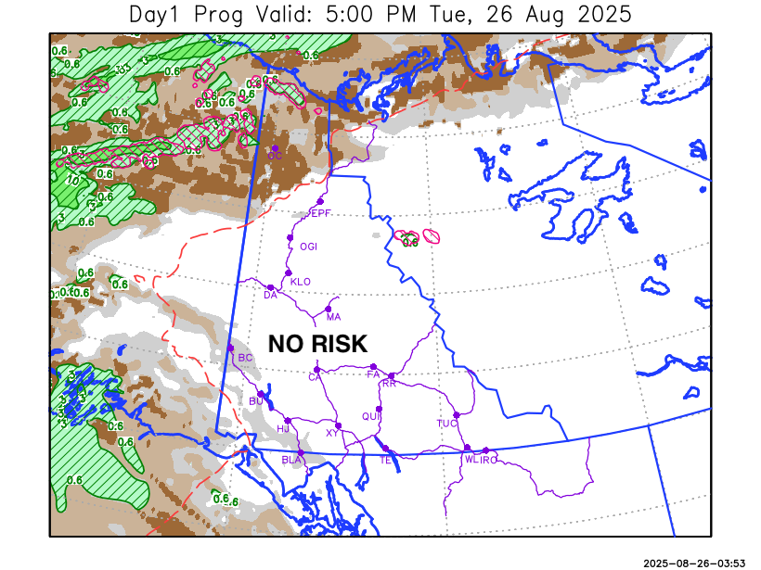
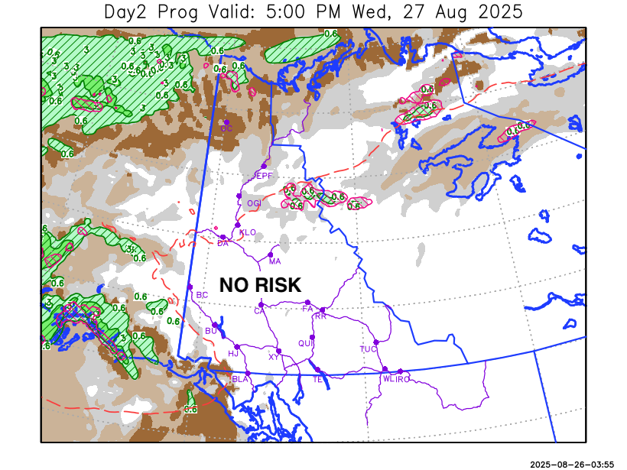

Forecast for | Wednesday | (Peak burning period and overnight)
Community | Clouds | Pcpn | POP | POL | Max Temp | Min RH | Min Temp | Max  RH | Wind Dir | Wind Speed
Old Crow | BKN |  | 10 |  | 19 | 52 | 10 | 84 | 220 | 15G30
Klondike Fc | SCT |  | 10 |  | 25 | 30 | 10 | 73 | 220 | 15
Mayo A | SCT |  | 10 |  | 24 | 31 | 13 | 78 | 220 | 14
Carmacks | SCT |  | 0 |  | 27 | 30 | 10 | 79 | 180 | 14
Faro | SCT |  | 0 |  | 24 | 33 | 9 | 82 | 220 | 13
Ross River | FEW |  | 0 |  | 26 | 32 | 7 | 83 | 220 | 10
Beaver Creek Town | SCT |  | 10 |  | 25 | 27 | 7 | 68 | 220 | 15G30
Burwash A | SCT |  | 0 |  | 22 | 36 | 7 | 75 | 160 | 15G30
Haines Junction | SCT |  | 0 |  | 22 | 35 | 8 | 93 | 200 | 15G30
Whitehorse Auto | SCT |  | 0 |  | 24 | 31 | 11 | 83 | 160 | 16
Teslin | FEW |  | 0 |  | 24 | 32 | 11 | 84 | 220 | 13
Watson Lake | CLR |  | 0 |  | 26 | 28 | 12 | 74 | 220 | 8

Forecast for |  |  | Thursday |  |  | (Peak burning period and overnight)
Community |  |  | Clouds |  |  | Pcpn | POP |  | POL |  | Max Temp |  | Min RH | Min Temp | Max  RH | Wind Dir | Wind Speed
Old Crow |  |  | BKN |  |  |  | 10 |  |  |  | 18 |  | 52 | 11 | 81 | 220 | 14
Klondike Fc |  |  | BKN |  |  |  | 0 |  |  |  | 24 |  | 33 | 12 | 71 | 140 | 10
Mayo A |  |  | SCT |  |  |  | 0 |  |  |  | 24 |  | 32 | 13 | 77 | 180 | 12
Carmacks |  |  | FEW |  |  |  | 0 |  |  |  | 26 |  | 31 | 11 | 79 | 160 | 15G30
Faro |  |  | FEW |  |  |  | 0 |  |  |  | 23 |  | 35 | 9 | 82 | 200 | 12
Ross River |  |  | FEW |  |  |  | 0 |  |  |  | 25 |  | 32 | 7 | 84 | 200 | 10
Beaver Creek Town |  |  | BKN |  |  |  | 0 |  |  |  | 26 |  | 31 | 8 | 68 | 160 | 15G30
Burwash A |  |  | SCT |  |  |  | 0 |  |  |  | 22 |  | 35 | 9 | 79 | 160 | 20G35
Haines Junction |  |  | SCT |  |  |  | 0 |  |  |  | 23 |  | 35 | 9 | 93 | 180 | 15G30
Whitehorse Auto |  |  | FEW |  |  |  | 0 |  |  |  | 24 |  | 30 | 11 | 83 | 180 | 16
Teslin |  |  | FEW |  |  |  | 0 |  |  |  | 24 |  | 32 | 10 | 80 | 220 | 11
Watson Lake |  |  | FEW |  |  |  | 0 |  |  |  | 26 |  | 30 | 12 | 75 | 270 | 8
3-Day Forecast Precipitation Totals from 13:00 Yesterday
OC | 2.4 |  | FA | 0.0 |  | JAK | 0.0
EPF | 0.0 |  | RR | 0.0 |  | TE | 0.0
ANT | 0.0 |  | BC | 0.0 |  | QUI | 0.0
DA | 0.0 |  | BCT | 0.0 |  | SWI | 0.0
FMI | 0.0 |  | BU | 0.0 |  | FL | 0.0
HEN | 0.0 |  | HJF | 0.0 |  | TUC | 0.0
BAR | 0.0 |  | RAI | 0.0 |  | HAS | 0.0
MA | 0.0 |  | CH | 0.0 |  | TC | 0.0
STW | 0.0 |  | BR | 0.0 |  | WL | 0.0
WIL | 0.0 |  | NU | 0.0 |  | PE | 0.0
XY | 0.0 |  | IRO | 0.0 |  | CA | 0.0
CC | 0.0 |  | ELK | 0.0 |  | DRU | 0.0
ATL | 0.0 |  | NA | NA |  | NA | NA
Matt Desorcy Meteorologist

Disclaimer : The information in these forecasts is collected and prepared for internal use by the Government of Yukon. The forecasts are specifically designed to meet the needs of the Wildland Fire Management and may not cover the requirements of other parties. Weather warnings or advisories are not included as part of the forecasts. Wildland Fire Management makes no representation and provides no warranty as to the accuracy of its weather forecasts. Any use the recipient chooses to make of the forecasts will be at its sole risk.

