YUKON WILDLAND FIRE MANAGEMENT WEATHER FORECAST - 9:00 AM ISSUE

27-Aug-2025
YESTERDAY'S VALUES
Community | Max  Temp  (°C) | Diff.  from  Normal | Min Temp  (°C) | Diff. from Normal | Pcpn  (mm) | Min RH | Max RH | L110 | L30
Old Crow | 18.7 | 4.3 | 6.4 | 2.8 | 0.0 | 54 | 96 | 0 | 0
Fort Mcpherson Airport | 25.0 |  | 6.0 |  | 0.9M | 38 | 94 | 0 | 0
Rock River Climate | 19.3 |  | 7.4 |  | 0.0 | 47 | 89 | NA | NA
Eagle Plains Fire | 22.0 |  | 10.3 |  | 0.0 | 37 | 78 | 0 | 0
Antimony Creek | 24.6 |  | 4.8 |  | 0.0 | 21 | 92 | 0 | 0
Klondike Fc | 26.8 |  | 7.0 |  | 0.0 | 18 | 89 | 0 | 0
Forty Mile | 23.8 |  | 8.9 |  | 0.0 | 26 | 87 | 0 | 0
Henderson | 21.6 |  | 12.8 |  | 0.0 | 28 | 56 | 0 | 0
Barlow | 23.8 |  | 11.3 |  | 0.0 | 31 | 63 | 0 | 0
Mayo A | 25.1 | 7.3 | 7.9 | 3.1 | 0.0 | 29 | 81 | 0 | 0
Stewart Crossing | 26.7 |  | 8.5 |  | 0.0 | 24 | 89 | 0 | 0
Willow Creek | 24.9 |  | 6.7 |  | 0.0 | 31 | 96 | 0 | 0
Pelly Farm | 27.0 | 8.7 | 5.4 | 1.5 | 0.0 | 23 | 97 | 0 | 0
Carmacks | 28.6 |  | 7.5 |  | 0.0 | 26 | 71 | 0 | 0
Drury Creek | 24.1 |  | 3.7 |  | 0.0 | 34 | 95 | 0 | 0
Faro | 24.9 | 8.2 | 4.9 | 0.2 | 0.0 | 31M | 97M | 0 | 0
Ross River | 25.8 |  | 2.7 |  | 0.0 | 28 | 97 | 0 | 0
Macmillan Pass | 20.9 |  | 6.9 |  | 0.0 | 32 | 82 | 0 | 0
Beaver Creek A | 23.2 | 6.8 | 8.8 | 5.9 | 0.0 | 34 | 82 | 0 | 0
Beaver Creek Town | 23.8 |  | 9.0 |  | 0.0 | 31 | 88 | 0 | 0
Burwash A | 21.4 | 5.4 | 2.0 | -0.7 | 0.0 | 38 | 87 | 0 | 0
Haines Junction | 23.6 | 7.2 | 3.0 | 1.9 | 0.0 | 35 | 94 | 0 | 0
Rainbow | 22.0 |  | 11.0 |  | 0.0 | 32 | 67 | 0 | 0
Champagne | 24.1 |  | 6.6 |  | 0.0 | 24 | 77 | 0 | 0
Braeburn | 26.8 |  | 2.4 |  | 0.0 | 21 | 94 | 0 | 0
Nursery | 25.7 |  | 2.8 |  | 0.0 | 26 | 95 | 0 | 0
Whitehorse Auto | 24.3 | 7.3 | 11.5 | 6.3 | 0.0 | 27 | 60 | 0 | 0
Mount Sima | 21.6 |  | 12.3 |  | 0.0 | 25 | 45 | 0 | 0
Carcross | 22.7 |  | 3.7 |  | 0.0 | 32 | 94 | 0 | 0
Atlin | 24.8 |  | 6.5 |  | 0.0 | 24 | 76 | 0 | 0
Jakes Corner | 25.3 |  | 5.3 |  | 0.0 | 24 | 80 | 0 | 0
Teslin | 24.9 |  | 5.1 |  | 0.0 | 28 | 91 | 0 | 0
Quiet Lake | 27.0 |  | 3.6 |  | 0.0 | 23 | 94 | 0 | 0
Swift River | 26.3 |  | 0.2 |  | 0.0 | 14 | 96 | 0 | 0
Tuchitua | 26.9 |  | -1.7 |  | 0.0 | 21 | 98 | 0 | 0
Hasselburg | 26.9 |  | 6.0 |  | 0.0 | 15 | 79 | 0 | 0
Tom Creek | 26.5 |  | 10.5 |  | 0.0 | 21 | 55 | 0 | 0
Watson Lake | 28.0 | 10.4 | 6.0 | 0.6 | 0.0 | 16 | 89 | 0 | 0
Iron Creek | 27.7 |  | 1.2 |  | 0.0 | 22 | 99 | 0 | 0
Max Temp is the actual maximum temperature in °C from yesterday afternoon or evening.
Min Temp is the actual overnight minimum temperature in °C up until 6:00 AM this morning.
Diff. from Normal is the difference from the 30 year average max or min temperature.
Pcpn is the precipitation in mm since 13:00 yesterday.
Min RH is the minimum observed RH in % from yesterday afternoon or evening.
Max RH is the maximum observed overnight RH in % up until 6:00 AM this morning.
L110 is the actual number of lightning strikes within 110 km and in the Yukon for 24 hours ending at 06:00 AM this morning.
L30 is the actual number of lightning strikes within 30 km and in the Yukon for 24 hours ending at 06:00 AM this morning.
M is missing data. * denotes precipitation at stations that failed to report for at least part of the evening and overnight period.

SYNOPSIS:
Today: Ridging is expected to remain in place through the mid-week, with very similar conditions compared to yesterday. Partly cloudy to mainly sunny skies through central and southern Yukon, while the northern Territory will see scattered to broken cloud cover. Highs in the mid-twenties (except upper teens in Old Crow) combined with RHs in the mid-20s to low-30s. Slight risk of crossovers in central and southern Yukon. Winds moderate out of the south/southwest through most of the Territory, except light in Tintina.

Thursday: No change in the overall weather pattern as the ridging persists across most of the Yukon, keeping conditions seasonably warm and dry. Scattered to broken skies in the Klondike and northern Tutchone while the remainder of the Yukon is expected to remain sunny. Temperatures climb into the mid to upper-20s with RHs in the mid-20s to low-30s. Slight risk of crossovers in central and southern Yukon. Gusty south/southeast winds possible in parts of Kluane and Southern Lakes, with light to moderate south/southwest winds elsewhere.

Friday: The core of the ridge will shift into eastern Yukon and NWT, with ridging expected to begin breaking down across the western half of the Yukon by late in the day. This will result in the chance of showers through the Klondike, Kluane, western Tatchun, and Northern Tutchone during the evening and overnight hours as a frontal system pushes through. Temperatures are expected to remain seasonably warm throughout the Yukon, in the mid to upper-20s, except cooler in Old Crow.

Saturday: Friday night’s system quickly clears out of the Yukon, leading to a return to drier conditions in all regions. However, temperatures will return to more seasonal values (upper teens to low twenties) in the Klondike, Kluane, and Northern Tutchone regions. Mid-twenties expected to remain in place through south-central and eastern Yukon.

Sunday: An upper-level ridge is expected to begin building back into the Yukon, leading to continued dry conditions and near- to above-seasonal temperatures.

Forecast for | Wednesday | (Peak burning period and overnight)
Community | Clouds | Pcpn | POP | POL | Max Temp | Min RH | Min Temp | Max  RH | Wind Dir | Wind Speed
Old Crow | BKN |  | 10 |  | 18 | 57 | 11 | 84 | 220 | 15G30
Klondike Fc | SCT |  | 0 |  | 25 | 26 | 10 | 69 | 250 | 11
Mayo A | SCT |  | 0 |  | 25 | 29 | 13 | 72 | 220 | 12
Carmacks | SCT |  | 0 |  | 27 | 25 | 10 | 78 | 180 | 10
Faro | SCT |  | 0 |  | 24 | 29 | 9 | 77 | 220 | 10G25
Ross River | FEW |  | 0 |  | 26 | 28 | 7 | 79 | 250 | 10
Beaver Creek Town | SCT |  | 0 |  | 24 | 28 | 7 | 68 | 220 | 15
Burwash A | SCT |  | 0 |  | 21 | 34 | 7 | 73 | 160 | 15
Haines Junction | SCT |  | 0 |  | 22 | 35 | 7 | 93 | 200 | 16
Whitehorse Auto | SCT |  | 0 |  | 25 | 30 | 11 | 83 | 180 | 15G30
Teslin | FEW |  | 0 |  | 25 | 28 | 11 | 83 | 220 | 15
Watson Lake | FEW |  | 0 |  | 27 | 25 | 12 | 69 | 270 | 8
POP is probability of precipitation in %.
POL is probability of lightning in %.

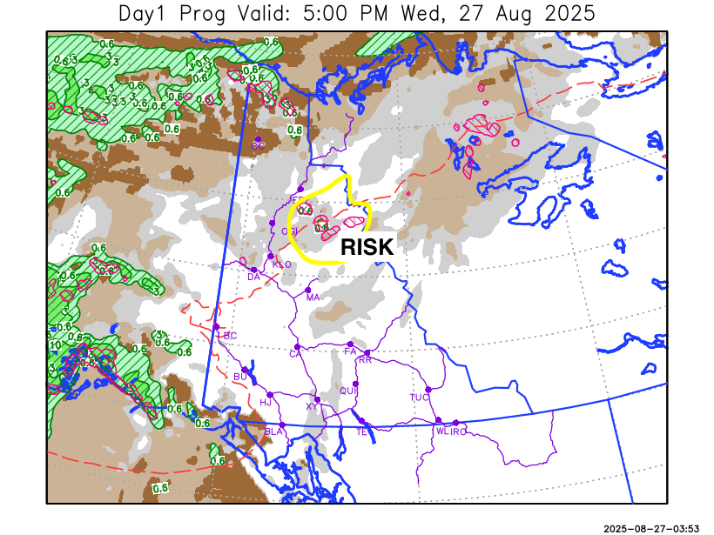
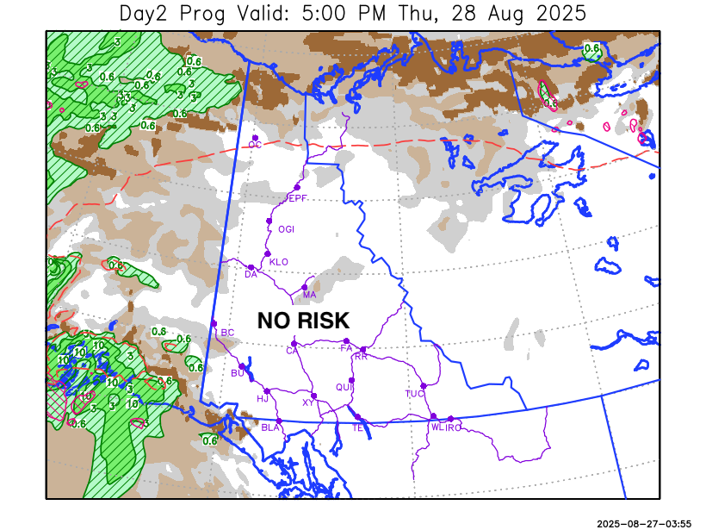

Forecast for | Thursday | (Peak burning period and overnight)
Community | Clouds | Pcpn | POP | POL | Max Temp | Min RH | Min Temp | Max  RH | Wind Dir | Wind Speed
Old Crow | BKN |  | 0 |  | 19 | 47 | 12 | 77 | 200 | 12
Klondike Fc | SCT |  | 0 |  | 26 | 26 | 12 | 69 | 140 | 10
Mayo A | FEW |  | 0 |  | 25 | 29 | 13 | 75 | 110 | 10
Carmacks | FEW |  | 0 |  | 27 | 26 | 11 | 75 | 160 | 15
Faro | FEW |  | 0 |  | 24 | 27 | 10 | 77 | 220 | 10
Ross River | FEW |  | 0 |  | 26 | 27 | 7 | 81 | 200 | 8
Beaver Creek Town | SCT |  | 0 |  | 26 | 29 | 8 | 71 | 180 | 15
Burwash A | FEW |  | 0 |  | 22 | 33 | 8 | 81 | 160 | 15G30
Haines Junction | SCT |  | 0 |  | 22 | 33 | 8 | 88 | 200 | 16
Whitehorse Auto | FEW |  | 0 |  | 25 | 28 | 11 | 78 | 160 | 15G30
Teslin | FEW |  | 0 |  | 25 | 30 | 10 | 80 | 200 | 10
Watson Lake | FEW |  | 0 |  | 27 | 27 | 12 | 77 | 270 | 8

Forecast for |  |  | Friday |  |  | (Peak burning period and overnight)
Community |  |  | Clouds |  |  | Pcpn | POP |  | POL |  | Max Temp |  | Min RH | Min Temp | Max  RH | Wind Dir | Wind Speed
Old Crow |  |  | BKN |  |  | R-/RW- | 60 |  |  |  | 19 |  | 53 | 7 | 75 | 250 | 30G50
Klondike Fc |  |  | SCT |  |  | R-/RW- | 40 |  |  |  | 24 |  | 32 | 9 | 73 | 290 | 15
Mayo A |  |  | SCT |  |  | R-/RW- | 40 |  |  |  | 25 |  | 28 | 14 | 76 | 270 | 14
Carmacks |  |  | SCT |  |  | RW- | 30 |  |  |  | 28 |  | 27 | 12 | 75 | 160 | 15G30
Faro |  |  | FEW |  |  | RW- | 20 |  |  |  | 25 |  | 27 | 10 | 79 | 220 | 13
Ross River |  |  | FEW |  |  | RW- | 20 |  |  |  | 27 |  | 26 | 8 | 79 | 200 | 10
Beaver Creek Town |  |  | BKN |  |  | RW- | 20 |  |  |  | 24 |  | 30 | 4 | 79 | 290 | 15G30
Burwash A |  |  | SCT |  |  | RW- | 20 |  |  |  | 22 |  | 32 | 8 | 81 | 200 | 15
Haines Junction |  |  | SCT |  |  | RW- | 20 |  |  |  | 22 |  | 33 | 9 | 89 | 200 | 20G40
Whitehorse Auto |  |  | FEW |  |  |  | 0 |  |  |  | 26 |  | 25 | 12 | 77 | 200 | 15G30
Teslin |  |  | CLR |  |  |  | 0 |  |  |  | 26 |  | 27 | 11 | 72 | 220 | 12
Watson Lake |  |  | CLR |  |  |  | 0 |  |  |  | 27 |  | 27 | 13 | 69 | 220 | 7
3-Day Forecast Precipitation Totals from 13:00 Yesterday
OC | 0.0 |  | FA | 0.0 |  | JAK | 0.0
EPF | 0.0 |  | RR | 0.0 |  | TE | 0.0
ANT | 0.0 |  | BC | 0.0 |  | QUI | 0.0
DA | 0.0 |  | BCT | 0.0 |  | SWI | 0.0
FMI | 0.0 |  | BU | 0.0 |  | FL | 0.0
HEN | 0.0 |  | HJF | 0.0 |  | TUC | 0.0
BAR | 0.0 |  | RAI | 0.0 |  | HAS | 0.0
MA | 0.0 |  | CH | 0.0 |  | TC | 0.0
STW | 0.0 |  | BR | 0.0 |  | WL | 0.0
WIL | 0.0 |  | NU | 0.0 |  | PE | 0.0
XY | 0.0 |  | IRO | 0.0 |  | CA | 0.0
CC | 0.0 |  | ELK | 0.0 |  | DRU | 0.0
ATL | 0.0 |  | NA | NA |  | NA | NA
Matt Desorcy Meteorologist

Disclaimer : The information in these forecasts is collected and prepared for internal use by the Government of Yukon. The forecasts are specifically designed to meet the needs of the Wildland Fire Management and may not cover the requirements of other parties. Weather warnings or advisories are not included as part of the forecasts. Wildland Fire Management makes no representation and provides no warranty as to the accuracy of its weather forecasts. Any use the recipient chooses to make of the forecasts will be at its sole risk.

