YUKON WILDLAND FIRE MANAGEMENT WEATHER FORECAST - 9:00 AM ISSUE

28-Aug-2025
YESTERDAY'S VALUES
Community | Max  Temp  (°C) | Diff.  from  Normal | Min Temp  (°C) | Diff. from Normal | Pcpn  (mm) | Min RH | Max RH | L110 | L30
Old Crow | 18.0 | 3.8 | 10.2 | 6.8 | 0.0 | 54 | 95 | 0 | 0
Fort Mcpherson Airport | 20.5 |  | 6.8 |  | 0.0M | 50 | 96 | 0 | 0
Rock River Climate | 17.3 |  | 9.7 |  | 0.0 | 51 | 79 | NA | NA
Eagle Plains Fire | 20.4 |  | 13.7 |  | 0.0 | 39 | 69 | 0 | 0
Antimony Creek | 23.9 |  | 3.2 |  | 0.0 | 28 | 95 | 0 | 0
Klondike Fc | 25.5 |  | 3.5 |  | 0.0 | 26 | 94 | 0 | 0
Forty Mile | 21.7 |  | 7.5 |  | 0.0 | 37 | 94 | 0 | 0
Henderson | 21.6 |  | 12.1 |  | 0.0 | 33 | 56 | 0 | 0
Barlow | 22.0 |  | 13.3 |  | 0.0 | 33 | 58 | 0 | 0
Mayo A | 23.6 | 6.1 | 6.8 | 2.2 | 0.0 | 33 | 87 | 0 | 0
Stewart Crossing | 23.9 |  | 8.0 |  | 0.0 | 29 | 88 | 0 | 0
Willow Creek | 22.2 |  | 4.9 |  | 0.0 | 35 | 96 | 0 | 0
Pelly Farm | 24.9 | 6.8 | 4.1 | 0.4 | 0.0 | 29 | 96 | 0 | 0
Carmacks | 28.9 |  | 9.0 |  | 0.0 | 22 | 71 | 0 | 0
Drury Creek | 26.0 |  | 5.4 |  | 0.0 | 28 | 92 | 0 | 0
Faro | 25.2 | 8.7 | 5.5 | 1.0 | 0.0 | 37M | 93M | 0 | 0
Ross River | 27.2 |  | 1.7 |  | 0.0 | 24 | 97 | 0 | 0
Macmillan Pass | 20.8 |  | 6.6 |  | 0.0 | 30 | 76 | 0 | 0
Beaver Creek A | 24.6 | 8.4 | 2.2 | -0.5 | 0.0 | 24 | 83 | 0 | 0
Beaver Creek Town | 25.3 |  | 2.7 |  | 0.0 | 20 | 88 | 0 | 0
Burwash A | 22.1 | 6.2 | 6.1 | 3.6 | 0.0 | 35 | 69 | 0 | 0
Haines Junction | 23.4 | 6.6 | 2.1 | 1.3 | 0.0 | 35 | 95 | 0 | 0
Rainbow | 21.4 |  | 11.7 |  | 0.0 | 37 | 69 | 0 | 0
Champagne | 22.7 |  | 9.1 |  | 0.0 | 33 | 79 | 0 | 0
Braeburn | 26.9 |  | 3.6 |  | 0.0 | 29 | 93 | 0 | 0
Nursery | 28.7 |  | -0.1 |  | 0.0 | 24 | 96 | 0 | 0
Whitehorse Auto | 25.3 | 8.5 | 10.3 | 5.3 | 0.0 | 28 | 71 | 0 | 0
Mount Sima | 21.7 |  | 10.2 |  | 0.0 | 33 | 61 | 0 | 0
Carcross | 23.5 |  | 6.3 |  | 0.0 | 34 | 95 | 0 | 0
Atlin | 24.4 |  | 8.3 |  | 0.0 | 34 | 88 | 0 | 0
Jakes Corner | 26.6 |  | 6.8 |  | 0.0 | 26 | 90 | 0 | 0
Teslin | 26.0 |  | 7.2 |  | 0.0 | 27 | 93 | 0 | 0
Quiet Lake | 27.3 |  | 4.7 |  | 0.0 | 28 | 91 | 0 | 0
Swift River | 25.5 |  | 4.0 |  | 0.0 | 27 | 96 | 0 | 0
Tuchitua | 27.8 |  | 2.4 |  | 0.0 | 20 | 98 | 0 | 0
Hasselburg | 26.1 |  | 8.3 |  | 0.0 | 23 | 84 | 0 | 0
Tom Creek | 26.8 |  | 11.9 |  | 0.0 | 22 | 71 | 0 | 0
Watson Lake | 27.9 | 10.5 | 8.8 | 3.5 | 0.0 | 22 | 92 | 0 | 0
Iron Creek | 28.7 |  | 7.0 |  | 0.0 | 21 | 94 | 0 | 0
Max Temp is the actual maximum temperature in °C from yesterday afternoon or evening.
Min Temp is the actual overnight minimum temperature in °C up until 6:00 AM this morning.
Diff. from Normal is the difference from the 30 year average max or min temperature.
Pcpn is the precipitation in mm since 13:00 yesterday.
Min RH is the minimum observed RH in % from yesterday afternoon or evening.
Max RH is the maximum observed overnight RH in % up until 6:00 AM this morning.
L110 is the actual number of lightning strikes within 110 km and in the Yukon for 24 hours ending at 06:00 AM this morning.
L30 is the actual number of lightning strikes within 30 km and in the Yukon for 24 hours ending at 06:00 AM this morning.
M is missing data. * denotes precipitation at stations that failed to report for at least part of the evening and overnight period.

SYNOPSIS:
Today: No change in the overall weather pattern as the ridging persists across most of the Yukon, keeping conditions seasonably warm and dry. Scattered cloud cover in the Klondike while the remainder of the Yukon is expected to be mainly sunny. Temperatures climb into the mid to upper-20s with RHs in the mid-20s to low-30s. Slight risk of crossovers in central and southern Yukon. Gusty south/southeast winds possible in parts of Kluane and Southern Lakes, with light to moderate south/southwest winds elsewhere.

Friday: The core of the ridge will shift into eastern Yukon and NWT, with ridging expected to begin breaking down across the western half of the Yukon by late in the day. This will result in the chance of showers through the Klondike, Kluane, western Tatchun, and Northern Tutchone during the evening and overnight hours as a low-pressure system and associated cold front pushes through. Temperatures are expected to remain seasonably warm throughout the Yukon on Friday (heating out before the passage of the system), in the mid to upper-20s, except cooler in Old Crow. Gusty southwest/west winds are expected through a broad area of the Territory, gusting to 30-40 km/h, except stronger in Old Crow where gusts are expected to reach 60-70 km/h late in the day.

Saturday: Friday night’s system quickly clears out of the Yukon, leading to a return to dry conditions in all regions. However, temperatures will return to more seasonal values (teens to low twenties) following the passage of Friday night’s cold front. Cooler in Old Crow with highs in the low double digits. A rather dry air mass will be in place, with minimum RHs in the upper-20s to 30s. Winds weaken across the Yukon, except gustier in Tintina.

Sunday: An upper-level ridge is expected to begin building back into the Yukon, leading to continued dry conditions and clearing skies throughout the day. The only exception being in central Yukon where a slight risk of a passing shower exists during the first half of the day, with skies becoming partly cloudy by afternoon. Highs in the upper teens to low twenties.

Monday: The upper-level ridge strengthens across the Yukon, leading to a return to seasonably warm and dry conditions. Highs are expected to climb back into the low to mid-twenties under mainly sunny skies (except cloudier/cooler in Old Crow). No precipitation expected in the Territory on Monday.

Forecast for | Thursday | (Peak burning period and overnight)
Community | Clouds | Pcpn | POP | POL | Max Temp | Min RH | Min Temp | Max  RH | Wind Dir | Wind Speed
Old Crow | BKN |  | 0 |  | 19 | 49 | 13 | 74 | 200 | 11
Klondike Fc | SCT |  | 0 |  | 26 | 25 | 13 | 71 | 140 | 13
Mayo A | FEW |  | 0 |  | 25 | 30 | 14 | 78 | 180 | 11
Carmacks | FEW |  | 0 |  | 27 | 26 | 11 | 76 | 160 | 15
Faro | FEW |  | 0 |  | 24 | 31 | 10 | 80 | 220 | 11
Ross River | FEW |  | 0 |  | 26 | 30 | 7 | 85 | 200 | 9
Beaver Creek Town | SCT |  | 0 |  | 26 | 30 | 8 | 74 | 160 | 15
Burwash A | FEW |  | 0 |  | 23 | 32 | 9 | 82 | 160 | 15G30
Haines Junction | FEW |  | 0 |  | 23 | 33 | 9 | 90 | 180 | 15G30
Whitehorse Auto | FEW |  | 0 |  | 25 | 30 | 11 | 82 | 160 | 15G30
Teslin | FEW |  | 0 |  | 25 | 31 | 10 | 88 | 220 | 12
Watson Lake | FEW |  | 0 |  | 27 | 27 | 12 | 76 | 270 | 9
POP is probability of precipitation in %.
POL is probability of lightning in %.

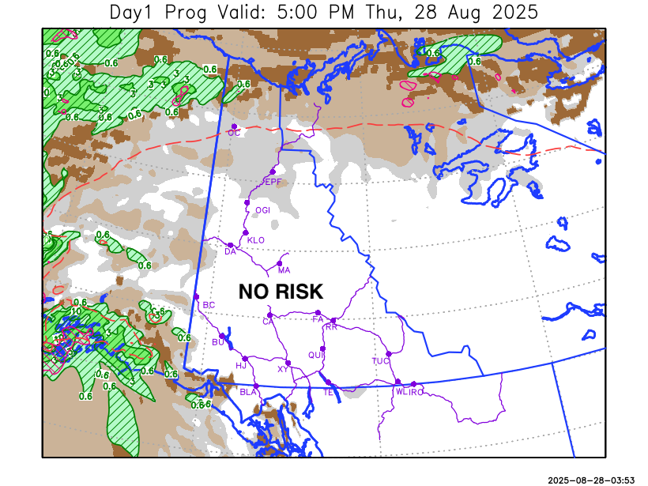
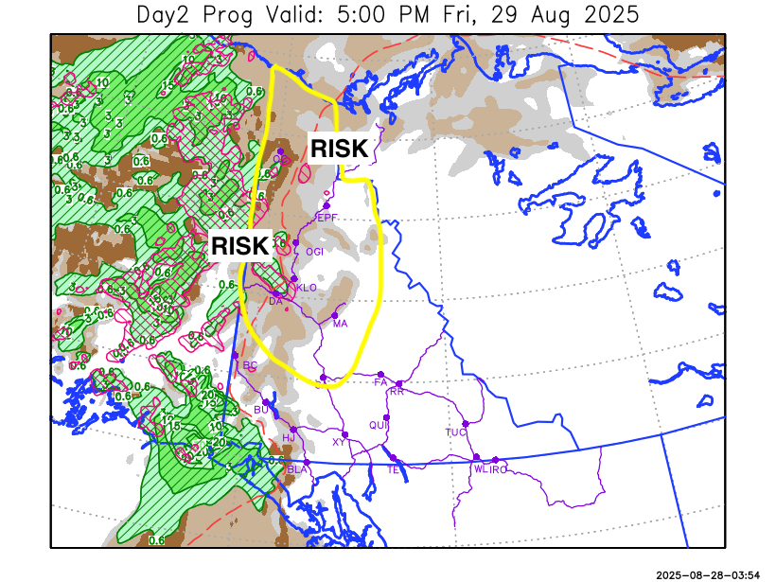

Forecast for | Friday | (Peak burning period and overnight)
Community | Clouds | Pcpn | POP | POL | Max Temp | Min RH | Min Temp | Max  RH | Wind Dir | Wind Speed
Old Crow | BKN | R-/TRW- | 60 | RISK | 20 | 50 | 6 | 77 | 250 | 40G60
Klondike Fc | SCT | RW-/TRW- | 60 | RISK | 24 | 33 | 4 | 71 | 270 | 15G30
Mayo A | SCT | RW-/TRW- | 40 | RISK | 25 | 32 | 9 | 80 | 270 | 12
Carmacks | SCT | RW-/TRW- | 40 | RISK | 28 | 28 | 8 | 70 | 320 | 15G35
Faro | FEW | R-/RW- | 40 |  | 25 | 30 | 8 | 83 | 220 | 15G30
Ross River | FEW | R-/RW- | 30 |  | 27 | 29 | 8 | 76 | 290 | 15
Beaver Creek Town | SCT | RW- | 20 |  | 24 | 30 | 2 | 78 | 270 | 15G35
Burwash A | SCT | RW- | 20 |  | 21 | 37 | 5 | 83 | 320 | 15G30
Haines Junction | SCT | RW- | 20 |  | 22 | 38 | 7 | 87 | 200 | 15G40
Whitehorse Auto | SCT | RW- | 20 |  | 25 | 29 | 11 | 76 | 220 | 15G35
Teslin | FEW |  | 0 |  | 25 | 25 | 12 | 80 | 220 | 15
Watson Lake | CLR |  | 0 |  | 27 | 27 | 12 | 67 | 220 | 10

Forecast for |  |  | Saturday |  |  | (Peak burning period and overnight)
Community |  |  | Clouds |  |  | Pcpn | POP |  | POL |  | Max Temp |  | Min RH | Min Temp | Max  RH | Wind Dir | Wind Speed
Old Crow |  |  | SCT |  |  | RW- | 20 |  |  |  | 11 |  | 52 | 5 | 79 | 250 | 20G40
Klondike Fc |  |  | SCT |  |  |  | 0 |  |  |  | 17 |  | 30 | 5 | 65 | 270 | 9
Mayo A |  |  | SCT |  |  |  | 0 |  |  |  | 16 |  | 32 | 9 | 66 | 250 | 13
Carmacks |  |  | SCT |  |  |  | 0 |  |  |  | 20 |  | 29 | 8 | 60 | 320 | 7
Faro |  |  | SCT |  |  |  | 0 |  |  |  | 16 |  | 30 | 5 | 68 | 290 | 12
Ross River |  |  | SCT |  |  |  | 0 |  |  |  | 19 |  | 30 | 3 | 64 | 290 | 13
Beaver Creek Town |  |  | BKN |  |  |  | 0 |  |  |  | 19 |  | 34 | 3 | 72 | 90 | 7
Burwash A |  |  | BKN |  |  |  | 0 |  |  |  | 16 |  | 39 | 6 | 78 | 110 | 8
Haines Junction |  |  | SCT |  |  |  | 0 |  |  |  | 20 |  | 32 | 5 | 85 | 160 | 8
Whitehorse Auto |  |  | SCT |  |  |  | 0 |  |  |  | 18 |  | 30 | 8 | 70 | 0 | 8
Teslin |  |  | SCT |  |  |  | 0 |  |  |  | 20 |  | 30 | 8 | 68 | 340 | 9
Watson Lake |  |  | FEW |  |  |  | 0 |  |  |  | 21 |  | 25 | 8 | 56 | 320 | 15G30
3-Day Forecast Precipitation Totals from 13:00 Yesterday
OC | 2.3 |  | FA | 1.5 |  | JAK | 0.0
EPF | 3.2 |  | RR | 0.6 |  | TE | 0.0
ANT | 2.0 |  | BC | 0.2 |  | QUI | 0.0
DA | 1.7 |  | BCT | 0.2 |  | SWI | 0.0
FMI | 2.0 |  | BU | 1.1 |  | FL | 0.0
HEN | 1.4 |  | HJF | 1.0 |  | TUC | 0.0
BAR | 2.6 |  | RAI | 0.6 |  | HAS | 0.0
MA | 3.9 |  | CH | 1.2 |  | TC | 0.0
STW | 3.6 |  | BR | 1.9 |  | WL | 0.0
WIL | 3.6 |  | NU | 1.3 |  | PE | 2.1
XY | 1.0 |  | IRO | 0.0 |  | CA | 1.8
CC | 0.1 |  | ELK | 0.0 |  | DRU | 1.9
ATL | 0.0 |  | NA | NA |  | NA | NA
Matt Desorcy Meteorologist

Disclaimer : The information in these forecasts is collected and prepared for internal use by the Government of Yukon. The forecasts are specifically designed to meet the needs of the Wildland Fire Management and may not cover the requirements of other parties. Weather warnings or advisories are not included as part of the forecasts. Wildland Fire Management makes no representation and provides no warranty as to the accuracy of its weather forecasts. Any use the recipient chooses to make of the forecasts will be at its sole risk.

