YUKON WILDLAND FIRE MANAGEMENT WEATHER FORECAST - 9:00 AM ISSUE

29-Aug-2025
YESTERDAY'S VALUES
Community | Max  Temp  (°C) | Diff.  from  Normal | Min Temp  (°C) | Diff. from Normal | Pcpn  (mm) | Min RH | Max RH | L110 | L30
Old Crow | 20.5 | 6.6 | 7.2 | 4.0 | 0.0 | 44 | 97 | 0 | 0
Fort Mcpherson Airport | 16.5 |  | 8.6 |  | 0.0M | 69 | 97 | 0 | 0
Rock River Climate | 19.2 |  | 11.7 |  | 0.0 | 40 | 66 | NA | NA
Eagle Plains Fire | 21.8 |  | 16.4 |  | 0.0 | 33 | 43 | 0 | 0
Antimony Creek | 24.1 |  | 8.1 |  | 0.0 | 28 | 82 | 0 | 0
Klondike Fc | 24.0 |  | 5.7 |  | 0.0 | 31 | 94 | 0 | 0
Forty Mile | 19.3 |  | 9.2 |  | 0.0 | 37 | 87 | 0 | 0
Henderson | 20.1 |  | 14.7 |  | 0.0 | 36 | 53 | 0 | 0
Barlow | 22.8 |  | 15.7 |  | 0.0 | 32 | 55 | 0 | 0
Mayo A | 24.1 | 6.8 | 11.8 | 7.4 | 0.0 | 30 | 67 | 0 | 0
Stewart Crossing | 24.3 |  | 12.2 |  | 0.0 | 29 | 71 | 0 | 0
Willow Creek | 22.8 |  | 10.5 |  | 0.0 | 31 | 82 | 0 | 0
Pelly Farm | 25.1 | 7.3 | 7.4 | 3.9 | 0.0 | 29 | 93 | 0 | 0
Carmacks | 28.0 |  | 8.5 |  | 0.0 | 22 | 72 | 0 | 0
Drury Creek | 25.7 |  | 5.4 |  | 0.0 | 26 | 95 | 0 | 0
Faro | 24.4 | 8.2 | 5.8 | 1.4 | 0.0 | 36M | 100M | 0 | 0
Ross River | 25.8 |  | 4.3 |  | 0.0 | 27 | 98 | 0 | 0
Macmillan Pass | 20.4 |  | 4.0 |  | 0.0 | 33 | 91 | 0 | 0
Beaver Creek A | 21.0 | 4.9 | 7.7 | 5.2 | 0.0 | 37 | 73 | 0 | 0
Beaver Creek Town | 21.5 |  | 10.2 |  | 0.0 | 34 | 76 | 0 | 0
Burwash A | 24.0 | 8.3 | 3.2 | 0.9 | 0.0 | 26 | 86 | 0 | 0
Haines Junction | 25.2 | 7.8 | 4.9 | 4.2 | 0.0 | 29 | 96 | 0 | 0
Rainbow | 23.2 |  | 11.7 |  | 0.0 | 33 | 72 | 0 | 0
Champagne | 23.8 |  | 12.2 |  | 0.0 | 34 | 65 | 0 | 0
Braeburn | 27.5 |  | 3.6 |  | 0.0 | 23 | 93 | 0 | 0
Nursery | 25.6 |  | 7.5 |  | 0.0 | 30 | 83 | 0 | 0
Whitehorse Auto | 23.8 | 7.2 | 11.6 | 6.7 | 0.0 | 28 | 67 | 0 | 0
Mount Sima | 20.9 |  | 12.2 |  | 0.0 | 32 | 52 | 0 | 0
Carcross | 22.7 |  | 5.6 |  | 0.0 | 42 | 95 | 0 | 0
Atlin | 24.0 |  | 8.2 |  | 0.0 | 37 | 80 | 0 | 0
Jakes Corner | 26.0 |  | 6.5 |  | 0.0 | 30 | 87 | 0 | 0
Teslin | 25.2 |  | 6.1 |  | 0.0 | 32 | 96 | 0 | 0
Quiet Lake | 24.6 |  | 5.6 |  | 0.0 | 33 | 97 | 0 | 0
Swift River | 25.5 |  | 2.0 |  | 0.0 | 28 | 97 | 0 | 0
Tuchitua | 26.4 |  | 0.7 |  | 0.0 | 30 | 98 | 0 | 0
Hasselburg | 25.9 |  | 6.7 |  | 0.0 | 25 | 96 | 0 | 0
Tom Creek | 26.9 |  | 10.4 |  | 0.0 | 23 | 81 | 0 | 0
Watson Lake | 27.4 | 10.2 | 7.4 | 2.3 | 0.0 | 26 | 91 | 0 | 0
Iron Creek | 28.4 |  | 3.4 |  | 0.0 | 25 | 99 | 0 | 0
Max Temp is the actual maximum temperature in °C from yesterday afternoon or evening.
Min Temp is the actual overnight minimum temperature in °C up until 6:00 AM this morning.
Diff. from Normal is the difference from the 30 year average max or min temperature.
Pcpn is the precipitation in mm since 13:00 yesterday.
Min RH is the minimum observed RH in % from yesterday afternoon or evening.
Max RH is the maximum observed overnight RH in % up until 6:00 AM this morning.
L110 is the actual number of lightning strikes within 110 km and in the Yukon for 24 hours ending at 06:00 AM this morning.
L30 is the actual number of lightning strikes within 30 km and in the Yukon for 24 hours ending at 06:00 AM this morning.
M is missing data. * denotes precipitation at stations that failed to report for at least part of the evening and overnight period.

SYNOPSIS:
Today: The core of the ridge will shift into eastern Yukon and NWT, with ridging expected to begin breaking down across the western half of the Yukon by late in the day. This will result in the chance of showers and thunderstorms through the Klondike, Kluane, western Tatchun, and Northern Tutchone during the evening and overnight hours as a low-pressure system and associated cold front pushes through. Isolated to scattered lightning risk, with highest risk in the Klondike. Temperatures are expected to remain seasonably warm throughout the Yukon today (heating out before the passage of the system), in the mid to upper-20s, except cooler in Old Crow. Gusty southwest/west winds are expected through a broad area of the Territory, gusting to 30-40 km/h, except stronger in Old Crow where gusts are expected to reach 60-70 km/h this evening and overnight tonight. Weaker winds in Tintina.

Saturday: Tonight’s frontal system quickly clears out of the Yukon, leading to a return to dry conditions in all regions, except for lingering isolated showers in the Klondike. Temperatures will cool to more seasonal values (teens to low twenties) following the passage of tonight’s cold front. Cooler in Old Crow with highs in the low double digits. A rather dry air mass will be in place, with minimum RHs in the upper-20s to 30s. Winds weaken across the Yukon, except remaining gustier in Old Crow.

Sunday: An upper-level ridge is expected to begin building back into southern Yukon. However, a weak disturbance is forecast to bring cloud cover to central Yukon, and a slight risk of a passing shower during the day. Highs in the upper teens to low twenties. Min RHs in the 25-35% range through southern Yukon, higher in central and northern regions.

Monday: The upper-level ridge strengthens across the Yukon, leading to a return to seasonably warm and dry conditions. Highs are expected to climb back into the low to mid-twenties under mainly sunny skies (except cloudier/cooler in Old Crow). No precipitation expected in the Territory on Monday.

Tuesday: Ridging intensifies in the Territory, leading to seasonably warm and dry conditions. Highs climb into the mid to upper twenties with slight risk of crossovers. Mainly sunny skies in central and southern Yukon. Cooler conditions in Old Crow with scattered to broken cloud cover.

Forecast for | Friday | (Peak burning period and overnight)
Community | Clouds | Pcpn | POP | POL | Max Temp | Min RH | Min Temp | Max  RH | Wind Dir | Wind Speed
Old Crow | BKN | R-/TRW- | 70 | RISK | 20 | 55 | 6 | 82 | 250 | 40G70
Klondike Fc | SCT | R-/TRW- | 70 | SCT | 24 | 35 | 4 | 71 | 270 | 15G35
Mayo A | SCT | R-/TRW- | 60 | ISO | 25 | 32 | 8 | 73 | 250 | 15G30
Carmacks | SCT | RW-/TRW- | 40 | ISO | 28 | 29 | 8 | 65 | 320 | 15G40
Faro | FEW | R-/RW- | 30 |  | 25 | 27 | 7 | 74 | 270 | 15G35
Ross River | FEW | R-/RW- | 30 |  | 26 | 27 | 8 | 69 | 180 | 15G30
Beaver Creek Town | SCT | RW-/TRW- | 30 | ISO | 23 | 35 | 1 | 79 | 270 | 15G35
Burwash A | SCT | RW- | 30 |  | 22 | 38 | 5 | 80 | 320 | 20G40
Haines Junction | BKN | RW- | 30 |  | 22 | 38 | 7 | 89 | 200 | 20G40
Whitehorse Auto | SCT | RW- | 30 |  | 25 | 33 | 11 | 74 | 220 | 15G35
Teslin | FEW |  | 0 |  | 25 | 28 | 12 | 76 | 220 | 15G30
Watson Lake | CLR |  | 0 |  | 27 | 27 | 13 | 60 | 220 | 13
POP is probability of precipitation in %.
POL is probability of lightning in %.

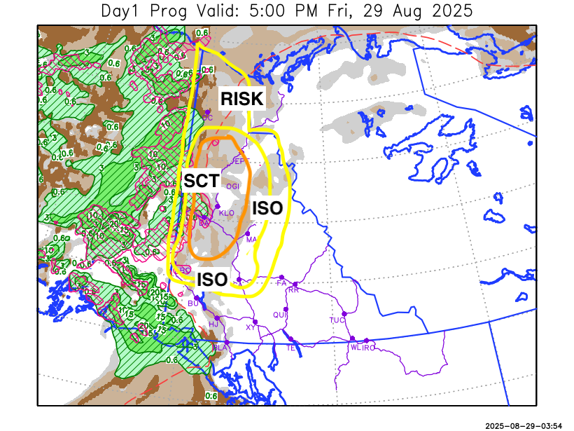
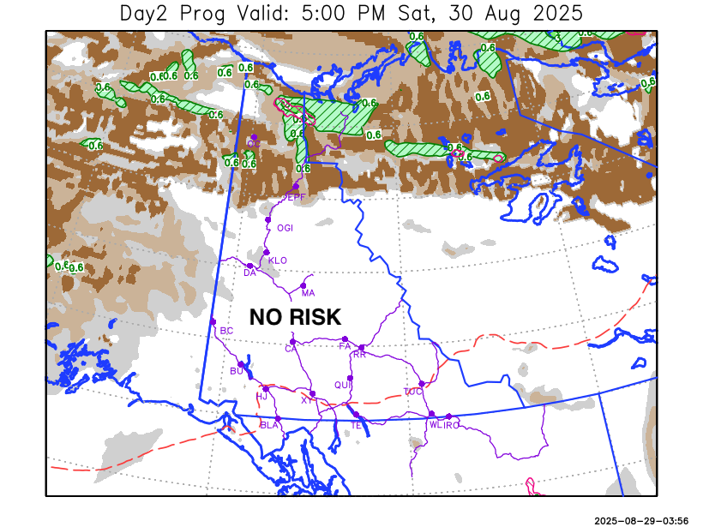

Forecast for | Saturday | (Peak burning period and overnight)
Community | Clouds | Pcpn | POP | POL | Max Temp | Min RH | Min Temp | Max  RH | Wind Dir | Wind Speed
Old Crow | BKN | RW- | 20 |  | 11 | 56 | 4 | 82 | 250 | 25G45
Klondike Fc | BKN | RW- | 20 |  | 17 | 35 | 5 | 78 | 250 | 8
Mayo A | BKN |  | 0 |  | 16 | 31 | 9 | 63 | 250 | 13
Carmacks | SCT |  | 0 |  | 20 | 29 | 7 | 62 | 90 | 7
Faro | SCT |  | 0 |  | 17 | 30 | 5 | 61 | 270 | 10
Ross River | SCT |  | 0 |  | 19 | 30 | 3 | 61 | 290 | 10
Beaver Creek Town | BKN |  | 0 |  | 17 | 38 | 3 | 72 | 90 | 8
Burwash A | SCT |  | 0 |  | 16 | 40 | 5 | 75 | 110 | 10
Haines Junction | SCT |  | 0 |  | 20 | 33 | 4 | 83 | 220 | 8
Whitehorse Auto | SCT |  | 0 |  | 18 | 30 | 8 | 68 | 0 | 7
Teslin | SCT |  | 0 |  | 20 | 29 | 8 | 69 | 340 | 8
Watson Lake | FEW |  | 0 |  | 21 | 23 | 8 | 55 | 320 | 15

Forecast for |  |  | Sunday |  |  | (Peak burning period and overnight)
Community |  |  | Clouds |  |  | Pcpn | POP |  | POL |  | Max Temp |  | Min RH | Min Temp | Max  RH | Wind Dir | Wind Speed
Old Crow |  |  | BKN |  |  |  | 0 |  |  |  | 13 |  | 58 | 6 | 85 | 250 | 15G30
Klondike Fc |  |  | BKN |  |  | RW- | 20 |  |  |  | 17 |  | 45 | 7 | 82 | 110 | 5
Mayo A |  |  | BKN |  |  | RW- | 20 |  |  |  | 17 |  | 40 | 9 | 80 | 270 | 12
Carmacks |  |  | SCT |  |  |  | 0 |  |  |  | 21 |  | 29 | 8 | 66 | 340 | 8
Faro |  |  | BKN |  |  |  | 0 |  |  |  | 18 |  | 34 | 6 | 67 | 270 | 10
Ross River |  |  | SCT |  |  |  | 0 |  |  |  | 20 |  | 34 | 4 | 70 | 270 | 10
Beaver Creek Town |  |  | BKN |  |  |  | 0 |  |  |  | 20 |  | 34 | 5 | 69 | 90 | 5
Burwash A |  |  | SCT |  |  |  | 0 |  |  |  | 19 |  | 34 | 7 | 68 | 160 | 8
Haines Junction |  |  | SCT |  |  |  | 0 |  |  |  | 21 |  | 25 | 6 | 73 | 160 | 5
Whitehorse Auto |  |  | SCT |  |  |  | 0 |  |  |  | 20 |  | 30 | 9 | 67 | 0 | 10
Teslin |  |  | SCT |  |  |  | 0 |  |  |  | 21 |  | 27 | 9 | 70 | 340 | 7
Watson Lake |  |  | SCT |  |  |  | 0 |  |  |  | 20 |  | 24 | 9 | 60 | 290 | 7
3-Day Forecast Precipitation Totals from 13:00 Yesterday
OC | 2.6 |  | FA | 0.7 |  | JAK | 0.0
EPF | 5.0 |  | RR | 0.3 |  | TE | 0.0
ANT | 3.1 |  | BC | 0.3 |  | QUI | 0.0
DA | 2.5 |  | BCT | 0.3 |  | SWI | 0.0
FMI | 4.0 |  | BU | 1.2 |  | FL | 0.0
HEN | 1.4 |  | HJF | 0.8 |  | TUC | 0.0
BAR | 2.7 |  | RAI | 0.8 |  | HAS | 0.0
MA | 2.4 |  | CH | 1.4 |  | TC | 0.0
STW | 2.3 |  | BR | 1.6 |  | WL | 0.0
WIL | 2.2 |  | NU | 1.4 |  | PE | 1.2
XY | 0.8 |  | IRO | 0.0 |  | CA | 0.8
CC | 0.0 |  | ELK | 0.0 |  | DRU | 1.0
ATL | 0.0 |  | NA | NA |  | NA | NA
Matt Desorcy Meteorologist

Disclaimer : The information in these forecasts is collected and prepared for internal use by the Government of Yukon. The forecasts are specifically designed to meet the needs of the Wildland Fire Management and may not cover the requirements of other parties. Weather warnings or advisories are not included as part of the forecasts. Wildland Fire Management makes no representation and provides no warranty as to the accuracy of its weather forecasts. Any use the recipient chooses to make of the forecasts will be at its sole risk.

