YUKON WILDLAND FIRE MANAGEMENT WEATHER FORECAST - 9:00 AM ISSUE

30-Aug-2025
YESTERDAY'S VALUES
Community | Max  Temp  (°C) | Diff.  from  Normal | Min Temp  (°C) | Diff. from Normal | Pcpn  (mm) | Min RH | Max RH | L110 | L30
Old Crow | 17.1 | 3.4 | 6.5 | 3.5 | 2.4 | 65 | 92 | 0 | 0
Fort Mcpherson Airport | 27.6 |  | 8.8 |  | 0.0M | 33 | 61 | 0 | 0
Rock River Climate | 23.3 |  | 2.6 |  | 6.0 | 32 | 99 | NA | NA
Eagle Plains Fire | 25.6 |  | 3.3 |  | 2.5 | 27 | 98 | 0 | 0
Antimony Creek | 24.9 |  | -0.9 |  | 1.9 | 33 | 88 | 11 | 0
Klondike Fc | 22.9 |  | -0.5 |  | 1.1 | 44 | 91 | 10 | 0
Forty Mile | 19.6 |  | 0.4 |  | 2.3 | 49 | 86 | 1 | 0
Henderson | 21.3 |  | 0.7 |  | 0.0 | 36 | 79 | 11 | 0
Barlow | 23.3 |  | 0.8 |  | 1.8 | 34 | 91 | 15 | 0
Mayo A | 24.7 | 7.7 | 7.0 | 2.8 | 0.0 | 33 | 55 | 38 | 0
Stewart Crossing | 25.5 |  | 4.9 |  | 0.0 | 29 | 81 | 40 | 0
Willow Creek | 24.5 |  | 4.5 |  | 0.0 | 32 | 75 | 38 | 5
Pelly Farm | 26.9 | 9.3 | 2.2 | -1.1 | 0.0 | 33 | 87 | 35 | 2
Carmacks | 30.5 |  | 6.7 |  | 0.0 | 22 | 68 | 16 | 0
Drury Creek | 28.0 |  | 12.1 |  | 0.0 | 24 | 62 | 1 | 0
Faro | 27.6 | 11.6 | 11.3 | 7.1 | 0.0 | 29M | 90M | 0 | 0
Ross River | 28.4 |  | 12.6 |  | 0.0 | 25 | 72 | 0 | 0
Macmillan Pass | 22.0 |  | 9.8 |  | 0.0 | 35 | 62 | 0 | 0
Beaver Creek A | 26.6 | 10.7 | -1.1 | -3.4 | 0.0M | 26 | 90 | 0 | 0
Beaver Creek Town | 27.5 |  | 1.0 |  | 0.0 | 21 | 87 | 0 | 0
Burwash A | 23.8 | 8.3 | 4.1 | 2.0 | 0.0M | 29 | 82 | 0 | 0
Haines Junction | 25.4 | 7.6 | 8.8 | 7.8 | 0.0 | 30 | 87 | 0 | 0
Rainbow | 24.1 |  | 9.5 |  | 0.0 | 34 | 83 | 0 | 0
Champagne | 24.5 |  | 12.7 |  | 0.0 | 32 | 66 | 0 | 0
Braeburn | 28.1 |  | 8.1 |  | 0.6 | 22 | 97 | 0 | 0
Nursery | 29.7 |  | 9.0 |  | 0.8 | 20 | 97 | 0 | 0
Whitehorse Auto | 25.7 | 9.3 | 9.5 | 4.8 | 1.0 | 26 | 88 | 0 | 0
Mount Sima | 22.0 |  | 6.2 |  | 0.3 | 28 | 98 | 0 | 0
Carcross | 23.3 |  | 12.0 |  | 0.0 | 38 | 72 | 0 | 0
Atlin | 24.6 |  | 12.0 |  | 0.0 | 23 | 73 | 0 | 0
Jakes Corner | 26.7 |  | 11.0 |  | 0.0 | 25 | 74 | 0 | 0
Teslin | 26.0 |  | 9.9 |  | 0.0 | 20 | 81 | 0 | 0
Quiet Lake | 28.3 |  | 10.6 |  | 0.0 | 29 | 78 | 0 | 0
Swift River | 26.4 |  | 6.8 |  | 0.0 | 18 | 85 | 0 | 0
Tuchitua | 27.9 |  | 4.8 |  | 0.0 | 25 | 99 | 0 | 0
Hasselburg | 27.4 |  | 9.3 |  | 0.0 | 20 | 64 | 0 | 0
Tom Creek | 27.2 |  | 11.6 |  | 0.0 | 19 | 60 | 0 | 0
Watson Lake | 28.8 | 11.8 | 8.4 | 3.5 | 0.0 | 16 | 78 | 0 | 0
Iron Creek | 28.6 |  | 6.0 |  | 0.0 | 20 | 92 | 0 | 0
Max Temp is the actual maximum temperature in °C from yesterday afternoon or evening.
Min Temp is the actual overnight minimum temperature in °C up until 6:00 AM this morning.
Diff. from Normal is the difference from the 30 year average max or min temperature.
Pcpn is the precipitation in mm since 13:00 yesterday.
Min RH is the minimum observed RH in % from yesterday afternoon or evening.
Max RH is the maximum observed overnight RH in % up until 6:00 AM this morning.
L110 is the actual number of lightning strikes within 110 km and in the Yukon for 24 hours ending at 06:00 AM this morning.
L30 is the actual number of lightning strikes within 30 km and in the Yukon for 24 hours ending at 06:00 AM this morning.
M is missing data. * denotes precipitation at stations that failed to report for at least part of the evening and overnight period.

SYNOPSIS:
Today: A cold front passed through the Yukon overnight, bringing cooler temperatures today. Weak ridging is rebuilding over the southern Yukon, while the upper flow remains largely zonal (indicating an absence of a significant ridge or trough). Highs will range from the mid-teens to low twenties, with cooler conditions at Old Crow. No crossovers are expected. Winds will generally be lighter, with most areas seeing afternoon speeds of 10–15 km/h, though Old Crow will be windier with westerlies at 40 km/h, gusting to 60 km/h. A slight chance of a late-day or overnight shower exists in the Klondike region; otherwise, dry weather is expected.

Sunday: Ridging will begin rebuilding across the territory on Sunday, bringing a slight warm-up. Highs will range from the upper teens to low twenties, with no crossovers expected. A weak upper impulse may bring a few morning showers to the Klondike and Northern Tutchone regions, but otherwise dry conditions are expected. Winds will be light, with afternoon speeds generally between 10 and 20 km/h.

Monday: Ridging will continue to build across the Yukon, leading to warmer temperatures. Highs on Monday will generally reach the low to mid-twenties, with some areas potentially climbing into the upper twenties. Winds will increase slightly, with afternoon speeds of 10–20 km/h and occasional gusts up to 30 km/h from the south to southwest.

Tuesday: Ridging remains in place across the Yukon, leading to another unusually warm day for early September. No precipitation is expected.

Wednesday: Little change in the pattern, with ridging persisting. This will lead to unusually warm temperatures and little to no rain chances.

Forecast for | Saturday | (Peak burning period and overnight)
Community | Clouds | Pcpn | POP | POL | Max Temp | Min RH | Min Temp | Max  RH | Wind Dir | Wind Speed
Old Crow | SCT |  | 0 | 0 | 10 | 60 | 4 | 90 | 250 | 40G60
Klondike Fc | SCT | RW- | 30 | 0 | 17 | 40 | 7 | 90 | 220 | 20
Mayo A | FEW |  | 0 | 0 | 16 | 35 | 10 | 70 | 250 | 15
Carmacks | FEW |  | 0 | 0 | 21 | 30 | 8 | 70 | 120 | 10
Faro | FEW |  | 0 | 0 | 18 | 30 | 6 | 80 | 290 | 10
Ross River | FEW |  | 0 | 0 | 20 | 30 | 3 | 80 | 290 | 10
Beaver Creek Town | SCT |  | 0 | 0 | 18 | 40 | 5 | 80 | 270 | 10
Burwash A | SCT |  | 0 | 0 | 17 | 45 | 6 | 85 | 140 | 15
Haines Junction | SCT |  | 2 | 0 | 20 | 45 | 5 | 85 | 270 | 15
Whitehorse Auto | SCT |  | 0 | 0 | 19 | 35 | 9 | 80 | 20 | 15
Teslin | SCT |  | 0 | 0 | 21 | 35 | 9 | 80 | 340 | 10
Watson Lake | SCT |  | 0 | 0 | 22 | 25 | 9 | 70 | 320 | 15
POP is probability of precipitation in %.
POL is probability of lightning in %.

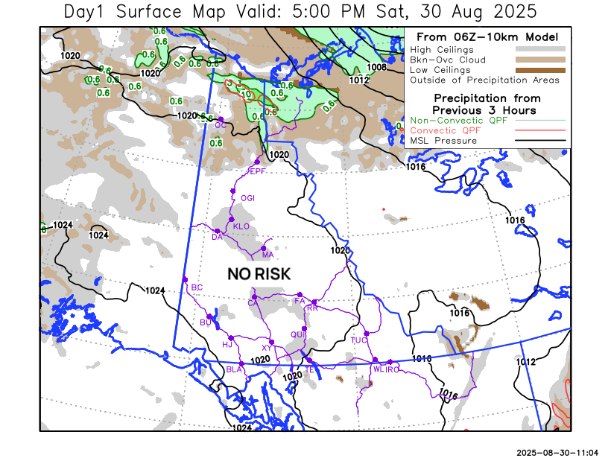
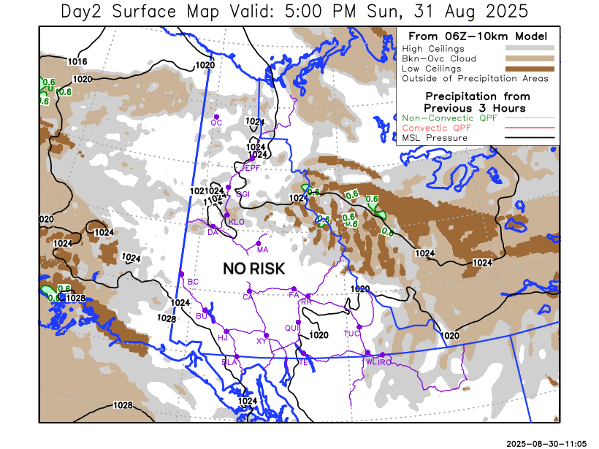

Forecast for | Sunday | (Peak burning period and overnight)
Community | Clouds | Pcpn | POP | POL | Max Temp | Min RH | Min Temp | Max  RH | Wind Dir | Wind Speed
Old Crow | BKN |  | 20 | 0 | 13 | 60 | 5 | 90 | 250 | 20
Klondike Fc | BKN | RW- | 50 | 0 | 18 | 50 | 7 | 95 | 270 | 10
Mayo A | BKN | RW- | 40 | 0 | 18 | 40 | 9 | 90 | 270 | 10
Carmacks | SCT |  | 20 | 0 | 23 | 35 | 8 | 80 | 180 | 10
Faro | FEW |  | 20 | 0 | 20 | 35 | 7 | 80 | 290 | 10
Ross River | FEW |  | 20 | 0 | 22 | 30 | 4 | 80 | 320 | 10
Beaver Creek Town | SCT |  | 0 | 0 | 21 | 35 | 5 | 80 | 90 | 10
Burwash A | FEW |  | 0 | 0 | 19 | 35 | 7 | 80 | 160 | 15
Haines Junction | SCT |  | 0 | 0 | 23 | 25 | 5 | 80 | 250 | 15
Whitehorse Auto | SCT |  | 0 | 0 | 21 | 25 | 9 | 70 | 340 | 10
Teslin | SCT |  | 0 | 0 | 22 | 30 | 9 | 75 | 320 | 10
Watson Lake | SCT |  | 0 | 0 | 21 | 25 | 9 | 70 | 290 | 10

Forecast for |  |  | Monday |  |  | (Peak burning period and overnight)
Community |  |  | Clouds |  |  | Pcpn | POP |  | POL |  | Max Temp |  | Min RH | Min Temp | Max  RH | Wind Dir | Wind Speed
Old Crow |  |  | BKN |  |  |  | 20 |  | 0 |  | 17 |  | 50 | 7 | 95 | 220 | 20G35
Klondike Fc |  |  | SCT |  |  |  | 20 |  | 0 |  | 23 |  | 35 | 8 | 90 | 220 | 15
Mayo A |  |  | SCT |  |  |  | 20 |  | 0 |  | 23 |  | 35 | 11 | 90 | 220 | 15
Carmacks |  |  | FEW |  |  |  | 0 |  | 0 |  | 27 |  | 25 | 10 | 75 | 140 | 15
Faro |  |  | FEW |  |  |  | 0 |  | 0 |  | 22 |  | 30 | 9 | 75 | 140 | 10
Ross River |  |  | FEW |  |  |  | 0 |  | 0 |  | 24 |  | 35 | 6 | 80 | 110 | 10
Beaver Creek Town |  |  | FEW |  |  |  | 0 |  | 0 |  | 25 |  | 30 | 6 | 80 | 110 | 10
Burwash A |  |  | FEW |  |  |  | 0 |  | 0 |  | 23 |  | 30 | 9 | 70 | 140 | 15
Haines Junction |  |  | FEW |  |  |  | 0 |  | 0 |  | 26 |  | 20 | 8 | 80 | 140 | 10
Whitehorse Auto |  |  | FEW |  |  |  | 0 |  | 0 |  | 24 |  | 20 | 11 | 70 | 160 | 10
Teslin |  |  | FEW |  |  |  | 0 |  | 0 |  | 24 |  | 25 | 11 | 75 | 120 | 10
Watson Lake |  |  | FEW |  |  |  | 0 |  | 0 |  | 22 |  | 25 | 10 | 75 | 120 | 10
3-Day Forecast Precipitation Totals from 13:00 Yesterday
OC | 2.4 |  | FA | 0.0 |  | JAK | 0.0
EPF | 2.8 |  | RR | 0.0 |  | TE | 0.0
ANT | 2.3 |  | BC | 0.0 |  | QUI | 0.0
DA | 0.6 |  | BCT | 0.0 |  | SWI | 0.0
FMI | 3.5 |  | BU | 0.0 |  | FL | 0.0
HEN | 0.1 |  | HJF | 0.0 |  | TUC | 0.0
BAR | 1.9 |  | RAI | 0.0 |  | HAS | 0.0
MA | 0.0 |  | CH | 0.0 |  | TC | 0.0
STW | 0.0 |  | BR | 0.6 |  | WL | 0.0
WIL | 0.0 |  | NU | 0.8 |  | PE | 0.0
XY | 1.0 |  | IRO | 0.0 |  | CA | 0.0
CC | 0.0 |  | ELK | 0.0 |  | DRU | 0.0
ATL | 0.0 |  | NA | NA |  | NA | NA
Scott Kehler Meteorologist

Disclaimer : The information in these forecasts is collected and prepared for internal use by the Government of Yukon. The forecasts are specifically designed to meet the needs of the Wildland Fire Management and may not cover the requirements of other parties. Weather warnings or advisories are not included as part of the forecasts. Wildland Fire Management makes no representation and provides no warranty as to the accuracy of its weather forecasts. Any use the recipient chooses to make of the forecasts will be at its sole risk.

