YUKON WILDLAND FIRE MANAGEMENT WEATHER FORECAST - 9:00 AM ISSUE

31-Aug-2025
YESTERDAY'S VALUES
Community | Max  Temp  (°C) | Diff.  from  Normal | Min Temp  (°C) | Diff. from Normal | Pcpn  (mm) | Min RH | Max RH | L110 | L30
Old Crow | 10.4 | -3.0 | -0.2 | -3.0 | 0.0 | 53 | 99 | 0 | 0
Fort Mcpherson Airport | 14.0 |  | 2.6 |  | 0.2 | 46 | 94 | 0 | 0
Rock River Climate | 8.6 |  | 0.5 |  | 0.0 | 51 | 87 | NA | NA
Eagle Plains Fire | 10.7 |  | 4.3 |  | 0.0 | 41 | 66 | 0 | 0
Antimony Creek | 15.7 |  | -1.7 |  | 0.0 | 31 | 95 | 0 | 0
Klondike Fc | 17.2 |  | -1.0 |  | 0.0 | 29 | 94 | 0 | 0
Forty Mile | 15.1 |  | 1.7 |  | 0.0 | 35 | 92 | 0 | 0
Henderson | 12.2 |  | 6.0 |  | 0.0 | 38 | 64 | 0 | 0
Barlow | 13.7 |  | 4.0 |  | 0.0 | 35 | 75 | 0 | 0
Mayo A | 14.7 | -2.1 | -0.3 | -4.3 | 0.0 | 31 | 88 | 0 | 0
Stewart Crossing | 14.3 |  | -0.6 |  | 0.0 | 33 | 97 | 0 | 0
Willow Creek | 16.7 |  | 0.1 |  | 0.0 | 29 | 94 | 0 | 0
Pelly Farm | 18.0 | 0.6 | 1.4 | -1.7 | 0.0 | 29 | 93 | 0 | 0
Carmacks | 20.4 |  | 1.6 |  | 0.0 | 26 | 84 | 0 | 0
Drury Creek | 18.5 |  | -0.8 |  | 0.0 | 25 | 92 | 0 | 0
Faro | 18.1 | 2.3 | -0.7 | -4.7 | 0.0 | 31M | 100M | 0 | 0
Ross River | 19.1 |  | -4.4 |  | 0.0 | 14 | 93 | 0 | 0
Macmillan Pass | 13.1 |  | -0.9 |  | 0.0 | 22 | 74 | 0 | 0
Beaver Creek A | 14.8 | -0.9 | 2.3 | 0.2 | 0.0 | 42 | 85 | 0 | 0
Beaver Creek Town | 16.1 |  | 1.8 |  | 0.0 | 37 | 88 | 0 | 0
Burwash A | 17.3 | 2.0 | 1.1 | -0.8 | 0.0M | 44 | 88 | 0 | 0
Haines Junction | 20.3 | 3.3 | 2.0 | 1.4 | 0.0 | 36 | 96 | 0 | 0
Rainbow | 19.3 |  | 3.2 |  | 0.0 | 34 | 90 | 0 | 0
Champagne | 19.8 |  | -2.1 |  | 0.0 | 28 | 92 | 0 | 0
Braeburn | 19.4 |  | -2.0 |  | 0.0 | 25 | 95 | 0 | 0
Nursery | 19.3 |  | -2.3 |  | 0.0 | 26 | 96 | 0 | 0
Whitehorse Auto | 18.3 | 2.2 | 2.9 | -1.6 | 0.0 | 29 | 84 | 0 | 0
Mount Sima | 16.3 |  | 8.3 |  | 0.0 | 35 | 59 | 0 | 0
Carcross | 20.3 |  | 1.3 |  | 0.0 | 30 | 96 | 0 | 0
Atlin | 21.7 |  | 7.0 |  | 0.0 | 30 | 76 | 0 | 0
Jakes Corner | 21.0 |  | 2.8 |  | 0.0 | 25 | 90 | 0 | 0
Teslin | 21.0 |  | 2.9 |  | 0.0 | 26 | 92 | 0 | 0
Quiet Lake | 21.3 |  | 1.8 |  | 0.0 | 24 | 83 | 0 | 0
Swift River | 22.8 |  | -0.3 |  | 0.0 | 21 | 94 | 0 | 0
Tuchitua | 21.4 |  | -4.6 |  | 0.0 | 17 | 95 | 0 | 0
Hasselburg | 20.7 |  | 2.9 |  | 0.0 | 18 | 63 | 0 | 0
Tom Creek | 21.8 |  | 5.0 |  | 0.0 | 21 | 55 | 0 | 0
Watson Lake | 22.5 | 5.7 | 2.8 | -1.9 | 0.0 | 19 | 77 | 0 | 0
Iron Creek | 24.3 |  | -1.9 |  | 0.0 | 19 | 97 | 0 | 0
Max Temp is the actual maximum temperature in °C from yesterday afternoon or evening.
Min Temp is the actual overnight minimum temperature in °C up until 6:00 AM this morning.
Diff. from Normal is the difference from the 30 year average max or min temperature.
Pcpn is the precipitation in mm since 13:00 yesterday.
Min RH is the minimum observed RH in % from yesterday afternoon or evening.
Max RH is the maximum observed overnight RH in % up until 6:00 AM this morning.
L110 is the actual number of lightning strikes within 110 km and in the Yukon for 24 hours ending at 06:00 AM this morning.
L30 is the actual number of lightning strikes within 30 km and in the Yukon for 24 hours ending at 06:00 AM this morning.
M is missing data. * denotes precipitation at stations that failed to report for at least part of the evening and overnight period.

SYNOPSIS:
Today: Ridging will begin rebuilding across the territory today, bringing a slight warm-up. Highs will range from the upper teens to low twenties, with no crossovers expected. A weak upper impulse is bringing a few morning showers to the Klondike and Northern Tutchone regions, but otherwise dry conditions are expected. Skies should clear as the day progresses. Winds will be light, with afternoon speeds generally between 10 and 20 km/h.

Monday: Ridging will continue to build across the Yukon, leading to warmer temperatures. Highs on Monday will generally reach the low to mid-twenties, with some areas climbing into the upper twenties. Crossovers are possible where temperatures reach the mid-twenties or higher. Winds will increase slightly, with afternoon speeds of 10–20 km/h and occasional gusts up to 30 km/h from the south to southwest, especially in the Klondike, Northern Tutchone, and Old Crow regions. No precipitation is expected.

Tuesday: Ridging remains in place across the Yukon, bringing another unusually warm day for early September, with highs mostly in the mid-twenties. There is a slight chance of a shower in the Klondike region; otherwise, no precipitation is expected. Winds will remain westerly and breezy at Old Crow, while elsewhere afternoon speeds will generally be 10–15 km/h or less.

Wednesday: Little change in the pattern, with ridging persisting. This will bring unusually warm and dry conditions.

Thursday: Ridging is likely to persist across most of the territory but may begin to weaken in the western and northern Yukon. For much of the territory, this will mean temperatures remain warmer than normal with little or no chance of rain. Somewhat cooler temperatures are possible in the western and northern Yukon, depending on how quickly the ridge shifts east.

Forecast for | Sunday | (Peak burning period and overnight)
Community | Clouds | Pcpn | POP | POL | Max Temp | Min RH | Min Temp | Max  RH | Wind Dir | Wind Speed
Old Crow | BKN |  | 20 | 0 | 13 | 50 | 2 | 90 | 200 | 20
Klondike Fc | SCT | RW- | 40 | 0 | 19 | 35 | 3 | 85 | 270 | 10
Mayo A | SCT | RW- | 40 | 0 | 18 | 35 | 5 | 90 | 220 | 10
Carmacks | SCT |  | 0 | 0 | 23 | 25 | 5 | 80 | 330 | 10
Faro | SCT |  | 0 | 0 | 19 | 25 | 2 | 85 | 290 | 10
Ross River | SCT |  | 0 | 0 | 21 | 20 | 2 | 85 | 320 | 10
Beaver Creek Town | SCT |  | 0 | 0 | 20 | 30 | 3 | 90 | 90 | 10
Burwash A | SCT |  | 0 | 0 | 19 | 35 | 2 | 90 | 160 | 15
Haines Junction | SCT |  | 0 | 0 | 23 | 25 | 3 | 90 | 200 | 15
Whitehorse Auto | SCT |  | 0 | 0 | 21 | 20 | 4 | 85 | 200 | 10
Teslin | SCT |  | 0 | 0 | 22 | 25 | 5 | 80 | 320 | 10
Watson Lake | SCT |  | 0 | 0 | 22 | 20 | 5 | 75 | 320 | 15
POP is probability of precipitation in %.
POL is probability of lightning in %.

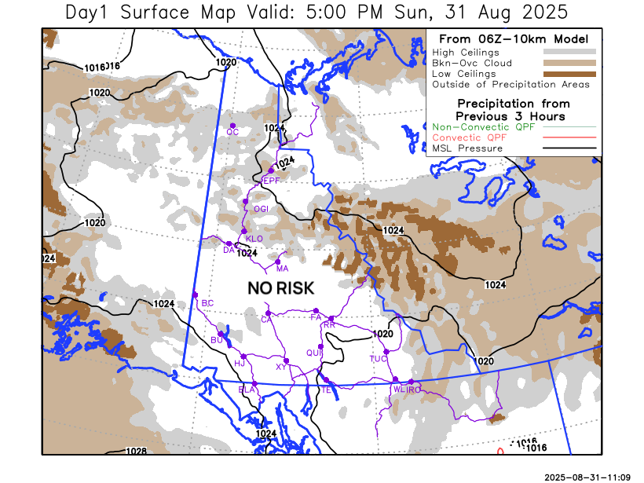
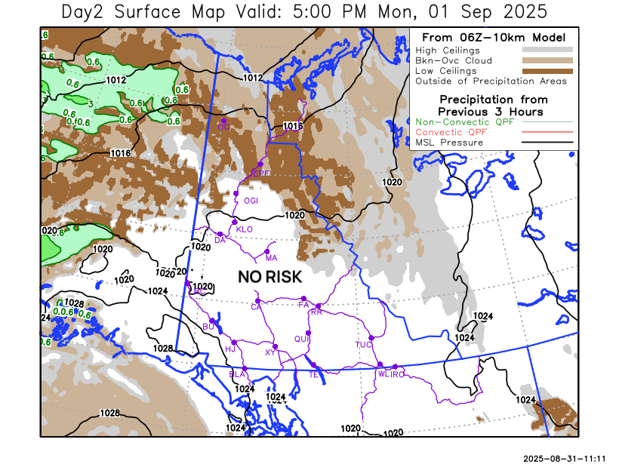
Forecast for | Monday | (Peak burning period and overnight)
Community | Clouds | Pcpn | POP | POL | Max Temp | Min RH | Min Temp | Max  RH | Wind Dir | Wind Speed
Old Crow | SCT |  | 0 | 0 | 16 | 45 | 2 | 85 | 220 | 20G35
Klondike Fc | SCT |  | 0 | 0 | 23 | 30 | 4 | 85 | 250 | 20
Mayo A | SCT |  | 0 | 0 | 22 | 35 | 5 | 85 | 220 | 20
Carmacks | FEW |  | 0 | 0 | 26 | 25 | 4 | 80 | 220 | 15
Faro | FEW |  | 0 | 0 | 22 | 25 | 4 | 75 | 140 | 10
Ross River | FEW |  | 0 | 0 | 23 | 25 | 3 | 75 | 110 | 10
Beaver Creek Town | FEW |  | 0 | 0 | 24 | 30 | 3 | 85 | 200 | 10
Burwash A | FEW |  | 0 | 0 | 22 | 30 | 4 | 80 | 160 | 15
Haines Junction | FEW |  | 0 | 0 | 26 | 20 | 3 | 85 | 220 | 15
Whitehorse Auto | FEW |  | 0 | 0 | 24 | 20 | 5 | 80 | 160 | 10
Teslin | FEW |  | 0 | 0 | 24 | 25 | 5 | 85 | 180 | 5
Watson Lake | FEW |  | 0 | 0 | 22 | 25 | 5 | 85 | 70 | 5

Forecast for |  |  | Tuesday |  |  | (Peak burning period and overnight)
Community |  |  | Clouds |  |  | Pcpn | POP |  | POL |  | Max Temp |  | Min RH | Min Temp | Max  RH | Wind Dir | Wind Speed
Old Crow |  |  | SCT |  |  |  | 20 |  | 0 |  | 17 |  | 45 | 3 | 90 | 250 | 30G50
Klondike Fc |  |  | BKN |  |  | RW- | 30 |  | 0 |  | 21 |  | 35 | 5 | 90 | 270 | 15
Mayo A |  |  | BKN |  |  |  | 0 |  | 0 |  | 23 |  | 35 | 6 | 90 | 270 | 15
Carmacks |  |  | FEW |  |  |  | 0 |  | 0 |  | 27 |  | 20 | 5 | 85 | 320 | 10
Faro |  |  | FEW |  |  |  | 0 |  | 0 |  | 24 |  | 20 | 5 | 80 | 290 | 10
Ross River |  |  | FEW |  |  |  | 0 |  | 0 |  | 25 |  | 20 | 4 | 80 | 270 | 10
Beaver Creek Town |  |  | SCT |  |  |  | 0 |  | 0 |  | 23 |  | 30 | 4 | 90 | 320 | 10
Burwash A |  |  | FEW |  |  |  | 0 |  | 0 |  | 23 |  | 30 | 5 | 90 | 320 | 10
Haines Junction |  |  | FEW |  |  |  | 0 |  | 0 |  | 27 |  | 20 | 4 | 90 | 200 | 15
Whitehorse Auto |  |  | FEW |  |  |  | 0 |  | 0 |  | 26 |  | 20 | 6 | 85 | 270 | 10
Teslin |  |  | FEW |  |  |  | 0 |  | 0 |  | 26 |  | 25 | 6 | 80 | 180 | 10
Watson Lake |  |  | FEW |  |  |  | 0 |  | 0 |  | 25 |  | 25 | 7 | 85 | 140 | 10
3-Day Forecast Precipitation Totals from 13:00 Yesterday
OC | 0.0 |  | FA | 0.0 |  | JAK | 0.0
EPF | 0.0 |  | RR | 0.0 |  | TE | 0.0
ANT | 0.0 |  | BC | 0.0 |  | QUI | 0.0
DA | 0.0 |  | BCT | 0.0 |  | SWI | 0.0
FMI | 0.0 |  | BU | 0.0 |  | FL | 0.0
HEN | 0.0 |  | HJF | 0.0 |  | TUC | 0.0
BAR | 0.0 |  | RAI | 0.0 |  | HAS | 0.0
MA | 0.0 |  | CH | 0.0 |  | TC | 0.0
STW | 0.0 |  | BR | 0.0 |  | WL | 0.0
WIL | 0.0 |  | NU | 0.0 |  | PE | 0.0
XY | 0.0 |  | IRO | 0.0 |  | CA | 0.0
CC | 0.0 |  | ELK | 0.0 |  | DRU | 0.0
ATL | 0.0 |  | NA | NA |  | NA | NA
Scott Kehler Meteorologist

Disclaimer : The information in these forecasts is collected and prepared for internal use by the Government of Yukon. The forecasts are specifically designed to meet the needs of the Wildland Fire Management and may not cover the requirements of other parties. Weather warnings or advisories are not included as part of the forecasts. Wildland Fire Management makes no representation and provides no warranty as to the accuracy of its weather forecasts. Any use the recipient chooses to make of the forecasts will be at its sole risk.

