YUKON WILDLAND FIRE MANAGEMENT WEATHER FORECAST - 9:00 AM ISSUE

29-Apr-2026
YESTERDAY'S VALUES
Community | Max  Temp  (°C) | Diff.  from  Normal | Min Temp  (°C) | Diff. from Normal | Pcpn  (mm) | Min RH | Max RH | L110 | L30
Old Crow | 7.6 | 7.0 | -0.3 | 11.4 | 3.4 | 52 | 98 | 0 | 0
Fort Mcpherson Airport | 5.5 |  | -0.5 |  | 0.0M(2) | 65 | 93 | 0 | 0
Rock River Climate | 6.6 |  | 0.4 |  | 0.2 | 59 | 98 | NA | NA
Eagle Plains Fire | 13.1 |  | 2.2 |  | 3.0 | 34 | 80 | 0 | 0
Antimony Creek | 14.0 |  | -3.5 |  | 0.0 | 30 | 96 | 0 | 0
Klondike Fc | M |  | M |  | M | M | M | 0 | 0
Forty Mile | 14.5 |  | 0.3 |  | 0.0 | 28 | 62 | 0 | 0
Henderson | 9.7 |  | 0.2 |  | 19.8 | 40 | 69 | 0 | 0
Barlow | 13.7 |  | 0.6 |  | 0.5 | 30 | 92 | 0 | 0
Mayo A | 13.9 | 3.5 | -1.7 | -0.2 | 1.9 | 32 | 97 | 0 | 0
Stewart Crossing | 14.8 |  | -0.7 |  | 6.0 | 30 | 98 | 0 | 0
Willow Creek | 13.1 |  | -0.1 |  | 1.8 | 33 | 98 | 0 | 0
Pelly Farm | M |  | M |  | M | M | M | 0 | 0
Carmacks | 13.7 |  | 2.6 |  | 0.0 | 32 | 62 | 0 | 0
Drury Creek | 16.6 |  | 1.2 |  | 0.0 | 27 | 84 | 0 | 0
Faro | 13.4 | 3.6 | 3.7 | 6.2 | 0.0 | 47M(2) | 92M(2) | 0 | 0
Ross River | 17.2 |  | -2.9 |  | 0.0 | 21 | 87 | 0 | 0
Macmillan Pass | 4.6 |  | -1.9 |  | 0.2 | 56 | 84 | 0 | 0
Beaver Creek A | 12.8 | 3.7 | -4.7 | 0.0 | 0.0 | 23 | 78 | 0 | 0
Beaver Creek Town | 16.4 |  | -4.2 |  | 14.0 | 20 | 81 | 0 | 0
Burwash A | 13.8 | 5.5 | -6.2 | -1.7 | 0.0M(2) | 18 | 84 | 0 | 0
Haines Junction | 14.9 | 5.9 | -4.0 | 0.3 | 0.0 | 19 | 84 | 0 | 0
Rainbow | 12.9 |  | -0.1 |  | 13.3 | 39 | 76 | 0 | 0
Champagne | 11.8 |  | 0.0 |  | 0.0 | 40 | 80 | 0 | 0
Braeburn | 14.6 |  | -0.8 |  | 0.0 | 33 | 77 | 0 | 0
Nursery | 14.2 |  | -3.1 |  | 0.0 | 34 | 94 | 0 | 0
Whitehorse Auto | 11.0 | 1.8 | 0.8 | 2.8 | 0.0 | 41 | 80 | 0 | 0
Mount Sima | 10.1 |  | -0.8 |  | 0.0 | 41 | 80 | 0 | 0
Carcross | 10.3 |  | -0.8 |  | 0.0 | 44 | 95 | 0 | 0
Atlin | 11.3 |  | -1.4 |  | 0.0 | 42 | 91 | 0 | 0
Jakes Corner | 11.5 |  | -1.3 |  | 0.0 | 39 | 89 | 0 | 0
Teslin | 11.3 |  | -0.9 |  | 0.0 | 39 | 91 | 0 | 0
Quiet Lake | 14.4 |  | -0.7 |  | 1.3 | 31 | 84 | 0 | 0
Swift River | 13.0 |  | 2.3 |  | 0.0 | 31 | 77 | 0 | 0
Tuchitua | 17.6 |  | -1.8 |  | 12.9 | 20 | 94 | 0 | 0
Hasselburg | 17.6 |  | 0.8 |  | 28.9 | 20 | 75 | 0 | 0
Tom Creek | 16.7 |  | 0.5 |  | 19.9 | 20 | 84 | 0 | 0
Watson Lake | 13.7 | 3.9 | -2.5 | 0.3 | 0.0 | 29 | 94M(2) | 0 | 0
Iron Creek | 18.1 |  | -2.3 |  | 15.0 | 20 | 95 | 0 | 0
Max Temp is the actual maximum temperature in °C from yesterday afternoon or evening.
Min Temp is the actual overnight minimum temperature in °C up until 6:00 AM this morning.
Diff. from Normal is the difference from the 30 year average max or min temperature.
Pcpn is the precipitation in mm since 13:00 yesterday.
Min RH is the minimum observed RH in % from yesterday afternoon or evening.
Max RH is the maximum observed overnight RH in % up until 6:00 AM this morning.
L110 is the actual number of lightning strikes within 110 km and in the Yukon for 24 hours ending at 06:00 AM this morning.
L30 is the actual number of lightning strikes within 30 km and in the Yukon for 24 hours ending at 06:00 AM this morning.
M is missing data. * denotes precipitation at stations that failed to report for at least part of the evening and overnight period.

SYNOPSIS:
Today: Yesterday’s arctic frontal passage leaves behind very cool but dry air in Klondike, Northern Tutchone and Tatchun with moderate gusty northerly winds persisting throughout the burning period. Rain continues today in the Ogilvies and up the Dempster Highway. Rainfall ending this morning in Southern Lakes and Haines Junction and persisting throughout the day in Tintina where a weak TROWAL will bring rain with embedded showers and a slight chance of thundershowers. Rain or showers throughout the day in Beaver Creek and Burwash.

Sunday: No significant change in the overall weather pattern is expected, with the cold air mass settled over the Territory. Winds remain moderate gusty northerly. Cool temperatures and relatively drier humidity is expected to persist. Temperatures overnight Sunday will drop below freezing throughout much of central and southern Yukon, and anywhere that clear skies persist overnight.

Monday: Cool conditions persist across the Yukon with daytime highs in the high single to low double digits. Showers or light rain are possible in all regions, but most likely in Old Crow and Tintina.

Tuesday: Little change in the upper air pattern, but some clearing may push daytime highs closer to the mid-teens in central Yukon except in southeast Yukon where another day of light rain is likely.

Wednesday: The cool upper low remains in place, keeping temperatures in the low to mid-teens for another day. No organized precipitation is expected however, showers remain possible throughout southern Yukon.

Forecast for | Wednesday | (Peak burning period and overnight)
Community | Clouds | Pcpn | POP | POL | Max Temp | Min RH | Min Temp | Max  RH | Wind Dir | Wind Speed
Old Crow | BKN |  | 2 | 0 | 6 | 78 | -3 | 94 | 250 | 11
Klondike Fc | BKN | SN- | 69 | 0 | 10 | 66 | 0 | 97 | 140 | 3
Mayo A | BKN |  | 39 | 0 | 10 | 60 | 5 | 98 | 110 | 5
Carmacks | BKN | RW- SW- | 50 | 0 | 11 | 66 | 2 | 94 | 140 | 9
Faro | BKN | RW- SN- | 69 | 0 | 7 | 65 | 1 | 96 | 140 | 7
Ross River | BKN | SW- | 2 | 0 | 11 | 63 | -1 | 94 | 140 | 6
Beaver Creek Town | BKN |  | 2 | 0 | 9 | 62 | -5 | 93 | 270 | 4
Burwash A | BKN | SN- | 16 | 0 | 5 | 66 | -2 | 94 | 140 | 6
Haines Junction | BKN | SN- | 63 | 0 | 8 | 72 | 1 | 96 | 160 | 7
Whitehorse Auto | BKN | RW- | 16 | 0 | 7 | 76 | 3 | 93 | 140 | 11
Teslin | BKN | RW- | 16 | 0 | 8 | 80 | 2 | 95 | 160 | 9
Watson Lake | BKN | R- | 50 | 0 | 11 | 59 | 3 | 95 | 140 | 6
POP is probability of precipitation in %.
POL is probability of lightning in %.

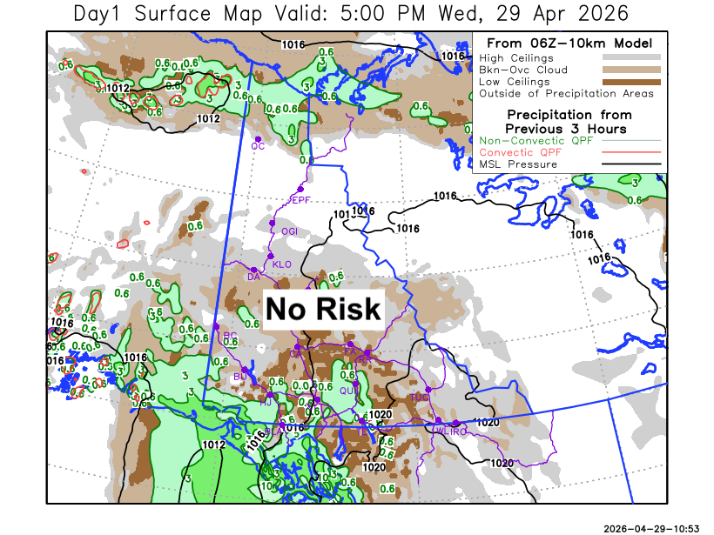
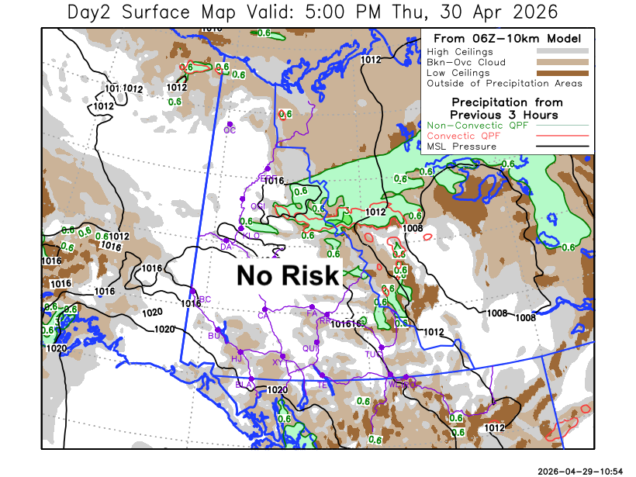

Forecast for | Thursday | (Peak burning period and overnight)
Community | Clouds | Pcpn | POP | POL | Max Temp | Min RH | Min Temp | Max  RH | Wind Dir | Wind Speed
Old Crow | SCT | SW- | 16 | 0 | 7 | 71 | -4 | 93 | 250 | 8
Klondike Fc | SCT |  | 0 | 0 | 10 | 64 | -2 | 90 | 110 | 4
Mayo A | SCT |  | 2 | 0 | 10 | 62 | 0 | 90 | 90 | 6
Carmacks | SCT |  | 0 | 0 | 13 | 56 | -2 | 89 | 160 | 6
Faro | SCT | SW- | 50 | 0 | 7 | 72 | -2 | 91 | 270 | 7
Ross River | SCT | RW- | 16 | 0 | 11 | 63 | -5 | 91 | 290 | 6
Beaver Creek Town | BKN |  | 0 | 0 | 11 | 58 | -6 | 84 | 110 | 5
Burwash A | BKN |  | 0 | 0 | 7 | 68 | -3 | 89 | 160 | 6
Haines Junction | BKN |  | 0 | 0 | 10 | 75 | -1 | 91 | 180 | 8
Whitehorse Auto | BKN | RW- | 16 | 0 | 9 | 67 | 0 | 92 | 160 | 6
Teslin | BKN |  | 0 | 0 | 9 | 67 | -1 | 94 | 220 | 6
Watson Lake | SCT |  | 0 | 0 | 11 | 57 | 0 | 89 | 270 | 8

Forecast for |  |  | Friday |  |  | (Peak burning period and overnight)
Community |  |  | Clouds |  |  | Pcpn | POP |  | POL |  | Max Temp |  | Min RH | Min Temp | Max  RH | Wind Dir | Wind Speed
Old Crow |  |  | BKN |  |  | R- SW- | 31 |  | 0 |  | 10 |  | 64 | -1 | 93 | 110 | 7
Klondike Fc |  |  | BKN |  |  |  | 0 |  | 0 |  | 13 |  | 68 | 1 | 82 | 110 | 9
Mayo A |  |  | BKN |  |  |  | 0 |  | 0 |  | 12 |  | 62 | 3 | 87 | 140 | 6
Carmacks |  |  | BKN |  |  |  | 0 |  | 0 |  | 14 |  | 55 | 1 | 82 | 160 | 15
Faro |  |  | BKN |  |  |  | 0 |  | 0 |  | 10 |  | 66 | 0 | 88 | 180 | 8
Ross River |  |  | SCT |  |  |  | 0 |  | 0 |  | 13 |  | 60 | -3 | 87 | 180 | 7
Beaver Creek Town |  |  | BKN |  |  |  | 0 |  | 0 |  | 14 |  | 60 | -3 | 86 | 110 | 7
Burwash A |  |  | BKN |  |  |  | 0 |  | 0 |  | 9 |  | 61 | -1 | 78 | 160 | 13
Haines Junction |  |  | BKN |  |  |  | 0 |  | 0 |  | 9 |  | 65 | 1 | 89 | 180 | 16
Whitehorse Auto |  |  | BKN |  |  |  | 0 |  | 0 |  | 10 |  | 59 | 2 | 85 | 160 | 13
Teslin |  |  | BKN |  |  |  | 0 |  | 0 |  | 10 |  | 59 | 0 | 91 | 180 | 8
Watson Lake |  |  | SCT |  |  |  | 0 |  | 0 |  | 13 |  | 49 | 1 | 85 | 220 | 6
3-Day Forecast Precipitation Totals from 13:00 Yesterday
OC | 3.7 |  | FA | 1.6 |  | JAK | 0.9
EPF | 3.1 |  | RR | 0.5 |  | TE | 0.3
ANT | 1.8 |  | BC | 0.0 |  | QUI | 3.3
DA | 1.7 |  | BCT | 14.0 |  | SWI | 1.4
FMI | 0.8 |  | BU | 0.8 |  | FL | 3.1
HEN | 21.7 |  | HJF | 1.2 |  | TUC | 15.6
BAR | 2.1 |  | RAI | 14.5 |  | HAS | 30.1
MA | 1.9 |  | CH | 0.5 |  | TC | 21.2
STW | 6.1 |  | BR | 0.9 |  | WL | 1.1
WIL | 5.1 |  | NU | 0.9 |  | PE | 2.1
XY | 0.4 |  | IRO | 16.9 |  | CA | 0.5
CC | 0.7 |  | ELK | 0.0 |  | DRU | 4.8
ATL | 0.9 |  | NA | NA |  | NA | NA
Matt Desorcy Meteorologist

Disclaimer : The information in these forecasts is collected and prepared for internal use by the Government of Yukon. The forecasts are specifically designed to meet the needs of the Wildland Fire Management and may not cover the requirements of other parties. Weather warnings or advisories are not included as part of the forecasts. Wildland Fire Management makes no representation and provides no warranty as to the accuracy of its weather forecasts. Any use the recipient chooses to make of the forecasts will be at its sole risk.

