YUKON WILDLAND FIRE MANAGEMENT WEATHER FORECAST - 9:00 AM ISSUE

12-May-2026
YESTERDAY'S VALUES
Community | Max  Temp  (°C) | Diff.  from  Normal | Min Temp  (°C) | Diff. from Normal | Pcpn  (mm) | Min RH | Max RH | L110 | L30
Old Crow | 0.2 | -6.1 | -2.4 | 2.8 | 0.0 | 68 | 94 | 0 | 0
Fort Mcpherson Airport | -0.4 |  | -3.8 |  | 0.0 | 59 | 93 | 0 | 0
Rock River Climate | 0.8 |  | -2.3 |  | 1.2 | 72 | 99 | NA | NA
Eagle Plains Fire | 5.7 |  | 1.1 |  | 0.3 | 59 | 92 | 0 | 0
Antimony Creek | 15.2 |  | -3.0 |  | 0.0 | 17 | 76 | 0 | 0
Klondike Fc | 16.0M | 1.6 | -3.7M | -3.7 | 0.0M | 16M | 85M | 0 | 0
Forty Mile | 13.1 |  | 0.7 |  | 0.0 | 22 | 52 | 0 | 0
Henderson | 11.4 |  | 1.2 |  | 0.0 | 20 | 44 | 0 | 0
Barlow | 14.6 |  | 2.6 |  | 0.0 | 18 | 43 | 0 | 0
Mayo A | 14.3 | 0.6 | -2.6 | -3.7 | 0.0 | 26 | 85 | 0 | 0
Stewart Crossing | 15.8 |  | -2.4 |  | 0.0 | 20 | 78 | 0 | 0
Willow Creek | 16.0 |  | -3.4 |  | 0.0 | 20 | 84 | 0 | 0
Pelly Farm | M |  | M |  | M | M | M | 0 | 0
Carmacks | 19.0 |  | 0.1 |  | 0.0 | 17 | 59 | 0 | 0
Drury Creek | 15.7 |  | -2.9 |  | 0.0 | 22 | 80 | 0 | 0
Faro | 13.9 | 1.2 | -3.7 | -3.9 | 0.0 | 44M | 88M | 0 | 0
Ross River | 15.2 |  | -6.0 |  | 0.0 | 22 | 89 | 0 | 0
Macmillan Pass | 5.9 |  | -0.3 |  | 0.2 | 53 | 82 | 0 | 0
Beaver Creek A | 13.1 | 1.2 | -3.8 | -2.1 | 0.0 | 22 | 77 | 0 | 0
Beaver Creek Town | 15.0 |  | -3.2 |  | 0.0 | 16 | 80 | 0 | 0
Burwash A | 12.7 | 1.6 | 0.5 | 2.8 | 0.0 | 26 | 62 | 0 | 0
Haines Junction | 12.0 | 0.3 | -3.0 | -1.4 | 0.0 | 26 | 83 | 0 | 0
Rainbow | 11.1 |  | 2.3 |  | 0.0 | 28 | 66 | 0 | 0
Champagne | 11.9 |  | -2.3 |  | 0.0 | 26 | 77 | 0 | 0
Braeburn | 15.2 |  | -4.4 |  | 0.0 | 19 | 79 | 0 | 0
Nursery | 15.3 |  | -4.7 |  | 0.0 | 18 | 88 | 0 | 0
Whitehorse Auto | 12.5 | 0.5 | -0.1 | 0.0 | 0.0 | 23 | 71 | 0 | 0
Mount Sima | 8.2 |  | -1.1 |  | 0.0 | 28 | 66 | 0 | 0
Carcross | 11.2 |  | -2.7 |  | 0.0 | 31 | 93 | 0 | 0
Atlin | 10.0 |  | -1.4 |  | 0.0 | 32 | 79 | 0 | 0
Jakes Corner | 12.4 |  | -2.7 |  | 0.0 | 22 | 80 | 0 | 0
Teslin | 12.1 |  | -2.8 |  | 0.0 | 24 | 87 | 0 | 0
Quiet Lake | 13.0 |  | -3.4 |  | 0.0 | 25 | 87 | 0 | 0
Swift River | 12.6 |  | -3.6 |  | 0.0 | 27 | 92 | 0 | 0
Tuchitua | 13.1 |  | -6.3 |  | 0.0 | 24 | 94 | 0 | 0
Hasselburg | 12.2 |  | -0.5 |  | 0.0 | 21 | 67 | 0 | 0
Tom Creek | 13.2 |  | -1.1 |  | 0.0 | 25 | 81 | 0 | 0
Watson Lake | 13.8 | 1.1 | -2.2 | -2.3 | 0.0 | 36M | 100M | 0 | 0
Iron Creek | 15.7 |  | -3.3 |  | 0.0 | 21 | 89 | 0 | 0
Max Temp is the actual maximum temperature in °C from yesterday afternoon or evening.
Min Temp is the actual overnight minimum temperature in °C up until 6:00 AM this morning.
Diff. from Normal is the difference from the 30 year average max or min temperature.
Pcpn is the precipitation in mm since 13:00 yesterday.
Min RH is the minimum observed RH in % from yesterday afternoon or evening.
Max RH is the maximum observed overnight RH in % up until 6:00 AM this morning.
L110 is the actual number of lightning strikes within 110 km and in the Yukon for 24 hours ending at 06:00 AM this morning.
L30 is the actual number of lightning strikes within 30 km and in the Yukon for 24 hours ending at 06:00 AM this morning.
M is missing data. * denotes precipitation at stations that failed to report for at least part of the evening and overnight period.

SYNOPSIS:
Today: Weak upper-level ridging is expected to be in place across the central and southern regions of the Territory today, keeping conditions fairly dry. Increasing cloudiness is expected this evening in Tintina and Southern Lakes as an area of cloud cover spreads into these regions from northern BC. Elsewhere, scattered to broken cloud cover is generally expected. Seasonal temperatures (in the teens) are forecast through the central and southern regions of Yukon, while Old Crow will be notably cooler with highs in the single digits under a moderate northerly flow. No crossovers expected today with min RHs broadly in the 20-30% range. Winds light to moderate south/southeasterly through central and southern regions. Light rain arrives in Tintina overnight tonight.

Wednesday: Weak upper-level troughing shifts into the Yukon while a deep upper-trough develops in the Gulf of Alaska. Temperatures expected to climb into the low to mid-teens, mildest in central Yukon through the southern Klondike, Northern Tutchone, and western Tatchun. Risk of isolated showers through most of central and southern Yukon, though steadier light rains are possible in Tintina. Slight risk of lightning in Tatchun and Beaver Creek district. Gusty in Haines Junction and Beaver Creek. Dry and cool in Old Crow under a moderate northeasterly flow.

Thursday: Broad troughing settles into the Territory, keeping temperatures near- to slightly below seasonal values. Scattered to broken skies in all regions with risk of showers through most of central and southern Yukon, highest POPs through central Yukon. Late-day clearing possible in Haines Junction district and Southern Lakes. Remaining cool and dry in Old Crow.

Friday: Disorganized upper-level pattern, with weak riding potentially redeveloping over the Territory. The weak ridging in the upper levels is not expected to translate to a notable warmup but will likely lead to a decrease in scattered shower activity with a few more sunny breaks compared to Thursday in central and southern regions, though showers/cloud likely to persist in Tintina. Slight increase in temperatures in Old Crow as highs climb into the upper single digits.

Saturday: Weak ridging persists over the Yukon, leading to similar conditions compared to Friday, except slightly warmer in Old Crow. Scattered cloud cover and near-seasonal temperatures. Slight risk of convective showers, particularly in the Beaver Creek district and southern Klondike.

Forecast for | Tuesday | (Peak burning period and overnight)
Community | Clouds | Pcpn | POP | POL | Max Temp | Min RH | Min Temp | Max  RH | Wind Dir | Wind Speed
Old Crow | BKN |  | 10 | NIL | 3 | 65 | -6 | 91 | 20 | 20G30
Klondike Fc | FEW |  | 0 | NIL | 17 | 20 | 3 | 80 | 70 | 15
Mayo A | FEW |  | 0 | NIL | 17 | 20 | 6 | 82 | 40 | 10
Carmacks | SCT |  | 0 | NIL | 18 | 25 | 4 | 75 | 140 | 15
Faro | BKN |  | 0 | NIL | 14 | 30 | 0 | 92 | 110 | 15
Ross River | BKN |  | 0 | NIL | 15 | 30 | -1 | 89 | 140 | 10
Beaver Creek Town | SCT |  | 0 | NIL | 16 | 25 | 0 | 76 | 110 | 10
Burwash A | FEW |  | 0 | NIL | 13 | 30 | 0 | 87 | 140 | 15G30
Haines Junction | SCT |  | 0 | NIL | 15 | 30 | 1 | 92 | 180 | 15
Whitehorse Auto | SCT |  | 0 | NIL | 15 | 30 | 3 | 84 | 140 | 15G30
Teslin | BKN |  | 0 | NIL | 13 | 35 | 3 | 87 | 110 | 10
Watson Lake | BKN | R- | 60 | NIL | 14 | 35 | 6 | 84 | 20 | 10
POP is probability of precipitation in %.
POL is probability of lightning in %.

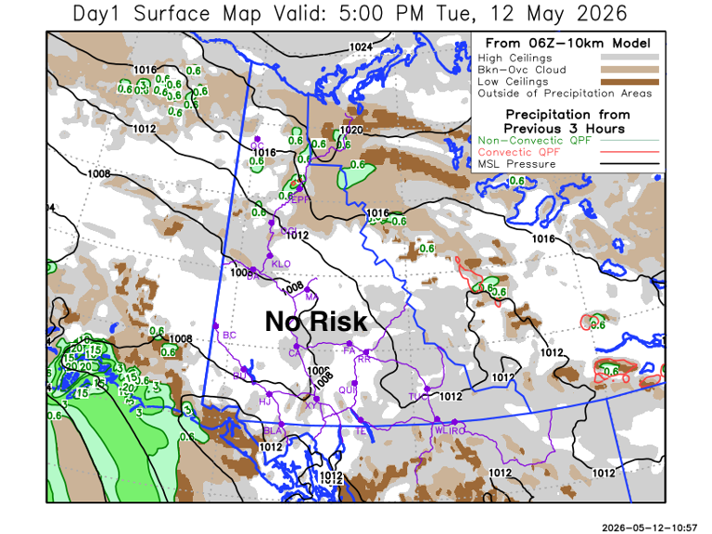
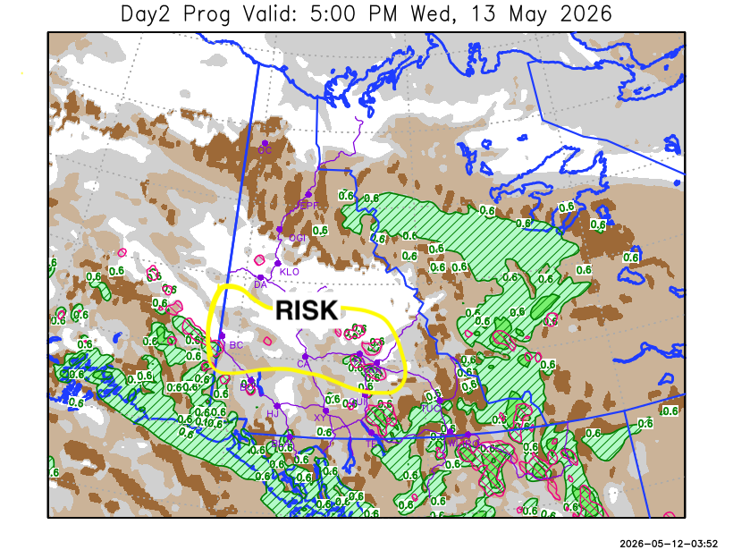

Forecast for | Wednesday | (Peak burning period and overnight)
Community | Clouds | Pcpn | POP | POL | Max Temp | Min RH | Min Temp | Max  RH | Wind Dir | Wind Speed
Old Crow | SCT |  | 0 | NIL | 4 | 65 | -7 | 86 | 70 | 20
Klondike Fc | SCT |  | 0 | NIL | 19 | 25 | 3 | 77 | 70 | 15
Mayo A | BKN | RW- | 20 | NIL | 17 | 30 | 6 | 86 | 40 | 15
Carmacks | BKN | RW-/TRW- | 20 | RISK | 20 | 25 | 5 | 68 | 140 | 15
Faro | BKN | RW-/TRW- | 60 | RISK | 15 | 35 | 3 | 95 | 160 | 10
Ross River | BKN | RW-/TRW- | 60 | RISK | 16 | 35 | 1 | 93 | 110 | 10
Beaver Creek Town | BKN | RW-/TRW- | 60 | RISK | 17 | 30 | 2 | 89 | 90 | 10
Burwash A | SCT |  | 10 | NIL | 13 | 35 | 2 | 84 | 140 | 20G40
Haines Junction | BKN |  | 0 | NIL | 16 | 30 | 2 | 84 | 180 | 15G30
Whitehorse Auto | BKN | R-/RW- | 30 | NIL | 14 | 35 | 4 | 78 | 180 | 20
Teslin | BKN | R-/RW- | 30 | NIL | 12 | 45 | 4 | 80 | 220 | 15
Watson Lake | OVC | R- | 70 | NIL | 11 | 70 | 5 | 91 | 290 | 10

Forecast for |  |  | Thursday |  |  | (Peak burning period and overnight)
Community |  |  | Clouds |  |  | Pcpn |  | POP |  | POL |  | Max Temp |  | Min RH | Min Temp | Max  RH | Wind Dir | Wind Speed
Old Crow |  |  | SCT |  |  |  |  | 0 |  | NIL |  | 5 |  | 60 | -5 | 90 | 70 | 20
Klondike Fc |  |  | BKN |  |  | RW-/TRW- |  | 40 |  | RISK |  | 16 |  | 40 | 4 | 80 | 90 | 15
Mayo A |  |  | BKN |  |  | RW-/TRW- |  | 40 |  | RISK |  | 13 |  | 45 | 5 | 88 | 40 | 10
Carmacks |  |  | BKN |  |  |  |  | 10 |  | NIL |  | 18 |  | 30 | 2 | 62 | 180 | 20
Faro |  |  | BKN |  |  | R-/RW- |  | 60 |  | NIL |  | 11 |  | 50 | 1 | 85 | 220 | 10
Ross River |  |  | BKN |  |  | R-/RW- |  | 70 |  | NIL |  | 13 |  | 50 | -1 | 87 | 220 | 10
Beaver Creek Town |  |  | OVC |  |  | R-/RW- |  | 80 |  | NIL |  | 11 |  | 70 | 0 | 94 | 270 | 15
Burwash A |  |  | BKN |  |  | R-/RW- |  | 60 |  | NIL |  | 10 |  | 50 | 0 | 79 | 160 | 15
Haines Junction |  |  | SCT |  |  |  |  | 0 |  | NIL |  | 12 |  | 30 | -1 | 85 | 180 | 15G30
Whitehorse Auto |  |  | SCT |  |  |  |  | 0 |  | NIL |  | 12 |  | 35 | 1 | 77 | 200 | 15G30
Teslin |  |  | BKN |  |  | RW- |  | 20 |  | NIL |  | 11 |  | 40 | 1 | 79 | 220 | 15
Watson Lake |  |  | BKN |  |  | R-/RW- |  | 40 |  | NIL |  | 11 |  | 50 | 3 | 82 | 270 | 15
3-Day Forecast Precipitation Totals from 13:00 Yesterday
OC | 0.0 |  | FA | 3.8 |  |  | JAK | 0.7
EPF | 2.3 |  | RR | 2.3 |  |  | TE | 0.7
ANT | 0.0 |  | BC | 3.5 |  |  | QUI | 2.5
DA | 0.0 |  | BCT | 3.5 |  |  | SWI | 5.3
FMI | 0.0 |  | BU | 0.8 |  |  | FL | 6.2
HEN | 0.5 |  | HJF | 0.0 |  |  | TUC | 8.6
BAR | 0.4 |  | RAI | 0.0 |  |  | HAS | 6.5
MA | 1.9 |  | CH | 0.3 |  |  | TC | 8.3
STW | 1.4 |  | BR | 0.1 |  |  | WL | 8.4
WIL | 0.4 |  | NU | 0.4 |  |  | PE | 0.0
XY | 0.8 |  | IRO | 11.9 |  |  | CA | 0.0
CC | 0.0 |  | ELK | 12.1 |  |  | DRU | 1.8
ATL | 0.7 |  | NA | NA |  |  | NA | NA
Matt Desorcy Meteorologist

Disclaimer : The information in these forecasts is collected and prepared for internal use by the Government of Yukon. The forecasts are specifically designed to meet the needs of the Wildland Fire Management and may not cover the requirements of other parties. Weather warnings or advisories are not included as part of the forecasts. Wildland Fire Management makes no representation and provides no warranty as to the accuracy of its weather forecasts. Any use the recipient chooses to make of the forecasts will be at its sole risk.

