YUKON WILDLAND FIRE MANAGEMENT WEATHER FORECAST - 9:00 AM ISSUE
13-May-2026
YESTERDAY'SVALUES
Community | Max  Temp  (°C) | Diff.  from  Normal | Min Temp  (°C) | Diff. from Normal | Pcpn  (mm) | Min RH | Max RH | L110 | L30
Old Crow | 0.5 | -6.2 | -6.7 | -2.0 | 0.0 | 57 | 75 | 0 | 0
Fort Mcpherson Airport | -1.1 |  | -7.3 |  | 0.0M | 67 | 93 | 0 | 0
Rock River Climate | 4.4 |  | -6.2 |  | 0.0 | 68 | 97 | NA | NA
Eagle Plains Fire | 10.4 |  | -5.2 |  | 0.0 | 39 | 90 | 0 | 0
Antimony Creek | 17.5 |  | -2.1 |  | 0.0 | 19 | 83 | 0 | 0
Klondike Fc | 17.8M | 3.1 | 3.3M | 3.1 | 0.0M | 18M | 64M | 0 | 0
Forty Mile | 16.7 |  | 5.7 |  | 0.0 | 19 | 54 | 0 | 0
Henderson | 13.7 |  | 5.5 |  | 0.0 | 20 | 47 | 0 | 0
Barlow | 17.4 |  | 6.7 |  | 0.0 | 18 | 40 | 0 | 0
Mayo A | 16.9 | 3.0 | -0.3 | -1.6 | 0.0 | 20 | 76 | 0 | 0
Stewart Crossing | 17.4 |  | -0.4 |  | 0.0 | 18 | 80 | 0 | 0
Willow Creek | 15.3 |  | -2.0 |  | 0.0 | 20 | 86 | 0 | 0
Pelly Farm | M |  | M |  | M | M | M | 0 | 0
Carmacks | 18.8 |  | 3.2 |  | 0.0 | 22 | 67 | 0 | 0
Drury Creek | 16.2 |  | 3.0 |  | 0.0 | 22 | 76 | 0 | 0
Faro | 15.6 | 2.7 | -1.1 | -1.5 | 0.0 | 35M | 99M | 0 | 0
Ross River | 16.7 |  | -3.0 |  | 0.0 | 19 | 87 | 0 | 0
Macmillan Pass | 6.7 |  | -3.2 |  | 0.0 | 47 | 81 | 0 | 0
Beaver Creek A | 15.6 | 3.5 | -2.3 | -0.8 | 0.0M | 25 | 80 | 0 | 0
Beaver Creek Town | 16.6 |  | -2.2 |  | 0.0 | 22 | 82 | 0 | 0
Burwash A | 14.1 | 2.8 | -5.0 | -2.8 | 0.0 | 32 | 90 | 0 | 0
Haines Junction | 14.6 | 3.1 | -3.3 | -1.8 | 0.0 | 32 | 91 | 0 | 0
Rainbow | 14.1 |  | 0.9 |  | 0.0 | 33 | 83 | 0 | 0
Champagne | 15.1 |  | -4.2 |  | 0.0 | 29 | 91 | 0 | 0
Braeburn | 17.2 |  | -1.0 |  | 0.0 | 25 | 81 | 0 | 0
Nursery | 16.9 |  | -3.7 |  | 0.0 | 25 | 87 | 0 | 0
Whitehorse Auto | 14.7 | 2.4 | 1.0 | 1.0 | 0.0 | 29 | 72 | 0 | 0
Mount Sima | 13.1 |  | 1.8 |  | 0.0 | 31 | 64 | 0 | 0
Carcross | 13.8 |  | -3.6 |  | 0.0 | 34 | 89 | 0 | 0
Atlin | 14.1 |  | 1.3 |  | 0.0 | 31 | 73 | 0 | 0
Jakes Corner | 15.9 |  | -1.4 |  | 0.0 | 24 | 85 | 0 | 0
Teslin | 14.8 |  | 2.9 |  | 0.0 | 28 | 79 | 0 | 0
Quiet Lake | 15.7 |  | 1.4 |  | 0.0 | 28 | 83 | 0 | 0
Swift River | 15.2 |  | 1.6 |  | 0.3 | 26 | 93 | 0 | 0
Tuchitua | 16.9 |  | 1.9 |  | 0.0 | 21 | 88 | 0 | 0
Hasselburg | 14.7 |  | 3.0 |  | 0.0 | 26 | 69 | 0 | 0
Tom Creek | 15.1 |  | 5.4 |  | 0.0 | 27 | 76 | 0 | 0
Watson Lake | 16.6 | 3.7 | 5.6 | 5.3 | 0.0 | 29 | 88 | 0 | 0
Iron Creek | 19.0 |  | 5.5 |  | 0.0 | 22 | 95 | 0 | 0
Max Temp is the actual maximum temperature in °C from yesterday afternoon or evening.
Min Temp is the actual overnight minimum temperature in °C up until 6:00 AM this morning.
Diff. from Normal is the difference from the 30 year average max or min temperature.
Pcpn is the precipitation in mm since 13:00 yesterday.
Min RH is the minimum observed RH in % from yesterday afternoon or evening.
Max RH is the maximum observed overnight RH in % up until 6:00 AM this morning.
L110 is the actual number of lightning strikes within 110 km and in the Yukon for 24 hours ending at 06:00 AM this morning.
L30 is the actual number of lightning strikes within 30 km and in the Yukon for 24 hours ending at 06:00 AM this morning.
M is missing data. * denotes precipitation at stations that failed to report for at least part of the evening and overnight period.

SYNOPSIS:
Today: A broad upper-level and surface trough will shift into the Yukon while another deep upper trough develops over the Gulf of Alaska. Temperatures are expected to climb into the low to mid-teens, with the mildest conditions across central Yukon through the southern Klondike, Northern Tutchone, and western Tatchun regions. Minimum relative humidity values will generally range from 35-45%, with even higher values expected in areas experiencing precipitation. However, lower values of 25-30% are forecast across the Klondike, Carmacks and Beaver Creek Town district. There is a slight risk of lightning from the Tatchun to Beaver Creek districts through Dawson, as well as north of Teslin near the centre of a low-pressure system during the evening hours. Steadier light rain is possible in the Tintina region. Conditions will be gusty in Burwash and Beaver Creek, with wind gusts up to 30 km/h. Meanwhile, Old Crow is expected to remain dry and cool under a moderate northeasterly flow.

Thursday: Low pressure near the Kluane and Tatchun border will bring widespread showers across much of central and southern Yukon. Minimum relative humidity values will generally remain above 45%, except in areas where little to no precipitation is expected, where values of 30-35% are forecast. Maximum temperatures are expected to remain in the low teens. Winds will generally be light from the southwest, except in Old Crow and Haines Junction where sustained winds of 15-20 km/h with gusts up to 30 km/h are forecast. There is again a slight risk of thunderstorm activity from Beaver Creek through Carmacks and Dawson, with an embedded isolated higher risk in the Mayo district and southern Klondike. Old Crow is expected to remain relatively cool and dry.

Friday: Disorganized upper-level pattern, with weak ridging potentially redeveloping over the Territory. The weak ridging in the upper levels is not expected to translate to a notable warmup but will likely lead to a decrease in scattered shower activity with a few more sunny breaks compared to Thursday in central and southern regions, though showers/cloud likely to persist in Tintina. Slight increase in temperatures in Old Crow as highs climb into the upper single digits. There is a risk of lightning in Tatchun.

Saturday: Weak upper-level ridging persists over the Yukon, leading to similar conditions compared to Friday, except slightly warmer in Old Crow. Scattered cloud cover and near-seasonal temperatures. Slight risk of convective showers, particularly in the Beaver Creek district and southern Klondike.

Sunday: Weak upper-level ridging over the Yukon will bring another day of near-seasonal temperatures. Winds on this day will strengthen from the south. Little to no precipitation is expected therefore drying trend is expected.

Forecast for | Wednesday | (Peak burning period and overnight)
Community | Clouds | Pcpn | POP | POL | Max Temp | Min RH | Min Temp | Max  RH | Wind Dir | Wind Speed
Old Crow | BKN |  | 0 | NIL | 4 | 55 | -6 | 85 | 40 | 20G30
Klondike Fc | SCT | RW-/TRW- | 30 | RISK | 19 | 25 | 3 | 80 | 70 | 15
Mayo A | BKN | RW-/TRW- | 40 | RISK | 17 | 30 | 6 | 85 | 40 | 15
Carmacks | BKN | RW-/TRW- | 20 | RISK | 20 | 25 | 5 | 70 | 160 | 15
Faro | BKN | RW-/TRW- | 70 | RISK | 15 | 35 | 2 | 95 | 90 | 10
Ross River | BKN | RW- | 70 | NIL | 16 | 35 | 1 | 90 | 140 | 10
Beaver Creek Town | BKN | RW-/TRW- | 60 | RISK | 19 | 25 | 3 | 90 | 90 | 10
Burwash A | SCT | RW- | 30 | NIL | 13 | 30 | 2 | 90 | 160 | 20G30
Haines Junction | SCT |  | 0 | NIL | 16 | 30 | 2 | 90 | 180 | 15G30
Whitehorse Auto | BKN | RW- | 30 | NIL | 14 | 30 | 5 | 85 | 180 | 20
Teslin | BKN | RW-/TRW- | 50 | RISK | 13 | 40 | 5 | 80 | 220 | 15
Watson Lake | OVC | R- | 70 | NIL | 12 | 60 | 5 | 90 | 270 | 10
POP is probability of precipitation in %.
POL is probability of lightning in %.

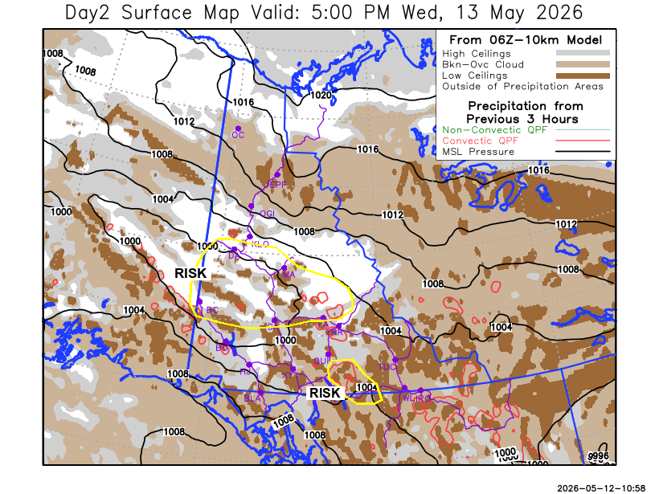
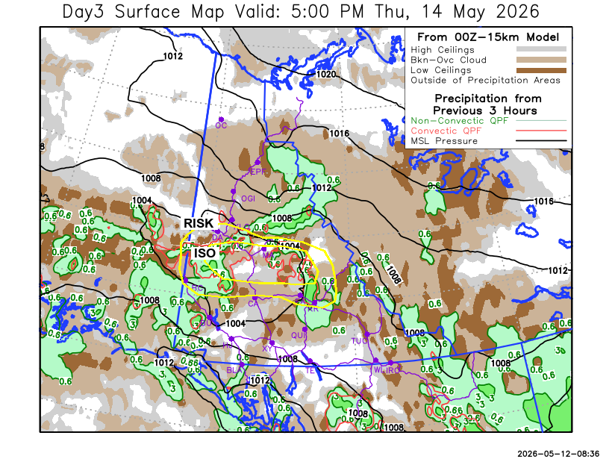

Forecast for | Thursday | (Peak burning period and overnight)
Community | Clouds | Pcpn | POP | POL | Max Temp | Min RH | Min Temp | Max  RH | Wind Dir | Wind Speed
Old Crow | BKN |  | 0 | NIL | 5 | 60 | -6 | 90 | 70 | 20
Klondike Fc | BKN | RW-/TRW- | 40 | RISK | 16 | 50 | 4 | 80 | 40 | 10
Mayo A | BKN | RW-/TRW- | 60 | ISO | 14 | 45 | 6 | 90 | 70 | 15
Carmacks | BKN | RW-/TRW- | 30 | RISK | 19 | 30 | 3 | 65 | 180 | 15
Faro | OVC | R-/TRW- | 70 | RISK | 11 | 50 | 2 | 90 | 220 | 10
Ross River | OVC | R-/TRW- | 70 | RISK | 14 | 50 | 0 | 90 | 220 | 10
Beaver Creek Town | OVC | RW-/TRW- | 70 | RISK | 12 | 60 | 1 | 90 | 290 | 15
Burwash A | OVC | R- | 60 | NIL | 10 | 35 | 0 | 80 | 140 | 20
Haines Junction | SCT |  | 0 | NIL | 12 | 30 | -1 | 85 | 180 | 15G30
Whitehorse Auto | SCT |  | 20 | NIL | 13 | 30 | 1 | 75 | 180 | 20
Teslin | BKN | RW- | 40 | NIL | 11 | 45 | 2 | 75 | 250 | 15
Watson Lake | OVC | R- | 70 | NIL | 12 | 60 | 4 | 90 | 70 | 10

Forecast for |  |  | Friday |  | (Peak burning period and overnight)
Community |  |  | Clouds |  | Pcpn |  |  | POP |  | POL |  | Max Temp |  | Min RH | Min Temp | Max  RH | Wind Dir | Wind Speed
Old Crow |  |  | BKN |  |  |  |  | 0 |  | NIL |  | 6 |  | 60 | -4 | 90 | 90 | 15
Klondike Fc |  |  | BKN |  | RW- |  |  | 30 |  | NIL |  | 16 |  | 25 | 3 | 85 | 0 | 5
Mayo A |  |  | SCT |  |  |  |  | 20 |  | NIL |  | 16 |  | 25 | 5 | 85 | 40 | 10
Carmacks |  |  | BKN |  | RW-/TRW- |  |  | 30 |  | RISK |  | 19 |  | 20 | 4 | 65 | 160 | 15
Faro |  |  | SCT |  | RW-/TRW- |  |  | 30 |  | RISK |  | 13 |  | 30 | 2 | 90 | 110 | 10
Ross River |  |  | SCT |  | RW-/TRW- |  |  | 40 |  | RISK |  | 16 |  | 25 | 0 | 90 | 140 | 10
Beaver Creek Town |  |  | OVC |  | R- |  |  | 70 |  | NIL |  | 11 |  | 50 | -1 | 90 | 290 | 10
Burwash A |  |  | BKN |  |  |  |  | 20 |  | NIL |  | 11 |  | 35 | 0 | 85 | 140 | 15
Haines Junction |  |  | SCT |  |  |  |  | 0 |  | NIL |  | 13 |  | 35 | 1 | 80 | 200 | 15G30
Whitehorse Auto |  |  | SCT |  |  |  |  | 0 |  | NIL |  | 13 |  | 25 | 4 | 80 | 180 | 15
Teslin |  |  | OVC |  | RW- |  |  | 30 |  | NIL |  | 10 |  | 30 | 3 | 90 | 270 | 10
Watson Lake |  |  | OVC |  | R- |  |  | 80 |  | NIL |  | 9 |  | 50 | 3 | 85 | 90 | 15
3-Day Forecast Precipitation Totals from 13:00 Yesterday
OC | 0.0 |  | FA | 4.8 |  |  | JAK | 0.1
EPF | 0.7 |  | RR | 6.0 |  |  | TE | 0.7
ANT | 1.6 |  | BC | 11.2 |  |  | QUI | 1.3
DA | 1.8 |  | BCT | 11.2 |  |  | SWI | 4.7
FMI | 0.0 |  | BU | 4.0 |  |  | FL | 5.7
HEN | 3.2 |  | HJF | 0.0 |  |  | TUC | 8.7
BAR | 1.4 |  | RAI | 0.0 |  |  | HAS | 6.9
MA | 4.3 |  | CH | 0.0 |  |  | TC | 8.9
STW | 2.0 |  | BR | 0.0 |  |  | WL | 9.0
WIL | 1.3 |  | NU | 0.6 |  |  | PE | 1.8
XY | 1.2 |  | IRO | 9.5 |  |  | CA | 0.0
CC | 0.0 |  | ELK | 13.0 |  |  | DRU | 1.9
ATL | 0.0 |  | NA | NA |  |  | NA | NA
Pallawi Paudel Meteorologist

Disclaimer : The information in these forecasts is collected and prepared for internal use by the Government of Yukon. The forecasts are specifically designed to meet the needs of the Wildland Fire Management and may not cover the requirements of other parties. Weather warnings or advisories are not included as part of the forecasts. Wildland Fire Management makes no representation and provides no warranty as to the accuracy of its weather forecasts. Any use the recipient chooses to make of the forecasts will be at its sole risk.

