YUKON WILDLAND FIRE MANAGEMENT WEATHER FORECAST - 9:00 AM ISSUE

14-May-2026
YESTERDAY'S VALUES
Community | Max  Temp  (°C) | Diff.  from  Normal | Min Temp  (°C) | Diff. from Normal | Pcpn  (mm) | Min RH | Max RH | L110 | L30
Old Crow | 4.0 | -3.1 | -1.1 | 3.2 | 0.0 | 51 | 72 | 0 | 0
Fort Mcpherson Airport | -0.1 |  | -3.8 |  | 0.0M | 44 | 66 | 0 | 0
Rock River Climate | -2.3 |  | -4.4 |  | 0.0 | 64 | 79 | NA | NA
Eagle Plains Fire | 4.1 |  | -5.3 |  | 0.0 | 57 | 76 | 0 | 0
Antimony Creek | 19.0 |  | 5.1 |  | 0.0 | 22 | 70 | 0 | 0
Klondike Fc | 20.2M | 5.3 | 7.2M | 6.8 | 0.0M | 19M | 70M | 0 | 0
Forty Mile | 17.9 |  | 3.4 |  | 0.0 | 27 | 67 | 0 | 0
Henderson | 15.1 |  | 7.2 |  | 0.0 | 26 | 51 | 0 | 0
Barlow | 18.0 |  | 7.2 |  | 0.0 | 24 | 52 | 0 | 0
Mayo A | 16.3 | 2.1 | 5.8 | 4.3 | 0.0 | 27 | 64 | 0 | 0
Stewart Crossing | 19.7 |  | 4.9 |  | 0.0 | 21 | 71 | 0 | 0
Willow Creek | 17.0 |  | 0.5 |  | 0.0 | 26 | 89 | 0 | 0
Pelly Farm | M |  | M |  | M | M | M | 0 | 0
Carmacks | 17.7 |  | 3.7 |  | 0.0 | 29 | 76 | 0 | 0
Drury Creek | 16.7 |  | 2.6 |  | 0.0 | 29 | 84 | 0 | 0
Faro | 14.6 | 1.5 | -0.2 | -0.8 | 0.0 | 51M | 99M | 0 | 0
Ross River | 17.0 |  | -2.0 |  | 3.3 | 27 | 97 | 0 | 0
Macmillan Pass | 6.3 |  | -2.2 |  | 0.0 | 47 | 80 | 0 | 0
Beaver Creek A | 17.5 | 5.2 | 2.0 | 3.3 | 0.2 | 22 | 84 | 0 | 0
Beaver Creek Town | 18.7 |  | 2.5 |  | 0.0 | 18 | 85 | 0 | 0
Burwash A | 15.1 | 3.6 | 2.4 | 4.4 | 0.0 | 33 | 80 | 0 | 0
Haines Junction | 16.1 | 4.0 | -0.2 | 1.9 | 0.0 | 32 | 88 | 0 | 0
Rainbow | 15.6 |  | 3.0 |  | 0.0 | 32 | 74 | 0 | 0
Champagne | 16.5 |  | 2.5 |  | 0.0 | 28 | 78 | 0 | 0
Braeburn | 16.3 |  | 1.7 |  | 0.0 | 29 | 77 | 0 | 0
Nursery | 15.6 |  | 0.3 |  | 0.0 | 31 | 83 | 0 | 0
Whitehorse Auto | 14.3 | 1.8 | 3.4 | 3.2 | 0.0 | 32 | 72 | 0 | 0
Mount Sima | 12.5 |  | 1.7 |  | 0.0 | 33 | 69 | 0 | 0
Carcross | 14.6 |  | 0.1 |  | 0.0 | 34 | 91 | 0 | 0
Atlin | 13.6 |  | 0.9 |  | 0.0 | 33 | 80 | 0 | 0
Jakes Corner | 16.3 |  | 0.4 |  | 0.0 | 27 | 81 | 0 | 0
Teslin | 13.2 |  | 0.1 |  | 0.0 | 38 | 87 | 0 | 0
Quiet Lake | 17.0 |  | -1.1 |  | 0.0 | 33 | 95 | 0 | 0
Swift River | 13.1 |  | -1.0 |  | 0.0 | 41 | 94 | 0 | 0
Tuchitua | 11.7 |  | 3.4 |  | 3.7 | 55 | 98 | 0 | 0
Hasselburg | 12.4 |  | 2.7 |  | 1.4 | 50 | 99 | 0 | 0
Tom Creek | 10.6 |  | 3.2 |  | 4.3 | 60 | 99 | 0 | 0
Watson Lake | 12.0 | -1.1 | 3.6 | 3.1 | 5.6 | 57M | 100M | 0 | 0
Iron Creek | 12.7 |  | 0.1 |  | 2.6 | 60 | 99 | 0 | 0
Max Temp is the actual maximum temperature in °C from yesterday afternoon or evening.
Min Temp is the actual overnight minimum temperature in °C up until 6:00 AM this morning.
Diff. from Normal is the difference from the 30 year average max or min temperature.
Pcpn is the precipitation in mm since 13:00 yesterday.
Min RH is the minimum observed RH in % from yesterday afternoon or evening.
Max RH is the maximum observed overnight RH in % up until 6:00 AM this morning.
L110 is the actual number of lightning strikes within 110 km and in the Yukon for 24 hours ending at 06:00 AM this morning.
L30 is the actual number of lightning strikes within 30 km and in the Yukon for 24 hours ending at 06:00 AM this morning.
M is missing data. * denotes precipitation at stations that failed to report for at least part of the evening and overnight period.

SYNOPSIS:
Today: Low pressure near the Kluane and Tatchun border will bring scattered showers across much of central and southern Yukon during the burning period. A risk of lightning exists through central Yukon, though should any strikes occur, they will be relatively isolated. Minimum relative humidity values will generally remain near or above 30%, except in parts of western Tatchun and southern Klondike where 20-30% is possible. Maximum temperatures are expected to remain in the low to mid-teens. Winds will generally be light, except in Southern Lakes and Kluane where gusts of 25-35 km/h are possible. Old Crow is expected to remain relatively cool and dry.

Friday: Disorganized upper-level pattern, with weak ridging gradually redeveloping over the Territory. The weak ridging in the upper levels is not expected to translate to a notable warmup but will likely lead to a decrease in scattered shower activity with a few more sunny breaks compared to Thursday in central and southern regions, though more showers/cloud likely to linger in Northern Tutchone and Beaver Creek district. Slight risk of lightning through Tatchun into southeast Yukon, but any activity will be isolated. Remaining cool in Old Crow.

Saturday: Weak upper-level ridging continues to gradually build over the Yukon, leading to a slight warmup compared to Friday, as well as a relatively dry air mass in place. Slight risk of crossovers in the Carmacks district and southern Klondike. Minimum RHs generally in the 20-30% range through central and southern Yukon. Slight risk of isolated late-day convective showers, particularly in central Yukon. Winds gusting up to 20-30 km/h possible in Kluane and Southern Lakes.

Sunday: Weak upper-level ridging over the Yukon will bring another day of near-seasonal temperatures, combined with a dry air mass. Winds will remain somewhat gustier, particularly in Southern Lakes and Kluane. No notable precipitation is expected in the Territory, though increasing cloud cover is expected late in the day with a building trough out west.

Monday: Weak troughing advances into the Yukon, bringing an increase in cloud cover to the region, as well as a slight risk of showers through the western half of the Territory. Seasonal temperatures generally continuing.

Forecast for | Thursday | (Peak burning period and overnight)
Community | Clouds | Pcpn | POP | POL | Max Temp | Min RH | Min Temp | Max  RH | Wind Dir | Wind Speed
Old Crow | FEW |  | 0 | NIL | 5 | 50 | -6 | 91 | 70 | 20
Klondike Fc | BKN | RW-/TRW- | 30 | RISK | 16 | 30 | 3 | 71 | 10 | 10
Mayo A | BKN | RW-/TRW- | 60 | ISO | 14 | 40 | 5 | 85 | 20 | 15
Carmacks | SCT |  | 10 | NIL | 17 | 25 | 4 | 60 | 180 | 10G25
Faro | BKN | RW-/TRW- | 30 | RISK | 13 | 40 | 1 | 82 | 250 | 10
Ross River | BKN | RW-/TRW- | 40 | RISK | 14 | 40 | 0 | 84 | 220 | 10
Beaver Creek Town | BKN | R-/TRW- | 70 | ISO | 13 | 45 | 1 | 93 | 290 | 15G25
Burwash A | BKN | R-/RW- | 40 | NIL | 11 | 40 | 1 | 83 | 140 | 15G30
Haines Junction | SCT |  | 0 | NIL | 16 | 30 | 0 | 88 | 180 | 15G30
Whitehorse Auto | SCT | RW- | 20 | NIL | 14 | 30 | 2 | 81 | 180 | 15G30
Teslin | BKN | RW- | 20 | NIL | 12 | 40 | 2 | 81 | 220 | 15G25
Watson Lake | BKN | R-/RW- | 60 | NIL | 12 | 45 | 4 | 84 | 290 | 15
POP is probability of precipitation in %.
POL is probability of lightning in %.

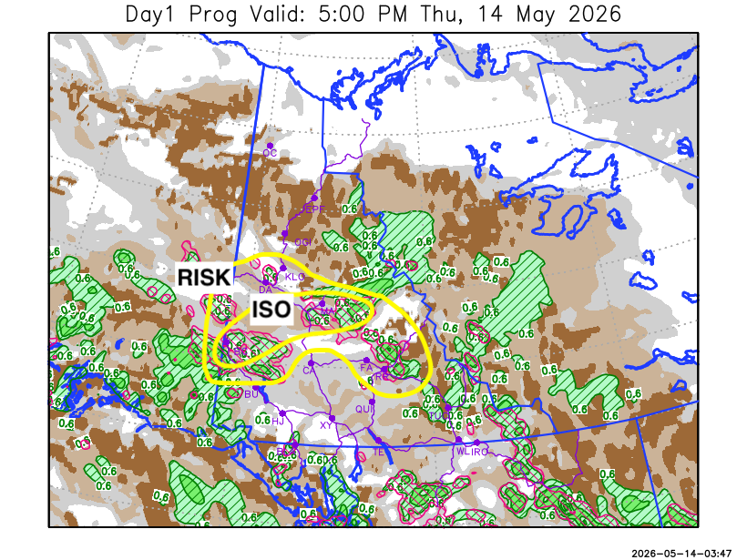
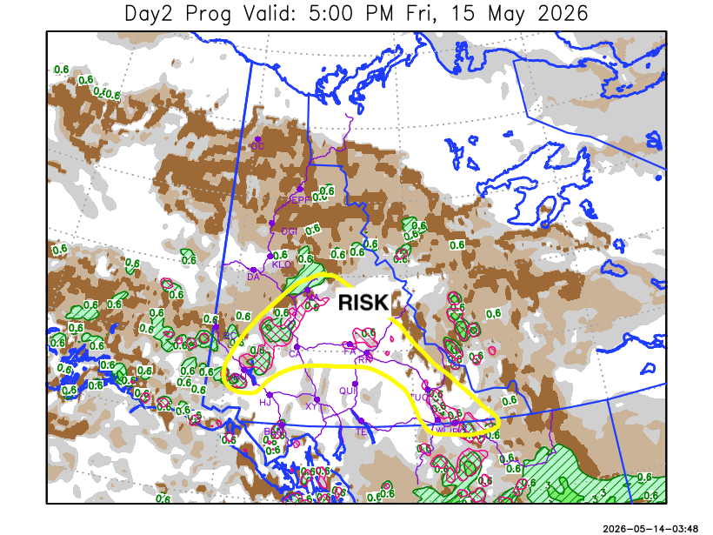

Forecast for | Friday | (Peak burning period and overnight)
Community | Clouds | Pcpn | POP | POL | Max Temp | Min RH | Min Temp | Max  RH | Wind Dir | Wind Speed
Old Crow | SCT |  | 0 | NIL | 6 | 55 | -4 | 91 | 70 | 20
Klondike Fc | BKN |  | 0 | NIL | 15 | 25 | 3 | 76 | 320 | 10
Mayo A | BKN | RW-/TRW- | 20 | RISK | 13 | 50 | 4 | 87 | 20 | 10
Carmacks | SCT | RW-/TRW- | 20 | RISK | 18 | 20 | 3 | 68 | 290 | 10
Faro | SCT | RW-/TRW- | 20 | RISK | 14 | 30 | 2 | 82 | 10 | 10
Ross River | SCT | RW-/TRW- | 30 | RISK | 16 | 30 | 0 | 84 | 70 | 10
Beaver Creek Town | BKN | R-/RW- | 60 | NIL | 12 | 60 | 1 | 91 | 320 | 10
Burwash A | SCT | RW-/TRW- | 30 | RISK | 11 | 40 | 0 | 84 | 140 | 15
Haines Junction | FEW |  | 0 | NIL | 16 | 30 | -1 | 84 | 200 | 15G30
Whitehorse Auto | SCT |  | 0 | NIL | 14 | 20 | 4 | 66 | 200 | 15
Teslin | BKN | RW- | 20 | NIL | 12 | 35 | 3 | 83 | 270 | 10
Watson Lake | BKN | RW-/TRW- | 40 | RISK | 12 | 45 | 3 | 86 | 90 | 10

Forecast for |  |  | Saturday |  |  | (Peak burning period and overnight)
Community |  |  | Clouds |  |  | Pcpn |  | POP |  | POL |  | Max Temp |  | Min RH | Min Temp | Max  RH | Wind Dir | Wind Speed
Old Crow |  |  | SCT |  |  |  |  | 0 |  | NIL |  | 10 |  | 50 | 0 | 95 | 110 | 15
Klondike Fc |  |  | SCT |  |  | RW-/TRW- |  | 40 |  | RISK |  | 18 |  | 25 | 5 | 76 | 90 | 10
Mayo A |  |  | SCT |  |  | RW-/TRW- |  | 30 |  | RISK |  | 18 |  | 25 | 7 | 80 | 180 | 5
Carmacks |  |  | FEW |  |  |  |  | 0 |  | NIL |  | 20 |  | 20 | 4 | 62 | 160 | 15G30
Faro |  |  | SCT |  |  | RW-/TRW- |  | 30 |  | RISK |  | 15 |  | 35 | 2 | 87 | 140 | 10
Ross River |  |  | SCT |  |  | RW-/TRW- |  | 30 |  | RISK |  | 17 |  | 30 | 0 | 86 | 160 | 10
Beaver Creek Town |  |  | SCT |  |  |  |  | 0 |  | NIL |  | 16 |  | 30 | -1 | 77 | 220 | 10
Burwash A |  |  | FEW |  |  |  |  | 0 |  | NIL |  | 14 |  | 30 | -1 | 71 | 160 | 15G30
Haines Junction |  |  | FEW |  |  |  |  | 0 |  | NIL |  | 16 |  | 20 | 0 | 84 | 180 | 15G30
Whitehorse Auto |  |  | SCT |  |  |  |  | 0 |  | NIL |  | 16 |  | 20 | 3 | 81 | 180 | 15G30
Teslin |  |  | SCT |  |  |  |  | 0 |  | NIL |  | 14 |  | 35 | 2 | 86 | 220 | 10
Watson Lake |  |  | SCT |  |  |  |  | 0 |  | NIL |  | 14 |  | 35 | 4 | 82 | 140 | 5
3-Day Forecast Precipitation Totals from 13:00 Yesterday
OC | 0.0 |  | FA | 1.1 |  |  | JAK | 1.5
EPF | 0.0 |  | RR | 6.7 |  |  | TE | 2.3
ANT | 0.4 |  | BC | 14.7 |  |  | QUI | 0.7
DA | 0.3 |  | BCT | 14.5 |  |  | SWI | 3.0
FMI | 0.4 |  | BU | 0.4 |  |  | FL | 3.3
HEN | 2.9 |  | HJF | 0.0 |  |  | TUC | 8.7
BAR | 2.7 |  | RAI | 0.0 |  |  | HAS | 5.1
MA | 1.8 |  | CH | 0.0 |  |  | TC | 12.2
STW | 4.1 |  | BR | 0.0 |  |  | WL | 12.3
WIL | 2.6 |  | NU | 0.1 |  |  | PE | 2.5
XY | 0.1 |  | IRO | 9.2 |  |  | CA | 0.0
CC | 1.0 |  | ELK | 5.7 |  |  | DRU | 0.4
ATL | 1.1 |  | NA | NA |  |  | NA | NA
Matt Desorcy Meteorologist

Disclaimer : The information in these forecasts is collected and prepared for internal use by the Government of Yukon. The forecasts are specifically designed to meet the needs of the Wildland Fire Management and may not cover the requirements of other parties. Weather warnings or advisories are not included as part of the forecasts. Wildland Fire Management makes no representation and provides no warranty as to the accuracy of its weather forecasts. Any use the recipient chooses to make of the forecasts will be at its sole risk.

