YUKON WILDLAND FIRE MANAGEMENT WEATHER FORECAST - 9:00 AM ISSUE

15-May-2026
YESTERDAY'S VALUES
Community | Max  Temp  (°C) | Diff.  from  Normal | Min Temp  (°C) | Diff. from Normal | Pcpn  (mm) | Min RH | Max RH | L110 | L30
Old Crow | 6.8 | -0.7 | -2.0 | 1.8 | 0.0 | 39 | 84 | 0 | 0
Fort Mcpherson Airport | 7.1 |  | -2.6 |  | 0.0M | 35 | 71 | 0 | 0
Rock River Climate | 1.1 |  | -2.7 |  | 0.0 | 50 | 63 | NA | NA
Eagle Plains Fire | 3.5 |  | -2.8 |  | 0.0 | 41 | 79 | 0 | 0
Antimony Creek | 15.7 |  | -3.6 |  | 0.0 | 29 | 85 | 1 | 0
Klondike Fc | 17.7M | 2.6 | -2.5M | -3.1 | 0.0M | 19M | 85M | 2 | 0
Forty Mile | 12.2 |  | -1.7 |  | 0.0 | 35 | 76 | 0 | 0
Henderson | 13.1 |  | 0.0 |  | 0.0 | 35 | 67 | 10 | 0
Barlow | 14.8 |  | 2.2 |  | 0.0 | 39 | 69 | 1 | 0
Mayo A | 10.7 | -3.7 | 0.9 | -0.7 | 6.9 | 50 | 93 | 0 | 0
Stewart Crossing | 17.4 |  | 0.4 |  | 9.3 | 31 | 97 | 0 | 0
Willow Creek | 17.6 |  | 2.7 |  | 2.0 | 27 | 97 | 0 | 0
Pelly Farm | M |  | M |  | M | M | M | 4 | 0
Carmacks | 17.5 |  | 1.8 |  | 0.0 | 23 | 64 | 0 | 0
Drury Creek | 14.2 |  | -1.4 |  | 0.0 | 29 | 85 | 0 | 0
Faro | 13.0 | -0.3 | -0.3 | -1.1 | 0.0 | 57M | 98M | 0 | 0
Ross River | 15.1 |  | -2.6 |  | 0.3 | 37 | 95 | 0 | 0
Macmillan Pass | 6.8 |  | 0.5 |  | 0.0 | 57 | 100 | 0 | 0
Beaver Creek A | 15.4 | 2.9 | 1.2 | 2.3 | 23.6 | 41 | 97 | 22 | 0
Beaver Creek Town | 16.2 |  | 2.3 |  | 25.7 | 35 | 97 | 22 | 0
Burwash A | 13.4 | 1.7 | 1.6 | 3.4 | 0.0 | 36 | 87 | 7 | 0
Haines Junction | 15.2 | 2.3 | -4.7 | -3.7 | 0.0 | 23 | 89 | 0 | 0
Rainbow | 14.7 |  | 0.3 |  | 0.0 | 23 | 76 | 0 | 0
Champagne | 14.9 |  | -2.1 |  | 0.0 | 24 | 81 | 0 | 0
Braeburn | 17.0 |  | -3.7 |  | 0.0 | 22 | 83 | 0 | 0
Nursery | 17.6 |  | -7.2 |  | 0.0 | 20 | 89 | 0 | 0
Whitehorse Auto | 13.9 | 1.2 | 0.7 | 0.4 | 0.0 | 24 | 71 | 0 | 0
Mount Sima | 10.2 |  | -1.7 |  | 0.0 | 29 | 67 | 0 | 0
Carcross | 13.2 |  | -4.3 |  | 0.0 | 32 | 93 | 0 | 0
Atlin | 12.4 |  | -2.1 |  | 0.0 | 32 | 78 | 0 | 0
Jakes Corner | 13.6 |  | -3.1 |  | 0.0 | 24 | 84 | 0 | 0
Teslin | 12.6 |  | -2.5 |  | 0.0 | 30 | 85 | 0 | 0
Quiet Lake | 14.0 |  | -2.9 |  | 0.0 | 28 | 89 | 0 | 0
Swift River | 12.1 |  | -2.0 |  | 0.0 | 34 | 95 | 0 | 0
Tuchitua | 13.0 |  | -3.6 |  | 0.8 | 49 | 98 | 0 | 0
Hasselburg | 12.5 |  | 0.0 |  | 0.0 | 34 | 90 | 0 | 0
Tom Creek | 14.1 |  | 2.4 |  | 0.0 | 33 | 89 | 0 | 0
Watson Lake | 13.6 | 0.3 | 3.9 | 3.2 | 0.4 | 44M | 97M | 0 | 0
Iron Creek | 14.7 |  | -2.2 |  | 0.3 | 34 | 98 | 0 | 0
Max Temp is the actual maximum temperature in °C from yesterday afternoon or evening.
Min Temp is the actual overnight minimum temperature in °C up until 6:00 AM this morning.
Diff. from Normal is the difference from the 30 year average max or min temperature.
Pcpn is the precipitation in mm since 13:00 yesterday.
Min RH is the minimum observed RH in % from yesterday afternoon or evening.
Max RH is the maximum observed overnight RH in % up until 6:00 AM this morning.
L110 is the actual number of lightning strikes within 110 km and in the Yukon for 24 hours ending at 06:00 AM this morning.
L30 is the actual number of lightning strikes within 30 km and in the Yukon for 24 hours ending at 06:00 AM this morning.
M is missing data. * denotes precipitation at stations that failed to report for at least part of the evening and overnight period.

SYNOPSIS:
Today: Disorganized upper-level pattern, with weak ridging gradually redeveloping over the Territory. The weak ridging in the upper levels is not expected to translate to a notable warmup but will likely lead to a decrease in scattered shower activity with a few more sunny breaks compared to yesterday in central and southern regions, though showers/cloud likely to linger in Northern Tutchone and Beaver Creek district. Slight risk of lightning from Mayo to Beaver Creek district, as well as in Tintina, but any activity will be isolated. Remaining cool in Old Crow. A few gustier locations possible by afternoon in Southern Lakes and Haines Junction district.

Saturday: Weak upper-level ridging continues to gradually build over the Yukon, leading to a slight warmup compared to today, as well as a relatively dry air mass in place. Slight risk of crossovers in the Carmacks district and southern Klondike. Minimum RHs generally in the 20-30% range through central and southern Yukon, though teens are possible in western Tatchun. Slight risk of isolated late-day convective showers/thundershowers, particularly in central Yukon and Tintina. Winds gusting up to 20-30 km/h possible in Kluane and Southern Lakes. Slight warmup in Old Crow as temperatures rise to around 10 C.

Sunday: Weak upper-level ridging over the Yukon will bring another day of near-seasonal temperatures, combined with a dry air mass (RHs in the 20-30% range). Gusty winds develop through a large area of the central and southern Territory, leading to widespread gusts of 25-40 km/h. No notable precipitation is expected in most of the Territory, though increasing cloud cover is expected late in the day with a building trough out west. Slight lightning risk in Tintina.

Monday: Weak troughing advances into the Yukon, bringing an increase in cloud cover to the region, as well as a slight risk of showers through the western half of the Territory. Seasonal temperatures generally continuing.

Tuesday: A weak ridge attempts to rebuild in the Territory, leading to clearing skies. Seasonal temperatures continue through the majority of the Yukon.

Forecast for | Friday | (Peak burning period and overnight)
Community | Clouds | Pcpn | POP | POL | Max Temp | Min RH | Min Temp | Max  RH | Wind Dir | Wind Speed
Old Crow | SCT |  | 0 | NIL | 6 | 45 | -3 | 92 | 70 | 15
Klondike Fc | SCT |  | 10 | NIL | 15 | 25 | 3 | 74 | 70 | 5
Mayo A | SCT | RW-/TRW- | 30 | RISK | 14 | 40 | 5 | 91 | 0 | 10
Carmacks | FEW |  | 0 | NIL | 17 | 20 | 3 | 63 | 160 | 15
Faro | SCT |  | 10 | NIL | 13 | 30 | 1 | 79 | 250 | 10
Ross River | BKN | RW- | 20 | NIL | 16 | 25 | 0 | 79 | 200 | 5
Beaver Creek Town | BKN | R-/TRW- | 60 | RISK | 12 | 55 | 1 | 89 | 290 | 10
Burwash A | SCT | RW-/TRW- | 40 | RISK | 10 | 40 | -1 | 83 | 140 | 10
Haines Junction | FEW |  | 0 | NIL | 15 | 25 | -1 | 87 | 200 | 10G25
Whitehorse Auto | SCT |  | 0 | NIL | 15 | 20 | 3 | 67 | 250 | 10G25
Teslin | BKN |  | 0 | NIL | 13 | 30 | 3 | 81 | 270 | 10
Watson Lake | BKN | RW-/TRW- | 60 | ISO | 13 | 40 | 5 | 86 | 70 | 10
POP is probability of precipitation in %.
POL is probability of lightning in %.

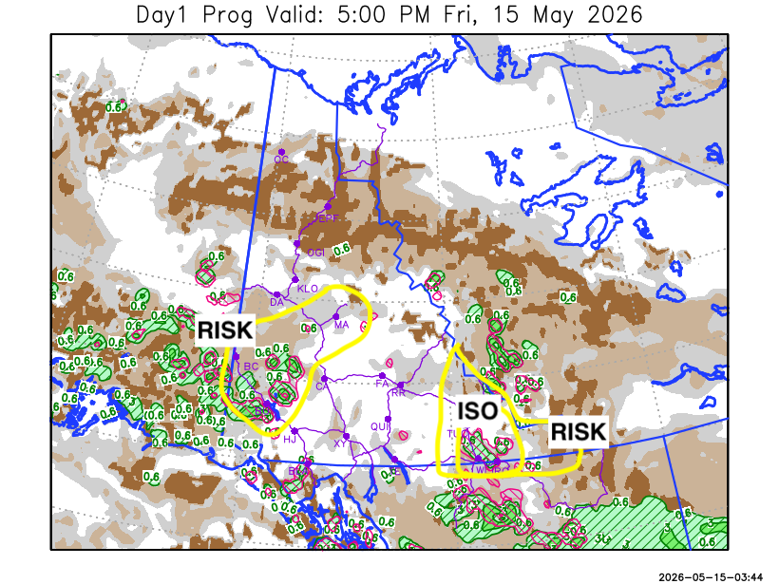
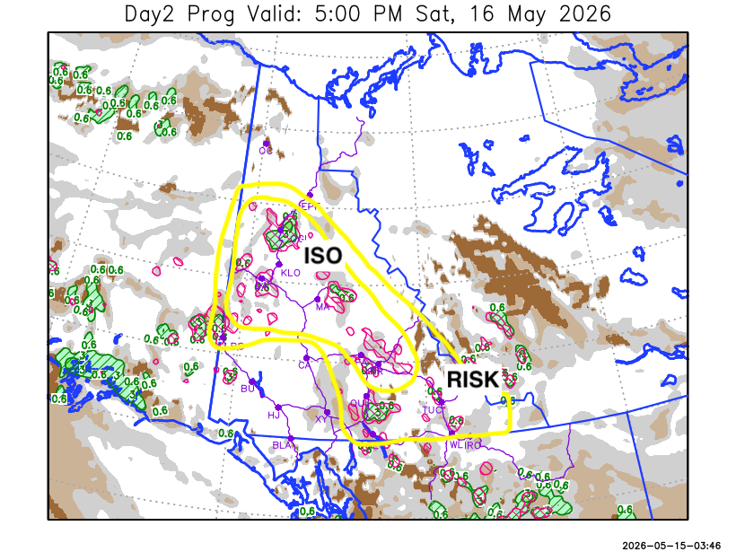

Forecast for | Saturday | (Peak burning period and overnight)
Community | Clouds | Pcpn | POP | POL | Max Temp | Min RH | Min Temp | Max  RH | Wind Dir | Wind Speed
Old Crow | SCT |  | 0 | NIL | 10 | 45 | 0 | 95 | 110 | 10
Klondike Fc | SCT | RW-/TRW- | 30 | ISO | 18 | 25 | 4 | 81 | 90 | 10
Mayo A | FEW | RW-/TRW- | 30 | ISO | 18 | 20 | 7 | 70 | 140 | 10
Carmacks | FEW |  | 10 | NIL | 20 | 15 | 4 | 51 | 160 | 15G30
Faro | FEW | RW-/TRW- | 40 | ISO | 14 | 35 | 2 | 86 | 140 | 10
Ross River | FEW | RW-/TRW- | 40 | ISO | 16 | 30 | -1 | 89 | 160 | 5
Beaver Creek Town | SCT | RW-/TRW- | 20 | RISK | 15 | 30 | -2 | 79 | 250 | 10
Burwash A | FEW |  | 0 | NIL | 13 | 25 | -2 | 67 | 160 | 20G30
Haines Junction | FEW |  | 0 | NIL | 16 | 20 | 0 | 81 | 180 | 15G30
Whitehorse Auto | SCT |  | 0 | NIL | 16 | 25 | 2 | 78 | 180 | 15G25
Teslin | SCT | RW-/TRW- | 20 | RISK | 14 | 35 | 3 | 84 | 200 | 10
Watson Lake | SCT | RW-/TRW- | 30 | RISK | 14 | 35 | 4 | 80 | 110 | 10

Forecast for |  |  | Sunday |  |  | (Peak burning period and overnight)
Community |  |  | Clouds |  |  | Pcpn |  | POP |  | POL |  | Max Temp |  | Min RH | Min Temp | Max  RH | Wind Dir | Wind Speed
Old Crow |  |  | BKN |  |  |  |  | 0 |  | NIL |  | 11 |  | 45 | 2 | 94 | 40 | 10
Klondike Fc |  |  | BKN |  |  |  |  | 0 |  | NIL |  | 18 |  | 20 | 5 | 59 | 140 | 10G25
Mayo A |  |  | SCT |  |  |  |  | 0 |  | NIL |  | 17 |  | 20 | 7 | 59 | 160 | 15G30
Carmacks |  |  | BKN |  |  |  |  | 0 |  | NIL |  | 18 |  | 20 | 4 | 64 | 160 | 20G40
Faro |  |  | BKN |  |  |  |  | 0 |  | NIL |  | 15 |  | 30 | 2 | 71 | 180 | 15G30
Ross River |  |  | BKN |  |  |  |  | 0 |  | NIL |  | 17 |  | 25 | 1 | 66 | 180 | 15G30
Beaver Creek Town |  |  | BKN |  |  |  |  | 0 |  | NIL |  | 16 |  | 25 | 1 | 69 | 110 | 15
Burwash A |  |  | BKN |  |  |  |  | 0 |  | NIL |  | 10 |  | 30 | 0 | 77 | 160 | 30G50
Haines Junction |  |  | BKN |  |  |  |  | 0 |  | NIL |  | 13 |  | 35 | 2 | 87 | 180 | 15G35
Whitehorse Auto |  |  | BKN |  |  |  |  | 0 |  | NIL |  | 12 |  | 25 | 4 | 73 | 160 | 20G40
Teslin |  |  | BKN |  |  |  |  | 0 |  | NIL |  | 13 |  | 25 | 4 | 68 | 180 | 15G30
Watson Lake |  |  | SCT |  |  | RW-/TRW- |  | 20 |  | RISK |  | 16 |  | 30 | 6 | 64 | 200 | 10G25
3-Day Forecast Precipitation Totals from 13:00 Yesterday
OC | 0.0 |  | FA | 2.0 |  |  | JAK | 0.0
EPF | 0.1 |  | RR | 2.8 |  |  | TE | 0.0
ANT | 0.7 |  | BC | 27.9 |  |  | QUI | 0.0
DA | 1.1 |  | BCT | 30.0 |  |  | SWI | 1.6
FMI | 0.9 |  | BU | 1.1 |  |  | FL | 1.5
HEN | 0.3 |  | HJF | 0.0 |  |  | TUC | 3.2
BAR | 0.8 |  | RAI | 0.0 |  |  | HAS | 1.7
MA | 8.7 |  | CH | 0.0 |  |  | TC | 2.4
STW | 10.0 |  | BR | 0.0 |  |  | WL | 2.9
WIL | 2.1 |  | NU | 0.0 |  |  | PE | 0.4
XY | 0.0 |  | IRO | 1.4 |  |  | CA | 0.0
CC | 0.0 |  | ELK | 0.2 |  |  | DRU | 0.2
ATL | 0.1 |  | NA | NA |  |  | NA | NA
Matt Desorcy Meteorologist

Disclaimer : The information in these forecasts is collected and prepared for internal use by the Government of Yukon. The forecasts are specifically designed to meet the needs of the Wildland Fire Management and may not cover the requirements of other parties. Weather warnings or advisories are not included as part of the forecasts. Wildland Fire Management makes no representation and provides no warranty as to the accuracy of its weather forecasts. Any use the recipient chooses to make of the forecasts will be at its sole risk.

