YUKON WILDLAND FIRE MANAGEMENT WEATHER FORECAST - 9:00 AM ISSUE

16-May-2026
YESTERDAY'S VALUES
Community | Max  Temp  (°C) | Diff.  from  Normal | Min Temp  (°C) | Diff. from Normal | Pcpn  (mm) | Min RH | Max RH | L110 | L30
Old Crow | 8.2 | 0.2 | 0.9 | 4.3 | 0.0 | 35 | 74 | 0 | 0
Fort Mcpherson Airport | 5.9 |  | 2.1 |  | 0.0M | 45 | 67 | 0 | 0
Rock River Climate | 1.0 |  | -2.1 |  | 0.0 | 59 | 86 | NA | NA
Eagle Plains Fire | 2.3 |  | -2.7 |  | 0.0 | 61 | 84 | 0 | 0
Antimony Creek | 14.0 |  | -0.6 |  | 0.0 | 23 | 78 | 0 | 0
Klondike Fc | 15.8M | 0.4 | 5.1M | 4.2 | 0.0M | 21M | 65M | 0 | 0
Forty Mile | 12.3 |  | 2.7 |  | 0.0 | 26 | 61 | 0 | 0
Henderson | 10.0 |  | 4.0 |  | 0.0 | 28 | 70 | 0 | 0
Barlow | 11.5 |  | 4.5 |  | 0.0 | 39 | 69 | 0 | 0
Mayo A | 13.4 | -1.2 | -0.6 | -2.4 | 0.0 | 43 | 94 | 0 | 0
Stewart Crossing | 11.8 |  | -1.2 |  | 0.0 | 46 | 97 | 0 | 0
Willow Creek | 13.7 |  | -2.5 |  | 0.0 | 27 | 94 | 0 | 0
Pelly Farm | M |  | M |  | M | M | M | 0 | 0
Carmacks | 19.5 |  | -0.8 |  | 0.0 | 18 | 81 | 0 | 0
Drury Creek | 16.4 |  | -2.8 |  | 0.0 | 20 | 79 | 0 | 0
Faro | 16.4 | 2.9 | -2.4 | -3.4 | 0.0 | 35M | 95M | 0 | 0
Ross River | 18.9 |  | -4.7 |  | 0.0 | 15 | 91 | 0 | 0
Macmillan Pass | 6.4 |  | -3.6 |  | 0.0 | 62 | 90 | 1 | 0
Beaver Creek A | 10.9 | -1.9 | -1.8 | -0.9 | 0.0M | 50 | 97 | 0 | 0
Beaver Creek Town | 11.5 |  | -1.5 |  | 0.3 | 42 | 96 | 0 | 0
Burwash A | 9.9 | -2.0 | -4.2 | -2.6 | 0.0 | 59 | 89 | 0 | 0
Haines Junction | 14.8 | 1.9 | -4.8 | -3.0 | 0.0 | 29 | 86 | 0 | 0
Rainbow | 13.7 |  | -0.1 |  | 0.0 | 28 | 77 | 0 | 0
Champagne | 14.8 |  | -6.2 |  | 0.0 | 23 | 84 | 0 | 0
Braeburn | 16.3 |  | -3.5 |  | 0.0 | 19 | 75 | 0 | 0
Nursery | 16.2 |  | -2.1 |  | 0.0 | 17 | 81 | 0 | 0
Whitehorse Auto | 13.6 | 0.7 | 0.2 | -0.3 | 0.0 | 18 | 67 | 0 | 0
Mount Sima | 9.6 |  | 1.0 |  | 0.0 | 24 | 56 | 0 | 0
Carcross | 13.6 |  | 1.0 |  | 0.0 | 30 | 81 | 0 | 0
Atlin | 12.7 |  | 2.7 |  | 0.0 | 26 | 65 | 0 | 0
Jakes Corner | 15.1 |  | 1.9 |  | 0.0 | 20 | 66 | 0 | 0
Teslin | 13.8 |  | 1.7 |  | 0.0 | 25 | 70 | 0 | 0
Quiet Lake | 16.0 |  | 0.6 |  | 0.0 | 20 | 75 | 0 | 0
Swift River | 14.4 |  | 0.8 |  | 0.0 | 24 | 88 | 0 | 0
Tuchitua | 16.9 |  | -0.9 |  | 0.3 | 22 | 98 | 0 | 0
Hasselburg | 14.8 |  | 2.8 |  | 0.0 | 26 | 91 | 0 | 0
Tom Creek | 13.8 |  | 2.4 |  | 0.0 | 38 | 87 | 0 | 0
Watson Lake | 12.9 | -0.6 | 3.5 | 2.6 | 5.0 | 51M | 100M | 0 | 0
Iron Creek | 16.6 |  | -1.8 |  | 0.0 | 38 | 97 | 0 | 0
Max Temp is the actual maximum temperature in °C from yesterday afternoon or evening.
Min Temp is the actual overnight minimum temperature in °C up until 6:00 AM this morning.
Diff. from Normal is the difference from the 30 year average max or min temperature.
Pcpn is the precipitation in mm since 13:00 yesterday.
Min RH is the minimum observed RH in % from yesterday afternoon or evening.
Max RH is the maximum observed overnight RH in % up until 6:00 AM this morning.
L110 is the actual number of lightning strikes within 110 km and in the Yukon for 24 hours ending at 06:00 AM this morning.
L30 is the actual number of lightning strikes within 30 km and in the Yukon for 24 hours ending at 06:00 AM this morning.
M is missing data. * denotes precipitation at stations that failed to report for at least part of the evening and overnight period.

SYNOPSIS:
Today: A weak upper-level ridge will support a warm and dry airmass. Daytime highs in the low to mid-teens throughout the Yukon. Minimum RH 20-30% through the central and southern Yukon, but 15-20% in the western Tatchun region and locally 10-15%. Light southerly winds prevail, but moderate 15-30km/h winds will develop in parts of the Kluane, Southern Lakes, and Tatchun regions. Isolated late-day convective showers/thundershowers, particularly in the central Yukon and Tintina. Shallow to moderate crossovers expected within the Carmacks district with RH 15-20%, locally 10-15%. Moderate 15-30km/h winds will overlap 15-20% RH between Hutshi and Minto, including Carmacks, for 6-8 hours.
Sunday: A weak upper-level ridge will bring another day of near-seasonal temperatures, combined with a dry air mass (RHs in the 20-30% range) throughout the Yukon. Moderate 15-25 km/h winds, gusting up to 40 km/h, will overspread the Southern Lakes, Kluane, Tatchun, and parts of Northern Tutchone and Klondike regions. A 60 km/h low level jet located 1.5-2 km AGL will site over the Southern Lakes, Tatchun, and Northern Tutchone regions. Isolated late afternoon showers near Old Crow. Isolated late day showers with the risk of lightning will develop over the terrain of the eastern Yukon focused over the eastern Tintina region.
Monday: A weak trough will bring unsettled conditions, raise moisture and weaken winds. RH will remain above 30% over most of the territory. Winds will remain below 10km/h with a general westerly flow, however parts of the Kluane and Southern Lakes regions may see winds around 20km/h. Widespread scattered showers develop late day throughout the Yukon. Generally seasonal temperatures continue across the Territory. Warmest temperatures in the Klondike Region along the Porcupine River valley where daytime highs will be in the mid to high teens.
Tuesday: A weak ridge will clear skies, increase the winds, and marginally lower RH in the south. Unsettled weather may continue over the central and northern Yukon. Seasonal temperatures continue throughout the Yukon.
Wednesday: A wave of Pacific moisture will bring widespread unsettled conditions and raise the RH across the Yukon. Temperatures may struggle to reach double digits in the southern and central Yukon, but mild conditions are expected to remain in the northern Yukon.

Forecast for | Saturday | (Peak burning period and overnight)
Community | Clouds | Pcpn | POP | POL | Max Temp | Min RH | Min Temp | Max  RH | Wind Dir | Wind Speed
Old Crow | SCT |  | 0 | NIL | 12 | 40 | 1 | 95 | 110 | 10
Klondike Fc | SCT | TRW- | 60 | ISO | 16 | 30 | 5 | 70 | 110 | 10
Mayo A | FEW | TRW- | 30 | ISO | 18 | 20 | 7 | 65 | 180 | 10G30
Carmacks | FEW |  | 0 | NIL | 20 | 15 | 4 | 50 | 180 | 15G40
Faro | FEW | TRW- | 20 | ISO | 14 | 25 | 2 | 85 | 200 | 10
Ross River | FEW | TRW- | 30 | ISO | 19 | 25 | 0 | 85 | 200 | 10
Beaver Creek Town | FEW | TRW- | 20 | RISK | 17 | 20 | -2 | 70 | 180 | 10
Burwash A | FEW |  | 0 | NIL | 12 | 30 | -1 | 60 | 160 | 20G30
Haines Junction | FEW |  | 0 | NIL | 15 | 25 | 1 | 80 | 200 | 10G30
Whitehorse Auto | FEW |  | 0 | NIL | 16 | 20 | 2 | 80 | 200 | 15G30
Teslin | SCT | TRW- | 20 | RISK | 14 | 40 | 2 | 85 | 180 | 10
Watson Lake | FEW | TRW- | 20 | RISK | 14 | 30 | 4 | 75 | 140 | 5
POP is probability of precipitation in %.
POL is probability of lightning in %.

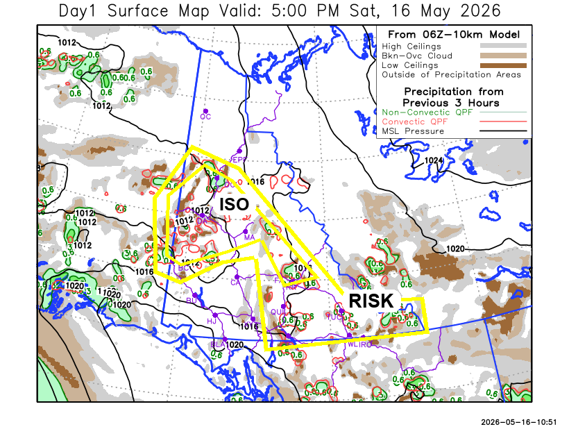
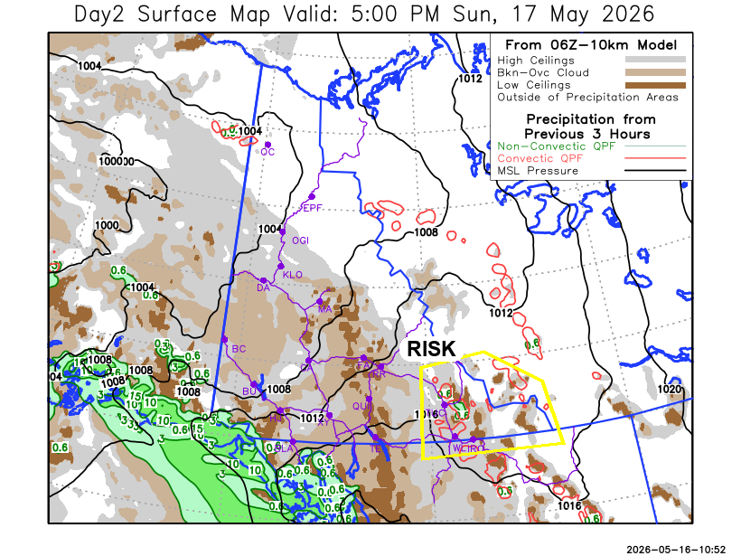

Forecast for | Sunday | (Peak burning period and overnight)
Community | Clouds | Pcpn | POP | POL | Max Temp | Min RH | Min Temp | Max  RH | Wind Dir | Wind Speed
Old Crow | BKN |  | 0 | NIL | 12 | 30 | 4 | 90 | 170 | 15
Klondike Fc | BKN |  | 0 | NIL | 17 | 25 | 5 | 65 | 140 | 10G30
Mayo A | BKN |  | 15 | NIL | 15 | 25 | 7 | 65 | 160 | 20G40
Carmacks | SCT |  | 0 | NIL | 16 | 30 | 4 | 65 | 180 | 20G50
Faro | BKN |  | 0 | NIL | 12 | 30 | 1 | 75 | 180 | 15G30
Ross River | BKN |  | 0 | NIL | 16 | 30 | 0 | 70 | 200 | 15G40
Beaver Creek Town | BKN |  | 5 | NIL | 15 | 25 | 1 | 69 | 160 | 10
Burwash A | BKN |  | 5 | NIL | 10 | 45 | 0 | 75 | 160 | 30G60
Haines Junction | BKN |  | 0 | NIL | 11 | 40 | 2 | 85 | 180 | 15G30
Whitehorse Auto | BKN |  | 0 | NIL | 10 | 40 | 3 | 75 | 170 | 20G40
Teslin | BKN |  | 15 | NIL | 10 | 30 | 4 | 80 | 180 | 20G40
Watson Lake | BKN | TRW- | 20 | RISK | 16 | 25 | 5 | 60 | 220 | 15G40

Forecast for |  |  | Monday |  |  | (Peak burning period and overnight)
Community |  |  | Clouds |  |  | Pcpn | POP |  | POL |  | Max Temp |  | Min RH | Min Temp | Max  RH | Wind Dir | Wind Speed
Old Crow |  |  | BKN |  |  |  | 15 |  | NIL |  | 13 |  | 30 | 1 | 90 | 270 | 15
Klondike Fc |  |  | BKN |  |  | RW- | 30 |  | NIL |  | 14 |  | 40 | 4 | 70 | 220 | 5
Mayo A |  |  | BKN |  |  | RW- | 40 |  | NIL |  | 14 |  | 35 | 6 | 90 | 220 | 10
Carmacks |  |  | BKN |  |  | RW- | 30 |  | NIL |  | 18 |  | 30 | 4 | 80 | 200 | 10
Faro |  |  | BKN |  |  | RW- | 30 |  | NIL |  | 13 |  | 35 | 1 | 80 | 220 | 10
Ross River |  |  | BKN |  |  |  | 20 |  | NIL |  | 16 |  | 35 | 0 | 75 | 220 | 10
Beaver Creek Town |  |  | BKN |  |  |  | 15 |  | NIL |  | 15 |  | 30 | -2 | 70 | 250 | 15
Burwash A |  |  | BKN |  |  | R- S- | 40 |  | NIL |  | 10 |  | 50 | 0 | 80 | 250 | 15
Haines Junction |  |  | SCT |  |  |  | 0 |  | NIL |  | 12 |  | 40 | 0 | 80 | 200 | 15G40
Whitehorse Auto |  |  | SCT |  |  |  | 15 |  | NIL |  | 13 |  | 30 | 2 | 70 | 220 | 15G30
Teslin |  |  | BKN |  |  |  | 15 |  | NIL |  | 12 |  | 40 | 1 | 75 | 220 | 15G30
Watson Lake |  |  | BKN |  |  |  | 15 |  | NIL |  | 14 |  | 40 | 4 | 60 | 250 | 10
3-Day Forecast Precipitation Totals from 13:00 Yesterday
OC | 0.0 |  | FA | 0.6 |  | JAK | 0.0
EPF | 0.0 |  | RR | 1.2 |  | TE | 0.3
ANT | 0.6 |  | BC | 0.3 |  | QUI | 0.4
DA | 1.4 |  | BCT | 0.6 |  | SWI | 0.5
FMI | 0.9 |  | BU | 0.5 |  | FL | 0.5
HEN | 1.5 |  | HJF | 0.0 |  | TUC | 0.6
BAR | 0.5 |  | RAI | 0.0 |  | HAS | 0.0
MA | 0.8 |  | CH | 0.0 |  | TC | 0.0
STW | 0.5 |  | BR | 0.0 |  | WL | 5.0
WIL | 0.2 |  | NU | 0.0 |  | PE | 0.1
XY | 0.0 |  | IRO | 0.0 |  | CA | 0.2
CC | 0.0 |  | ELK | 0.0 |  | DRU | 0.2
ATL | 0.0 |  | NA | NA |  | NA | NA
Dylan Kikuta Meteorologist

Disclaimer : The information in these forecasts is collected and prepared for internal use by the Government of Yukon. The forecasts are specifically designed to meet the needs of the Wildland Fire Management and may not cover the requirements of other parties. Weather warnings or advisories are not included as part of the forecasts. Wildland Fire Management makes no representation and provides no warranty as to the accuracy of its weather forecasts. Any use the recipient chooses to make of the forecasts will be at its sole risk.

