YUKON WILDLAND FIRE MANAGEMENT WEATHER FORECAST - 9:00 AM ISSUE

17-May-2026
YESTERDAY'S VALUES
Community | Max  Temp  (°C) | Diff.  from  Normal | Min Temp  (°C) | Diff. from Normal | Pcpn  (mm) | Min RH | Max RH | L110 | L30
Old Crow | 15.4 | 7.0 | 2.2 | 5.2 | 0.0 | 31 | 77 | 0 | 0
Fort McPherson Airport | 10.9 |  | 0.2 |  | 0.0M | 48 | 85 | 0 | 0
Rock River Climate | 8.7 |  | 4.3 |  | 0.0 | 41 | 69 | NA | NA
Eagle Plains Fire | 12.5 |  | 3.7 |  | 0.0 | 31 | 69 | 0 | 0
Antimony Creek | 18.3 |  | 0.8 |  | 0.0 | 22 | 73 | 0 | 0
Klondike Fc | 17.7M | 2.1 | -0.9M | -2.0 | 0.5M | 23M | 96M | 0 | 0
Forty Mile | 17.2 |  | 1.1 |  | 1.3 | 26 | 97 | 0 | 0
Henderson | 14.6 |  | 3.9 |  | 0.3 | 31 | 48 | 0 | 0
Barlow | 18.0 |  | 5.8 |  | 0.0 | 14 | 30 | 0 | 0
Mayo A | 17.9 | 3.0 | -1.4 | -3.4 | 0.0 | 17 | 83 | 0 | 0
Stewart Crossing | 19.1 |  | 5.0 |  | 0.0 | 12 | 41 | 0 | 0
Willow Creek | 19.2 |  | 4.2 |  | 0.0 | 13 | 47 | 0 | 0
Pelly Farm | M |  | M |  | M | M | M | 0 | 0
Carmacks | 20.5 |  | 3.1 |  | 0.0 | 13 | 56 | 0 | 0
Drury Creek | 18.3 |  | -1.8 |  | 0.0 | 20 | 84 | 1 | 0
Faro | 18.4 | 4.7 | -1.2 | -2.4 | 0.0 | 36M | 99M | 2 | 0
Ross River | 21.5 |  | -3.1 |  | 0.0 | 17 | 92 | 3 | 1
Macmillan Pass | 9.3 |  | -1.7 |  | 0.0 | 51 | 83 | 0 | 0
Beaver Creek A | 15.3 | 2.3 | -2.6 | -2.0 | 0.0 | 19 | 80 | 0 | 0
Beaver Creek Town | 16.3 |  | -2.3 |  | 0.0 | 17 | 82 | 0 | 0
Burwash A | 13.6 | 1.5 | 1.5 | 3.0 | 0.0M | 20 | 59 | 0 | 0
Haines Junction | 16.5 | 3.6 | 1.9 | 4.0 | 0.0 | 12 | 55 | 0 | 0
Rainbow | 14.8 |  | 2.7 |  | 0.0 | 20 | 61 | 0 | 0
Champagne | 15.6 |  | -3.1 |  | 0.0 | 17 | 75 | 0 | 0
Braeburn | 18.9 |  | -2.2 |  | 0.0 | 17 | 75 | 0 | 0
Nursery | 19.4 |  | 0.2 |  | 0.0 | 17 | 66 | 0 | 0
Whitehorse Auto | 16.5 | 3.4 | 1.7 | 1.1 | 0.0 | 21 | 65 | 0 | 0
Mount Sima | 12.8 |  | -0.6 |  | 0.0 | 25 | 66 | 0 | 0
Carcross | 14.9 |  | -0.1 |  | 0.0 | 28 | 79 | 0 | 0
Atlin | 14.8 |  | 0.0 |  | 0.0 | 31 | 73 | 0 | 0
Jakes Corner | 17.3 |  | -1.7 |  | 0.0 | 24 | 79 | 0 | 0
Teslin | 15.6 |  | -1.4 |  | 0.0 | 25 | 86 | 0 | 0
Quiet Lake | 18.1 |  | 0.3 |  | 0.0 | 23 | 80 | 1 | 0
Swift River | 15.3 |  | -3.6 |  | 0.0 | 27 | 94 | 0 | 0
Tuchitua | 18.5 |  | -4.1 |  | 0.0 | 25 | 96 | 0 | 0
Hasselburg | 16.6 |  | -0.4 |  | 0.0 | 25 | 86 | 0 | 0
Tom Creek | 13.8 |  | 2.8 |  | 0.0 | 30 | 74 | 0 | 0
Watson Lake | 14.7 | 1.0 | 0.8 | -0.3 | 0.0 | 41M | 100M | 0 | 0
Iron Creek | 17.6 |  | -4.2 |  | 0.0 | 25 | 97 | 0 | 0
Max Temp is the actual maximum temperature in °C from yesterday afternoon or evening.
Min Temp is the actual overnight minimum temperature in °C up until 6:00 AM this morning.
Diff. from Normal is the difference from the 30 year average max or min temperature.
Pcpn is the precipitation in mm since 13:00 yesterday.
Min RH is the minimum observed RH in % from yesterday afternoon or evening.
Max RH is the maximum observed overnight RH in % up until 6:00 AM this morning.
L110 is the actual number of lightning strikes within 110 km and in the Yukon for 24 hours ending at 06:00 AM this morning.
L30 is the actual number of lightning strikes within 30 km and in the Yukon for 24 hours ending at 06:00 AM this morning.
M is missing data. * denotes precipitation at stations that failed to report for at least part of the evening and overnight period.

SYNOPSIS:
Today: An upper low in the Gulf of Alaska has begun to spread cloud cover over the southeastern Yukon today, with that cloud deck progressing north and west as the day progresses. As a result, temperatures today will be slightly cooler than yesterday in most regions, except perhaps a degree or two warmer in Old Crow. Despite the increasing cloud cover, little precipitation is expected, other than a chance of a light convective shower in the Tatchun, Tintina, and Northern Tutchone regions. We cannot rule out a lightning strike or two with these showers, but the risk is too low to outline. The main concern today is the strong winds, especially in the Kluane, western Tatchun, and Southern Lakes. In general, winds will be southeasterly 25-35 km/h gusting to 45-60 km/h. Check the tabular forecasts for regional specifics. The air mass also remains very dry across the territory, with afternoon RH values likely to drop as low as 20% in some regions. While crossovers remain unlikely due to the moderate temperatures, these lower RH values coincide with strong winds in the Kluane/Tatchun/Southern Lakes.

Monday: Weak upper-level troughing builds into the Yukon, but the weather will not change dramatically. Compared to today, winds will decrease somewhat, but it will remain breezy in parts of the Kluane, western Tatchun, and Southern Lakes with speeds of 20-30 km/h and gusts as high as 40 km/h. Otherwise, little significant weather is expected. The upper trough is expected to generate some scattered showers throughout the day, with the best chance of precipitation through the central Yukon including the southern Klondike and Northern Tutchone regions. The risk of lightning is presently too low to outline. Crossovers are unlikely.

Tuesday: Broadly quiet weather is expected on Tuesday as weak upper ridging rebuilds across the Yukon. Temperatures will mainly be in the teens with no crossovers expected. Winds will remain 20-30 km/h with gusts as high as 40 km/h in parts of the Kluane, western Tatchun, and Southern Lakes regions. No other active weather is expected.

Wednesday: Looking into the longer range there is no sign of any significant change in the weather pattern through midweek. The upper-level flow remains roughly zonal (west to east), with no signs of strong ridging or troughing. This means near normal weather is most probable across the Territory.

Thursday: No change for Thursday with fairly typical mid-May weather expected. There are hints of a deeper trough over Alaska potentially moving in for the weekend.

Forecast for | Sunday | (Peak burning period and overnight)
Community | Clouds | Pcpn | POP | POL | Max Temp | Min RH | Min Temp | Max  RH | Wind Dir | Wind Speed
Old Crow | BKN |  | 0 | NIL | 17 | 30 | 4 | 80 | 180 | 15
Klondike Fc | SCT | RW- | 30 | NIL | 18 | 25 | 6 | 70 | 140 | 20
Mayo A | SCT | RW- | 30 | NIL | 17 | 25 | 7 | 70 | 160 | 20
Carmacks | SCT |  | 20 | NIL | 18 | 20 | 4 | 70 | 160 | 25G40
Faro | SCT | RW- | 30 | NIL | 16 | 35 | 1 | 85 | 180 | 25G40
Ross River | SCT | RW- | 30 | NIL | 18 | 20 | 0 | 75 | 180 | 25G40
Beaver Creek Town | BKN |  | 10 | NIL | 16 | 20 | 1 | 70 | 140 | 15
Burwash A | BKN |  | 10 | NIL | 12 | 20 | 0 | 75 | 160 | 35G60
Haines Junction | BKN |  | 20 | NIL | 13 | 20 | 2 | 85 | 180 | 20G30
Whitehorse Auto | BKN |  | 10 | NIL | 15 | 25 | 3 | 75 | 160 | 35G55
Teslin | BKN | RW- | 30 | NIL | 15 | 35 | 4 | 80 | 180 | 20
Watson Lake | BKN | RW- | 30 | NIL | 15 | 40 | 5 | 90 | 200 | 15
POP is probability of precipitation in %.
POL is probability of lightning in %.

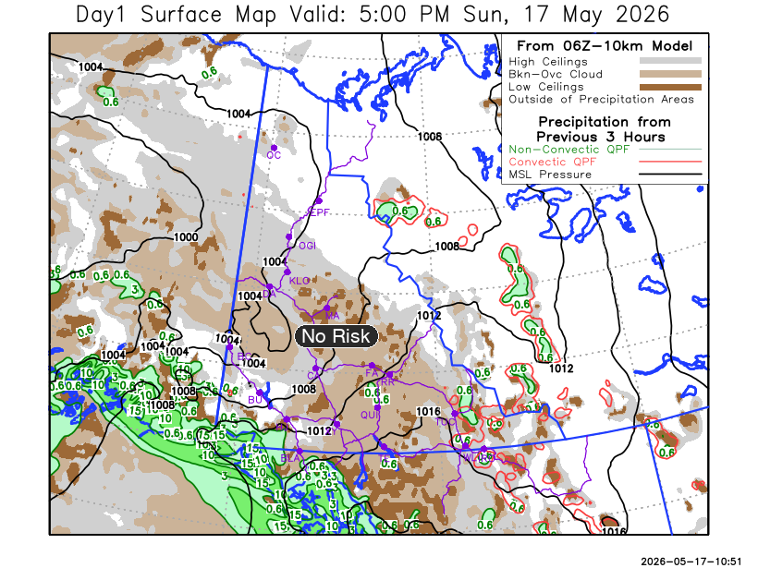
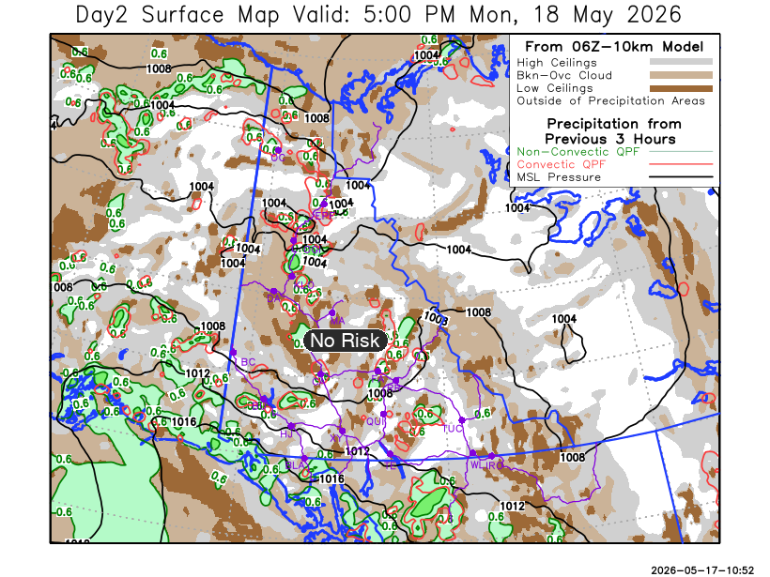

Forecast for | Monday | (Peak burning period and overnight)
Community | Clouds | Pcpn | POP | POL | Max Temp | Min RH | Min Temp | Max  RH | Wind Dir | Wind Speed
Old Crow | SCT | RW- | 40 | NIL | 14 | 45 | 0 | 90 | Var | 10
Klondike Fc | BKN | RW- | 60 | NIL | 16 | 35 | 4 | 90 | 200 | 15
Mayo A | BKN | RW- | 50 | NIL | 15 | 35 | 7 | 90 | 200 | 15-20
Carmacks | BKN | RW- | 40 | NIL | 17 | 30 | 4 | 85 | 180 | 20
Faro | SCT |  | 20 | NIL | 14 | 40 | 1 | 85 | 250 | 10-20
Ross River | SCT |  | 20 | NIL | 16 | 30 | 0 | 75 | 250 | 10-20
Beaver Creek Town | SCT | RW- | 40 | NIL | 15 | 30 | -2 | 85 | 270 | 10
Burwash A | BKN |  | 20 | NIL | 11 | 45 | -1 | 85 | 160 | 20G30
Haines Junction | BKN |  | 20 | NIL | 13 | 40 | 0 | 85 | 270 | 20G30
Whitehorse Auto | BKN |  | 20 | NIL | 14 | 30 | 2 | 70 | 200 | 25G40
Teslin | SCT |  | 20 | NIL | 13 | 35 | 1 | 75 | 220 | 20
Watson Lake | BKN |  | 20 | NIL | 14 | 40 | 3 | 70 | 250 | 15-20

Forecast for |  |  | Tuesday |  |  | (Peak burning period and overnight)
Community |  |  | Clouds |  |  | Pcpn | POP |  | POL |  | Max Temp |  | Min RH | Min Temp | Max  RH | Wind Dir | Wind Speed
Old Crow |  |  | SCT |  |  |  | 20 |  | NIL |  | 13 |  | 45 | 3 | 90 | 180 | 20
Klondike Fc |  |  | FEW |  |  |  | 20 |  | NIL |  | 18 |  | 25 | 6 | 80 | 220 | 15
Mayo A |  |  | FEW |  |  |  | 20 |  | NIL |  | 16 |  | 30 | 6 | 80 | 180 | 15-20
Carmacks |  |  | FEW |  |  |  | 20 |  | NIL |  | 18 |  | 25 | 3 | 80 | 160 | 20G30
Faro |  |  | FEW |  |  |  | 20 |  | NIL |  | 13 |  | 35 | 1 | 85 | 180 | 15
Ross River |  |  | FEW |  |  |  | 20 |  | NIL |  | 16 |  | 30 | 0 | 80 | 180 | 15
Beaver Creek Town |  |  | SCT |  |  |  | 10 |  | NIL |  | 17 |  | 25 | 1 | 75 | 180 | 10
Burwash A |  |  | SCT |  |  |  | 10 |  | NIL |  | 11 |  | 35 | 0 | 80 | 160 | 25G40
Haines Junction |  |  | SCT |  |  |  | 10 |  | NIL |  | 12 |  | 35 | 2 | 85 | 270 | 20
Whitehorse Auto |  |  | FEW |  |  |  | 10 |  | NIL |  | 14 |  | 30 | 3 | 80 | 160 | 25G40
Teslin |  |  | FEW |  |  |  | 10 |  | NIL |  | 12 |  | 35 | 2 | 85 | 180 | 20
Watson Lake |  |  | SCT |  |  |  | 10 |  | NIL |  | 13 |  | 35 | 3 | 75 | 180 | 20
3-Day Forecast Precipitation Totals from 13:00 Yesterday
OC | 1.0 |  | FA | 0.7 |  | JAK | 0.0
EPF | 4.1 |  | RR | 0.1 |  | TE | 0.0
ANT | 2.6 |  | BC | 0.5 |  | QUI | 0.0
DA | 1.9 |  | BCT | 0.5 |  | SWI | 0.3
FMI | 1.5 |  | BU | 3.6 |  | FL | 0.9
HEN | 2.1 |  | HJF | 0.0 |  | TUC | 0.0
BAR | 1.7 |  | RAI | 0.0 |  | HAS | 0.0
MA | 1.6 |  | CH | 0.0 |  | TC | 0.6
STW | 0.7 |  | BR | 1.3 |  | WL | 1.2
WIL | 0.9 |  | NU | 0.0 |  | PE | 0.6
XY | 0.0 |  | IRO | 1.8 |  | CA | 2.8
CC | 0.0 |  | ELK | 0.9 |  | DRU | 3.2
ATL | 0.0 |  | NA | NA |  | NA | NA
Scott Kehler Meteorologist

Disclaimer : The information in these forecasts is collected and prepared for internal use by the Government of Yukon. The forecasts are specifically designed to meet the needs of the Wildland Fire Management and may not cover the requirements of other parties. Weather warnings or advisories are not included as part of the forecasts. Wildland Fire Management makes no representation and provides no warranty as to the accuracy of its weather forecasts. Any use the recipient chooses to make of the forecasts will be at its sole risk.

