YUKON WILDLAND FIRE MANAGEMENT WEATHER FORECAST - 9:00 AM ISSUE
23-May-2026
YESTERDAY'S VALUES
Community | Max  Temp  (°C) | Diff.  from  Normal | Min Temp  (°C) | Diff. from Normal | Pcpn  (mm) | Min RH | Max RH | L110 | L30
Old Crow | 14.0 | 3.2 | 1.8 | 2.4 | 1.0 | 42 | 94 | 1 | 0
Fort Mcpherson Airport | 9.0 |  | 2.1 |  | 0.0M | 60 | 79 | 0 | 0
Rock River Climate | 8.3 |  | 2.7 |  | 5.0 | 75 | 98 | NA | NA
Eagle Plains Fire | 8.7 |  | 2.8 |  | 2.7 | 64 | 95 | 0 | 0
Antimony Creek | 15.5 |  | -1.4 |  | 0.0 | 18 | 85 | 0 | 0
Klondike Fc | 16.6M | -0.3 | -1.6M | -3.8 | 0.0M | 18M | 93M | 0 | 0
Forty Mile | 14.2 |  | -1.5 |  | 0.0 | 21 | 94 | 0 | 0
Henderson | 12.3 |  | 3.2 |  | 0.0 | 20 | 52 | 1 | 0
Barlow | 15.0 |  | 2.8 |  | 0.0 | 18 | 71 | 1 | 0
Mayo A | 12.5 | -3.8 | 2.1 | -1.0 | 0.0 | 38 | 90 | 1 | 0
Stewart Crossing | 14.1 |  | 3.4 |  | 0.0 | 25 | 82 | 1 | 0
Willow Creek | 10.6 |  | -1.5 |  | 0.0 | 51 | 96 | 1 | 0
Pelly Farm | M |  | M |  | M | M | M | 1 | 1
Carmacks | 12.5 |  | -0.3 |  | 0.0 | 36 | 94 | 0 | 0
Drury Creek | 9.7 |  | 0.6 |  | 0.0 | 49 | 91 | 0 | 0
Faro | 9.9 | -5.1 | 2.6 | 0.2 | 0.0 | 61M | 95M | 0 | 0
Ross River | 11.4 |  | -3.4 |  | 0.0 | 29 | 92 | 0 | 0
Macmillan Pass | 6.6 |  | -0.9 |  | 0.0 | 55 | 100 | 0 | 0
Beaver Creek A | 12.5 | -1.8 | 2.1 | 1.5 | 0.1M | 23 | 83 | 0 | 0
Beaver Creek Town | 13.0 |  | 1.9 |  | 0.0 | 20 | 82 | 0 | 0
Burwash A | 11.7 | -1.7 | -2.1 | -1.7 | 0.0 | 28 | 85 | 0 | 0
Haines Junction | 14.5 | 0.0 | -4.8 | -3.4 | 0.0 | 18 | 77 | 0 | 0
Rainbow | 13.2 |  | -1.3 |  | 0.0 | 29 | 68 | 0 | 0
Champagne | 12.8 |  | -3.0 |  | 0.0 | 26 | 79 | 0 | 0
Braeburn | 10.9 |  | -5.3 |  | 0.0 | 39 | 88 | 0 | 0
Nursery | 14.6 |  | -3.8 |  | 0.0 | 21 | 81 | 0 | 0
Whitehorse Auto | 12.0 | -2.4 | -0.6 | -2.2 | 0.0 | 26 | 67 | 0 | 0
Mount Sima | 7.4 |  | -2.2 |  | 0.0 | 35 | 63 | 0 | 0
Carcross | 13.6 |  | -2.2 |  | 0.0 | 27 | 89 | 0 | 0
Atlin | 8.8 |  | -1.4 |  | 0.0 | 39 | 81 | 0 | 0
Jakes Corner | 10.6 |  | -3.8 |  | 0.0 | 30 | 76 | 0 | 0
Teslin | 10.7 |  | -3.3 |  | 0.2 | 36 | 89 | 0 | 0
Quiet Lake | 10.4 |  | -3.4 |  | 0.0 | 42 | 91 | 0 | 0
Swift River | 8.1 |  | -2.4 |  | 0.0 | 47 | 92 | 0 | 0
Tuchitua | 11.6 |  | -3.9 |  | 0.3 | 34 | 96 | 0 | 0
Hasselburg | 10.8 |  | -3.7 |  | 0.0 | 32 | 95 | 0 | 0
Tom Creek | 10.3 |  | -1.6 |  | 0.0 | 36 | 82 | 0 | 0
Watson Lake | 10.7 | -4.2 | -2.2 | -4.5 | 0.0 | 49 | 100M | 0 | 0
Iron Creek | 14.5 |  | -5.1 |  | 0.0 | 29 | 93 | 0 | 0

Max Temp is the actual maximum temperature in °C from yesterday afternoon or evening.
Min Temp is the actual overnight minimum temperature in °C up until 6:00 AM this morning.
Diff. from Normal is the difference from the 30 year average max or min temperature.
Pcpn is the precipitation in mm since 13:00 yesterday.
Min RH is the minimum observed RH in % from yesterday afternoon or evening.
Max RH is the maximum observed overnight RH in % up until 6:00 AM this morning.
L110 is the actual number of lightning strikes within 110 km and in the Yukon for 24 hours ending at 06:00 AM this morning.
L30 is the actual number of lightning strikes within 30 km and in the Yukon for 24 hours ending at 06:00 AM this morning.
M is missing data. * denotes precipitation at stations that failed to report for at least part of the evening and overnight period.

SYNOPSIS
Today: An upper-level trough combined with a weak surface low located near the southern Klondike will bring a slightly unstable air mass across the Territory. Scattered rain showers and the risk of thundershowers are expected across the Klondike, Northern Tutchone, Tatchun, and parts of Kluane, producing light and spotty rainfall amounts. Moderate winds of 10-15 km/h are forecast, with gusts of 25-30 km/h strongest through southern regions, particularly in the Haines Junction district. Farther north near Old Crow, winds will be lighter, with gusts closer to 20 km/h. Maximum temperatures are expected to reach the low to mid-teens. Minimum relative humidity values of 20-30% are forecast along the Tintina, Southern Lakes, and Tatchun regions, with localized pockets of lower RH also possible in the southern Klondike. Elsewhere, minimum RH values of 35% or higher are expected.
Sunday: A deep upper-level trough centered near the Alberta-NWT border will bring a cooling trend to the Yukon. At the surface, a trough extending westward through the Tatchun region into the southern Klondike and Alaska will act as a focus for convective development. Scattered showers and thundershowers are expected to develop during the afternoon hours along this corridor, extending from Dawson city eastward toward Faro. Additional shower activity is also expected in northern Tintina, eastern Tatchun, and across the Southern Lakes, Kluane, and broadly the Klondike region as the unsettled pattern prevails. Winds are also forecast to strengthen across northern portions of the Territory with winds 20 km/h gusting to 40 km/h in Old Crow. Far southern parts of Yukon will see winds of 15 km/h with the occasional gusts up to 25 km/h. Otherwise generally light winds of 5-10 km/h are forecast.
Monday: A ridge of high pressure building northward from the southwest into the Kluane region will tighten the pressure gradient across northern half of the Yukon, resulting in moderate easterly winds, particularly in the Klondike and Northern Tutchone. Some shower and isolated thundershower activity will remain possible across southern regions, particularly Kluane, southern Klondike and Tintina, but confidence in exact shower placement is low.
Tuesday: Another deep trough moving in from Alaska is expected to advance from the west, with the potential to develop into a surface low pressure in western Yukon. This system is likely to bring renewed unsettled conditions, with more showers and thundershowers activity across central regions near the Ogilvie mountain range and isolated to scattered showers over southern regions.

Wednesday: A strengthening low-pressure system tracking into the NWT will bring showers and a risk of thundershower activity to the northern half of the Yukon, including the Eagle Plains area. Winds across much of the Territory will shift to a southwesterly flow, while areas in the north will see more of a northerly component. Winds are expected to be moderate to strong, with the strongest gusts forecast through southern portions of the Territory, including the Tintina, Southern Lakes, and Tatchun regions.
Forecast for | Saturday | (Peak burning period and overnight)
Community | Clouds | Pcpn | POP | POL | Max Temp | Min RH | Min Temp | Max  RH | Wind Dir | Wind Speed
Old Crow | BKN | RW-/TRW- | 40 | ISO | 15 | 35 | 2 | 90 | 20 | 15G20
Klondike Fc | SCT | RW-/TRW- | 30 | ISO | 16 | 30 | 4 | 85 | 10 | 5-10
Mayo A | BKN | RW-/TRW- | 80 | ISO | 12 | 40 | 6 | 85 | 40 | 5-10
Carmacks | SCT | RW-/TRW- | 40 | RISK | 16 | 20 | 2 | 55 | 160 | 10
Faro | SCT | RW-/TRW- | 30 | RISK | 13 | 35 | 1 | 75 | 270 | 10
Ross River | BKN | RW-/TRW- | 30 | RISK | 15 | 35 | -1 | 75 | 250 | 5
Beaver Creek Town | OVC | R-/TRW- | 80 | RISK | 12 | 35 | 0 | 90 | 290 | 10
Burwash A | OVC | RW-/SN- | 30 | NIL | 10 | 35 | -2 | 75 | 160 | 15G20
Haines Junction | SCT |  | 0 | NIL | 11 | 25 | -2 | 85 | 190 | 15G20
Whitehorse Auto | BKN | RW- | 30 | NIL | 12 | 25 | 1 | 70 | 180 | 15G25
Teslin | SCT |  | 10 | NIL | 11 | 35 | 0 | 70 | 220 | 15G25
Watson Lake | BKN |  | 0 | NIL | 13 | 30 | 4 | 60 | 290 | 15G20
POP is probability of precipitation in %.
POL is probability of lightning in %.

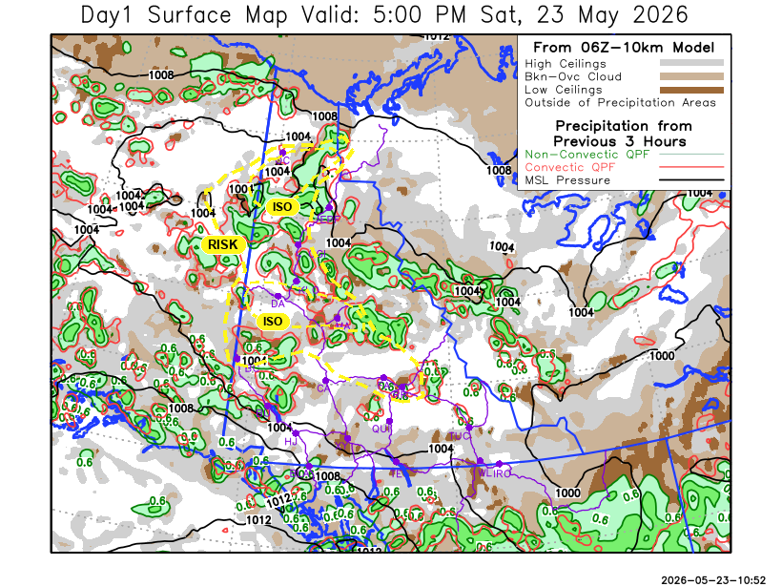
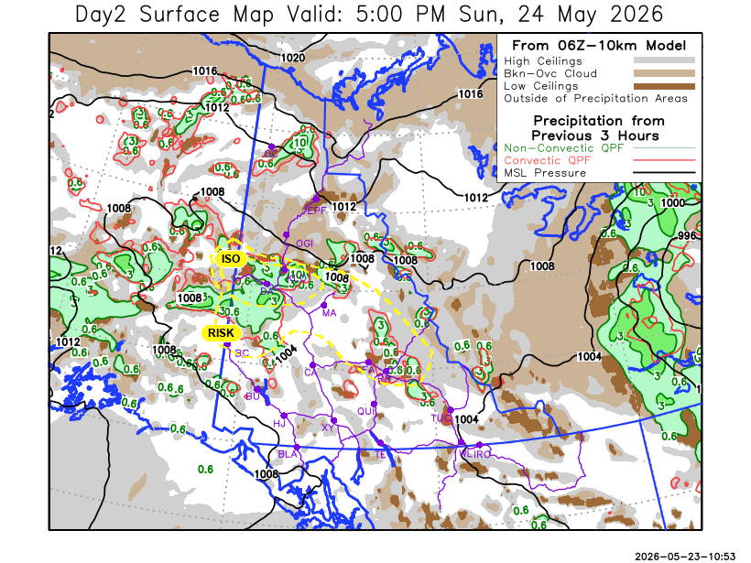
Forecast for | Sunday | (Peak burning period and overnight)
Community | Clouds | Pcpn | POP | POL | Max Temp | Min RH | Min Temp | Max  RH | Wind Dir | Wind Speed
Old Crow | BKN | RW- | 30 | NIL | 11 | 45 | -2 | 80 | 30 | 20G40
Klondike Fc | BKN | RW-/TRW- | 60 | ISO | 14 | 60 | 4 | 80 | 40 | 5-10
Mayo A | OVC | R-/TRW- | 80 | RISK | 13 | 55 | 6 | 85 | 40 | 5-10
Carmacks | SCT |  | 0 | NIL | 17 | 20 | 4 | 75 | 10 | 10
Faro | BKN | RW-/TRW- | 60 | RISK | 13 | 45 | 1 | 85 | 30 | 10
Ross River | BKN | RW-/TRW- | 50 | RISK | 15 | 45 | -1 | 80 | 10 | 10
Beaver Creek Town | OVC | RW-/TRW- | 80 | RISK | 11 | 55 | 1 | 90 | 300 | 15
Burwash A | BKN | RW- | 40 | NIL | 10 | 40 | 0 | 90 | 200 | 10
Haines Junction | SCT |  | 20 | NIL | 14 | 25 | 1 | 75 | 180 | 5
Whitehorse Auto | SCT |  | 0 | NIL | 12 | 20 | 3 | 60 | 340 | 15G20
Teslin | BKN |  | 20 | NIL | 13 | 25 | 4 | 65 | 130 | 10
Watson Lake | SCT | RW- | 40 | NIL | 14 | 25 | 5 | 70 | 270 | 15G25

Forecast for |  |  | Monday |  | (Peak burning period and overnight)
Community |  |  | Clouds |  | Pcpn |  | POP |  | POL |  | Max Temp |  | Min RH | Min Temp | Max  RH | Wind Dir | Wind Speed
Old Crow |  |  | SCT |  |  |  | 0 |  | NIL |  | 10 |  | 45 | 0 | 78 | 40 | 20G35
Klondike Fc |  |  | BKN |  | RW-/TRW- |  | 30 |  | RISK |  | 15 |  | 35 | 4 | 72 | 90 | 5
Mayo A |  |  | BKN |  |  |  | 0 |  | NIL |  | 15 |  | 35 | 6 | 75 | 60 | 10-15
Carmacks |  |  | BKN |  |  |  | 0 |  | NIL |  | 17 |  | 30 | 4 | 74 | 90 | 10
Faro |  |  | BKN |  |  |  | 20 |  | NIL |  | 15 |  | 40 | 2 | 82 | 70 | 10
Ross River |  |  | BKN |  | RW- |  | 30 |  | NIL |  | 16 |  | 35 | 0 | 81 | 80 | 15
Beaver Creek Town |  |  | OVC |  | RW-/TRW- |  | 40 |  | RISK |  | 14 |  | 40 | -2 | 85 | 160 | 5
Burwash A |  |  | SCT |  |  |  | 20 |  | NIL |  | 12 |  | 40 | 0 | 82 | 20 | 10
Haines Junction |  |  | SCT |  | RW- |  | 30 |  | NIL |  | 17 |  | 30 | 2 | 80 | 160 | 10
Whitehorse Auto |  |  | OVC |  | R- |  | 40 |  | NIL |  | 15 |  | 30 | 5 | 74 | 160 | 10
Teslin |  |  | OVC |  | RW- |  | 50 |  | NIL |  | 14 |  | 35 | 4 | 88 | 40 | 10
Watson Lake |  |  | OVC |  | R- |  | 70 |  | NIL |  | 12 |  | 35 | 5 | 83 | 90 | 15G30
3-Day Forecast Precipitation Totals from 13:00 Yesterday
OC | 1.8 |  | FA | 2.3 |  | JAK | 0.5
EPF | 6.2 |  | RR | 2.1 |  | TE | 1.1
ANT | 1.8 |  | BC | 10.8 |  | QUI | 0.3
DA | 1.6 |  | BCT | 10.7 |  | SWI | 0.5
FMI | 2.2 |  | BU | 3.1 |  | FL | 0.5
HEN | 4.7 |  | HJF | 0.6 |  | TUC | 1.5
BAR | 5.7 |  | RAI | 0.3 |  | HAS | 2.0
MA | 5.5 |  | CH | 0.1 |  | TC | 2.1
STW | 3.8 |  | BR | 0.4 |  | WL | 2.4
WIL | 3.2 |  | NU | 0.0 |  | PE | 4.3
XY | 0.4 |  | IRO | 1.1 |  | CA | 0.1
CC | 0.5 |  | ELK | 0.4 |  | DRU | 0.5
ATL | 0.3
Pallawi Paudel Meteorologist

Disclaimer : The information in these forecasts is collected and prepared for internal use by the Government of Yukon. The forecasts are specifically designed to meet the needs of the Wildland Fire Management and may not cover the requirements of other parties. Weather warnings or advisories are not included as part of the forecasts. Wildland Fire Management makes no representation and provides no warranty as to the accuracy of its weather forecasts. Any use the recipient chooses to make of the forecasts will be at its sole risk.

