YUKON WILDLAND FIRE MANAGEMENT WEATHER FORECAST - 9:00 AM ISSUE

24-May-2026
YESTERDAY'S VALUES
Community | Max  Temp  (°C) | Diff.  from  Normal | Min Temp  (°C) | Diff. from Normal | Pcpn  (mm) | Min RH | Max RH | L110 | L30
Old Crow | 15.5 | 4.3 | 1.4 | 1.6 | 0.2 | 29 | 89 | 2 | 0
Fort Mcpherson Airport | 16.3 |  | 0.9 |  | 0.0 | 43 | 81 | 0 | 0
Rock River Climate | 10.1 |  | 2.2 |  | 1.0 | 50 | 88 | NA | NA
Eagle Plains Fire | 13.1 |  | 1.9 |  | 2.0 | 41 | 96 | 0 | 0
Antimony Creek | 16.5 |  | -1.3 |  | 0.0 | 18 | 95 | 4 | 0
Klondike Fc | 18.1M | 1.0 | -0.8M | -3.2 | 0.0M | 17M | 94M | 4 | 0
Forty Mile | 15.0 |  | 0.4 |  | 0.0 | 23 | 93 | 3 | 0
Henderson | 10.1 |  | 2.6 |  | 0.0 | 32 | 81 | 5 | 0
Barlow | 14.8 |  | 3.5 |  | 0.0 | 28 | 71 | 2 | 0
Mayo A | 13.6 | -2.9 | 2.9 | -0.4 | 3.0 | 28 | 91 | 0 | 0
Stewart Crossing | 15.6 |  | 2.9 |  | 0.0 | 28 | 92 | 2 | 0
Willow Creek | 13.8 |  | -0.8 |  | 1.6 | 31 | 97 | 2 | 0
Pelly Farm | M |  | M |  | M | M | M | 2 | 1
Carmacks | 17.1 |  | 1.5 |  | 0.0 | 16 | 52 | 0 | 0
Drury Creek | 13.3 |  | -1.0 |  | 0.0 | 25 | 80 | 0 | 0
Faro | 11.7 | -3.5 | -0.8 | -3.4 | 0.0 | 51 | 97M | 0 | 0
Ross River | 12.4 |  | -4.8 |  | 0.0 | 24 | 91 | 0 | 0
Macmillan Pass | 7.1 |  | -1.3 |  | 0.0 | 53 | 98 | 0 | 0
Beaver Creek A | 10.4 | -4.1 | 0.2 | -0.6 | 2.3 | 46 | 96 | 1 | 0
Beaver Creek Town | 11.1 |  | 2.3 |  | 0.0 | 38 | 88 | 1 | 0
Burwash A | 10.1 | -3.5 | -2.4 | -2.2 | 0.9M | 35 | 99 | 0 | 0
Haines Junction | 12.9 | -1.3 | -5.9 | -5.2 | 0.0 | 24 | 78 | 0 | 0
Rainbow | 12.1 |  | -1.9 |  | 0.0 | 24 | 69 | 0 | 0
Champagne | 12.2 |  | -6.8 |  | 0.0 | 21 | 76 | 0 | 0
Braeburn | 14.5 |  | -5.3 |  | 0.0 | 17 | 73 | 0 | 0
Nursery | 13.7 |  | -7.2 |  | 0.0 | 21 | 81 | 0 | 0
Whitehorse Auto | 11.8 | -2.8 | -2.6 | -4.3 | 0.0 | 19 | 68 | 0 | 0
Mount Sima | 9.5 |  | -3.2 |  | 0.0 | 28 | 65 | 0 | 0
Carcross | 11.5 |  | -5.0 |  | 0.0 | 29 | 85 | 0 | 0
Atlin | 10.6 |  | -2.7 |  | 0.0 | 30 | 70 | 0 | 0
Jakes Corner | 12.5 |  | -3.8 |  | 0.0 | 23 | 71 | 0 | 0
Teslin | 11.6 |  | -3.6 |  | 0.0 | 24 | 79 | 0 | 0
Quiet Lake | 14.1 |  | -2.9 |  | 0.0 | 21 | 82 | 0 | 0
Swift River | 10.5 |  | -4.5 |  | 0.0 | 26 | 89 | 0 | 0
Tuchitua | 13.7 |  | -7.9 |  | 0.0 | 22 | 92 | 0 | 0
Hasselburg | 12.4 |  | -0.7 |  | 0.0 | 25 | 88 | 0 | 0
Tom Creek | 12.2 |  | -0.8 |  | 0.0 | 24 | 75 | 0 | 0
Watson Lake | 12.3 | -2.8 | -1.9 | -4.4 | 0.0 | 35 | 97 | 0 | 0
Iron Creek | 15.1 |  | 0.4 |  | 0.0 | 21 | 76 | 0 | 0

Max Temp is the actual maximum temperature in °C from yesterday afternoon or evening.
Min Temp is the actual overnight minimum temperature in °C up until 6:00 AM this morning.
Diff. from Normal is the difference from the 30 year average max or min temperature.
Pcpn is the precipitation in mm since 13:00 yesterday.
Min RH is the minimum observed RH in % from yesterday afternoon or evening.
Max RH is the maximum observed overnight RH in % up until 6:00 AM this morning.
L110 is the actual number of lightning strikes within 110 km and in the Yukon for 24 hours ending at 06:00 AM this morning.
L30 is the actual number of lightning strikes within 30 km and in the Yukon for 24 hours ending at 06:00 AM this morning.
M is missing data. * denotes precipitation at stations that failed to report for at least part of the evening and overnight period.

SYNOPSIS:
Today: A deep upper-level trough centered near the Alberta-NWT border will bring a cooling trend to the Yukon. At the surface, a trough extending westward through the Tatchun region into the southern Klondike and Alaska will act as a focus for convective development. Scattered showers and thundershowers are expected to develop during the afternoon hours along this corridor, extending from Dawson city eastward toward Faro. Winds are also forecast to strengthen across northern portions of the Territory with winds 20 km/h gusting to 40 km/h in Old Crow. Far southern parts of Yukon will see winds of 10-15 km/h with the occasional gusts up to 25 km/h. Elsewhere, generally light winds of 5-10 km/h are forecast.

Monday: Surface low pressure in Alaska will extend its trough across through the border of Kluane and Southern Klondike region while tightening the pressure gradient across the northern half of the Yukon, resulting in moderate easterly winds, particularly in the Old Crow, Southern Klondike and Tintina regions. Scattered showers and a slight isolated thundershower activity will remain possible across southern regions, particularly Kluane, southern Klondike and Southern Lakes. Maximum temperature again in the low to mid-teens with minimum relative humidity values of 25-30% across western Northern Tutchone and Tatchun, otherwise values at or above 35% are expected.

Tuesday: Another deep trough moving in from Alaska is expected to advance from the west, with the potential to develop into a surface low pressure in western Yukon. This system is likely to bring renewed unsettled conditions, with more showers and thundershowers activity across central regions near the Ogilvie mountain range and isolated to scattered showers over southern/western regions. Winds will shift to a southerly flow for much of the territory with 15-25 km/h and gusts up to 50 km/h in the Kluane to Tatchun corridor.

Wednesday: A strengthening low-pressure system in northern NWT will bring showers and a risk of thundershower activity to the northern half of the Yukon, including the Eagle Plains/central Klondike area. Winds across much of the Territory under a southwesterly flow, while areas in the north will see more of a northerly component. Winds are expected to be moderate to strong, with the strongest southerly gusts forecast through southern portions of the Territory, including the Tintina, Southern Lakes, and Tatchun regions.

Thursday: Another weak surface low will enter the southern Klondike region from Alaska bringing northerly winds to Old Crow, southwesterly winds for Tatchun, Southern Lakes and Tintina, and light winds elsewhere. Another day of unsettled conditions in the central and southern regions where the low is situated, leading to scattered showers and thundershower activity.

Forecast for | Sunday | (Peak burning period and overnight)
Community | Clouds | Pcpn | POP | POL | Max Temp | Min RH | Min Temp | Max  RH | Wind Dir | Wind Speed
Old Crow | SCT | RW- | 30 | NIL | 12 | 30 | -1 | 85 | 20 | 20G35
Klondike Fc | SCT | RW-/TRW- | 50 | ISO | 16 | 35 | 4 | 80 | 40 | 10
Mayo A | SCT | RW-/TRW- | 50 | RISK | 14 | 30 | 6 | 85 | 40 | 10
Carmacks | SCT |  | 0 | NIL | 17 | 15 | 5 | 75 | 0 | 10
Faro | SCT | RW-/TRW- | 60 | RISK | 15 | 30 | 1 | 85 | 40 | 15
Ross River | BKN | RW-/TRW- | 50 | RISK | 16 | 25 | 0 | 80 | 40 | 10
Beaver Creek Town | SCT | RW-/TRW- | 30 | RISK | 13 | 35 | 0 | 85 | 290 | 10
Burwash A | SCT |  | 0 | NIL | 11 | 35 | 0 | 80 | 290 | 15
Haines Junction | BKN |  | 0 | NIL | 15 | 20 | 4 | 60 | 340 | 5
Whitehorse Auto | BKN |  | 0 | NIL | 14 | 15 | 5 | 60 | 110 | 10
Teslin | BKN |  | 10 | NIL | 13 | 25 | 5 | 65 | 90 | 10
Watson Lake | BKN |  | 0 | NIL | 14 | 25 | 7 | 55 | 270 | 10
POP is probability of precipitation in %.
POL is probability of lightning in %.
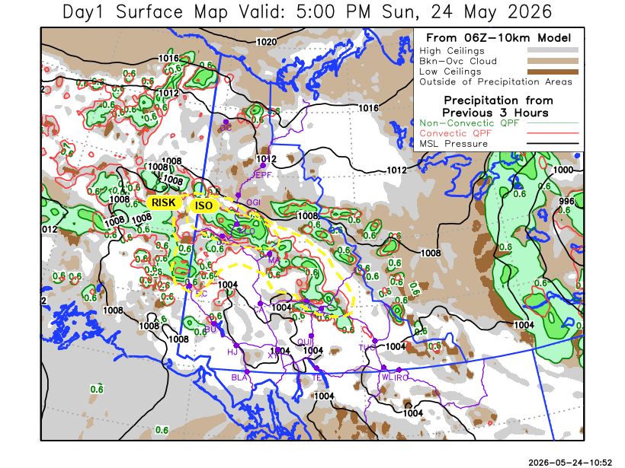
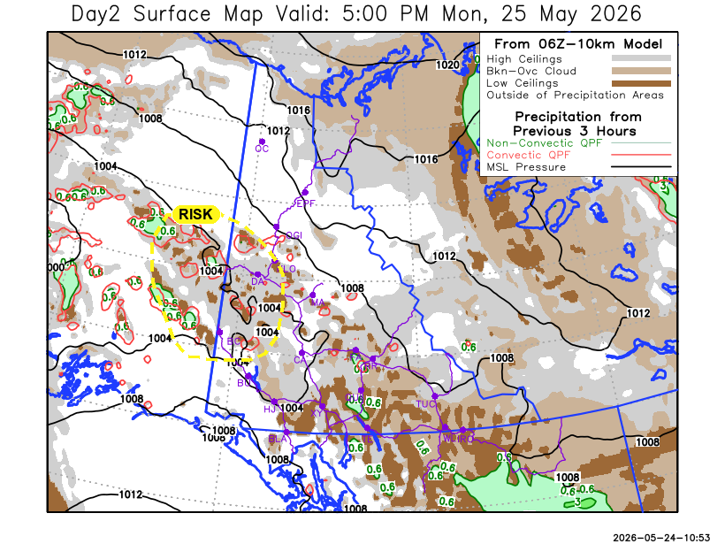
Forecast for | Monday | (Peak burning period and overnight)
Community | Clouds | Pcpn | POP | POL | Max Temp | Min RH | Min Temp | Max  RH | Wind Dir | Wind Speed
Old Crow | SCT |  | 10 | NIL | 14 | 35 | 1 | 75 | 90 | 20G35
Klondike Fc | BKN | RW-/TRW- | 30 | RISK | 17 | 30 | 7 | 65 | 90 | 15
Mayo A | SCT |  | 10 | NIL | 15 | 35 | 8 | 70 | 90 | 15
Carmacks | FEW |  | 0 | NIL | 20 | 20 | 7 | 60 | 140 | 15G25
Faro | SCT | RW- | 30 | NIL | 16 | 40 | 3 | 80 | 110 | 15
Ross River | SCT | RW- | 20 | NIL | 16 | 35 | 1 | 75 | 110 | 10
Beaver Creek Town | SCT | RW-/TRW- | 10 | RISK | 16 | 40 | 1 | 80 | 140 | 10
Burwash A | SCT | RW- | 10 | NIL | 15 | 30 | 1 | 70 | 160 | 20G30
Haines Junction | FEW |  | 10 | NIL | 18 | 25 | 3 | 80 | 180 | 10
Whitehorse Auto | SCT | RW- | 20 | NIL | 15 | 40 | 5 | 80 | 160 | 15G25
Teslin | SCT | RW- | 30 | NIL | 14 | 40 | 4 | 80 | 160 | 15
Watson Lake | BKN | RW- | 30 | NIL | 12 | 35 | 6 | 75 | 110 | 15G30

Forecast for |  |  | Tuesday |  | (Peak burning period and overnight)
Community |  |  | Clouds |  | Pcpn |  | POP |  | POL |  | Max Temp |  | Min RH | Min Temp | Max  RH | Wind Dir | Wind Speed
Old Crow |  |  | BKN |  | R-/TRW- |  | 50 |  | RISK |  | 16 |  | 35 | 5 | 85 | 90 | 20G40
Klondike Fc |  |  | BKN |  | R-/TRW- |  | 60 |  | RISK |  | 15 |  | 40 | 5 | 80 | 180 | 15
Mayo A |  |  | BKN |  | RW-/TRW- |  | 30 |  | RISK |  | 15 |  | 35 | 6 | 70 | 180 | 15G30
Carmacks |  |  | SCT |  |  |  | 0 |  | NIL |  | 18 |  | 25 | 3 | 60 | 180 | 20G40
Faro |  |  | BKN |  |  |  | 20 |  | NIL |  | 15 |  | 30 | 1 | 75 | 200 | 20G40
Ross River |  |  | SCT |  |  |  | 10 |  | NIL |  | 17 |  | 30 | -1 | 65 | 200 | 20G40
Beaver Creek Town |  |  | BKN |  | RW-/TRW- |  | 30 |  | RISK |  | 15 |  | 30 | 0 | 65 | 220 | 15G35
Burwash A |  |  | BKN |  |  |  | 10 |  | NIL |  | 12 |  | 35 | 0 | 65 | 180 | 20G40
Haines Junction |  |  | SCT |  |  |  | 0 |  | NIL |  | 12 |  | 40 | 0 | 80 | 180 | 20G40
Whitehorse Auto |  |  | FEW |  |  |  | 0 |  | NIL |  | 13 |  | 30 | 3 | 70 | 180 | 20G45
Teslin |  |  | FEW |  |  |  | 0 |  | NIL |  | 14 |  | 35 | 2 | 75 | 200 | 20G30
Watson Lake |  |  | BKN |  |  |  | 20 |  | NIL |  | 16 |  | 40 | 6 | 65 | 270 | 15G25
3-Day Forecast Precipitation Totals from 13:00 Yesterday
OC | 0.4 |  | FA | 2.2 |  | JAK | 0.7
EPF | 2.0 |  | RR | 1.1 |  | TE | 1.0
ANT | 1.0 |  | BC | 2.9 |  | QUI | 1.1
DA | 1.7 |  | BCT | 2.6 |  | SWI | 0.8
FMI | 5.4 |  | BU | 0.9 |  | FL | 0.1
HEN | 2.5 |  | HJF | 0.0 |  | TUC | 0.4
BAR | 2.1 |  | RAI | 0.3 |  | HAS | 1.3
MA | 5.5 |  | CH | 0.2 |  | TC | 0.7
STW | 0.2 |  | BR | 0.0 |  | WL | 0.4
WIL | 1.6 |  | NU | 0.4 |  | PE | 0.1
XY | 0.5 |  | IRO | 0.9 |  | CA | 0.0
CC | 1.4 |  | ELK | 1.9 |  | DRU | 0.5
ATL | 1.5
Pallawi Paudel Meteorologist

Disclaimer : The information in these forecasts is collected and prepared for internal use by the Government of Yukon. The forecasts are specifically designed to meet the needs of the Wildland Fire Management and may not cover the requirements of other parties. Weather warnings or advisories are not included as part of the forecasts. Wildland Fire Management makes no representation and provides no warranty as to the accuracy of its weather forecasts. Any use the recipient chooses to make of the forecasts will be at its sole risk.

