YUKON WILDLAND FIRE MANAGEMENT WEATHER FORECAST - 9:00 AM ISSUE

25-May-2026
YESTERDAY'S VALUES
Community | Max  Temp  (°C) | Diff.  from  Normal | Min Temp  (°C) | Diff. from Normal | Pcpn  (mm) | Min RH | Max RH | L110 | L30
Old Crow | 12.1 | 0.5 | 0.3 | 0.1 | 0.0 | 50 | 83 | 0 | 0
Fort Mcpherson Airport | 9.5 |  | -2.2 |  | 0.0 | 46 | 84 | 0 | 0
Rock River Climate | 6.9 |  | -1.5 |  | 0.2 | 59 | 83 | NA | NA
Eagle Plains Fire | 10.7 |  | -1.6 |  | 0.0 | 44 | 82 | 0 | 0
Antimony Creek | 14.8 |  | -0.5 |  | 0.0 | 39 | 97 | 3 | 0
Klondike Fc | 17.6M | 0.2 | -1.0M | -3.6 | 1.0M | 33M | 98M | 3 | 2
Forty Mile | 15.3 |  | 2.6 |  | 1.3 | 32 | 97 | 2 | 0
Henderson | 11.3 |  | 2.1 |  | 1.4 | 36 | 86 | 3 | 0
Barlow | 13.2 |  | 2.5 |  | 0.0 | 34 | 82 | 2 | 0
Mayo A | 14.0 | -2.7 | 0.9 | -2.6 | 0.0 | 38 | 96 | 1 | 0
Stewart Crossing | 15.8 |  | 1.8 |  | 0.8 | 30 | 91 | 0 | 0
Willow Creek | 16.3 |  | 0.8 |  | 0.0 | 19 | 91 | 0 | 0
Pelly Farm | M |  | M |  | M | M | M | 0 | 0
Carmacks | 16.9 |  | 0.9 |  | 0.0 | 18 | 79 | 0 | 0
Drury Creek | 17.2 |  | -0.8 |  | 0.0 | 18 | 85 | 0 | 0
Faro | 14.4 | -1.0 | -0.3 | -3.1 | 0.2 | 38M | 83M | 0 | 0
Ross River | 16.4 |  | -2.0 |  | 0.0 | 19 | 93 | 1 | 0
Macmillan Pass | 8.5 |  | -0.4 |  | 0.6 | 57 | 91 | 7 | 0
Beaver Creek A | 11.3 | -3.4 | -2.9 | -3.9 | 3.2M | 48 | 96 | 0 | 0
Beaver Creek Town | 12.1 |  | -2.4 |  | 0.0 | 36 | 93 | 0 | 0
Burwash A | 11.1 | -2.6 | 1.0 | 1.0 | 0.0 | 27 | 85 | 0 | 0
Haines Junction | 15.4 | 0.6 | 2.4 | 2.7 | 0.0 | 16 | 53 | 0 | 0
Rainbow | 13.7 |  | 3.2 |  | 0.0 | 18 | 53 | 0 | 0
Champagne | 13.6 |  | 1.4 |  | 0.0 | 16 | 62 | 0 | 0
Braeburn | 16.1 |  | -0.8 |  | 0.0 | 16 | 76 | 0 | 0
Nursery | 15.4 |  | 1.5 |  | 0.0 | 17 | 67 | 0 | 0
Whitehorse Auto | 13.5 | -1.3 | 6.6 | 4.7 | 0.0 | 19 | 48 | 0 | 0
Mount Sima | 9.1 |  | 3.8 |  | 0.0 | 23 | 50 | 0 | 0
Carcross | 12.9 |  | 2.1 |  | 0.0 | 14 | 64 | 0 | 0
Atlin | 10.7 |  | 4.6 |  | 0.0 | 25 | 58 | 0 | 0
Jakes Corner | 13.9 |  | 2.6 |  | 0.0 | 18 | 57 | 0 | 0
Teslin | 11.9 |  | 2.3 |  | 0.0 | 25 | 76 | 0 | 0
Quiet Lake | 15.6 |  | 4.1 |  | 0.0 | 18 | 70 | 0 | 0
Swift River | 14.1 |  | 2.9 |  | 0.0 | 19 | 72 | 0 | 0
Tuchitua | 17.9 |  | 3.1 |  | 0.0 | 18 | 76 | 0 | 0
Hasselburg | 15.5 |  | 4.8 |  | 0.0 | 18 | 85 | 0 | 0
Tom Creek | 14.7 |  | 4.4 |  | 0.0 | 18 | 82 | 0 | 0
Watson Lake | 13.9 | -1.4 | 7.1 | 4.5 | 0.0 | 22 | 81 | 0 | 0
Iron Creek | 17.8 |  | 4.8 |  | 0.0 | 14 | 74 | 0 | 0
Max Temp is the actual maximum temperature in °C from yesterday afternoon or evening.
Min Temp is the actual overnight minimum temperature in °C up until 6:00 AM this morning.
Diff. from Normal is the difference from the 30 year average max or min temperature.
Pcpn is the precipitation in mm since 13:00 yesterday.
Min RH is the minimum observed RH in % from yesterday afternoon or evening.
Max RH is the maximum observed overnight RH in % up until 6:00 AM this morning.
L110 is the actual number of lightning strikes within 110 km and in the Yukon for 24 hours ending at 06:00 AM this morning.
L30 is the actual number of lightning strikes within 30 km and in the Yukon for 24 hours ending at 06:00 AM this morning.
M is missing data. * denotes precipitation at stations that failed to report for at least part of the evening and overnight period.

SYNOPSIS:
Today: A surface trough will produce unsettled conditions over the Yukon Plateau with locally dry conditions while damp and windy conditions will prevail over northern Yukon. On the Yukon Plateau, light winds and relative humidity values of 30-40% are expected and locally 25% over western Tatchun region. Scattered convective showers and thundershowers will develop over the Plateau from Dawson to Whitehorse in the afternoon and drizzle is expected over the Tintina region. North of the Ogilvie Mountains in the Old Crow Region, rain free skies are expected with relative humidity above 40% and moderate easterly winds sustained at 20 km/h and gusting to 40km/h. Relative humidity values may approach 30% near Old Crow town.

Tuesday: The moisture axis lifts north and brings unsettled conditions to northern Yukon but behind the boundary, an elevated fire weather threat will develop over southern and central Yukon. Minimum relative humidity will sit around 20-30% over southern and central Yukon and will be accompanied by widespread southerly flow at 20-30km/h gusting 40-60 km/h. The strongest overlap of dry air with gusty winds will occur over Tatchun, Southern Lakes, and Northern Tutchone region. Slow moving showers will develop between Beaver Creek and Mayo in the afternoon, and locations caught underneath will see temperatures drop into the mid-single digits.

Wednesday: A strengthening surface low in the NWT will re-enforce unsettled conditions over the northern half of the Yukon. Relative humidity will remain above 35% over the Old Crow region and winds will ease below 20 km/h. Marginally dry conditions (RH 30-40%) will develop over southern and central Yukon, with pockets as low as 25% RH in Tintina, Tatchun, and southern Klondike region. Moderate southerly winds continue over southern Yukon from Carmacks to Watson Lake.

Thursday: Another wave of moisture will bring unsettled conditions throughout the Yukon and relatively cool temperatures. Winds will further diminish and are generally expected to remain below 10 km/h apart from stronger winds in Old Crow. A pocket of marginally dry air (~ 30%) may develop over Tatchun region.

Friday: Unsettled weather continues across southern and central Yukon, influenced by a strong upper low over the Gulf of Alaska. Scattered showers generally expected through a large area of the Territory. Daytime highs will climb into the low to mid-teens and sustained winds are generally expected to remain below 10 km/h. Pockets of dry air may develop over Tatchun, Southern Lakes, and Tintina region, but no crossovers are anticipated.

Forecast for | Monday | (Peak burning period and overnight)
Community | Clouds | Pcpn | POP | POL | Max Temp | Min RH | Min Temp | Max  RH | Wind Dir | Wind Speed
Old Crow | FEW |  | 0 | NIL | 13 | 35 | 1 | 80 | 150 | 20G30
Klondike Fc | BKN | RW-/TRW- | 20 | RISK | 18 | 35 | 8 | 70 | 130 | 10
Mayo A | BKN | RW-/TRW- | 30 | RISK | 17 | 30 | 9 | 80 | 90 | 10
Carmacks | SCT | RW-/TRW- | 30 | RISK | 20 | 30 | 7 | 60 | 140 | 10
Faro | SCT | RW-/TRW- | 30 | RISK | 14 | 40 | 3 | 80 | 140 | 15G35
Ross River | BKN | RW- | 20 | NIL | 16 | 40 | 1 | 80 | 140 | 15G35
Beaver Creek Town | SCT | RW-/TRW- | 20 | RISK | 16 | 30 | 0 | 70 | 170 | 10
Burwash A | FEW | RW-/TRW- | 20 | RISK | 14 | 35 | 1 | 70 | 160 | 15G25
Haines Junction | FEW | RW-/TRW- | 20 | RISK | 18 | 30 | 3 | 80 | 200 | 10G30
Whitehorse Auto | SCT | RW-/TRW- | 40 | RISK | 15 | 40 | 5 | 80 | 160 | 10
Teslin | SCT |  | 15 | NIL | 13 | 45 | 5 | 85 | 100 | 10
Watson Lake | SCT | R- | 40 | NIL | 12 | 45 | 5 | 85 | 110 | 15G30
POP is probability of precipitation in %.
POL is probability of lightning in %.

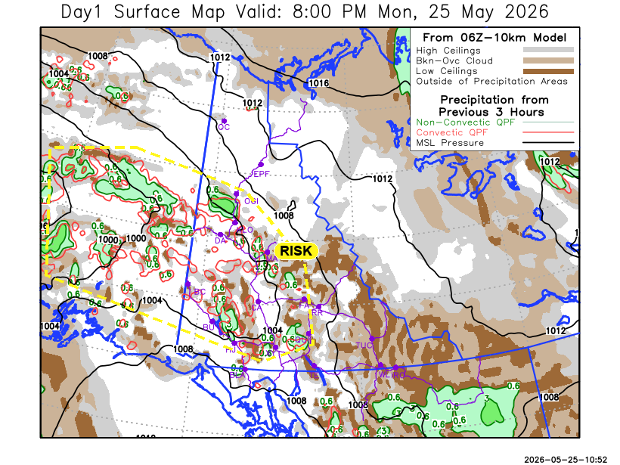
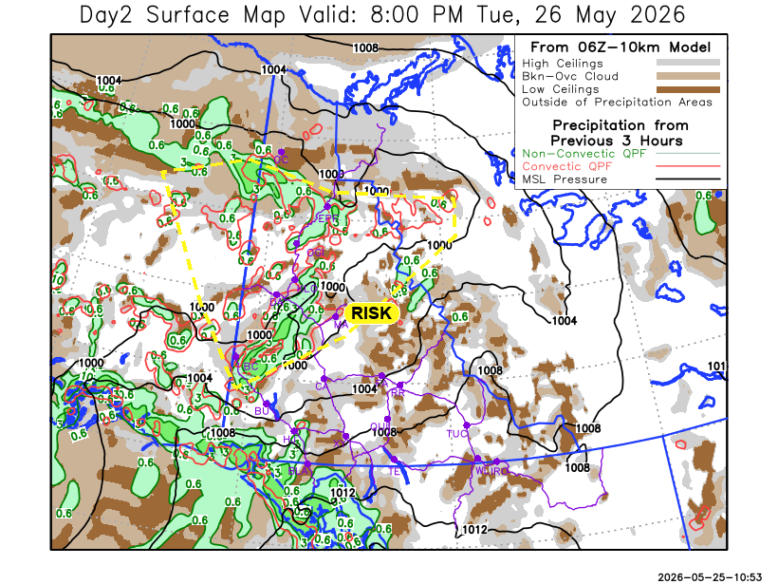

Forecast for | Tuesday | (Peak burning period and overnight)
Community | Clouds | Pcpn | POP | POL | Max Temp | Min RH | Min Temp | Max  RH | Wind Dir | Wind Speed
Old Crow | BKN | R- | 40 | NIL | 14 | 35 | 3 | 95 | 140 | 15
Klondike Fc | BKN | RW-/TRW- | 70 | RISK | 15 | 40 | 5 | 80 | 200 | 10
Mayo A | BKN | RW-/TRW- | 20 | RISK | 16 | 30 | 6 | 65 | 180 | 15
Carmacks | FEW |  | 0 | NIL | 17 | 25 | 3 | 50 | 180 | 20G60
Faro | SCT |  | 15 | NIL | 14 | 25 | 0 | 65 | 200 | 20G40
Ross River | SCT |  | 0 | NIL | 16 | 25 | -1 | 65 | 200 | 20G40
Beaver Creek Town | SCT | RW-/TRW- | 60 | RISK | 13 | 30 | -1 | 75 | 220 | 10
Burwash A | SCT |  | 0 | NIL | 10 | 30 | -1 | 65 | 180 | 25G50
Haines Junction | SCT |  | 15 | NIL | 11 | 35 | 1 | 80 | 180 | 20G40
Whitehorse Auto | SCT |  | 0 | NIL | 13 | 30 | 3 | 70 | 190 | 20G40
Teslin | SCT |  | 0 | NIL | 12 | 30 | 3 | 70 | 200 | 20G50
Watson Lake | BKN |  | 2 | NIL | 17 | 35 | 7 | 70 | 270 | 10

Forecast for |  |  | Wednesday |  |  | (Peak burning period and overnight)
Community |  |  | Clouds |  |  | Pcpn | POP |  | POL |  | Max Temp |  | Min RH | Min Temp | Max  RH | Wind Dir | Wind Speed
Old Crow |  |  | BKN |  |  |  | 15 |  | NIL |  | 12 |  | 60 | 0 | 85 | 20 | 15
Klondike Fc |  |  | BKN |  |  |  | 0 |  | NIL |  | 17 |  | 25 | 4 | 75 | 220 | 5
Mayo A |  |  | BKN |  |  | R- | 20 |  | NIL |  | 14 |  | 30 | 6 | 75 | 200 | 5
Carmacks |  |  | BKN |  |  |  | 0 |  | NIL |  | 17 |  | 25 | 2 | 60 | 180 | 15
Faro |  |  | BKN |  |  |  | 0 |  | NIL |  | 11 |  | 30 | 1 | 70 | 220 | 10
Ross River |  |  | BKN |  |  |  | 0 |  | NIL |  | 14 |  | 30 | -1 | 65 | 220 | 10
Beaver Creek Town |  |  | BKN |  |  |  | 16 |  | NIL |  | 15 |  | 30 | 0 | 70 | 220 | 5
Burwash A |  |  | BKN |  |  |  | 15 |  | NIL |  | 10 |  | 35 | 0 | 75 | 180 | 15
Haines Junction |  |  | BKN |  |  |  | 15 |  | NIL |  | 11 |  | 40 | -1 | 85 | 220 | 15
Whitehorse Auto |  |  | BKN |  |  |  | 15 |  | NIL |  | 11 |  | 35 | 1 | 75 | 200 | 15
Teslin |  |  | SCT |  |  |  | 15 |  | NIL |  | 10 |  | 35 | 1 | 80 | 200 | 15
Watson Lake |  |  | BKN |  |  |  | 0 |  | NIL |  | 13 |  | 30 | 4 | 60 | 250 | 20G40
3-Day Forecast Precipitation Totals from 13:00 Yesterday
OC | 2.9 |  | FA | 0.6 |  | JAK | 0.8
EPF | 3.7 |  | RR | 0.1 |  | TE | 0.5
ANT | 5.3 |  | BC | 4.4 |  | QUI | 2.4
DA | 4.1 |  | BCT | 1.2 |  | SWI | 0.0
FMI | 4.5 |  | BU | 0.2 |  | FL | 0.3
HEN | 4.3 |  | HJF | 0.0 |  | TUC | 0.5
BAR | 6.4 |  | RAI | 0.3 |  | HAS | 0.8
MA | 1.5 |  | CH | 0.3 |  | TC | 0.8
STW | 3.5 |  | BR | 0.7 |  | WL | 1.0
WIL | 1.1 |  | NU | 1.2 |  | PE | 3.0
XY | 1.0 |  | IRO | 1.2 |  | CA | 0.4
CC | 1.3 |  | ELK | 2.4 |  | DRU | 1.6
ATL | 0.5 |  | NA | NA |  | NA | NA
Dylan Kikuta Meteorologist

Disclaimer : The information in these forecasts is collected and prepared for internal use by the Government of Yukon. The forecasts are specifically designed to meet the needs of the Wildland Fire Management and may not cover the requirements of other parties. Weather warnings or advisories are not included as part of the forecasts. Wildland Fire Management makes no representation and provides no warranty as to the accuracy of its weather forecasts. Any use the recipient chooses to make of the forecasts will be at its sole risk.

