YUKON WILDLAND FIRE MANAGEMENT WEATHER FORECAST - 9:00 AM ISSUE

26-May-2026
YESTERDAY'S VALUES
Community | Max  Temp  (°C) | Diff.  from  Normal | Min Temp  (°C) | Diff. from Normal | Pcpn  (mm) | Min RH | Max RH | L110 | L30
Old Crow | 12.8 | 0.8 | 2.7 | 2.2 | 0.0 | 27 | 66 | 0 | 0
Fort Mcpherson Airport | 8.9 |  | 0.6 |  | 0.0M | 45 | 80 | 0 | 0
Rock River Climate | 4.9 |  | 0.4 |  | 0.0 | 55 | 80 | NA | NA
Eagle Plains Fire | 9.4 |  | -0.7 |  | 0.0 | 38 | 82 | 0 | 0
Antimony Creek | 16.8 |  | 7.2 |  | 0.3 | 29 | 78 | 0 | 0
Klondike Fc | 16.5M | -1.1 | 5.9M | 3.1 | 0.0M | 33M | 84M | 4 | 0
Forty Mile | 15.9 |  | 5.9 |  | 0.0 | 32 | 82 | 4 | 4
Henderson | 13.5 |  | 5.0 |  | 0.0 | 31 | 74 | 0 | 0
Barlow | 14.7 |  | 6.5 |  | 1.8 | 31 | 72 | 0 | 0
Mayo A | 14.4 | -2.5 | 6.6 | 2.9 | 2.1 | 32 | 80 | 0 | 0
Stewart Crossing | 17.5 |  | 7.0 |  | 1.5 | 29 | 83 | 0 | 0
Willow Creek | 16.6 |  | 6.8 |  | 0.3 | 26 | 72 | 0 | 0
Pelly Farm | M |  | M |  | M | M | M | 0 | 0
Carmacks | 19.8 |  | 4.1 |  | 2.1 | 22 | 91 | 0 | 0
Drury Creek | 16.1 |  | 4.8 |  | 0.0 | 31 | 85 | 0 | 0
Faro | 13.8 | -1.8 | 5.8 | 2.8 | 0.0 | 56M | 100M | 0 | 0
Ross River | 13.7 |  | 0.6 |  | 0.3 | 40 | 88 | 0 | 0
Macmillan Pass | 7.4 |  | 1.6 |  | 0.0 | 35 | 89 | 0 | 0
Beaver Creek A | 15.1 | 0.2 | -0.1 | -1.4 | 0.0 | 23 | 76 | 0 | 0
Beaver Creek Town | 15.1 |  | 0.0 |  | 0.0 | 22 | 83 | 0 | 0
Burwash A | 14.0 | 0.1 | 2.8 | 2.7 | 0.0M | 27 | 52 | 0 | 0
Haines Junction | 16.7 | 2.1 | 4.8 | 5.0 | 0.0 | 18 | 43 | 0 | 0
Rainbow | 15.3 |  | 4.2 |  | 0.0 | 28 | 42 | 0 | 0
Champagne | 14.8 |  | -1.5 |  | 0.0 | 25 | 68 | 0 | 0
Braeburn | 16.3 |  | 2.0 |  | 0.0 | 31 | 63 | 0 | 0
Nursery | 15.1 |  | 5.0 |  | 0.0 | 30 | 55 | 0 | 0
Whitehorse Auto | 13.0 | -2.0 | 4.4 | 2.4 | 0.0 | 34 | 57 | 0 | 0
Mount Sima | 9.3 |  | 1.5 |  | 0.0 | 41 | 64 | 0 | 0
Carcross | 15.8 |  | 1.4 |  | 0.0 | 28 | 69 | 0 | 0
Atlin | 14.5 |  | 7.9 |  | 0.0 | 31 | 48 | 0 | 0
Jakes Corner | 16.1 |  | 5.7 |  | 0.0 | 34 | 55 | 0 | 0
Teslin | 12.4 |  | 4.6 |  | 0.0 | 46 | 77 | 0 | 0
Quiet Lake | 11.6 |  | 3.5 |  | 3.1 | 56 | 97 | 0 | 0
Swift River | 11.4 |  | 2.8 |  | 0.0 | 46 | 87 | 0 | 0
Tuchitua | 13.1 |  | 0.5 |  | 0.0 | 31 | 97 | 0 | 0
Hasselburg | 10.3 |  | 3.1 |  | 0.5 | 51 | 95 | 0 | 0
Tom Creek | 9.1 |  | 0.6 |  | 0.0 | 59 | 99 | 0 | 0
Watson Lake | 10.1 | -5.5 | 2.1 | -0.7 | 0.0 | 55M | 100M | 0 | 0
Iron Creek | 10.8 |  | -2.3 |  | 0.6 | 46 | 98 | 0 | 0
Max Temp is the actual maximum temperature in °C from yesterday afternoon or evening.
Min Temp is the actual overnight minimum temperature in °C up until 6:00 AM this morning.
Diff. from Normal is the difference from the 30 year average max or min temperature.
Pcpn is the precipitation in mm since 13:00 yesterday.
Min RH is the minimum observed RH in % from yesterday afternoon or evening.
Max RH is the maximum observed overnight RH in % up until 6:00 AM this morning.
L110 is the actual number of lightning strikes within 110 km and in the Yukon for 24 hours ending at 06:00 AM this morning.
L30 is the actual number of lightning strikes within 30 km and in the Yukon for 24 hours ending at 06:00 AM this morning.
M is missing data. * denotes precipitation at stations that failed to report for at least part of the evening and overnight period.

SYNOPSIS:
Today: A potent 50 km/h low-level jet will surge behind a lifting surface trough and unsettled conditions will develop over northern Yukon, but a dry and windy airmass will produce an elevated fire weather threat over southern and central Yukon. Minimum relative humidity values of 25-30%, locally 20%, will accompany southerly 20-30km/h winds gusting 40-60 km/h. The strongest overlap of dry air with gusty winds will occur over western Tatchun and spill into the edges of adjacent regions. Daytime highs will be on the cool side (low teens) and areas caught underneath a narrow band of showers between Beaver Creek and Mayo will see temperatures plummet to 5 degrees. Over Klondike region, a west-east oriented line of broken convective showers and thundershowers will track north and weaken into plain showers by the time it reaches Old Crow town.

Wednesday: Winds begin to subside but dry air remains in place over southern and central Yukon while a strengthening surface low in the NWT will re-enforce unsettled conditions over the northern half of the Yukon. Relative humidity will remain above 35% over the Old Crow region and winds will ease below 20 km/h. Convective showers and thundershowers will develop south of Old Crow through the Ogilvie Mountains in the afternoon. Relative humidity values around 30% will be common over southern and central Yukon, with pockets around 25% in Tintina, Tatchun, Kluane, and southern Klondike region. Moderate southerly winds up to 20 km/h may continue over the Southern Lakes and Tintina region.

Thursday: Another impulse of Pacific moisture will spark showers throughout the Yukon and keep daytime highs around 10 degrees. Light southeasterly winds below 10 km/h are expected for most apart from Old Crow where conditions remain breezy. Minimum relative humidity values around 30%, locally 25%, will be common over southern and central Yukon, but daytime highs in the low teens will limit the risk of crossovers. Light steady rain is possible over the Tintina region as a surface low develops along the Rockies.

Friday: Unsettled weather continues across the Yukon, influenced by a strong upper low over the Gulf of Alaska and a surface low ejecting north over the NWT. Showers are generally expected through a large area of the Territory, but steady rain and snow is possible over the Mackenzies. The driest and warmest air will be in the southeast (Tatchun, Tintina) where RH will sit around 30%, locally 25%, but daytime highs in the low teens will limit the risk of crossovers. A slight breeze may develop in the southeast.

Saturday: Unsettled weather will taper and the airmass over the southeast will dry out further. Minimum relative humidity values of 20-30% will be common over Tintina region and potentially Tatchun and the Southern Lakes. Daytime highs will struggle to break above the low teens yet again so crossover conditions appear unlikely, and winds should remain on the lighter side.

Forecast for | Tuesday | (Peak burning period and overnight)
Community | Clouds | Pcpn | POP | POL | Max Temp | Min RH | Min Temp | Max  RH | Wind Dir | Wind Speed
Old Crow | BKN | RW- | 30 | NIL | 14 | 40 | 3 | 90 | 120 | 15
Klondike Fc | BKN | RW- TRW- | 60 | RISK | 13 | 40 | 4 | 80 | 200 | 5
Mayo A | BKN | RW- TRW- | 60 | RISK | 13 | 30 | 7 | 60 | 180 | 15
Carmacks | SCT |  | 5 | NIL | 15 | 25 | 3 | 55 | 200 | 25G60
Faro | BKN |  | 5 | NIL | 13 | 25 | 1 | 70 | 220 | 20G50
Ross River | BKN |  | 0 | NIL | 13 | 25 | 1 | 60 | 220 | 20G50
Beaver Creek Town | SCT | RW- TRW- | 60 | RISK | 15 | 30 | -1 | 70 | 200 | 5
Burwash A | BKN |  | 15 | NIL | 10 | 30 | 0 | 60 | 150 | 30G60
Haines Junction | SCT | R- | 20 | NIL | 10 | 35 | 1 | 80 | 180 | 20G50
Whitehorse Auto | SCT |  | 0 | NIL | 12 | 30 | 3 | 70 | 200 | 20G50
Teslin | BKN |  | 0 | NIL | 12 | 30 | 4 | 70 | 230 | 20G60
Watson Lake | BKN |  | 0 | NIL | 15 | 35 | 6 | 65 | 240 | 15
POP is probability of precipitation in %.
POL is probability of lightning in %.

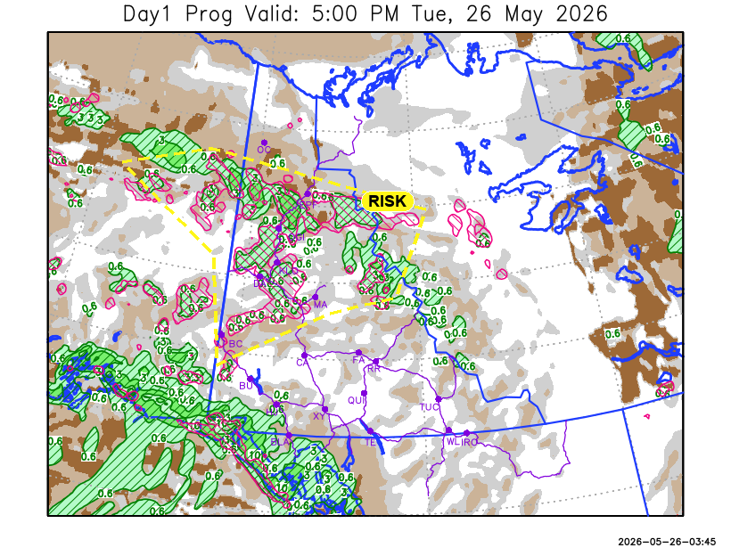
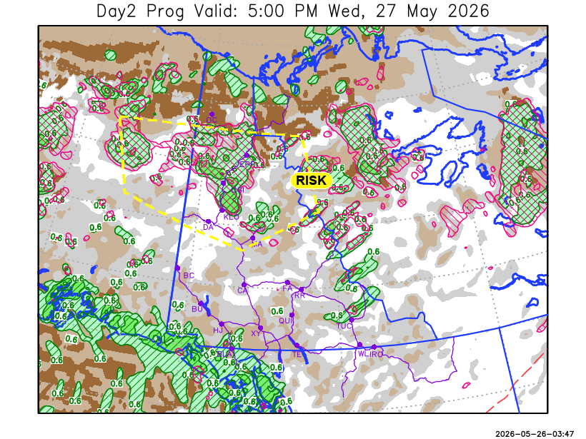

Forecast for | Wednesday | (Peak burning period and overnight)
Community | Clouds | Pcpn | POP | POL | Max Temp | Min RH | Min Temp | Max  RH | Wind Dir | Wind Speed
Old Crow | OVC | R- SN- | 40 | NIL | 7 | 55 | -1 | 85 | 20 | 25
Klondike Fc | BKN | RW- TRW- | 30 | RISK | 15 | 30 | 4 | 80 | 200 | 10
Mayo A | BKN | RW- TRW- | 30 | RISK | 12 | 40 | 6 | 70 | 180 | 5
Carmacks | BKN |  | 15 | NIL | 15 | 25 | 3 | 60 | 200 | 15
Faro | SCT |  | 15 | NIL | 11 | 25 | 0 | 80 | 230 | 15
Ross River | SCT |  | 5 | NIL | 11 | 30 | -2 | 75 | 230 | 15
Beaver Creek Town | BKN |  | 15 | NIL | 15 | 30 | 1 | 70 | 270 | 5
Burwash A | BKN |  | 15 | NIL | 10 | 35 | 0 | 70 | 140 | 20G30
Haines Junction | SCT |  | 0 | NIL | 11 | 35 | -1 | 90 | 230 | 10
Whitehorse Auto | SCT |  | 0 | NIL | 11 | 35 | 1 | 75 | 200 | 15
Teslin | SCT |  | 0 | NIL | 9 | 35 | 1 | 80 | 210 | 20G30
Watson Lake | SCT |  | 15 | NIL | 12 | 35 | 3 | 60 | 250 | 20G40

Forecast for |  |  | Thursday |  |  | (Peak burning period and overnight)
Community |  |  | Clouds |  |  | Pcpn | POP |  | POL |  | Max Temp |  | Min RH | Min Temp | Max  RH | Wind Dir | Wind Speed
Old Crow |  |  | OVC |  |  |  | 15 |  | NIL |  | 7 |  | 45 | -2 | 85 | 40 | 20G35
Klondike Fc |  |  | BKN |  |  |  | 15 |  | NIL |  | 12 |  | 35 | 4 | 80 | 110 | 10
Mayo A |  |  | BKN |  |  | RW- | 40 |  | NIL |  | 12 |  | 30 | 5 | 85 | 160 | 5
Carmacks |  |  | SCT |  |  |  | 15 |  | NIL |  | 12 |  | 25 | 3 | 70 | 160 | 10
Faro |  |  | SCT |  |  | RW- | 20 |  | NIL |  | 11 |  | 30 | 1 | 80 | 170 | 10
Ross River |  |  | BKN |  |  | RW- | 40 |  | NIL |  | 11 |  | 30 | 0 | 80 | 170 | 10
Beaver Creek Town |  |  | BKN |  |  | R- SN- | 80 |  | NIL |  | 10 |  | 50 | 0 | 90 | 290 | 5
Burwash A |  |  | SCT |  |  | SN- | 40 |  | NIL |  | 7 |  | 35 | -1 | 75 | 160 | 10
Haines Junction |  |  | SCT |  |  |  | 15 |  | NIL |  | 10 |  | 30 | -1 | 85 | 300 | 10
Whitehorse Auto |  |  | SCT |  |  | R- | 30 |  | NIL |  | 10 |  | 30 | 2 | 80 | 180 | 10
Teslin |  |  | BKN |  |  | R- | 30 |  | NIL |  | 11 |  | 40 | 2 | 80 | 190 | 5
Watson Lake |  |  | BKN |  |  | R- | 60 |  | NIL |  | 14 |  | 35 | 6 | 80 | 140 | 15
3-Day Forecast Precipitation Totals from 13:00 Yesterday
OC | 4.5 |  | FA | 0.5 |  | JAK | 0.1
EPF | 5.0 |  | RR | 0.3 |  | TE | 0.0
ANT | 4.4 |  | BC | 2.1 |  | QUI | 3.4
DA | 3.3 |  | BCT | 2.1 |  | SWI | 0.1
FMI | 1.7 |  | BU | 3.3 |  | FL | 1.6
HEN | 2.6 |  | HJF | 0.0 |  | TUC | 0.5
BAR | 11.6 |  | RAI | 0.3 |  | HAS | 0.5
MA | 6.4 |  | CH | 0.5 |  | TC | 0.0
STW | 5.3 |  | BR | 0.0 |  | WL | 0.0
WIL | 1.2 |  | NU | 0.0 |  | PE | 3.5
XY | 0.0 |  | IRO | 0.8 |  | CA | 3.0
CC | 0.3 |  | ELK | 0.0 |  | DRU | 0.1
ATL | 0.6 |  | NA | NA |  | NA | NA
Dylan Kikuta Meteorologist

Disclaimer : The information in these forecasts is collected and prepared for internal use by the Government of Yukon. The forecasts are specifically designed to meet the needs of the Wildland Fire Management and may not cover the requirements of other parties. Weather warnings or advisories are not included as part of the forecasts. Wildland Fire Management makes no representation and provides no warranty as to the accuracy of its weather forecasts. Any use the recipient chooses to make of the forecasts will be at its sole risk.

